UNITED STATES
SECURITIES AND EXCHANGE COMMISSION
WASHINGTON, D.C. 20549

FORM 8-K

CURRENT REPORT
Pursuant to Section 13 or 15(d) of the
Securities Exchange Act of 1934

Date of Report (Date of earliest event reported): October 8, 2026

AngioDynamics, Inc.
(Exact Name of Registrant as Specified in Charter)

Delaware | 000-50761 | 11-3146460
(State or Other Jurisdiction of Incorporation) | (Commission File Number) | (IRS Employer Identification No.)

14 Plaza Drive, Latham, New York |  | 12110
(Address of Principal Executive Offices) |  | (Zip Code)

(518) 795-1400

(Registrant’s telephone number, including area code)

Check the appropriate box below if the Form 8-K filing is intended to simultaneously satisfy the filing obligation of the registrant under any of the following provisions:

☐ | Written communications pursuant to Rule 425 under the Securities Act (17 CFR 230.425)

☐ | Soliciting material pursuant to Rule 14a-12 under the Exchange Act (17 CFR 240.14a-12)

☐ | Pre-commencement communications pursuant to Rule 14d-2(b) under the Exchange Act (17 CFR 240.14d-2 (b))

☐ | Pre-commencement communications pursuant to Rule 13e-4(c) under the Exchange Act (17 CFR 240.13e-4 (c))

Securities registered pursuant to Section 12(b) of the Act:

Title of each class | Trading Symbol(s) | Name of each exchange on which  registered
Common Stock, par value $0.01 per share | ANGO | NASDAQ Global Select Market

Indicate by check mark whether the registrant is an emerging growth company as defined in Rule 405 of the Securities Act of 1933 (§230.405 of this chapter) or Rule 12b-2 of the Securities Exchange Act of 1934 (§240.12b-2 of this chapter).

Emerging growth company ☐

If an emerging growth company, indicate by check mark if the registrant has elected not to use the extended transition period for complying with any new or revised financial accounting standards provided pursuant to Section 13(a) of the Exchange Act. ☐

Item 2.02 – Results of Operations and Financial Condition.

On October 8, 2026, AngioDynamics, Inc. (“AngioDynamics”) issued a press release announcing financial results for the fiscal first quarter ended August 31, 2026. A copy of the press release is furnished herewith as Exhibit 99.1.

The information set forth in Item 2.02 of this Form 8-K (including Exhibit 99.1) shall not be deemed “filed” for purposes of Section 18 of the Securities Exchange Act of 1934, as amended (the “Exchange Act”), or otherwise subject to the liabilities under that Section. Furthermore, such information shall not be deemed to be incorporated by reference into any filing under the Securities Act of 1933, as amended (the “Securities Act”), or the Exchange Act, except as shall be expressly set forth by specific reference in such a filing.

Item 7.01 – Regulation FD Disclosure.

Presentation slides discussing AngioDynamics and its fiscal first quarter ended August 31, 2026 are furnished herewith as Exhibit 99.2.

The presentation slides furnished pursuant to Item 7.01 of this Form 8-K (including Exhibit 99.2) shall not be deemed “filed” for purposes of Section 18 of the Exchange Act, or otherwise subject to the liabilities under that Section. Furthermore, the presentation slides shall not be deemed to be incorporated by reference into any filing under the Securities Act or the Exchange Act.

Forward-Looking Statements

This document and its attachments contain forward-looking statements within the meaning of the Private Securities Litigation Reform Act of 1995. All statements regarding AngioDynamics’ expected future financial position, results of operations, cash flows, business strategy, budgets, projected costs, capital expenditures, products, competitive positions, growth opportunities, plans and objectives of management for future operations, as well as statements that include the words such as “expects,” “reaffirms,” “intends,” “anticipates,” “plans,” “believes,” “seeks,” “estimates,” “projects”, “optimistic,” or variations of such words and similar expressions, are forward-looking statements. These forward-looking statements are not guarantees of future performance and are subject to risks and uncertainties. Investors are cautioned that actual events or results may differ materially from AngioDynamics’ expectations, expressed or implied. Factors that may affect the actual results achieved by AngioDynamics include, without limitation, the scale and scope of the COVID-19 global pandemic, the ability of AngioDynamics to develop its existing and new products, technological advances and patents attained by competitors, infringement of AngioDynamics’ technology or assertions that AngioDynamics’ technology infringes the technology of third parties, the ability of AngioDynamics to effectively compete against competitors that have substantially greater resources, future actions by the FDA or other regulatory agencies, domestic and foreign health care reforms and government regulations, results of pending or future clinical trials, overall economic conditions (including inflation, tariffs, labor shortages and supply chain challenges including the cost and availability of raw materials), the results of on-going litigation, challenges with respect to third-party distributors or joint venture partners or collaborators, the results of sales efforts, the effects of product recalls and product liability claims, changes in key personnel, the ability of AngioDynamics to execute on strategic initiatives, the effects of economic, credit and capital market conditions, general market conditions, market acceptance, foreign currency exchange rate fluctuations, the effects on pricing from group purchasing organizations and competition, the ability of AngioDynamics to obtain regulatory clearances or approval of its products, or to integrate acquired businesses, as well as the risk factors listed from time to time in AngioDynamics’ SEC filings, including but not limited to its Annual Report on Form 10-K for the year ended May 31, 2026. AngioDynamics does not assume any obligation to publicly update or revise any forward-looking statements for any reason.

Item 9.01 – Financial Statements and Exhibits.

(d) Exhibits.

Exhibit No. |  | Description
99.1 |  | Press Release, dated October 8, 2026.
99.2 |  | Presentation, dated October 8, 2026.

SIGNATURE

Pursuant to the requirements of the Securities Exchange Act of 1934, the registrant has duly caused this report to be signed on its behalf by the undersigned hereunto duly authorized.

 | ANGIODYNAMICS, INC.
 | (Registrant)
Date: October 8, 2026 | By: /s/ Lawrence T. Weiss
 | Name: Lawrence T. Weiss
 | Title: Senior Vice President, Chief
 | Legal Officer and Corporate Secretary

Exhibit 99.1

AngioDynamics Reports Fiscal Year 2027 First Quarter Financial Results; Continued Execution Drives Med Tech Growth and Profitability

Delivered its eighth consecutive quarter of double-digit Med Tech segment growth and positive adjusted EBITDA

LATHAM, N.Y.--(BUSINESS WIRE)— Oct. 8, 2026-- AngioDynamics, Inc. (NASDAQ: ANGO), a leading and transformative medical technology company focused on restoring healthy blood flow in the body’s vascular system, expanding cancer treatment options, and improving quality of life for patients, today announced financial results for the first quarter of fiscal year 2027, which ended August 31, 2026.

Fiscal Year 2027 First Quarter Financial Highlights

 | Quarter Ended  August 31, 2026 | YoY Growth
Net Sales | $80.9 million | 6.9%
Med Tech Net Sales | $39.9 million | 13.2%
Med Device Net Sales | $41.0 million | 1.4%

 | • | GAAP gross margin of 59.4%

 | • | GAAP loss per share of $0.17

 | • | Adjusted loss per share of $0.04

 | • | Adjusted EBITDA of $5.0 million

 | • | Announced the appointment of Eric Honroth as President and Chief Executive Officer, effective November 2, 2026, succeeding Jim Clemmer

 | • | Received FDA IDE (Investigational Device Exemption) approval for the RELIEF study evaluating NanoKnife IRE for the treatment of benign prostatic hyperplasia

“Our first quarter results reflect the continued, consistent execution we’ve built into this business,” said Jim Clemmer, President and Chief Executive Officer of AngioDynamics. “Med Tech again led our growth, highlighted by Auryon’s 21st consecutive quarter of double-digit atherectomy growth, continued performance in Mechanical Thrombectomy, and ongoing strength in our NanoKnife oncology platform. We remain focused on the fundamentals that have driven our performance over the past several years, and we’re confident in our ability to deliver on the outlook we’ve laid out for fiscal 2027.”

Mr. Clemmer continued, “As I shared previously, after ten years leading this company, I have decided to retire, and the Board has completed a comprehensive search for my successor. I’m pleased to share that Eric Honroth will become our next President and Chief Executive Officer. He brings the right experience and leadership to build on the foundation we’ve established, and I will remain closely involved to ensure a smooth transition.”

Fiscal First Quarter 2027 Financial Results

Net sales for the first quarter of fiscal year 2027 were $80.9 million, an increase of 6.9% compared to the prior-year quarter.

Med Tech net sales were $39.9 million, a 13.2% increase from $35.3 million in the prior-year period. Med Tech includes the Auryon peripheral atherectomy platform, our thrombus management platform which is led by AlphaVac and AngioVac, and the NanoKnife irreversible electroporation platform.

Growth during the quarter was driven by solid performance across the Med Tech segment. Auryon sales were $18.9 million, an increase of 14.7% compared to the prior-year quarter.

In our Mechanical Thrombectomy business, AlphaVac sales grew 37.4% compared to the prior year quarter and 6.4% sequentially. AngioVac faced a tough comparison, declining 5.9% versus prior year and yet growing 9.1% sequentially. Overall, Mechanical Thrombectomy delivered sales of $12.0 million, an increase of 6.7% compared to the prior-year quarter. NanoKnife sales were $8.3 million, an increase of 29.0% compared to the prior-year quarter, driven primarily by continued demand for prostate procedures, including 24.1% growth in probes and 53.5% growth in capital sales.

Med Device net sales were $41.0 million, a 1.4% increase compared to $40.4 million in the prior-year period.

Gross margin for the first quarter of fiscal 2027 was 59.4%, which was 410 basis points higher compared to the first quarter of fiscal 2026, primarily driven by favorable pricing and the ongoing revenue mix shift toward Med Tech, partially offset by the manufacturing transition and global inflation all of which were in-line with the Company’s expectations. Gross margin also benefited from tariff refunds received during the quarter; absent this benefit, gross margin would have been 57.8%. As previously stated, the Company expects gross margin to be lower in the second half of fiscal 2027 than in the first half.

The Company recorded a GAAP net loss of $7.1 million, or a loss per share of $0.17, in the first quarter of fiscal 2027, compared to a net loss of $10.9 million, or a loss per share of $0.26, a year ago. Excluding the items shown in the non-GAAP reconciliation table below, adjusted net loss for the first quarter of fiscal 2027 was $1.8 million, or a loss per share of $0.04. This compares to an adjusted net loss during the fiscal first quarter of 2026 of $4.2 million, or a loss per share of $0.10.

Adjusted EBITDA in the first quarter of fiscal 2027, excluding the items shown in the non-GAAP reconciliation table below, was $5.0 million, compared to $2.2 million in the first quarter of fiscal 2026.

Tariff-related expenses were $0.9 million during the quarter, compared to $1.7 million for the prior year quarter, in line with the Company’s expectations. Additionally, the Company received $1.2 million of tariff refunds during the quarter, resulting in net tariff benefit of $0.4 million.

2

In the first quarter of fiscal 2027, the Company used $15.3 million of cash from operations, compared to $15.9 million in the first quarter of fiscal 2026.

At August 31, 2026, the Company had $34.0 million in cash and maintains a debt-free balance sheet.

CEO Update

The Company announced earlier today that Eric Honroth has been appointed President and Chief Executive Officer, effective November 2, 2026, succeeding Jim Clemmer. The appointment follows a comprehensive search process led by the Board of Directors. Mr. Clemmer, who announced his intention to retire after ten years leading the Company, will remain with AngioDynamics as an executive advisor to support a smooth transition. Additional information is available in the Company’s separate press release announcing the appointment.

FDA IDE Approval for RELIEF BPH Study

The Company received FDA approval of its IDE for the RELIEF study, a feasibility trial evaluating NanoKnife IRE for the treatment of benign prostatic hyperplasia. The study is designed to enroll 40 subjects at up to five U.S. clinical sites, with a primary endpoint measuring change in the International Prostate Symptom Score at six months. RELIEF extends the NanoKnife IRE platform beyond oncology into one of the most common conditions affecting men’s health. The Company views the study as an important step in expanding the long-term addressable market for its IRE technology.

Fiscal Year 2027 Financial Guidance

Based on its first quarter performance and current outlook for the remainder of the fiscal year, the Company is reiterating its previously issued fiscal year 2027 guidance, as outlined below.

Guidance Metric | Guidance  (As of October 8, 2026)
Net Sales | $336.0M - $341.0M
Med Tech Net Sales Growth | 12% – 15%
Med Device Net Sales Growth | Flat
Gross Margin | 54% – 55%
Adjusted EBITDA | $13.0M - $16.0M
Adjusted EPS | ($0.29) – ($0.24)

3

Tariff Related Guidance Assumptions

For fiscal 2027, the Company expects a tariff impact broadly similar to fiscal 2026, (excluding any tariff refunds) based on its current view of the tariff situation, which remains dynamic and subject to change.

Conference Call

The Company’s management will host a conference call at 8:00 am ET on the date of this announcement to discuss the results.

To participate in the conference call, dial 1-877-407-0784 (domestic) or +1-201-689-8560 (international). This conference call will also be webcast and can be accessed from the “Investors” section of the AngioDynamics website at www.angiodynamics.com. The webcast replay of the call will be available at the same site approximately one hour after the end of the call.

Use of Non-GAAP Measures

Management uses non-GAAP measures to establish operational goals and believes that non-GAAP measures may assist investors in analyzing the underlying trends in AngioDynamics’ business over time. Investors should consider these non-GAAP measures in addition to, not as a substitute for or as superior to, financial reporting measures prepared in accordance with GAAP. In this news release, AngioDynamics has reported adjusted EBITDA, adjusted net income and adjusted earnings per share. Management uses these measures in its internal analysis and review of operational performance. Management believes that these measures provide investors with useful information in comparing AngioDynamics’ performance over different periods. By using these non-GAAP measures, management believes that investors get a better picture of the performance of AngioDynamics’ underlying business. Management encourages investors to review AngioDynamics’ financial results prepared in accordance with GAAP to understand AngioDynamics’ performance taking into account all relevant factors, including those that may only occur from time to time but have a material impact on AngioDynamics’ financial results. Please see the tables that follow for a reconciliation of non-GAAP measures to measures prepared in accordance with GAAP.

About AngioDynamics, Inc.

AngioDynamics is a leading and transformative medical technology company focused on restoring healthy blood flow in the body’s vascular system, expanding cancer treatment options and improving quality of life for patients.

The Company’s innovative technologies and devices are chosen by talented physicians in fast-growing healthcare markets to treat unmet patient needs. For more information, visit www.angiodynamics.com.

4

Safe Harbor

This release contains forward-looking statements within the meaning of the Private Securities Litigation Reform Act of 1995. All statements regarding AngioDynamics’ expected future financial position, results of operations, cash flows, business strategy, budgets, projected costs, capital expenditures, products, competitive positions, growth opportunities, plans and objectives of management for future operations, as well as statements that include the words such as “expects,” “reaffirms,” “intends,” “anticipates,” “plans,” “believes,” “seeks,” “estimates,” “projects,” “optimistic,” or variations of such words and similar expressions, are forward-looking statements. These forward-looking statements are not guarantees of future performance and are subject to risks and uncertainties. Investors are cautioned that actual events or results may differ materially from AngioDynamics’ expectations, expressed or implied. Factors that may affect the actual results achieved by AngioDynamics include, without limitation, the scale and scope of the COVID-19 global pandemic, the ability of AngioDynamics to develop its existing and new products, technological advances and patents attained by competitors, infringement of AngioDynamics’ technology or assertions that AngioDynamics’ technology infringes the technology of third parties, the ability of AngioDynamics to effectively compete against competitors that have substantially greater resources, future actions by the FDA or other regulatory agencies, domestic and foreign health care reforms and government regulations, results of pending or future clinical trials, overall economic conditions (including inflation, tariffs, labor shortages and supply chain challenges including the cost and availability of raw materials), the results of on-going litigation, challenges with respect to third-party distributors or joint venture partners or collaborators, the results of sales efforts, the effects of product recalls and product liability claims, changes in key personnel, the ability of AngioDynamics to execute on strategic initiatives, the effects of economic, credit and capital market conditions, general market conditions, market acceptance, foreign currency exchange rate fluctuations, the effects on pricing from group purchasing organizations and competition, the ability of AngioDynamics to obtain regulatory clearances or approval of its products, or to integrate acquired businesses, as well as the risk factors listed from time to time in AngioDynamics’ SEC filings, including but not limited to its Annual Report on Form 10-K for the year ended May 31, 2026. AngioDynamics does not assume any obligation to publicly update or revise any forward-looking statements for any reason.

5

ANGIODYNAMICS, INC. AND SUBSIDIARIES
CONSOLIDATED INCOME STATEMENTS
(in thousands, except per share data)

 |  | Three Months Ended
 |  | Aug 31, 2026 |  |  |  | Aug 31, 2025
 |  | (unaudited) |  |  |  | (unaudited)
Net sales |  | $ | 80,915 |  |  | $ | 75,711
Cost of sales (exclusive of intangible amortization) |  |  | 32,875 |  |  |  | 33,854
Gross margin |  |  | 48,040 |  |  |  | 41,857
% of net sales |  |  | 59.4 | % |  |  | 55.3 | %
Operating expenses
Research and development |  |  | 7,979 |  |  |  | 6,417
Sales and marketing |  |  | 29,986 |  |  |  | 28,130
General and administrative |  |  | 12,467 |  |  |  | 12,555
Amortization of intangibles |  |  | 2,729 |  |  |  | 2,653
Acquisition, restructuring and other items, net |  |  | 2,181 |  |  |  | 2,758
Total operating expenses |  |  | 55,342 |  |  |  | 52,513
Operating loss |  |  | (7,302 | ) |  |  | (10,656 | )
Interest expense, net |  |  | (88 | ) |  |  | (4 | )
Other income (expense), net |  |  | 94 |  |  |  | (178 | )
Total other income (expense), net |  |  | 6 |  |  |  | (182 | )
Loss before income tax (benefit) expense |  |  | (7,296 | ) |  |  | (10,838 | )
Income tax (benefit) expense |  |  | (199 | ) |  |  | 65
Net loss |  | $ | (7,097 | ) |  | $ | (10,903 | )
Loss per share
Basic |  | $ | (0.17 | ) |  | $ | (0.26 | )
Diluted |  | $ | (0.17 | ) |  | $ | (0.26 | )
Weighted average shares outstanding
Basic |  |  | 42,022 |  |  |  | 41,174
Diluted |  |  | 42,022 |  |  |  | 41,174

6

ANGIODYNAMICS, INC. AND SUBSIDIARIES
GAAP TO NON-GAAP RECONCILIATION
(in thousands, except per share data)

Reconciliation of Net Loss to non-GAAP Adjusted Net Loss:

 |  | Three Months Ended
 |  | Aug 31, 2026 |  |  |  | Aug 31, 2025
 |  | (unaudited) |  |  |  | (unaudited)
Net loss |  | $ | (7,097 | ) |  | $ | (10,903 | )
Amortization of intangibles |  |  | 2,729 |  |  |  | 2,653
Acquisition, restructuring and other items, net (1) |  |  | 2,181 |  |  |  | 2,758
Tax effect of non-GAAP items (2) |  |  | 350 |  |  |  | 1,313
Adjusted net loss |  | $ | (1,837 | ) |  | $ | (4,179 | )

Reconciliation of Diluted Loss Per Share to non-GAAP Adjusted Diluted Loss Per Share:

 |  | Three Months Ended
 |  | Aug 31, 2026 |  |  |  | Aug 31, 2025
 |  | (unaudited) |  |  |  | (unaudited)
Diluted loss per share |  | $ | (0.17 | ) |  | $ | (0.26 | )
Amortization of intangibles |  |  | 0.06 |  |  |  | 0.06
Acquisition, restructuring and other items, net (1) |  |  | 0.05 |  |  |  | 0.07
Tax effect of non-GAAP items (2) |  |  | 0.02 |  |  |  | 0.03
Adjusted diluted loss per share |  | $ | (0.04 | ) |  | $ | (0.10 | )
Adjusted diluted sharecount (3) |  |  | 42,022 |  |  |  | 41,174

(1) | Includes costs related to merger and acquisition activities, restructuring, and unusual items, including asset impairments and write-offs, certain litigation, and other items.

(2) | Adjustment to reflect the income tax provision on a non-GAAP basis has been calculated assuming no valuation allowance on the Company’s U.S. deferred tax assets and an effective tax rate of 23% for the periods ended August 31, 2026 and 2025.

(3) | Diluted shares may differ for non-GAAP measures as compared to GAAP due to a GAAP loss.

7

ANGIODYNAMICS, INC. AND SUBSIDIARIES
GAAP TO NON-GAAP RECONCILIATION (Continued)
(in thousands, except per share data)

Reconciliation of Net Loss to Adjusted EBITDA:

 |  | Three Months Ended
 |  | Aug 31, 2026 |  |  |  | Aug 31, 2025
 |  | (unaudited) |  |  |  | (unaudited)
Net loss |  | $ | (7,097 | ) |  | $ | (10,903 | )
Income tax (benefit) expense |  |  | (199 | ) |  |  | 65
Interest expense, net |  |  | 88 |  |  |  | 4
Depreciation and amortization |  |  | 5,498 |  |  |  | 5,950
Stock based compensation |  |  | 4,502 |  |  |  | 4,470
Acquisition, restructuring and other items, net (1) |  |  | 2,181 |  |  |  | 2,574
Adjusted EBITDA |  | $ | 4,973 |  |  | $ | 2,160

(1) | Includes costs related to merger and acquisition activities, restructuring, and unusual items, including asset impairments and write-offs, certain litigation, and other items.

8

ANGIODYNAMICS, INC. AND SUBSIDIARIES
ACQUISITION, RESTRUCTURING, AND OTHER ITEMS, NET DETAIL
(in thousands)

 |  | Three Months Ended
 |  | Aug 31, 2026 |  |  |  | Aug 31, 2025
 |  | (unaudited) |  |  |  | (unaudited)
Legal (1) |  | $ | 406 |  |  | $ | 213
Plant closure (2) |  |  | 617 |  |  |  | 2,345
Transition service agreement (3) |  |  | — |  |  |  | (302 | )
CEO transition (4) |  |  | 770 |  |  |  | —
Other |  |  | 388 |  |  |  | 502
Total |  | $ | 2,181 |  |  | $ | 2,758

(1) | Legal expenses related to litigation that is outside the normal course of business.

(2) | Plant closure expense, related to the restructuring of our manufacturing footprint which was announced on January 5, 2024.

(3) | Transition services agreements that were entered into with Merit and Spectrum.

(4) | CEO retirement and transition expenses related to the CEO search and retention agreements with the Company’s executive leadership team.

9

ANGIODYNAMICS, INC. AND SUBSIDIARIES
NET SALES BY PRODUCT CATEGORY AND BY GEOGRAPHY
(in thousands)

 |  | Three Months Ended
 |  | Aug 31, 2026 |  |  |  | Aug 31, 2025 |  |  |  | % Growth
 |  | (unaudited) |  |  |  | (unaudited)
Net Sales
Med Tech |  | $ | 39,916 |  |  | $ | 35,261 |  |  |  | 13.2 | %
Med Device |  |  | 40,999 |  |  |  | 40,450 |  |  |  | 1.4 | %
 |  | $ | 80,915 |  |  | $ | 75,711 |  |  |  | 6.9 | %
Net Sales
United States |  | $ | 71,068 |  |  | $ | 66,456 |  |  |  | 6.9 | %
International |  |  | 9,847 |  |  |  | 9,255 |  |  |  | 6.4 | %
 |  | $ | 80,915 |  |  | $ | 75,711 |  |  |  | 6.9 | %

GROSS MARGIN BY PRODUCT CATEGORY
(in thousands)

 |  | Three Months Ended
 |  | Aug 31, 2026 |  |  |  | Aug 31, 2025 |  |  |  | % Change
 |  | (unaudited) |  |  |  | (unaudited)
Med Tech |  | $ | 26,424 |  |  | $ | 21,922 |  |  |  | 20.5 | %
Gross margin % of sales |  |  | 66.2 | % |  |  | 62.2 | %
Med Device |  | $ | 21,616 |  |  | $ | 19,935 |  |  |  | 8.4 | %
Gross margin % of sales |  |  | 52.7 | % |  |  | 49.3 | %
Total |  | $ | 48,040 |  |  | $ | 41,857 |  |  |  | 14.8 | %
Gross margin % of sales |  |  | 59.4 | % |  |  | 55.3 | %

10

ANGIODYNAMICS, INC. AND SUBSIDIARIES
CONSOLIDATED BALANCE SHEETS

(in thousands)

 |  | Aug 31, 2026 |  |  |  | May 31, 2026
 |  | (unaudited) |  |  |  | (audited)
Assets
Current assets:
Cash |  | $ | 33,973 |  |  | $ | 53,864
Accounts receivable, net |  |  | 44,905 |  |  |  | 48,325
Inventories |  |  | 54,953 |  |  |  | 52,436
Prepaid expenses and other |  |  | 9,172 |  |  |  | 8,769
Total current assets |  |  | 143,003 |  |  |  | 163,394
Property, plant and equipment, net |  |  | 27,728 |  |  |  | 27,097
Other assets |  |  | 9,308 |  |  |  | 9,463
Intangible assets, net |  |  | 61,894 |  |  |  | 67,209
Total assets |  | $ | 241,933 |  |  | $ | 267,163
Liabilities and stockholders’ equity
Current liabilities:
Accounts payable |  | $ | 26,579 |  |  | $ | 31,513
Accrued liabilities |  |  | 28,811 |  |  |  | 38,909
Other current liabilities |  |  | 4,299 |  |  |  | 4,295
Total current liabilities |  |  | 59,689 |  |  |  | 74,717
Deferred income taxes |  |  | 4,680 |  |  |  | 5,316
Other long-term liabilities |  |  | 13,601 |  |  |  | 16,305
Total liabilities |  |  | 77,970 |  |  |  | 96,338
Stockholders’ equity |  |  | 163,963 |  |  |  | 170,825
Total Liabilities and Stockholders’ Equity |  | $ | 241,933 |  |  | $ | 267,163

11

ANGIODYNAMICS, INC. AND SUBSIDIARIES
CONSOLIDATED STATEMENTS OF CASH FLOWS
(in thousands)

 |  | Three Months Ended
 |  | Aug 31, 2026 |  |  |  | Aug 31, 2025
 |  | (unaudited) |  |  |  | (unaudited)
Cash flows from operating activities:
Net loss |  | $ | (7,097 | ) |  | $ | (10,903 | )
Adjustments to reconcile net loss to net cash used in operating activities:
Depreciation and amortization |  |  | 5,498 |  |  |  | 5,950
Non-cash lease expense |  |  | 366 |  |  |  | 445
Non-cash interest expense |  |  | 72 |  |  |  | 70
Stock based compensation |  |  | 4,502 |  |  |  | 4,470
Deferred income taxes |  |  | (306 | ) |  |  | (16 | )
Change in accounts receivable allowances |  |  | (57 | ) |  |  | 108
Fixed and intangible asset disposals |  |  | 81 |  |  |  | (27 | )
Other |  |  | (707 | ) |  |  | 264
Changes in operating assets and liabilities:
Accounts receivable |  |  | 3,471 |  |  |  | 139
Inventories |  |  | (2,715 | ) |  |  | (192 | )
Prepaid expenses and other |  |  | (1,019 | ) |  |  | (5,525 | )
Accounts payable, accrued and other liabilities |  |  | (17,419 | ) |  |  | (10,697 | )
Net cash used in operating activities |  |  | (15,330 | ) |  |  | (15,914 | )
Cash flows from investing activities:
Additions to property, plant and equipment |  |  | (379 | ) |  |  | (731 | )
Additions to placement and evaluation units |  |  | (2,769 | ) |  |  | (820 | )
Net cash used in investing activities |  |  | (3,148 | ) |  |  | (1,551 | )
Cash flows from financing activities:
Principal payments on finance arrangements |  |  | (99 | ) |  |  | (91 | )
Proceeds (outlays) from issuances of shares of common stock |  |  | (1,276 | ) |  |  | 234
Net cash (used in) provided by financing activities |  |  | (1,375 | ) |  |  | 143
Effect of exchange rate changes on cash and cash equivalents |  |  | (38 | ) |  |  | 191
Decrease in cash |  |  | (19,891 | ) |  |  | (17,131 | )
Cash at beginning of period |  |  | 53,864 |  |  |  | 55,893
Cash at end of period |  | $ | 33,973 |  |  | $ | 38,762

12

Exhibit 99.2

First Quarter FY 2027Earnings Results October 8, 2026

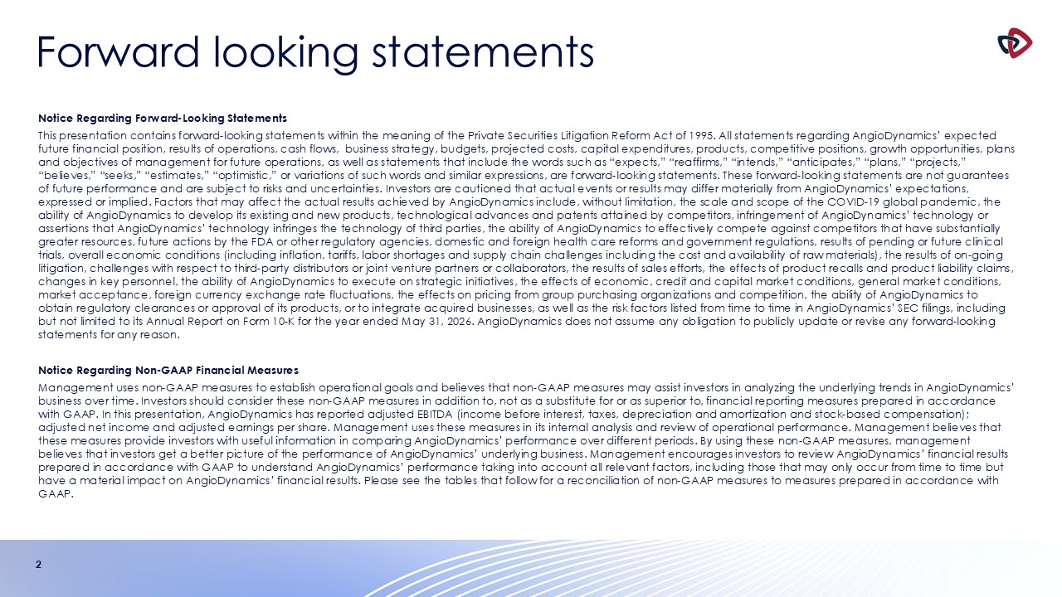
Forward looking statements 2 Notice Regarding Forward-Looking Statements This presentation contains forward-looking statements within the meaning of the Private Securities Litigation Reform Act of 1995. All statements regarding AngioDynamics’ expected future financial position, results of operations, cash flows, business strategy, budgets, projected costs, capital expenditures, products, competitive positions, growth opportunities, plans and objectives of management for future operations, as well as statements that include the words such as “expects,” “reaffirms,” “intends,” “anticipates,” “plans,” “projects,” “believes,” “seeks,” “estimates,” “optimistic,” or variations of such words and similar expressions, are forward-looking statements. These forward-looking statements are not guarantees of future performance and are subject to risks and uncertainties. Investors are cautioned that actual events or results may differ materially from AngioDynamics’ expectations, expressed or implied. Factors that may affect the actual results achieved by AngioDynamics include, without limitation, the scale and scope of the COVID-19 global pandemic, the ability of AngioDynamics to develop its existing and new products, technological advances and patents attained by competitors, infringement of AngioDynamics’ technology or assertions that AngioDynamics’ technology infringes the technology of third parties, the ability of AngioDynamics to effectively compete against competitors that have substantially greater resources, future actions by the FDA or other regulatory agencies, domestic and foreign health care reforms and government regulations, results of pending or future clinical trials, overall economic conditions (including inflation, tariffs, labor shortages and supply chain challenges including the cost and availability of raw materials), the results of on-going litigation, challenges with respect to third-party distributors or joint venture partners or collaborators, the results of sales efforts, the effects of product recalls and product liability claims, changes in key personnel, the ability of AngioDynamics to execute on strategic initiatives, the effects of economic, credit and capital market conditions, general market conditions, market acceptance, foreign currency exchange rate fluctuations, the effects on pricing from group purchasing organizations and competition, the ability of AngioDynamics to obtain regulatory clearances or approval of its products, or to integrate acquired businesses, as well as the risk factors listed from time to time in AngioDynamics’ SEC filings, including but not limited to its Annual Report on Form 10-K for the year ended May 31, 2026. AngioDynamics does not assume any obligation to publicly update or revise any forward-looking statements for any reason. Notice Regarding Non-GAAP Financial Measures Management uses non-GAAP measures to establish operational goals and believes that non-GAAP measures may assist investors in analyzing the underlying trends in AngioDynamics’ business over time. Investors should consider these non-GAAP measures in addition to, not as a substitute for or as superior to, financial reporting measures prepared in accordance with GAAP. In this presentation, AngioDynamics has reported adjusted EBITDA (income before interest, taxes, depreciation and amortization and stock-based compensation); adjusted net income and adjusted earnings per share. Management uses these measures in its internal analysis and review of operational performance. Management believes that these measures provide investors with useful information in comparing AngioDynamics’ performance over different periods. By using these non-GAAP measures, management believes that investors get a better picture of the performance of AngioDynamics’ underlying business. Management encourages investors to review AngioDynamics’ financial results prepared in accordance with GAAP to understand AngioDynamics’ performance taking into account all relevant factors, including those that may only occur from time to time but have a material impact on AngioDynamics’ financial results. Please see the tables that follow for a reconciliation of non-GAAP measures to measures prepared in accordance with GAAP.

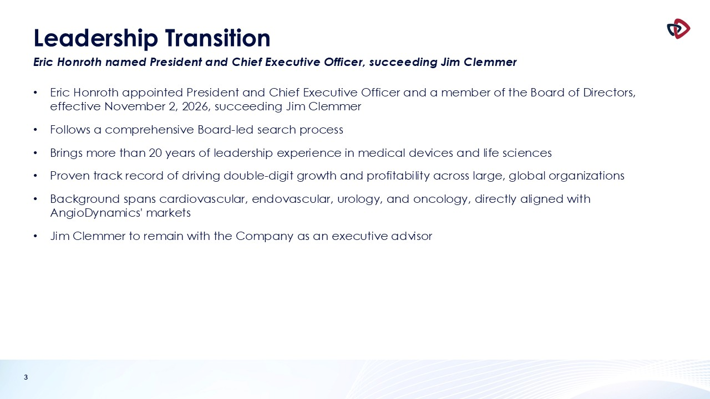
3 Leadership Transition Eric Honroth named President and Chief Executive Officer, succeeding Jim Clemmer Eric Honroth appointed President and Chief Executive Officer and a member of the Board of Directors, effective November 2, 2026, succeeding Jim Clemmer Follows a comprehensive Board-led search process Brings more than 20 years of leadership experience in medical devices and life sciences Proven track record of driving double-digit growth and profitability across large, global organizations Background spans cardiovascular, endovascular, urology, and oncology, directly aligned with AngioDynamics' markets Jim Clemmer to remain with the Company as an executive advisor

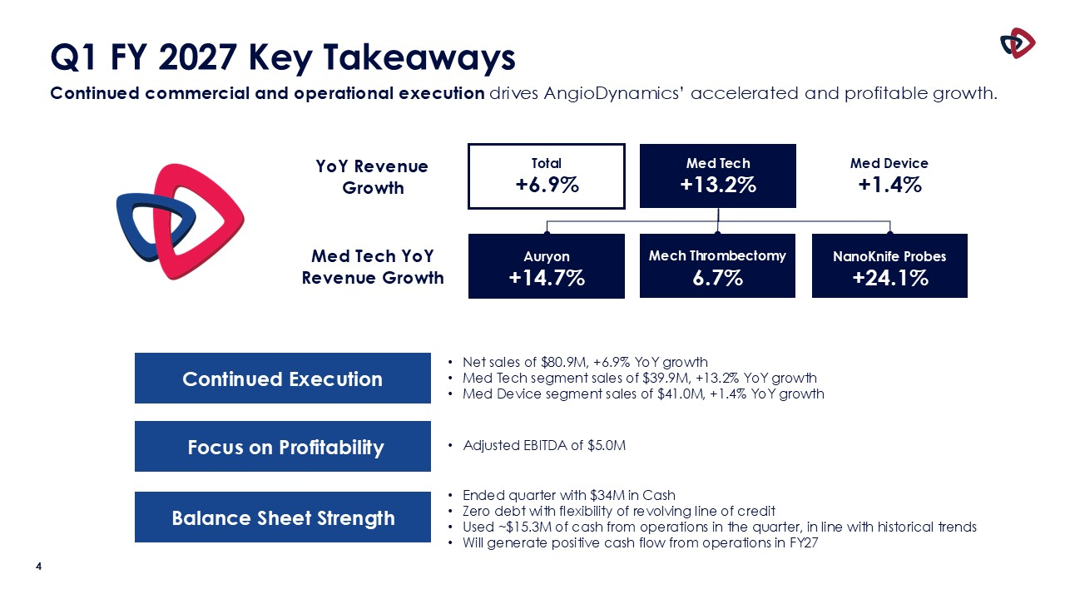
4 Q1 FY 2027 Key Takeaways Continued commercial and operational execution drives AngioDynamics’ accelerated and profitable growth. Total +6.9% YoY Revenue Growth Med Tech +13.2% Med Device +1.4% Auryon +14.7% Med Tech YoY Revenue Growth Mech Thrombectomy 6.7% NanoKnife Probes +24.1% Focus on Profitability Balance Sheet Strength Ended quarter with $34M in Cash Zero debt with flexibility of revolving line of credit Used ~$15.3M of cash from operations in the quarter, in line with historical trends Will generate positive cash flow from operations in FY27 Adjusted EBITDA of $5.0M Continued Execution Net sales of $80.9M, +6.9% YoY growth Med Tech segment sales of $39.9M, +13.2% YoY growth Med Device segment sales of $41.0M, +1.4% YoY growth

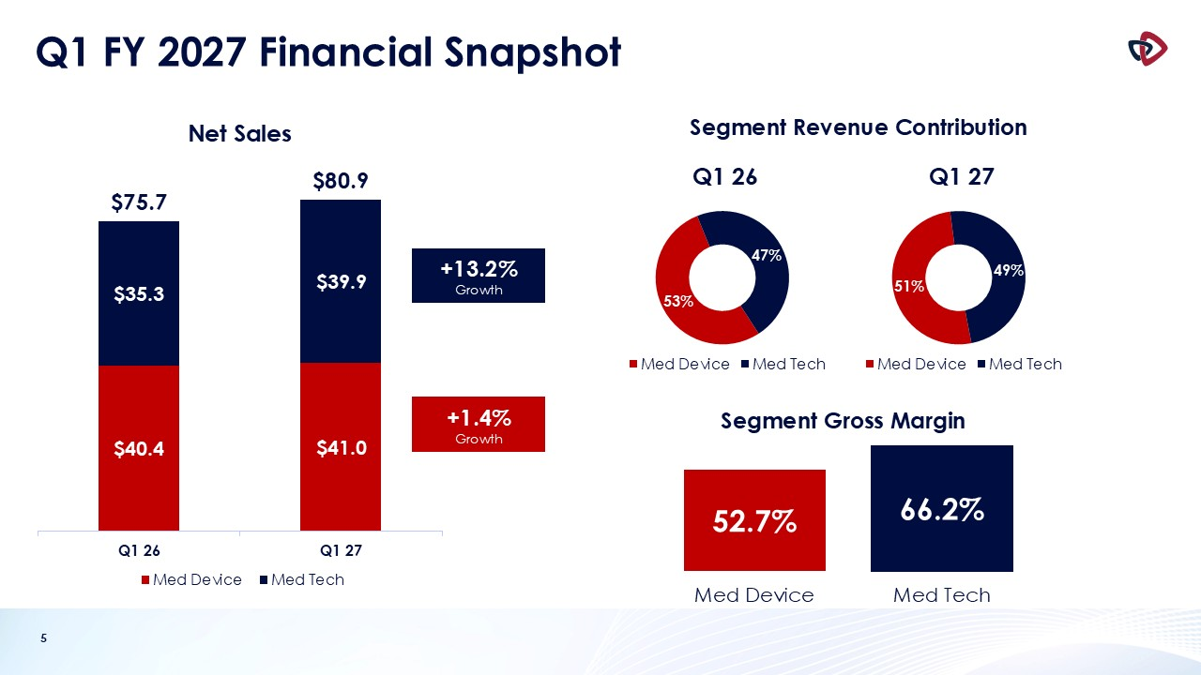
5 Q1 FY 2027 Financial Snapshot +1.4% Growth +13.2% Growth Segment Revenue Contribution Segment Gross Margin 52.7% 66.2% Med Device Med Tech

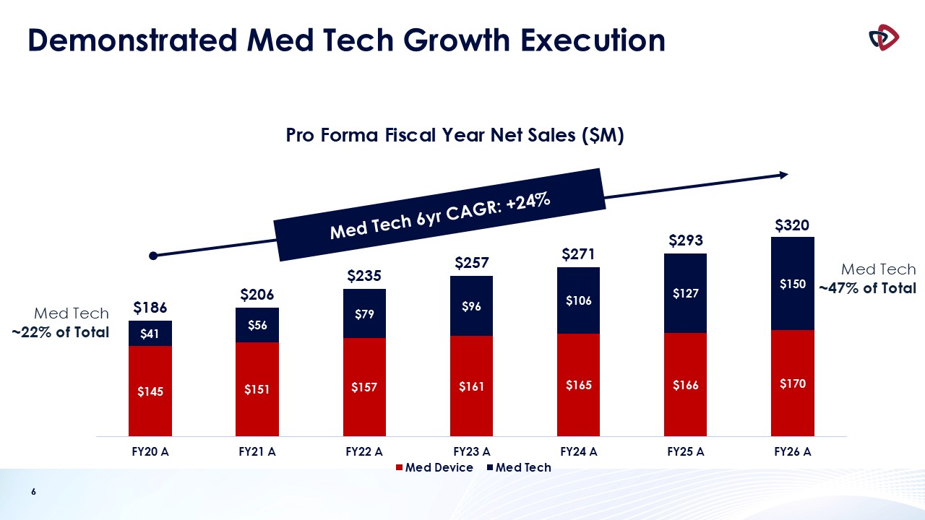
6 Demonstrated Med Tech Growth Execution 6 Med Tech ~22% of Total Med Tech 6yr CAGR: +24% Med Tech ~47% of Total

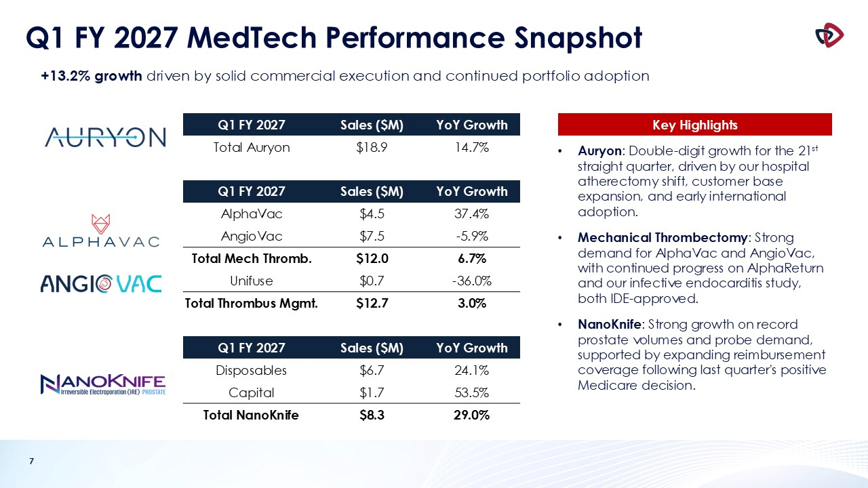
7 Q1 FY 2027 MedTech Performance Snapshot Auryon: Double-digit growth for the 21st straight quarter, driven by our hospital atherectomy shift, customer base expansion, and early international adoption. Mechanical Thrombectomy: Strong demand for AlphaVac and AngioVac, with continued progress on AlphaReturn and our infective endocarditis study, both IDE-approved. NanoKnife: Strong growth on record prostate volumes and probe demand, supported by expanding reimbursement coverage following last quarter's positive Medicare decision. Q1 FY 2027 Sales ($M) YoY Growth Total Auryon $18.9 14.7% Q1 FY 2027 Sales ($M) YoY Growth AlphaVac $4.5 37.4% AngioVac $7.5 -5.9% Total Mech Thromb. $12.0 6.7% Unifuse $0.7 -36.0% Total Thrombus Mgmt. $12.7 3.0% Q1 FY 2027 Sales ($M) YoY Growth Disposables $6.7 24.1% Capital $1.7 53.5% Total NanoKnife $8.3 29.0% +13.2% growth driven by solid commercial execution and continued portfolio adoption Key Highlights

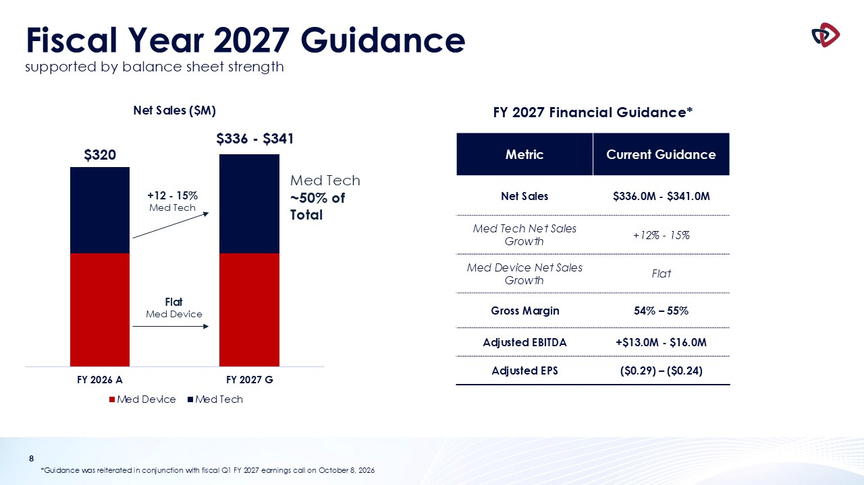
8 Fiscal Year 2027 Guidancesupported by balance sheet strength *Guidance was reiterated in conjunction with fiscal Q1 FY 2027 earnings call on October 8, 2026 +12 - 15% Med Tech Metric Current Guidance Net Sales $336.0M - $341.0M Med Tech Net Sales Growth +12% - 15% Med Device Net Sales Growth Flat Gross Margin 54% – 55% Adjusted EBITDA +$13.0M - $16.0M Adjusted EPS ($0.29) – ($0.24) Flat Med Device FY 2027 Financial Guidance* Med Tech ~50% of Total


9 Appendix

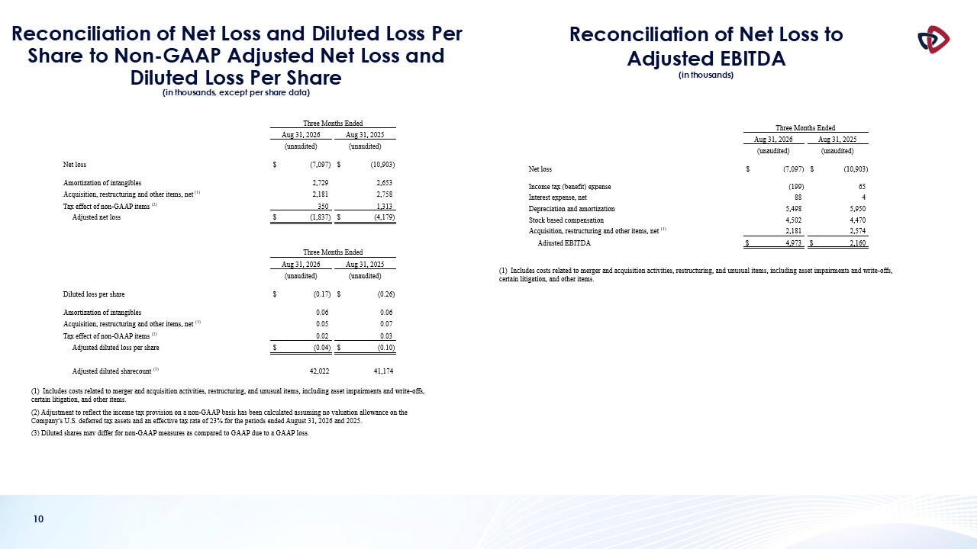
10 Reconciliation of Net Loss and Diluted Loss Per Share to Non-GAAP Adjusted Net Loss and Diluted Loss Per Share(in thousands, except per share data) Reconciliation of Net Loss to Adjusted EBITDA (in thousands)

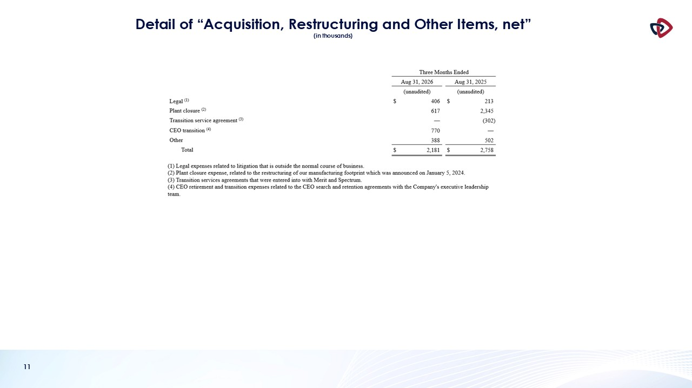
11 Detail of “Acquisition, Restructuring and Other Items, net” (in thousands)

