UNITED STATES
SECURITIES AND EXCHANGE COMMISSION
Washington, D.C. 20549
FORM 10-K
☒ |  |  | ANNUAL REPORT PURSUANT TO SECTION 13 OR 15(d) OF THE SECURITIES EXCHANGE ACT OF 1934
For the fiscal year ended May 31, 2026

OR

☐ |  |  | TRANSITION REPORT PURSUANT TO SECTION 13 OR 15(d) OF THE SECURITIES EXCHANGE ACT OF 1934

For the transition period from to

Commission file number 0-50761
AngioDynamics, Inc.
(Exact name of registrant as specified in its charter)


Delaware |  |  |  |  |  | 11-3146460
(State or other jurisdiction of  incorporation or organization) |  |  |  |  |  | (I.R.S. Employer  Identification No.)

14 Plaza Drive, Latham, New York 12110
(Address of principal executive offices and zip code)
(518) 795-1400
Registrant’s telephone number, including area code

Securities registered pursuant to Section 12(b) of the Act:
Title of each class |  |  | Trading Symbol |  |  | Name of each exchange on which registered
Common Stock, par value $.01 per share |  |  | ANGO |  |  | NASDAQ Global Select Market
Securities registered pursuant to Section 12(g) of the Act:
None
(Title of Class)

Indicate by check mark if the registrant is a well-known seasoned issuer, as defined in Rule 405 of the Securities Act. Yes ☐ No ☒
Indicate by check mark if the registrant is not required to file reports pursuant to Section 13 or 15(d) of the Act. Yes ☐ No ☒
Indicate by check mark whether the registrant (1) has filed all reports required to be filed by Section 13 or 15(d) of the Securities Exchange Act of 1934 during the preceding 12 months (or for such shorter period that the registrant was required to file such reports), and (2) has been subject to such filing requirements for the past 90 days. Yes ☒ No ☐
Indicate by check mark whether the registrant has submitted electronically and posted on its corporate website, if any, every Interactive Data File required to be submitted and posted pursuant to Rule 405 of Regulation S-T during the preceding 12 months (or for such shorter period that the registrant was required to submit and post such files). Yes ☒ No ☐
Indicate by check mark if disclosure of delinquent filers pursuant to Item 405 of Regulation S-K is not contained herein, and will not be contained, to the best of registrant’s knowledge, in definitive proxy or information statements incorporated by reference in Part III of this Form 10-K or any amendment to this Form 10-K. ☐
Indicate by check mark whether the registrant is a large accelerated filer, an accelerated filer, a non-accelerated filer, a smaller reporting company, or an emerging growth company. See definitions of “large accelerated filer”, “accelerated filer”, “smaller reporting company” and "emerging growth company" in Rule 12b-2 of the Exchange Act. (Check one):

 |  |  | Large accelerated filer |  |  | ☐ |  |  |  |  |  | Accelerated filer |  |  | ☒
 |  |  | Non-accelerated filer |  |  | ☐ |  |  |  |  |  | Smaller reporting company |  |  | ☐
 |  |  | Emerging growth company |  |  | ☐
Indicate by check mark whether the registrant has filed a report on and attestation to its management’s assessment of the effectiveness of its internal control over financial reporting under Section 404(b) of the Sarbanes-Oxley Act (15 U.S.C. 7262(b)) by the registered public accounting firm that prepared or issued its audit report. Yes ☒ No ☐
If securities are registered pursuant to Section 12(b) of the Act, indicate by check mark whether the financial statements of the registrant included in the filing reflect the correction of an error to previously issued financial statements. ☐
Indicate by check mark whether any of those error corrections are restatements that required a recovery analysis of incentive-based compensation received by any of the registrant’s executive officers during the relevant recovery period pursuant to §240.10D-1(b). ☐
Indicate by check mark whether the registrant is a shell company (as defined in Rule 12b-2 of the Exchange Act). Yes ☐ No ☒

As of November 30, 2025, the last business day of the registrant’s most recently completed second fiscal quarter, the aggregate market value of the registrant’s common stock held by non-affiliates was approximately $436,293,219 computed by reference to the last sale price of the common stock on that date as reported by The NASDAQ Global Select Market.

As of July 10, 2026 there were 41,332,389 shares of the registrant’s common stock outstanding.

DOCUMENTS INCORPORATED BY REFERENCE
The information required for Part III of this Annual Report on Form 10-K is incorporated by reference to the registrant’s Proxy Statement for its 2026 Annual Meeting of Stockholders to be filed within 120 days of the registrant's fiscal year ended May 31, 2026.

AngioDynamics, Inc. and Subsidiaries
INDEX

 |  |  |  |  |  | Page
Part I:
Item 1. |  |  | Business |  |  | 2
Item 1A. |  |  | Risk Factors |  |  | 15
Item 1B. |  |  | Unresolved Staff Comments |  |  | 30
Item 1C. |  |  | Cyber Security |  |  | 30
Item 2. |  |  | Properties |  |  | 30
Item 3. |  |  | Legal Proceedings |  |  | 31
Item 4. |  |  | Mine Safety Disclosures |  |  | 31
Part II:
Item 5. |  |  | Market for Registrant’s Common Equity, Related Stockholder Matters and Issuer Purchases of Equity |  |  | 32
Item 6. |  |  | [Reserved] |  |  | 33
Item 7. |  |  | Management’s Discussion and Analysis of Financial Condition and Results of Operations |  |  | 33
Item 7A. |  |  | Quantitative and Qualitative Disclosures About Market Risk |  |  | 43
Item 8. |  |  | Financial Statements and Supplementary Data |  |  | 43
Item 9. |  |  | Changes in and Disagreements with Accountants on Accounting and Financial Disclosure |  |  | 43
Item 9A. |  |  | Controls and Procedures |  |  | 44
Item 9B. |  |  | Other Information |  |  | 46
Item 9C. |  |  | Foreign Jurisdictions that Prevent Inspections |  |  | 46
Part III:
Item 10. |  |  | Directors, Executive Officers and Corporate Governance |  |  | 47
Item 11. |  |  | Executive Compensation |  |  | 47
Item 12. |  |  | Security Ownership of Certain Beneficial Owners and Management and Related Stockholder Matters |  |  | 47
Item 13. |  |  | Certain Relationships and Related Transactions, and Director Independence |  |  | 47
Item 14. |  |  | Principal Accounting Fees and Services |  |  | 47
Part IV:
Item 15. |  |  | Exhibits, Financial Statement Schedules |  |  | 48

1

Part I
Unless otherwise indicated in this report, "AngioDynamics," the "Company," "we," "our" or "us" refers to AngioDynamics, Inc and our consolidated subsidiaries.
Disclosure Regarding Forward-Looking Statements
This annual report on Form 10-K, including the sections entitled “Management’s Discussion and Analysis of Financial Condition and Results of Operations,” contains forward-looking statements within the meaning of the Private Securities Litigation Reform Act of 1995. All statements regarding AngioDynamics' expected future financial position, results of operations, cash flows, business strategy, budgets, projected costs, capital expenditures, products, competitive positions, growth opportunities, plans and objectives of management for future operations, as well as statements that include the words such as "expects," "reaffirms," "intends," "anticipates," "plans," "believes," "seeks," "estimates," "projects," "optimistic," or variations of such words and similar expressions, are forward-looking statements. These forward-looking statements are not guarantees of future performance and are subject to risks and uncertainties. Investors are cautioned that actual events or results may differ materially from AngioDynamics' expectations, expressed or implied. Factors that may affect the actual results achieved by AngioDynamics include, without limitation, the ability of AngioDynamics to develop its existing and new products, technological advances and patents attained by competitors, infringement of AngioDynamics' technology or assertions that AngioDynamics' technology infringes the technology of third parties, the ability of AngioDynamics to effectively compete against competitors that have substantially greater resources, future actions by the FDA or other regulatory agencies, domestic and foreign health care reforms and government regulations, results of pending or future clinical trials, overall economic conditions (including inflation, tariffs, labor shortages and supply chain challenges including the cost and availability of raw materials), the results of on-going litigation, challenges with respect to third-party distributors or joint venture partners or collaborators, the results of sales efforts, the effects of product recalls and product liability claims, changes in key personnel, the ability of AngioDynamics to execute on strategic initiatives, the effects of economic, credit and capital market conditions, general market conditions, market acceptance, foreign currency exchange rate fluctuations, the effects on pricing from group purchasing organizations and competition, the ability of AngioDynamics to obtain regulatory clearances or approval of its products, or to integrate acquired businesses. Other risks and uncertainties include, but are not limited to, the factors described from time to time in our reports filed with the Securities and Exchange Commission (the "SEC").
Although we believe that the assumptions underlying the forward-looking statements contained herein are reasonable, any of the assumptions could be inaccurate and, therefore, there can be no assurance that the forward-looking statements included in this annual report on Form 10-K will prove to be accurate. In light of the significant uncertainties inherent in the forward-looking statements included herein, the inclusion of such information should not be regarded as a representation by us or any other person that our objectives and plans will be achieved. Any forward-looking statements are made pursuant to the Private Securities Litigation Reform Act of 1995 and, as such, investors are cautioned not to place undue reliance on these forward-looking statements which speak only as of the date stated, or if no date is stated, as of the date of this report. AngioDynamics does not assume any obligation to publicly update or revise any forward-looking statements for any reason.
Disclosure Regarding Trademarks
This report includes trademarks, tradenames and service marks that are our property or the property of other third parties. Solely for convenience, such trademarks and tradenames sometimes appear without any “™” or “®” symbol. However, failure to include such symbols is not intended to suggest, in any way, that we will not assert our rights or the rights of any applicable licensor, to these trademarks and tradenames. For a complete listing of all our trademarks, tradenames and service marks please visit www.angiodynamics.com/IP.

Item 1. Business.
OVERVIEW
AngioDynamics is a dynamic, diversified medical technology company committed to expanding treatment options and improving patient outcomes and quality of life by designing, manufacturing and selling products and technologies which aid clinicians in the treatment of patients with cardiovascular disease and cancer diagnoses. Our execution strategy is built on innovative R&D, clinical and regulatory pathway expansion and customer centric sales performance.
HISTORY
AngioDynamics was founded in Queensbury, N.Y., U.S., in 1988 and began manufacturing and shipping product in the early 1990s. The Company is headquartered in Latham, N.Y., with manufacturing primarily out of the Queensbury facility. Initially dedicated to the research and development of products used in interventional radiology, the Company soon became well established as a producer of diagnostic catheters for non-coronary angiography and thrombolytic delivery systems.
2

The Company grew over the following years as a result of acquisitions of companies including RITA Medical Systems in January 2007, Oncobionic in May 2008, the assets of Diomed in June 2008, Vortex Medical, Inc. in October 2012, the assets of Microsulis Medical Limited in January 2013, and Clinical Devices in August 2013. These acquisitions added product lines including ablation and NanoKnife systems, vascular access products, angiographic products and accessories, dialysis products, drainage products, thrombolytic products, embolization products and venous products. In May 2012, the Company acquired Navilyst Medical's Fluid Management business, which the Company sold in May 2019 to Medline Industries, Inc. pursuant to an asset purchase agreement.
In August 2018, the Company acquired the BioSentry product line from Surgical Specialties, LLC, which the Company sold in June 2023 to Merit Medical Systems, Inc. pursuant to an asset purchase agreement. In September 2018, the Company acquired RadiaDyne, which included endorectal and vaginal balloons. On October 2, 2019, the Company acquired Eximo Medical, Ltd., a pre-commercial stage medical device company and its proprietary 355nm laser atherectomy technology (now called Auryon), which treats Peripheral Artery Disease. On December 17, 2019, the Company acquired the C3 Wave tip location asset from Medical Components Inc. On July 27, 2021, AngioDynamics acquired the Camaro Support Catheter asset from QX Medical, LLC.
On June 8, 2023, the Company completed the sale of the dialysis and BioSentry businesses to Merit Medical Systems, Inc. On February 15, 2024, the Company completed the sale of its PICC and Midline businesses, which included the C3 Wave tip location asset, to Spectrum Vascular. As of February 29, 2024, the Company discontinued the RadioFrequency Ablation and Syntrax product lines.
AngioDynamics is publicly traded on the NASDAQ stock exchange under the symbol ANGO.
PRODUCTS
Our product offerings fall within two segments, Med Tech and Med Device. All products discussed below have been cleared for sale in the United States by the Food and Drug Administration. International regulatory clearances vary by product and jurisdiction.
Med Tech
Auryon
The Auryon Atherectomy System represents one of our latest advancements in the treatment of peripheral arterial disease. The device is engineered to deliver an optimized wavelength and short pulse width to remove a wide range of lesion types while minimizing damage to the vessel wall endothelium. Incorporating integrated aspiration, the Auryon System enhances procedural safety by helping remove plaque from the vasculature. The device delivers safe, effective and versatile treatment across a broad spectrum of lesion types and anatomical locations including above and below the knee. Designed for flexibility, the device supports femoral, pedal or radial access allowing physicians to expand treatment options for their patients. The Auryon system delivers a safe, efficient and comprehensive treatment option on one single platform.
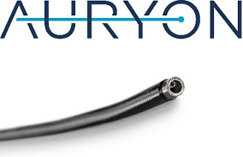
Thrombectomy
Our Thrombus Management portfolio includes the AlphaVac Mechanical Thrombectomy System, AngioVac venous drainage cannula and circuit, as well as catheter directed thrombolytic devices, including the Uni-Fuse system and the Uni-Fuse+ system. AngioDynamics offers a range of options when treating thrombus and removing fresh, soft thrombi or emboli.

3

AngioVac
Our AngioVac venous drainage system includes a Venous Drainage Cannula and Extracorporeal Circuit. The cannula is indicated for use as a venous drainage cannula and for removal of fresh, soft thrombi or emboli during extracorporeal bypass. The AngioVac circuit is indicated for use in procedures requiring extracorporeal circulatory support for periods of up to six hours. AngioVac devices are for use with other manufacturers’ off-the-shelf pump, filter and reinfusion cannula, to facilitate venous drainage as part of an extracorporeal bypass procedure.

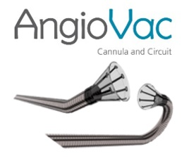
The AngioVac venous drainage cannula is a 22 French flat coil-reinforced cannula designed with a proprietary self-expanding nitinol reinforced funnel shaped distal tip. The funnel shaped tip enhances venous drainage flow when the distal tip is exposed by retracting the sheath, helps prevent clogging of the cannula with commonly encountered undesirable intravascular material, and facilitates embolic removal of such extraneous material.
AlphaVac
The AlphaVac System is an emergent mechanical aspiration device that eliminates the need for perfusionist support. AlphaVac is offered in both a 22 French flat coil-reinforced cannula and an 18 French braided reinforced cannula each designed with a proprietary self-expanding nitinol reinforced funnel shaped distal tip. AlphaVac is indicated for the non-surgical removal of thrombi or emboli from vasculature as well as aspiration of contrast media and other fluids from the vasculature. The cannula is intended for use in the venous system. The handle is indicated as a vacuum source for the AlphaVac MMA system. The AlphaVac F18 system is indicated for the treatment of pulmonary embolism and allows for the utilization in the non-surgical removal of thrombi or emboli from the venous vasculature, reducing thrombus burden and improving right ventricular function in patients with PE.

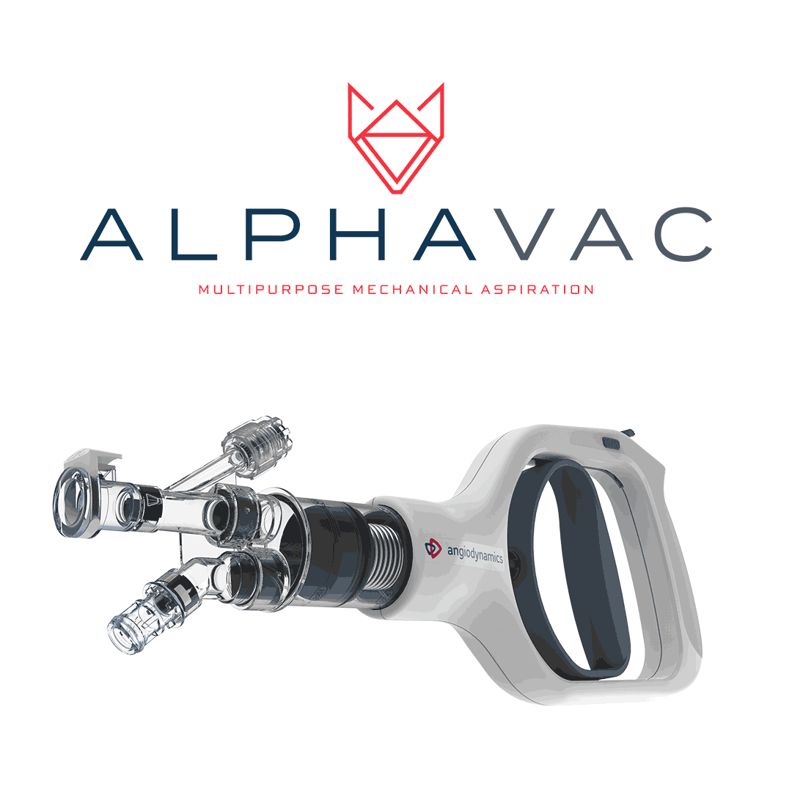
Thrombolytic Catheters
Thrombolytic catheters are used to deliver thrombolytic agents, which are drugs that dissolve blood clots in hemodialysis access grafts, arteries, veins and surgical bypass grafts. AngioDynamics’ Uni-Fuse infusion catheter features pressure response outlets, a proprietary slit technology that provides a consistent, even distribution of fluid volume along the entire length of the infusion pattern, designed to provide an advantage over standard side-hole catheters.

4

NanoKnife
The NanoKnife IRE Ablation System is an alternative to traditional thermal ablation that received 510(k) clearance from the Food and Drug Administration for the surgical ablation of soft tissue. The system utilizes low energy direct current electrical pulses to permanently open pores in target cell membranes. These permanent pores or nano-scale defects in the cell membranes result in cell death. The treated tissue is then removed by the body’s natural processes in a matter of weeks, mimicking natural cell death. Unlike other ablation technologies, the NanoKnife System does not achieve tissue ablation using thermal energy.
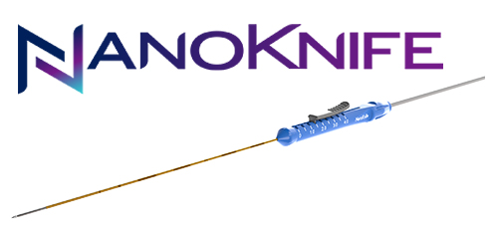
The NanoKnife System consists of two major components: a Low Energy Direct Current, or LEDC Generator and needle-like electrode probes. Up to six (6) electrode probes can be placed into or around the targeted soft tissue. Once the probes are in place, the user enters the appropriate parameters for voltage, number of pulses, interval between pulses, and the pulse length into the generator user interface. The generator then delivers a series of short electric pulses between each electrode probe. Full paralytic anesthesiology is required for safe IRE delivery.
In December 2024, the NanoKnife System received expanded FDA 510(k) clearance for the ablation of prostate tissue which broadens treatment options for men and reinforces the system’s strong safety and efficacy profile.
In February 2026, the NanoKnife system received BSI approval for the product to bear the MDR CE mark supporting expanded indications for the ablation of pancreas, kidney, liver or prostate tumors, including intermediate risk prostate cancer.

Med Device
Peripheral Products (Interventional Devices)
We offer a comprehensive portfolio of products for use during minimally invasive procedures. Product categories include an extensive line of angiographic catheters, guidewires, drainage catheters and micropuncture kits.
Angiographic Catheters & Guidewires
Our extensive line of various angiographic catheter configurations are designed to allow physicians to navigate and reach targeted anatomical locations within a patient’s vasculature that are in need of angiographic diagnosis. Typically run over a diagnostic guidewire, our angiographic catheters allow physicians to deliver contrast media to the desired location to determine the diagnosis and subsequent therapeutic modalities, as needed for the patient.
AngioDynamics offers three different angiographic catheter lines to meet physicians’ procedural needs. All of our catheters feature our soft, atraumatic, super-radiopaque tip that is uniquely welded to our co-extruded nylon shaft, which provides excellent visibility under fluoroscopy and re-enforced tip stability.
•Soft-Vu Angiographic Catheters highlight the soft, atraumatic super-radiopaque and proprietary tip-to-shaft weld in a full offering of different tip shapes, lengths and French sized flush and selective catheters. Flush catheters are used in procedures where a large volume of contrast is required to deliver a concentrated bolus of contrast quickly for visualization or larger anatomical locations, such as the aorta or for run-offs into lower extremities. Selective catheters are typically used to gain access to more specific vasculature within the body to deliver smaller amounts of contrast.
•Mariner Hydrophilic Catheters also feature a hydrophilic coating on the distal 20cm of the catheter that reduces friction during catheter advancement in the vasculature and allows for smooth navigation, as well as, optimum handling and control by the physician.
•Accu-Vu Sizing Catheters are our line of flush catheters that also feature highly visible radiopaque marker bands, which are heat embedded, along the catheter shaft, providing a smooth transition across the catheter shaft to ensure the marker bands will not separate from the shaft. These radiopaque marker bands come in different patterns along the shaft and allow physicians, under fluoroscopy, to take measurements in different anatomical locations for the placement of stents, IVC filters or other devices. The tight tolerances and consistent placement across the entire sizing pattern, within +/-1mm of accuracy, provide a highly accurate measurement to the physician.
5

AngioDynamics offers a line of diagnostic and interventional guidewires which are designed to aid in delivering diagnostic and/or therapeutic devices to the desired location.
•The ADx Peripheral Vascular Guidewire line is AngioDynamics diagnostic line of guidewires that is available in a multitude of fixed core wire configurations, including J-Tip and Bentson, in various lengths and outer diameters (OD). By utilizing a proprietary pre-coat process for the Polytetrafluoroethylene (PTFE) and upholding tight specifications, our ADx Guidewires offer high quality and performance for physicians.
•The NiT-Vu High Performance Micro Guidewires are our highly kink resistant nitinol shaft interventional wires that feature a highly visible radiopaque tungsten tip and lubricious coating. The NiT-Vu wires are designed to reduce friction during wire advancement and also provides torque control, flexibility and kink resistance.
Drainage Products
To aid physicians in percutaneous drainage procedures, AngioDynamics offers the Total Abscession Drainage Catheters. The Total Abscession Drainage Catheter is available in Multipurpose/General and Biliary configurations, and also offers a Nephrostomy option. The portfolio offers options with a radiopaque marker band at the distal tip to aid in placement.
•The Total Abscession Drainage Catheter line offers a soft, kink resistant shaft that features the lubricious Blue Silk Finish for easier insertion and pushability, while providing the optimal patient comfort. The unique Vault Locking Mechanism securely fixes the pigtail and prevents tampering or accidental removal.
Micropuncture Kits
AngioDynamics offers physicians two micropuncture kit lines that are designed to start each procedure with ease and efficiency: Mini Stick MAX Coaxial Microintroducer Kits and Micro-Introducer Kits. Each kit features a coaxial design with a 4F or 5F sheath introducer and stiff or standard dilator, along with a 21G needle and various 0.018” access wire configurations.
•Mini Stick MAX Coaxial Introducer kits contain a unique containment clip that keeps all the unique components of the kit together and organized. The kit options include our AngioDynamics proprietary coaxial introducer with smooth transition at the tip, translucent 21G needle with bevel indicator and 0.018” access wire available in three different wire material configurations.
•The Micro-Introducer Kits offer a variety of configurations that aid in simplifying set up and gaining vascular access.
Ports
Ports are implantable devices utilized for the central venous administration of a variety of medical therapies and for blood sampling and diagnostic purposes. Central venous access facilitates a more systemic delivery of treatment agents, while mitigating certain harsh side effects of certain treatment protocols and eliminating the need for repeated access to peripheral veins. Depending upon needle gauge size and the port size, a port can be utilized for up to approximately 2,000 accesses once implanted in the body. Our ports are used primarily in systemic or regional short- and long-term cancer treatment protocols that require frequent infusions of highly concentrated or toxic medications (such as chemotherapy agents, antibiotics or analgesics) and frequent blood samplings. Our port products and accessories include:
•SmartPort, SmartPort+, SmartPort Plastic: The SmartPort power-injectable port with Vortex technology offers the ability for a clinician to access a vein for both the delivery of medications or fluids and for administering power-injected contrast to perform a CT scan. The ability to access a port for power-injected contrast studies eliminates the need for additional needle sticks in the patient’s arm and wrist veins. Once implanted, repeated access to the bloodstream can be accomplished with greater ease and less discomfort. Our SmartPort port line is available in standard, mini and low-profile to accommodate more patient anatomies. The SmartPort+ port line combines Vortex technology with BioFlo catheters. In addition to the three titanium port body sizes, there is a plastic port body.
•BioFlo Port: Our BioFlo Port was the first port available featuring a catheter with Endexo Technology. Advanced features of the BioFlo Port include multiple profile and catheter options, a large septum area for ease of access, PASV and non-PASV valve technology and the ability to administer contrast through a CT injection for purposes of imaging. The BioFlo port family is available in single or dual lumen configurations.
•Xcela Plus: The Xcela Plus Port product family is Power-Injectable and part of a complete portfolio of vascular access products, and is fully compatible with the LifeGuard Safety Infusion product family. It has easily identifiable critical information radiopaque “CT” lettering which helps to confirm if port is power-injectable or flipped. The Xcela Plus port family is available in single lumen standard size in either a non-valved or valved configuration.
6

Port Technologies
•BioFlo Endexo: AngioDynamics offers the BioFlo catheter, the only catheter on the market with Endexo Technology, a material more resistant to thrombus accumulation, in vitro (based on platelet count). Endexo Technology is a permanent and non-eluting polymer that is “blended” into the polyurethane from which the catheter is made. It is present throughout the catheter, including the extraluminal, intraluminal and cut catheter surface of the tip. Endexo Technology remains present for the life of the catheter. The BioFlo catheter’s long-term durability and efficacy is intended to provide clinicians a high degree of safety and confidence in providing better patient care and improved patient outcomes.
•Vortex: Our Vortex port technology line of ports features a clear-flow port technology that, we believe, revolutionized port design. With its rounded chamber, the Vortex port is designed to have no sludge-harboring corners or dead spaces. This product line consists of titanium, plastic and dual-lumen offerings.
•PASV Valve Technology: The PASV Valve Technology is designed to automatically resist backflow and reduce blood reflux that could lead to catheter-related complications.
Venous Insufficiency
VenaCure EVLT laser system
Our VenaCure EVLT system products are used in endovascular laser procedures to treat superficial venous disease (varicose veins). Superficial venous disease is a malfunction of one or more valves in the leg veins whereby blood refluxes or does not return to the heart, thereby pooling in the legs and leading to symptoms such as pain, swelling and ulcerations. The VenaCure EVLT system uses laser energy to stop the reflux by ablating (collapsing and destroying) the affected vein. Blood is then re-routed to other healthy veins.
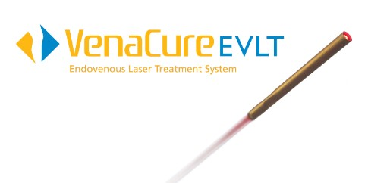
The procedure is minimally invasive and generally takes less than an hour, typically allowing the patient to quickly return to normal activities.
The VenaCure EVLT system is sold as a system that includes diode laser hardware and procedure kits which include disposable laser fiber components, an access sheath, access wires and needles. Our VenaCure EVLT 1470 nanometer wavelength laser allows physicians to more efficiently heat the vein wall using lower power settings thereby reducing the risk of collateral damage. The NeverTouch tip fiber eliminates laser tip contact with the vein wall, which in turn minimizes perforations of the vein wall that typically result in less pain and bruising as compared to traditional bare-tip fibers. The NeverTouch tip also maximizes ultrasonic visibility, making it easier for physicians to use. Procedure kits are available in a variety of lengths and configurations to accommodate varied patient anatomies.
NeverTouch and NeverTouch Direct gold-tip laser fibers, is an integral part of AngioDynamics’ advanced varicose vein treatment and establishes a new standard for patient comfort, visibility and ease of use. The innovation behind the NeverTouch tip is a glass weld at the distal tip. This glass weld tip technology has less focal charring of the vein wall versus a bar-tip fiber. The NeverTouch procedure kit is available in 25cm, 45cm, 65cm, and 90cm lengths. It is also available with an .018” access system, which eliminates the need for a 5F micro-access sheath and the need to exchange wires and size up, resulting in few procedure steps, and may result in faster procedure time.
The 400 Micron Perforator & Accessory Vein Ablation kit (PVAK) is an AngioDynamics VenaCure EVLT endovenous laser vein treatment offering that provides patients a minimally-invasive choice for treating the source of their varicose veins. The PVAK kit may also provide patients a potentially quicker recovery and return to normal daily routines, as compared to surgical stripping. The PVAK kit allows for simple access and accurate positioning. The smaller fiber aids in access and positioning for deep and saphenous veins. The 21G venous access needle ensures easy, atraumatic access and the .018” guidewire navigates small, tortuous veins with a floppy tip and has a firm anchor to guide the sheath and hold it in place.

7

Microwave Ablation
Solero Microwave Tissue Ablation (MTA) System
The Solero MTA System features the Solero Microwave (MW) Generator and the specially designed Solero MW Applicators. The solid state Solero MW Generator with a 2.45 GHz operating frequency can power up to 140W for optimized power delivery and fast ablations. The Solero MW Applicator’s patented dipole array and ceramic tip tuning diffuses MW energy nearly spherically, and its patented cooling channel with thermocouple provides real-time monitoring to help protect non-targeted tissue during the ablation. In addition, the Solero MTA System offers physicians scalability with a single applicator designed for multiple, predictable ablation volumes by varying time and wattage. Solero is a single applicator system able to complete up to a 5 cm ablation in six (6) minutes at maximum power. It is designed for open, laparoscopic and percutaneous ablation of soft tissue masses.
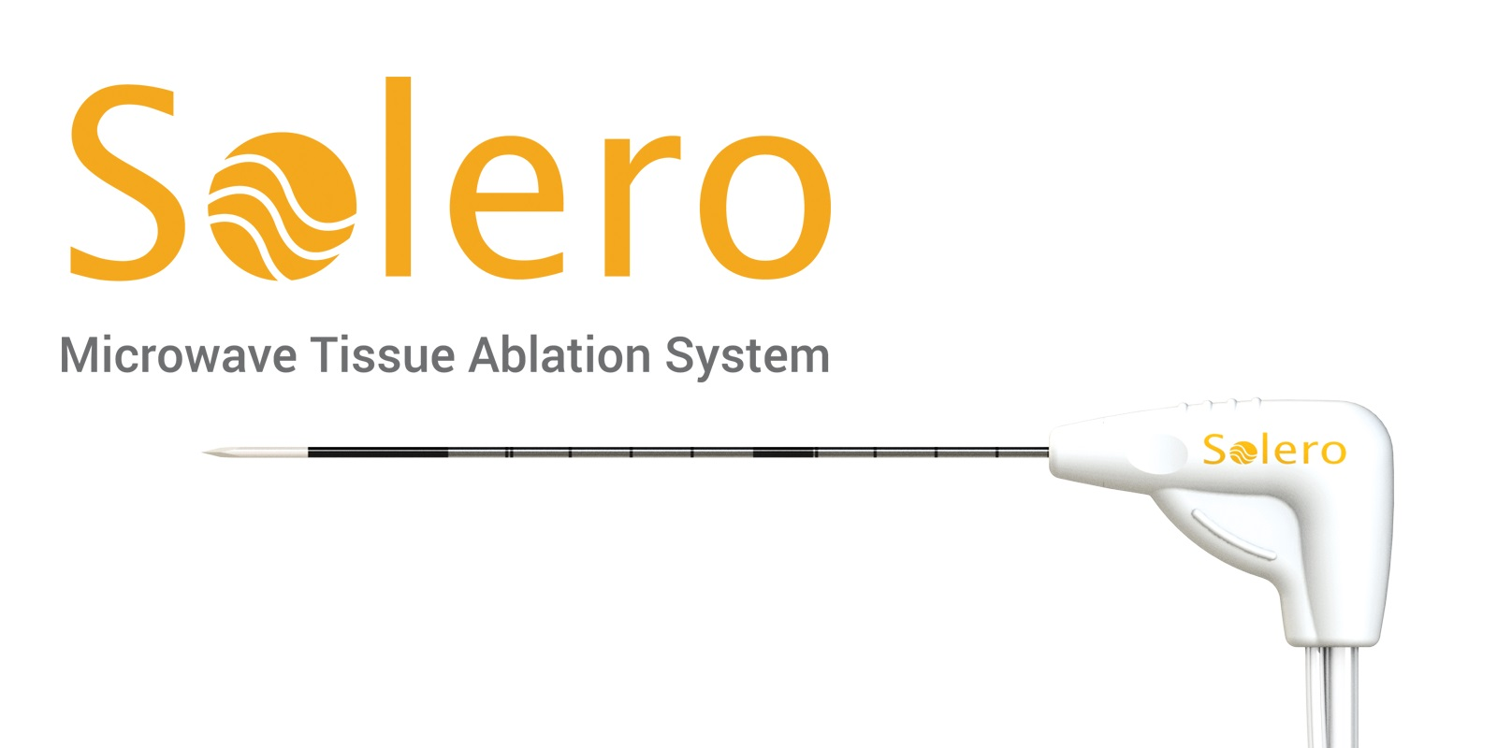

The Solero MTA System and Accessories are indicated for the ablation of soft tissue during open procedures by the FDA in the USA and for open laparoscopic and percutaneous procedures under the European MDR regulations. The Solero MTA System is not intended for cardiac use.
IsoLoc Endorectal Balloon
The IsoLoc Endorectal Balloon's unique, customer-driven design is the result of collaborations with Radiation Oncologists, Therapists and Physicists with one goal in mind, to create a new standard for endorectal balloons (ERB) in the oncology space.
The design of the IsoLoc device not only addresses patient comfort, but also simplifies three challenging clinical scenarios that many physicians face when using radiation therapy for and/or in relation to the prostate. First, its' gas-release tip removes rectal gas and reduces prostate motion for gaseous patients. Secondly, the structure of the ERB aids in defining the anatomy for difficult planning scenarios with post-radical patients. Lastly, the IsoLoc device repositions and lifts the bowel in patients that have a low-lying bowel.
Alatus Vaginal Balloon Packing System
The Alatus device was developed with the patient's comfort in mind and to assist the physician to move healthy tissue away from the radiation treatment field. Prior to the Alatus device, the clinician would push gauze into the vagina to move the bladder and bowel away from the radiation treatment field. Inserting gauze into the vagina can be uncomfortable before treatment and unpleasant at the end of treatment as it tends to dry out before removing.
RESEARCH & DEVELOPMENT
Our growth depends in large part on the continuous introduction of new and innovative products, together with ongoing enhancements to our existing products. This happens through internal product development, technology licensing, strategic alliances and acquisitions. Our research and development (R&D) teams work closely with our marketing teams, sales force and regulatory and compliance teams to incorporate customer feedback into our development and design process. We believe that we have a reputation among interventional physicians as a strong partner for developing high quality products because of our tradition of close physician collaboration, dedicated market focus, responsiveness and execution capabilities for product development and commercialization. We recognize the importance of, and intend to continue to make investments in R&D.
COMPETITION
We encounter significant competition across our product lines and in each market in which our products are sold. These markets are characterized by rapid change resulting from technological advances, scientific discoveries and changing customer needs and expectations. We face competitors, ranging from large manufacturers with multiple business lines, to small manufacturers that offer a limited selection of products.
Our primary competitors include: Boston Scientific Corporation; Cook Medical; Medical Components, Inc. (MedComp); TeleFlex Medical; Becton Dickinson; Medtronic; Merit Medical; Terumo Medical Corporation; Johnson and Johnson; Philips
8

Healthcare; Stryker Corporation; Penumbra, Inc.; Siemens Healthineers; Abbott Laboratories; Profound Medical; EDAP TMS; and Total Vein Systems.
We believe our products compete primarily based on their quality, clinical outcomes, ease of use, reliability, physician familiarity and cost-effectiveness. In the current environment of managed care, which is characterized by economically motivated buyers, consolidation among health care providers, increased competition and declining reimbursement rates, we have been increasingly required to compete on the basis of price. We believe that our continued competitive success will depend upon our ability to develop or acquire scientifically advanced technology, apply our technology cost-effectively across product lines and markets, attract and retain skilled personnel, obtain patent or other protection for our products, obtain required regulatory and reimbursement approvals, manufacture and successfully market our products either directly or through third parties, and maintain sufficient inventory to meet customer demand.
SALES AND MARKETING
We sell our broad line of quality devices in the United States primarily through a direct sales force and internationally through a combination of direct sales and distributor relationships. We support our customers and sales organization with a marketing staff that includes product managers, customer service representatives and other marketing specialists. We focus our sales and marketing efforts on interventional radiologists, interventional cardiologists, vascular surgeons, urologists, interventional and surgical oncologists and critical care nurses.
MANUFACTURING
We manufacture certain products from two leased manufacturing properties, one in Queensbury, NY and one small facility in Glens Falls, NY, providing capabilities which include manufacturing, service, offices, engineering and research and we lease distribution warehouses. We also utilize third-party manufacturers for the manufacturing of certain products. We have custom-designed proprietary manufacturing and processing equipment and have developed proprietary enhancements for existing production machinery that is utilized in our facilities and by our third-party manufacturers. Our products are manufactured from raw materials and are assembled and tested to ensure compliance with applicable regulatory standards and our internal specifications.
The manufacturing facilities, both ours and third-party, are registered with the FDA and have been certified to ISO 13485 standards. ISO 13485 is a quality system standard that satisfies European Union regulatory requirements, thus allowing us to market and sell our products in European Union countries. AngioDynamics is certified under the Medical Device Single Audit Program ("MDSAP") which allows a recognized auditing organization to conduct a single regulatory audit of a medical device manufacturer to satisfy the relevant requirements of the regulatory authorities participating in the program. International partners that are participating in the MDSAP include:
•Therapeutic Goods Administration of Australia
•Brazil’s Agência Nacional de Vigilância Sanitária
•Health Canada
•Japan’s Ministry of Health, Labour and Welfare, and the Japanese Pharmaceuticals and Medical Devices Agency
•U.S. Food and Drug Administration
Our manufacturing facilities are subject to periodic inspections by regulatory authorities to ensure compliance with domestic and non-U.S. regulatory requirements. See “Government Regulation” section of this Item 1 for additional information. See Part I, Item 2 "Properties" in this Annual Report on Form 10-K for details on each manufacturing location.
BACKLOG
We seek to maintain sufficient inventory on hand to ship product within 24-48 hours of order receipt to meet customer demand, and accordingly our backlog is not significant. As we shift additional manufacturing to Costa Rica and/or other manufacturing partners, we have built sufficient safety stock to reduce the risk of backlog during the transition.
9

INTELLECTUAL PROPERTY
Patents, trademarks and other proprietary rights are very important to our business. We also rely upon trade secrets, manufacturing know-how, technological innovations and licensing opportunities to maintain and improve our competitive position. We regularly monitor and review third-party proprietary rights, including patents and patent applications, as available, to aid in the development of our intellectual property strategy, avoid infringement of third-party proprietary rights, and identify licensing opportunities. The Company owns an extensive portfolio of patents and patent applications in the United States and in certain foreign countries. The portfolio also includes exclusive licenses to third party patents and applications. Most of our products are sold under the AngioDynamics trade name or trademark. Additionally, products are sold under product trademarks and/or registered product trademarks owned by AngioDynamics, Inc., or an affiliate or subsidiary. Some products contain trademarks of companies other than AngioDynamics.
See Part I, Item 3 "Legal Proceedings" and Note 17 to the consolidated financial statements in this Annual Report on Form 10-K for additional details on litigation regarding proprietary technology.
LITIGATION
We operate in an industry characterized by extensive patent litigation. Patent litigation can result in significant damage awards and injunctions that could prevent the manufacture and sale of affected products, or result in significant royalty payments in order to continue selling those products. The medical device industry is also susceptible to significant product liability claims. These claims may be brought by individuals seeking relief on their own behalf or purporting to represent a class. In addition, product liability claims may be asserted against us in the future based on events we are not aware of at the present time. At any given time, we are involved in a number of product liability actions. For additional information, see both Part I, Item 3 "Legal Proceedings" and Note 17 to the consolidated financial statements in this Annual Report on Form 10-K.
GOVERNMENT REGULATION
The products we manufacture and market are subject to regulation by the United States Food and Drug Administration (FDA) under the Federal Food, Drug, and Cosmetic Act, or FDCA, and international regulations in our specific target markets.
United States FDA Regulation
Before a new medical device can be introduced into the market, a manufacturer generally must obtain marketing clearance or approval from the FDA through either a 510(k) submission (a premarket notification) or a premarket approval application (PMA).
The 510(k) clearance procedure is available only if a manufacturer can establish that its device is “substantially equivalent” in intended use and in safety and effectiveness to a “predicate device,” which is (i) a device that has been cleared through the 510(k) clearance process; (ii) a device that was legally marketed prior to May 28, 1976 (preamendment device); or (iii) a device that was originally on the U.S. market as a Class III device (Premarket approval) and later downclassified to Class II or I. After a device receives 510(k) clearance, any modification that could significantly affect its safety or effectiveness, or that would constitute a major change in its intended use, requires a new 510(k) clearance. The 510(k) clearance procedure including questions and responses may take up to 12 months. The FDA may determine that a new or modified device is not substantially equivalent to a predicate device or may require that additional information, including clinical data, be submitted before a determination is made, either of which could significantly delay the introduction of a new or modified device. If a device cannot demonstrate substantial equivalence, it may be subject to either a De Novo 510(k) submission or a PMA.
The PMA application procedure is more comprehensive than the 510(k) procedure and typically takes more time to complete. The PMA application must be supported by scientific evidence providing pre-clinical and clinical data relating to the safety and efficacy of the device and must include other information about the device and its components, design, manufacturing, and labeling. The FDA will approve a PMA application only if reasonable assurance that the device is safe and effective for its intended use can be provided. As part of the PMA application review, the FDA will inspect the manufacturer’s facilities for compliance with its Quality System Regulation, or QSR. As part of the PMA approval the FDA may place restrictions on the device, such as requiring additional patient follow-up for an indefinite period of time. If the FDA’s evaluation of the PMA application or the manufacturing facility is not favorable, the FDA may deny approval of the PMA application or issue a “not approvable” letter. The FDA may also require additional clinical trials, which can delay the PMA approval process by several years. After the PMA is approved, if changes are made to a device, its manufacturing or labeling, a PMA supplement containing additional information must be filed for prior FDA approval.
Historically, our products have been introduced into the market using the 510(k) procedure.
FDA submissions require extensive validations and testing which requires a significant amount of time and financial resources. Changes in both regulations and FDA perspectives have increased time and testing requirements, which have caused
10

and are expected to continue to cause significant delays and increased costs for clearances and approvals. The increased focus by the FDA on such issues as chemical identification of all colorants, non-acceptance of certain colorants (certain forms of carbon black) and other concerns, and increased requirement for clinical data to support submissions, continue to cause challenges and delays. In addition, changes to existing products call into question previously approved devices and result in additional costs for testing and material analysis.
The devices manufactured by us are also subject to the QSR, which imposes elaborate testing, control, documentation and other quality assurance procedures on our manufacturing facilities. Every phase of production, including raw materials, components and subassembly, manufacturing, testing, quality control, labeling, tracing of customers after distribution and follow-up and reporting of complaint information is governed by the FDA’s QMSR. Device manufacturers are required to register their facilities and list their products with the FDA and certain state agencies. The FDA periodically inspects manufacturing facilities and, if there are alleged violations, the operator of a facility must correct them or satisfactorily demonstrate the absence of the violations or face regulatory action. Failure to maintain compliance with the QMSR may result in the issuance of one or more Forms 483 or warning letters and could potentially result in a consent decree. Failure to maintain the QMSR appropriately could result in the issuance of further warning letters. In addition, non-compliance with applicable FDA requirements can result in, among other things, fines, injunctions, civil penalties, recall or seizure of products, total or partial suspension of production, failure of the FDA to grant marketing approvals, inability to obtain clearances or approvals for products, withdrawal of marketing approvals, a recommendation by the FDA to disallow us to enter into government contracts, and/or criminal prosecutions. The FDA also has the authority to request repair, replacement or refund of the cost of any device manufactured or distributed by us.
Other U.S. Regulatory Bodies
We and our products are subject to a variety of federal, state and local laws in those jurisdictions where our products are, or will be, marketed. We and our products are also subject to a variety of federal, state and local laws relating to matters such as safe working conditions, manufacturing practices, environmental protection, fire hazard control and disposal of hazardous or potentially hazardous substances. In addition, we are subject to various federal and state laws governing our relationships with the physicians and others who purchase or make referrals for our products. For instance, federal law prohibits payments of any form that are intended to induce a referral for any item payable under Medicare, Medicaid or any other federal healthcare program. Many states have similar laws. There can be no assurance that we will not be required to incur significant costs to comply with such laws and regulations now or in the future, or that such laws or regulations will not have a material adverse effect upon our ability to do business.
International Regulation
Internationally, all of our current products are considered medical devices under applicable regulatory regimes, and we anticipate that this will be true for all of our future products. Sales of medical devices are subject to regulatory requirements in most countries. The regulatory review process varies greatly from country to country.
In order to distribute and sell products into the European Union as well as a number of other countries including many Central European Free Trade Agreement participants, Scandinavian, and Middle Eastern countries, a CE Mark is required. New products must be compliant with the Medical Device Regulation ("MDR") as of May 2021 and previously CE Marked products must become compliant when their certification expires, with a transition period ending December 2027 for higher classification devices, or December 2028 for lower classification devices. Products with an expiring certification must be in distribution before certification expiration dates to continue to be sold. Clinical evaluations of products under MDR requires more information than previously required. All devices must have current clinical literature that specifically addresses data-driven safety and performance criteria, and legacy devices often require additional biocompatibility, bench testing and redesign to address changes in standards over time. Additionally, there can be extended time frames under MDR for product certifications that can be 12-18 months or longer. During that time period, significant design modifications cannot be made. All legacy devices have achieved the MDR CE Mark.
Similar regulations are in place for Canada, Japan, China, Brazil and most other countries. In some cases, we rely on our international distributors to obtain regulatory approvals, complete product registrations, comply with clinical trial requirements and complete those steps that are customarily taken in the applicable jurisdictions.
International sales of medical devices manufactured in the United States that are not approved or cleared by the FDA for use in the United States, or are banned or deviate from lawful performance standards, are subject to FDA export requirements. Before exporting such products to a foreign country, we must first comply with the FDA’s regulatory procedures for exporting unapproved devices.
The process of obtaining approval to distribute medical products is costly and time-consuming in virtually all the major markets where we sell medical devices. We cannot assure that any new medical devices we develop will be cleared, approved
11

or certified in a timely or cost-effective manner or cleared, approved or certified at all. There can be no assurance that new laws or regulations regarding the release or sale of medical devices will not delay or prevent sale of our current or future products.
THIRD-PARTY REIMBURSEMENT AND ANTI-FRAUD AND CORRUPT PRACTICES REGULATION
United States
The delivery of our devices is subject to regulation by the Department of Health and Human Services (HHS) and comparable state and non-U.S. agencies responsible for reimbursement and regulation of health care items and services. U.S. laws and regulations are imposed primarily in conjunction with the Medicare and Medicaid programs, as well as the government’s interest in regulating the quality and cost of health care. Foreign governments also impose regulations in conjunction with their health care reimbursement programs and the delivery of health care items and services.
U.S. federal health care laws apply when we or customers submit claims for items or services that are reimbursed under Medicare, Medicaid, or other federally-funded health care programs. The principal U.S. federal laws include: (1) the Anti-kickback Statute which prohibits offers to pay or receive remuneration of any kind for the purpose of inducing or rewarding referrals of items or services reimbursable by a federal health care program, subject to certain safe harbor exceptions; (2) the False Claims Act which prohibits the submission of false or otherwise improper claims for payment to a federally-funded health care program, including claims resulting from a violation of the Anti-kickback Statute; (3) the Stark law which prohibits physicians from referring Medicare or Medicaid patients to a provider that bills these programs for the provision of certain designated health services if the physician (or a member of the physician’s immediate family) has a financial relationship with that provider; and (4) health care fraud statutes that prohibit false statements and improper claims to any third-party payer. There are often similar state false claims, anti-kickback, and anti-self-referral and insurance laws that apply to state-funded Medicaid and other health care programs and private third-party payers. In addition, the U.S. Foreign Corrupt Practices Act (FCPA) can be used to prosecute companies in the U.S. for arrangements with physicians or other parties outside the U.S. if the physician or party is a government official of another country and the arrangement violates the law of that country.
International
The delivery of our devices in any EU member country is subject to evolving regulation by the EU Medical Device Regulations, notified bodies and comparable nation-specific bodies whether part of the EU or not, responsible for reimbursement and regulation of health care items and services. Our success in international markets will depend largely upon the availability of reimbursement from the national public health payers as well as private, third party payors, through which healthcare providers are paid in those markets. Reimbursement and healthcare payment systems vary significantly by country. The main types of healthcare payment systems are government sponsored healthcare and private insurance. Reimbursement approval must be obtained individually in each country in which our products are marketed. Members of our healthcare economics team work directly with providers, our distributors and health systems to obtain reimbursement approval in the countries in which they will use or sell our products. There can be no assurance that reimbursement approvals will be received. See Part I. Item 1A "Risk Factors" in this Annual Report on Form 10-K.
INSURANCE
Our product liability insurance coverage is limited to a maximum of $10 million per product liability claim and an annual aggregate policy limit of $10 million, subject to a self-insured retention of $500,000 per occurrence and $2 million in the aggregate. The policy covers, subject to policy conditions and exclusions, claims of bodily injury and property damage from any product sold or manufactured by us.
There is no assurance that this level of coverage is adequate. We may not be able to sustain or maintain this level of coverage and cannot assure you that adequate insurance coverage will continue to be available on commercially reasonable terms, or at all. A successful product liability claim or other claim, with respect to uninsured or underinsured liabilities, could have a material adverse effect on our business. See Part I. Item 1A "Risk Factors" in this Annual Report on Form 10-K.
ENVIRONMENTAL, HEALTH AND SAFETY
We are subject to federal, state and local laws, rules, regulations and policies governing the use, generation, manufacture, storage, air emission, effluent discharge, handling and disposal of certain hazardous and potentially hazardous substances used in connection with our operations. Our operations are also subject to laws and regulations related to occupational health and safety. We maintain safety, training and maintenance programs as part of our ongoing efforts to ensure compliance with applicable laws and regulations. Although we believe that we have complied with environmental, health and safety laws and regulations in all material respects and, to date, have not been required to take any action to correct any noncompliance, there can be no assurance that we will not be required to incur significant costs to comply with environmental regulations in the future.

12

EMPLOYEES
As of May 31, 2026, we had approximately 632 full time employees. None of our employees are represented by a labor union and we have never experienced a work stoppage. In the highly competitive medical technology industry, we consider attracting, developing, engaging and retaining high performing talent in positions critical to our long-term growth strategy including but not limited to technical, operational, marketing, sales, research and development, and management. Our ability to recruit and retain such talent depends on several factors, including culture, compensation and benefits, talent development, career opportunities, recognition and work environment. Our goal is to create a diverse and inclusive culture that encourages an environment where employees feel welcomed, respected and valued. We are committed to making employment decisions without regard to race, religion, ethnicity or national origin, gender, sexual orientation, gender identity or expression, age, disability, protected veteran status or any other characteristics protected by law.
The engagement of our workforce is crucial to delivering on our competitive strategy, and we place high importance on informed and engaged employees. We communicate frequently and transparently with our employees through a variety of communication methods, including video and written communications, town hall meetings and our company intranet.
Executive Officers of the Company
The following table sets forth certain information with respect to our executive officers.
Name |  |  |  |  |  | Age |  |  |  |  |  | Position
James C. Clemmer |  |  |  |  |  | 61 |  |  |  |  |  | President and Chief Executive Officer
Stephen A. Trowbridge |  |  |  |  |  | 51 |  |  |  |  |  | Executive Vice President and Chief Financial Officer
Lawrence T. Weiss |  |  |  |  |  | 57 |  |  |  |  |  | Senior Vice President, Chief Legal Officer & Corporate Secretary
Chad T. Campbell |  |  |  |  |  | 55 |  |  |  |  |  | Senior Vice President and General Manager, Oncology and Interventional Devices
Laura Piccinini |  |  |  |  |  | 56 |  |  |  |  |  | Senior Vice President and General Manager, Cardiovascular and International
Warren G. Nighan |  |  |  |  |  | 57 |  |  |  |  |  | Senior Vice President, Global Supply Chain, Quality and Regulatory Affairs
James C. Clemmer became our President and Chief Executive Officer (CEO) in April 2016. Prior to joining AngioDynamics, Mr. Clemmer served as President of the $1.8 billion medical supplies segment at Covidien plc. where he directed the strategic and day-to-day operations for global business divisions that collectively manufactured 23 different product categories. In addition, he managed global manufacturing, research and development, operational excellence, business development and all other functions associated with the medical supplies business. Prior to his role at Covidien, Mr. Clemmer served as Group President at Kendall Healthcare (which was acquired by Tyco International in 1994), where he managed the U.S. business across five divisions and built the strategic plan for the medical supplies segment before Covidien was spun off from Tyco. Mr. Clemmer began his career at Sage Products, Inc. Mr. Clemmer currently serves on the Board of Directors for AngioDynamics and previously served on the Board of Directors for Lantheus Medical Imaging. Mr. Clemmer is a graduate of the Massachusetts College of Liberal Arts, where he served as interim president from August 2015 until March 2016. As previously disclosed, Mr. Clemmer has announced his intention to retire on the earlier of November 30, 2026 and appointment of a successor CEO.
Stephen A. Trowbridge was appointed Executive Vice President and Chief Financial Officer (CFO) in February 2020, having served as Interim Chief Financial Officer since October 2019. Prior to his appointment as CFO, he served as the Company’s Senior Vice President and General Counsel. He joined AngioDynamics in June 2008 as Corporate Counsel. In addition to serving as the Company’s CFO and managing the finance functions, Mr. Trowbridge also manages the Legal function. Prior to AngioDynamics, Mr. Trowbridge served as Corporate Counsel at Philips Healthcare and Intermagnetics General Corporation. Mr. Trowbridge began his career with Cadwalader, Wickersham & Taft LLP in the firm’s Mergers and Acquisitions and Securities Group. Mr. Trowbridge received a Bachelor of Science in Science and Technology Studies from Rensselaer Polytechnic Institute, a Juris Doctor from the University of Pennsylvania Law School, and a Master of Business Administration from Duke University’s Fuqua School of Business.
Lawrence T. Weiss was appointed Senior Vice President, Chief Legal Officer and Corporate Secretary in December 2024. Prior to joining AngioDynamics, Mr. Weiss served as Executive Vice President and Chief Legal Officer of Butterfly Network, Inc., overseeing legal, compliance, quality and regulatory functions. Prior roles include Chief Legal Officer of Emulate, Inc., and Senior Vice President, General Counsel, and Corporate Secretary for Analog Devices, Inc. Mr. Weiss' career includes leadership positions at Medtronic, Covidien, and Tyco Healthcare, where he managed international legal matters, mergers and acquisitions, intellectual property litigation, and global compliance initiatives. He began his career in the Corporate department of Goodwin Procter & Hoar in Boston. Mr. Weiss holds a Juris Doctor from Boston University and a Bachelor’s degree from Tulane University. He serves on the Boards of Directors for Greater Boston Legal Services and the Northeast Chapter of the Association for Corporate Counsel.
13

Chad T. Campbell joined AngioDynamics in May 2016 as the Senior Vice President and General Manager for Vascular Access (now Interventional Devices). As of October 2021, Mr. Campbell assumed responsibility of the Oncology Global Business Unit in addition to his role of General Manager for Vascular Access. In his role, Mr. Campbell oversees global commercialization of the Global Business Unit’s portfolio. Mr. Campbell joined AngioDynamics from Medtronic where he served as the Vice President of Marketing for the Patient Care and Safety business after serving as the Vice President of Marketing for the SharpSafety business at Covidien (Medtronic). During his tenure at Covidien, Mr. Campbell also held roles including Director of Marketing, Area Vice President of Sales, Region Manager, Product Manager and Account Manager. Mr. Campbell received a Bachelor of Arts from the University of Kentucky.
Laura Piccinini was appointed Senior Vice President and General Manager for Endovascular Therapies (now Cardiovascular) and International in January 2024, after serving as Senior Vice President and General Manager for International since joining AngioDynamics in June 2021. Ms. Piccinini brings more than 25 years of experience in leadership roles in the medical device industry, with an extensive background in the field of respiratory and surgical care. From June 2020 to June 2021, she served as CEO and a member of the Board of Directors for Respiratory Motion, Inc. Prior to that, from 2017 to 2020, she served as Global Head of Commercial Operations for the Implants business unit at Nobel Biocare Systems, then a Danaher subsidiary now part of Envista Holdings. From 2015 to 2017, Ms. Piccinini served as President of EMEA at Covidien and prior to that at Stryker. Ms. Piccinini is a graduate of the Parma University of Medicine, where she received a nursing degree with specializations in ICU, Anesthesia, and First Aid as a Helicopter Flight Coordinator.
Warren G. Nighan was appointed Senior Vice President, Global Supply Chain, Quality and Regulatory Affairs in March 2024, after serving as Senior Vice President of Quality and Regulatory Affairs since joining AngioDynamics in April 2017. Before joining AngioDynamics, Mr. Nighan was a quality and regulatory consultant to clients in FDA-regulated industries, specializing in execution and management of quality systems implementation and remediation. Previously, Mr. Nighan served as the Executive Vice President of Global Clinical, Quality Affairs and Regulatory Affairs at Haemonetics Corporation, Vice President of Quality/Regulatory/Clinical/Technical Services at St. Jude Medical’s Atrial Fibrillation Division, and Corporate Vice President of Quality/Compliance at Tyco Healthcare/Covidien (Medtronic). Mr. Nighan earned a Bachelor and Master of Science in Nursing from Northeastern University’s Bouvé College of Health Sciences.
AVAILABLE INFORMATION
Our corporate headquarters is located at 14 Plaza Drive, Latham, New York 12110. Our phone number is (518) 795-1400. Our website is www.angiodynamics.com.
We make available, free-of-charge through our website, our Annual Reports on Form 10-K, quarterly reports on Form 10-Q, current reports on Form 8-K and amendments to those reports filed or furnished pursuant to Section 13(a) of the Securities Exchange Act of 1934, as amended, as soon as reasonably practicable after we electronically file or furnish such materials to the SEC. In addition, our website includes, among other things, charters of the various committees of our Board of Directors and our code of conduct and ethics applicable to all employees, officers and directors. Within the time period required by the SEC, we will post on our website any amendment to the code of conduct and ethics and any waiver applicable to any executive officer, director or senior financial officer. We use our website as a means of disclosing material non-public information and for complying with our disclosure obligations under Regulation FD. Accordingly, investors should monitor our website, in addition to following our press releases, SEC filings and public conference calls and webcasts. We use these channels as well as social media and blogs to communicate with the public about our company, our services and other issues. It is possible that the information we post on social media and blogs could be deemed to be material information. Therefore, we encourage investors, the media, and others interested in our Company to review the information we post on the social media channels and blogs listed on our website. Any stockholder also may obtain copies of these documents, free of charge, by sending a request in writing to our Corporate headquarters, Attention: Saleem Cheeks. Information on our website or connected to our website is not incorporated by reference into this Annual Report on Form 10-K.

14

Item 1A. Risk Factors.
In addition to the other information contained in this Annual Report on Form 10-K and in our other filings with the Securities and Exchange Commission, the following risk factors should be considered carefully by investors in evaluating our business. Our financial and operating results are subject to a number of risks and uncertainties, including those set forth below, many of which are not within our control. Our business, financial condition, results of operations and/or liquidity could be materially and adversely affected by any of these risks or by additional risks not presently known to us or that we currently deem immaterial.
RISKS RELATED TO OUR BUSINESS AND INDUSTRY
We face intense competition in the medical device industry which continues to experience consolidation. We may be unable to compete effectively with respect to technological innovation and price which may have a material adverse effect on our revenues, financial condition, results of operations and/or liquidity.
The markets for our products are highly competitive and we expect competition to continue to intensify, in part due to the trend of increased consolidation, which may result in companies with greater scale and market power. The medical device industry is characterized by rapid technological change, frequent product introductions and evolving customer requirements. Our customers consider many factors when choosing products, including technology, features and benefits, quality, reliability, ease of use, clinical or economic outcomes, availability, price and customer service. We face competition globally from a wide range of companies, many of whom have substantially greater financial, marketing and other resources than us. We may not be able to compete effectively, and we may lose market share to our competitors.
Our competitors may succeed in adapting faster than us to changing customer needs or requirements, in developing and introducing technologies and products earlier, in obtaining patent protection (which could create barriers to market entry for us) or regulatory clearance earlier, or in commercializing new products or technologies more rapidly than us. Our competitors may also develop products and technologies that are superior to ours or that otherwise could render our products obsolete or noncompetitive. We may also face competition from providers of other medical therapies, such as pharmaceutical companies, that may offer non-surgical therapies for conditions that are currently, or in the future may be, treated using our products. If we are not able to compete effectively, our market share and revenue may decline.
In addition, the increasing purchasing power of health systems, group purchasing organizations (“GPOs”) and integrated health delivery networks (“IDNs”), together with increased competition and declining reimbursement rates, has resulted increasingly with the Company competing on the basis of price. Due to the highly competitive nature of the GPO and IDN contracting processes, we may not be able to obtain market prices for our products or obtain or maintain contract positions with major GPOs and IDNs, which could adversely impact our profitability. Also, sales through a GPO or IDN can be significant to our business and our inability to retain contracts with our customers, or acquire additional contracts, could have a material adverse effect on our business, financial condition, results of operations and/or liquidity.
Our inability to continue to effectively develop, acquire and/or market new products and technologies could have a material adverse effect on our business, financial condition and/or results of operations.
The market for our devices is characterized by rapid technological change, new product introductions, technological improvements, changes in physician requirements and evolving industry standards. Product life cycles are relatively short because medical device manufacturers continually develop more effective and less expensive versions of existing devices in response to physician demand. Our products are technologically complex and we engage in significant product development and improvement programs to maintain and improve our competitive position, including market studies and clinical trials that may require more time and expense than anticipated. We may not, however, be successful in enhancing existing products, or developing new products or technologies that will achieve regulatory approval, be developed or manufactured in a cost-effective manner, obtain appropriate intellectual property protection or receive market acceptance. We also may be unable to recover all or a meaningful part of our investment in these products or technologies. Additionally, there can be no assurance that the size of the markets in which we compete will increase above existing levels or not decline, that we will be able to maintain, gain or regain market share or that we can compete effectively on the basis of price or that the number of procedures in which our products are used will increase above existing levels or not decline.
In particular, the future prospects of many of our high growth products, such as the NanoKnife system, the AngioVac system, the AlphaVac system and the Auryon system, rely on continued market development and continued generation of clinical data pursuant to clinical trials conducted by us, our competitors or other third parties. If the results of these trials are not what we expect or fail to generate meaningful clinical data, it may adversely impact our ability to obtain product approvals. If any of these products fail to achieve clinical acceptance or are perceived unfavorably by the market, it could severely limit our
15

ability to drive revenue growth, which could have a material adverse effect on our business, financial condition, results of operations and/or liquidity.
As part of our business strategy, we expect to continue to engage in business development activities which includes selectively evaluating and pursuing the acquisition of complementary businesses, technologies and products. These activities may result in substantial investment of our time and financial resources and competition for targets may be significant. We may not be able to identify appropriate acquisition candidates, consummate transactions, obtain agreements with favorable terms or obtain any necessary financing or regulatory approvals. Further, once a business is acquired, any inability to successfully integrate the business or achieve anticipated cost savings or operating synergies, decreases in customer loyalty or product orders, failure to retain and develop its workforce, failure to establish and maintain appropriate controls, higher or unanticipated expenses, or unknown or contingent liabilities could adversely affect our ability to realize the anticipated benefits of any acquisition. The evaluation and integration of an acquired business, whether or not successful, requires significant efforts which may result in additional expenses and divert the attention of our management and technical personnel from other projects.
If we proceed with one or more significant acquisitions in which the consideration consists of cash, a substantial portion of our available cash could be used to consummate the acquisitions. If we consummate one or more acquisitions in which the consideration consists of capital stock, our stockholders could suffer significant dilution of their interest in us. In addition, we could incur or assume significant amounts of indebtedness in connection with acquisitions. These transactions are inherently risky and may not enhance our financial position or results of operations or create value for our shareholders as they are based on projections and assumptions which are uncertain and subject to change and there can be no assurance that any past or future transaction will be successful.
If we fail to develop and successfully manufacture and launch new products, generate satisfactory clinical results, provide sufficient economic value, enhance existing products, or identify, acquire and integrate complementary businesses, technologies and products or if we experience a decrease in market size or market share or declines in average selling price or procedural volumes, or otherwise fail to compete effectively, we may not achieve our growth goals, which could have a material adverse effect on our business, financial condition and/or results of operations.
If we do not maintain our reputation with interventional physicians, interventional and surgical oncologists, and critical care nurses, our growth will be limited and our business could be harmed.
Physicians typically influence the medical device purchasing decisions of the hospitals and other healthcare institutions in which they practice. Consequently, our reputation with interventional physicians, interventional and surgical oncologists, and critical care nurses is crucial to our continued growth. We believe that we have built a positive reputation based on the quality of our products, our physician-driven product development efforts, our marketing and training efforts and our presence at medical society meetings. Any actual or perceived diminution in the quality of our products, or our failure or inability to maintain these other efforts, could damage our reputation with interventional physicians, interventional and surgical oncologists, and critical care nurses, and cause our growth to be limited and our business to be harmed, which could have a material adverse effect on our business, financial condition, results of operations and/or liquidity.
Our business and prospects rely heavily upon our ability to successfully complete clinical trials, including, but not limited to, our Ambition BTK clinical study. We may choose to, or may be required to, suspend, repeat or terminate our clinical trials if they are not conducted in accordance with regulatory requirements, the results are negative or inconclusive or the trials are not well designed.
Clinical trials must be conducted in accordance with the applicable laws and regulations in the jurisdictions in which the clinical trials are conducted, including current Good Clinical Practices. The clinical trials are subject to oversight by the FDA, regulatory agencies in other jurisdictions, ethics committees and institutional review boards at the medical institutions where the clinical trials are conducted. Clinical trial protocols may require a large number of patients to be enrolled in the trials. Patient enrollment is a function of many factors, including the size of the patient population for the target indication, the proximity of patients to clinical sites, the eligibility criteria for the trial, the existence of competing clinical trials and the availability of alternative or new treatments. Clinical trials may be suspended by the FDA or by a regulatory agency in another jurisdiction at any time if the FDA or the regulatory agency finds deficiencies in the conduct of these trials or it is believed that these trials expose patients to unacceptable health risks.
We, the FDA or regulatory agencies in other jurisdictions might delay or terminate our clinical trials for various reasons, including insufficient patient enrollment, fatalities, unforeseen adverse side effects by enrolled patients or the development of new therapies that require us to revise or amend our clinical trial protocols. Patients may be discouraged from enrolling in our clinical trials if the trial protocol requires them to undergo extensive follow-up to assess safety and effectiveness, if they
16

determine that the treatments received under the trial protocols are not attractive or involve unacceptable risks or discomforts or if they participate in contemporaneous clinical trials of competing products.
In addition, we rely on contract research organizations, or CROs, with respect to conducting our clinical trials. We may experience significant cost overruns associated with, and we may encounter difficulties managing, these CROs. Termination of our clinical trials or significant delays in completing our clinical trials could have a material adverse effect on our business, financial condition, results of operations and/or liquidity.
We are dependent on single and limited source suppliers which subjects our business and results of operations to risks of supplier business interruptions.
We currently purchase significant amounts of several key products, raw materials and product components from single and limited source suppliers and anticipate that we will do so for future products as well. Any delays in delivery of or shortages in those or other products and components could interrupt and delay manufacturing of our products, lead to backlogs and result in the cancellation of orders for our products. Any or all of these suppliers could discontinue the manufacture or supply of these products, raw materials and/or components at any time.
Due to FDA and other business considerations, we may not be able to identify and integrate alternative sources of supply in a timely fashion or at all. Any transition to alternate suppliers may result in production delays and increased costs and may limit our ability to deliver products to our customers. Furthermore, if we are unable to identify alternative sources of supply, we would have to modify our products to use substitute components, which may cause delays in shipments, backlogs, increased prices for our products or increased design and manufacturing costs.
In addition, we historically have purchased and may purchase in the future certain products as a distributor for the manufacturer of those products. Any constraint or interruption in the supply of raw materials, other product components or finished products that we distribute could materially impact our ability to sell products, and have a material adverse effect on our business, financial condition, results of operations and/or liquidity.
We rely on third-party manufacturers to manufacture some of our products today, and we have announced a plan to move to a partially outsourced model for manufacturing in various parts of the world, which exposes us to additional risks, including reduced control over manufacturing, delivery timing, product quality issues, potential price fluctuations, regulatory, environmental, labor or other operational disruptions, which would result in a loss of revenue or reduced profitability.
We currently rely on third-party manufacturers for a portion of our products. We also announced a plan to transfer certain product manufacturing processes from Queensbury, NY to third-party manufacturers located in various parts of the world, including, but not limited to the United States, Costa Rica, Latvia, Italy, Israel and China. The restructuring activities associated with this plan are expected to be completed in the first quarter of fiscal year 2027. If we are unable to effectively execute on this plan within the announced timeline it could have a material adverse effect on our business, financial condition and/or results of operations.
Our manufacturing strategy may present certain risks and uncertainties that could have a material adverse effect on our business, financial condition and/or results of operations, many of which we cannot predict, including, but not limited to:
•the ability to effectively negotiate and enter into contracts with third party manufacturers;
•if market demand for our products is less than our purchase obligations to our manufacturers, we may incur substantial penalties and substantial inventory write-offs;
•manufacturers of our products are subject to ongoing periodic inspections by the FDA and other regulatory authorities for compliance with strictly enforced good manufacturing practices regulations and similar foreign standards, and we do not have control over our third-party manufacturers’ compliance with these regulations and standards;
•we may have to share intellectual property rights, including any improvements in the manufacturing processes or new manufacturing processes for our products;
•our product costs may increase if our manufacturers pass their increasing costs onto us;
•if our agreement with a third-party manufacturer expires, we may not be able to renegotiate a new agreement with that manufacturer on favorable terms, if at all. If we cannot successfully complete such renegotiation, we may not be able to locate any necessary acceptable replacement manufacturers or enter into favorable agreements with such replacement manufacturers in a timely manner, if at all; and
•manufacturing could be curtailed or partially or completely shut down as the result of a number of circumstances, most of which are outside of our control, such as unscheduled maintenance, an earthquake, hurricane, flood, tsunami or other natural disaster, significant labor strikes or work stoppages, government implementation of export limitations or freezes, political unrest or pandemics.
17

In addition, our business practices in international markets are subject to the requirements of the U.S. Foreign Corrupt Practices Act of 1977, as amended (the "FCPA"), any violation of which could subject us to significant fines, criminal sanctions and other penalties. We expect all of our contracted manufacturing facilities, to comply with all applicable laws and to otherwise meet our standards of conduct. Our ability to find manufacturing facilities that uphold these standards is a challenge, especially with respect to facilities located outside the United States. We also are subject to the risk that one or more of these manufacturing facilities will engage in business practices in violation of our standards or applicable laws, which could damage our reputation, hurt our relationship with our customers and result in negative publicity, damage to our brand and a material and adverse effect on our business, financial condition, results of operations and/or liquidity.
Recent changes in trade policy, treaties, government regulations and tariffs have created significant uncertainty about the future relationship between the U.S. and various other countries where we have employees, customers, suppliers and operations. Changes in policy regarding international trade, including import and export regulation and international trade agreements, could negatively impact our business. The implementation of new tariffs on imports from Canada, Mexico, China or other countries for an extended period and without specific exemptions for our products, and any reciprocal tariffs or other reactions by other countries thereto, could have a material adverse impact on our financial condition, results of operations and cash flows.
A portion of our component sourcing, supply chain and manufacturing activities are conducted in or partially sourced from China. As a result, our business, financial condition, results of operations could be affected significantly by economic, political and legal developments in China as well as trade disputes between China and the United States and the potential imposition of bilateral tariffs. The imposition of tariffs or export restrictions on products imported by us from China could require us to (i) increase prices to our customers or (ii) locate suitable alternative manufacturing capacity or relocate our operations from China to other countries. In the event we are unable to increase our prices or find alternative manufacturing capacity or relocate to an alternative base of operation outside of China on favorable terms, we would likely experience higher manufacturing costs and lower gross margins, which could have an adverse effect on our business and results of operations.
We are heavily dependent on third-party distributors to generate a substantial portion of our international revenues and are at the risk of these distributors also selling for our competitors, failing to be financially viable and failing to effectively distribute our products in compliance with applicable laws.
Outside of North America we rely heavily on third party distributors, either on a country-by-country basis or on a multi-country, regional basis, to market, sell and distribute our products where we do not have a direct sales and marketing presence (including, among others, China, Japan, Brazil, the Middle East and many European countries). As such, our revenue, if any, depends on the terms of such arrangements and the distributors’ efforts. These efforts may turn out not to be sufficient and our third-party distributors may not effectively sell our products. International distributors accounted for approximately 75% of international revenues for the fiscal year ended May 31, 2026. International sales increased 9% in fiscal year 2026 partially due to the sale of the PICCs, Midline, dialysis and BioSentry businesses, along with the discontinuation of the RadioFrequency Ablation product line. If we are unable to maintain our relationships or establish direct sales capabilities on acceptable terms or at all, we may lose significant revenue or be unable to achieve our growth aspirations. In certain circumstances, distributors may also sell competing products, or products for competing diagnostic modalities, and may have incentives to shift sales towards those competing products. As a result, we cannot assure you that our international distributors will increase or maintain our current levels of unit sales or increase or maintain our current unit pricing, which, in turn, could have a material adverse effect on our business, financial condition, results of operations and/or liquidity. In addition, there is a risk that our distributors will not be financially viable due to current economic and/or regulatory events in their respective countries or remit payments to us in a timely manner. If our distributors fail to comply with applicable laws or fail to effectively market and sell our products, our financial condition and results of operations could be materially and adversely impacted.
We face currency and other risks associated with international sales.
We generate revenue from international sales which could expose us to risks including fluctuations in currency values, trade restrictions, tariff and trade regulations, U.S. export controls, U.S. and non-U.S. tax laws, shipping delays and economic and political instability, which could have a material adverse effect on our business, results of operations, financial conditions and cash flows.
If we are unable to convince customers that our products can improve the cost structure of their business, or to secure adequate reimbursement for our products our revenue growth and profitability may be materially and adversely impacted.
Our products are used in medical procedures and purchased principally by hospitals or physicians which typically bill various third-party payors, such as governmental programs (e.g., Medicare, Medicaid and comparable foreign programs), private insurance plans and managed care plans, for the healthcare services provided to their patients. Worldwide initiatives to contain healthcare costs have led governments and the private sector to enact cost containment efforts as a means of managing
18

the growth of health care utilization. Common techniques include policies on price regulation, competitive pricing, bidding and tender mechanics, coverage and payment, comparative effectiveness of therapies, technology assessments, and managed-care arrangements. These changes are causing the marketplace to put increased emphasis on the delivery of more cost-effective medical devices and therapies. Government programs, including Medicare and Medicaid, private health care insurance, and managed-care plans have attempted to control costs by limiting the amount of reimbursement they will pay for particular procedures or treatments, tying reimbursement to outcomes, shifting to population health management, and other mechanisms designed to constrain utilization and contain costs. The ability of our customers to obtain appropriate reimbursement for products and services from third-party payors is critical to the success of medical device companies because it affects which products customers purchase and the prices they are willing to pay. Even if a device has received clearance or approval for marketing by the FDA, there is no assurance that third-party payors, including Medicare and managed care companies, will cover the cost of the device and related procedures. Even if coverage is available, third-party payors may place restrictions on the circumstances where they provide coverage or may offer reimbursement that is not sufficient to cover the cost of our products. This has created an increasing level of price sensitivity among customers for our products and could have a material adverse effect on our business, financial condition, results of operations and/or liquidity.
Third-party payors who cover the cost of medical products or equipment, in addition to allowing a general charge for the procedure, often maintain lists of exclusive suppliers or approved lists of products deemed to be cost-effective. If our products are not on approved lists of third-party payors, healthcare providers must determine if the additional cost and effort required in obtaining prior authorization, and the uncertainty of actually obtaining coverage, is justified by any perceived clinical benefits from using our products.
Finally, the advent of contracted fixed rates per procedure has made it difficult to receive reimbursement for disposable products, even if the use of these products improves clinical outcomes. In addition, many third-party payors are moving to managed care systems in which providers contract to provide comprehensive healthcare for a fixed cost per person. Managed care providers often attempt to control the cost of healthcare by authorizing fewer elective surgical procedures. Under current prospective payment systems, such as the diagnosis related group system and the hospital out-patient prospective payment system, both of which are used by Medicare and in many managed care systems used by private third-party payors, the cost of our products will be incorporated into the overall cost of a procedure and not be separately reimbursed.
If hospitals and physicians cannot obtain adequate reimbursement for our products or the procedures in which they are used, this could have a material adverse effect on our business, financial condition, results of operations and/or liquidity.
Reimbursement varies by country and can significantly impact the acceptance of new technology. Implementation of healthcare reforms in the United States and in other countries may limit, reduce or eliminate reimbursement for our products and adversely affect both our pricing flexibility and the demand for our products. Even when we develop a promising new product, we may find limited demand for the product unless reimbursement approval is obtained from private and governmental third-party payors. Changes in healthcare systems in the United States or elsewhere in a manner that significantly reduces reimbursement for procedures using our medical devices or denies coverage for these procedures, or adverse decisions relating to our products by administrators of these systems in coverage or reimbursement issues, would have an adverse impact on the acceptance of our products and the prices which our customers are willing to pay for them.
Pending or future product liability claims brought against us, especially if our product liability insurance coverage is inadequate, could adversely impact our business, operations and financial results.
The design, manufacture and marketing of the types of medical devices we sell entail an inherent risk of product liability. We are periodically subject to product liability claims, and patients or customers may in the future bring claims against us in a number of circumstances and for a number of reasons, including if our products were misused, if a component of our product fails, if our manufacture or design was flawed, if the product produced unsatisfactory results or if the instructions for use and operating manuals and disclosure of product related risks for our products were found to be inadequate. For example, numerous product liability claims involving the Company's port products which were previously pending in various state and federal court jurisdictions have been consolidated, together with additional product liability claims, in a single multidistrict litigation in the U.S. District Court for the Southern District of California. We are unable to predict the outcome of these proceedings. See Part I, Item 3 "Legal Proceedings" in this Annual Report on Form 10-K for additional information on these proceedings.
In addition, individuals or groups seeking to represent a class may file suit against us in the future. Legal proceedings in general, class actions, multidistrict litigation, governmental investigations and actions in particular, can be expensive and disruptive, and adverse publicity could harm our reputation, regardless of validity of the allegations. The outcome of litigation, particularly class action and multidistrict litigation, is difficult to assess or quantify. Plaintiffs in these types of lawsuits often
19

seek recovery of very large or indeterminate amounts, including not only actual damages, but also punitive damages. The magnitude of the potential losses relating to these lawsuits may remain unknown for substantial periods of time.
We carry a product liability policy with a limit of $10.0 million per product liability claim and an aggregate policy limit of $10.0 million, subject to a self-insured retention of $0.5 million per occurrence and $2.0 million in the aggregate. We believe, based on claims made against us in the past, our existing product liability insurance coverage is reasonably adequate to protect us from any liabilities we might incur. However, there is no assurance that this coverage will be sufficient to satisfy any claim made against us. In addition, we may not be able to continue to maintain adequate coverage at a reasonable cost and on reasonable terms, if at all. Any product liability claim brought against us, with or without merit, could increase our product liability insurance rates or prevent us from securing any coverage in the future. Additionally, if one or more product liability claims is brought against us for uninsured liabilities or is in excess of our insurance coverage, our financial condition, results of operations and/or liquidity could be negatively impacted. Further, such claims may require us to recall some of our products, which could result in significant costs to us.
We may be exposed to risks associated with product line divestitures as we may never realize the expected benefits and could cause operational disruptions with personnel, systems and infrastructure changes.
The Company's recent divestitures of certain product lines, along with potential future divestitures of certain other product lines will allow us to transform ourselves into a high growth, highly profitable, medical technology company. If we are unable to achieve our growth and profitability objectives due to competition, lack of acceptance of our products, failure to generate favorable clinical data or gain regulatory approvals, or other risks as described in this section, or due to other events, we will not be successful in transforming our business and may not see the appropriate market valuation. The divestiture of product lines will impact revenue, earnings and cash flows, which over time we expect to replace by investing in higher margin revenue streams. There is a risk that we will be unable to replace the revenue, earnings and cash flow that these product lines generated, or that the cost of such will be higher than expected. If we are unable to achieve our profit and growth objectives, such failure will be exacerbated by the loss of revenue, earnings and cash flow generated by our divested product lines and could materially impact our financial position and results of operations, resulting in a decline in our stock price.
The sale of product lines could require us to restructure significant personnel, systems and infrastructure which may cause disruptions to our financial controls, IT, administrative support, manufacturing or regulatory processes and could have a material adverse effect on our business.
International and national economic and industry conditions constantly change, and could materially and adversely affect our business, financial condition and results of operations.
Our business, financial condition and results of operation are affected by many changing economic, industry and other conditions beyond our control. Actual or potential changes in international, national, regional and local economic, business and financial conditions, including recession, high inflation and trade protection measures, creditworthiness of our customers, fluctuations in currency values, U.S. export controls, U.S. and non-U.S. tax laws, shipping delays and economic and political instability, may negatively affect consumer preferences, perceptions, spending patterns or demographic trends, any of which could adversely affect our business, financial condition, results of operations and/or liquidity.
We are subject to macro-economic fluctuations in the U.S. and worldwide economy. Concerns about consumer and investor confidence, volatile corporate profits and reduced capital spending, international conflicts, terrorist and military activity, civil unrest and pandemic illness could reduce customer orders or cause customer order cancellations. In addition, political and social turmoil may put further pressure on economic conditions in the United States and abroad. The global economy has been periodically impacted by the effects of global economic downturns. There can be no assurance that there will not be further such events or deterioration in the global economy. These economic conditions make it more difficult for us to accurately forecast and plan our future business activities.
Volatility in the cost of raw materials, components, freight and energy increases the costs of producing and distributing our products. New laws or regulations adopted in response to climate change could also increase energy and transportation costs, as well as the costs of certain raw materials and components. Increases in oil prices may increase our packaging and transportation costs. Recently, the costs of labor, raw materials, transportation, construction, services, and energy necessary for the production and distribution of our products have increased significantly. While we have implemented cost containment measures, selective price increases and taken other actions to offset these inflationary pressures in our supply chain, we may not be able to completely offset all the increases in our operational costs, any of which could adversely affect our business, financial condition, results of operations and/or liquidity.
Sales outside the U.S. accounted for approximately 14% of our net sales during our fiscal year ended May 31, 2026. We anticipate that sales from international operations will continue to represent a significant portion of our total sales, and we
20

intend to continue our expansion into emerging and/or faster-growing markets outside the U.S. Our sales and profitability from our international operations are subject to risks and uncertainties that could have a material adverse effect on our business, financial condition and/or results of operations, many of which we cannot predict, including:
•fluctuations in currency exchange rates which may, in some instances affect spending behavior and reduce cash flows and revenue outside the U.S.;
•healthcare reform legislation;
•multiple non-U.S. regulatory requirements that are subject to change and could restrict our ability to manufacture and sell our products;
•local product preferences and product requirements;
•longer-term receivables than are typical in the U.S. and/or the ability to obtain payment;
•trade protection measures, tariffs and import or export licensing requirements;
•less intellectual property protection in some countries outside the U.S. than exists in the U.S.;
•different labor regulations and workforce instability;
•the potential payment of U.S. income taxes on earnings of certain foreign subsidiaries subject to U.S. taxation upon repatriation;
•the expiration and non-renewal of foreign tax rulings;
•potential negative consequences from changes in or interpretation of tax laws, including changes in our effective tax rate or the applicable tax rate in one or more jurisdictions; and
•economic instability and inflation, tariffs, recession or interest rate fluctuations.

Geopolitical developments related to various global conflicts are sources of uncertainty and may cause disruptions to global or regional markets, supply chains or operations in the regions. Russia’s invasion and military attacks on Ukraine have triggered significant sanctions from U.S. and European leaders. The Israel/Hamas war and the military conflict involving Iran and the associated geopolitical tensions in the Middle East have also disrupted operations of companies doing business in the Middle East. These events may escalate and have created increasingly volatile global economic conditions. Resulting changes in U.S. trade policy could trigger retaliatory actions by Russia, its allies and other affected countries, including China and Israel, resulting in a “trade war.” A trade war could result in increased costs for raw materials we use in our manufacturing and could result in Russia, Israel and other foreign governments imposing tariffs on products that we export outside the U.S. or otherwise limiting our ability to sell our products abroad. These increased costs could have a material adverse effect on our business, financial condition and results of operations. Furthermore, if global conflicts continue for a long period of time, or if other countries, including the U.S., become further involved in the conflict, we could face material adverse effects on our business, financial condition, results of operations and/or liquidity.
Further, trade disputes or tensions may adversely affect our sales, including as a result of the imposition of tariffs or other barriers or restrictions on trade, or increase our costs. The institution of trade tariffs both globally and between the U.S. and China specifically could negatively impact the overall economic condition in our markets, including China, which could pose a significant risk to our business and would affect our revenue and cost of goods sold. The extent, focus and duration of any such tariffs and the resulting impact on general economic conditions and on our business are uncertain and depend on various factors, such as negotiations between the U.S. and affected countries, the responses of other countries or regions, exemptions or exclusions that may be granted, availability and cost of alternative sources of supply, and demand for our products in affected markets. Further, actions we take to adapt to new tariffs or trade restrictions may cause us to modify our operations or forgo business opportunities, which could have a material adverse impact on our business, financial condition, results of operations and/or liquidity.
Our business could be harmed if we cannot hire or retain qualified personnel or fail to successfully manage the transition to a new Chief Executive Officer.
Our business depends upon our ability to attract and retain highly qualified personnel, including managerial, sales, and technical personnel. We compete for key personnel with other companies, healthcare institutions, academic institutions, government entities and other organizations. We do not have written employment agreements with our executive officers, other than the Chief Executive Officer ("CEO"). Our ability to maintain and expand our business may be impaired if we are unable to retain our current key personnel or hire or retain other qualified personnel in the future, including personnel for our manufacturing facilities and field based sales employees. If we are not able to hire and retain personnel in our manufacturing facilities, we may not meet our production demand. In addition, our sales force is highly talented and we face intense competition in our industry for sales personnel which could have an adverse effect on our business and revenue if there is significant turnover.
Additionally, certain of our officers, including our CEO, have significant tenure with the Company, are highly knowledgeable of the Company’s business and operations, maintain key external relationships on behalf of the Company, and
21

have been integral to the success of the Company. Significant resources and attention may need to be expended at the executive and Board levels to identify and onboard successors in the event of an unexpected or unplanned departure of any such officers. As previously disclosed, our President and CEO, James C. Clemmer, has announced his intention to retire on the earlier of November 30, 2026 and appointment of a successor CEO, and our Board has initiated a search for a new CEO. CEO transitions can be inherently difficult to manage. During this succession and transition period, there could be uncertainty among investors, customers, third parties and employees concerning our future leadership, which could negatively impact our operating results and may cause disruption to the Company’s business. We may not be able to employ a suitable replacement CEO at favorable terms in the near future, or at all. If we do identify and appoint a suitable successor CEO, the effectiveness of our new CEO, and our ability to maintain continuity during the transition, could have a material adverse impact on our business, financial condition or results of operations.

If we are unable to manage our growth profitably, our business, financial results and stock price could suffer.
Our future financial results will depend in part on our ability to profitably manage our growth. Management will need to maintain existing customers and attract new customers, recruit, retain and effectively manage employees, as well as expand operations and integrate customer support and financial control systems. If integration-related expenses and capital expenditure requirements are greater than anticipated or if we are unable to manage our growth profitably, our financial results and the market price of our common stock may decline.
In recent years we have begun to implement operational excellence initiatives which include a number of restructuring, realignment and cost reduction initiatives. We may not realize the benefits of these initiatives to the extent or on the timing we anticipated and the ongoing difficulties in implementing these measures may be greater than anticipated and/or offset by inflationary pressures, which could cause us to incur additional costs or result in business disruptions. In addition, if these measures are not successful or sustainable, we may undertake additional realignment and cost reduction efforts, which could result in significant additional expenses and adversely impact our ability to achieve our other strategic goals and business plans.
We may fail to attract additional capital necessary to expand our business or may incur indebtedness which could impose operating and financial restrictions on us as a result of debt service obligations which could significantly limit our ability to execute our business strategy or curtail our growth.
We may require additional capital to expand our business. If cash generated internally is insufficient to fund capital requirements, we may require debt or equity financing. In addition, we may require financing to fund any significant acquisitions we may seek to make. Disruptions in the capital markets and increases in the cost of capital have previously resulted, and could again result, in volatility, decreased liquidity, and widening of credit spreads, which could make needed financing either unavailable or available on terms unsatisfactory to us which could result in significant stockholder dilution.
We may incur indebtedness or draw amounts on credit facilities in the future subject to limitations contained in the agreements governing our debt. The interest rate on potential borrowings could be a floating rate which could expose us to the risk of increased interest expense in the future. The terms of indebtedness could require us to comply with certain financial maintenance covenants. In addition, any future indebtedness could include, covenants restricting or limiting our ability to take certain actions. These covenants could adversely affect our ability to obtain additional financing, to finance future operations, to pursue certain business opportunities or take certain corporate actions. The covenants could also restrict our flexibility in planning for changes in our business and the industry and could make us more vulnerable to economic downturns and adverse developments, could limit our flexibility in planning for, or reacting to, changes and opportunities in the markets in which we compete, could place us at a competitive disadvantage compared to our competitors that have less debt or could require us to dedicate a substantial portion of our cash flow to service our debt.
Our ability to meet our cash requirements could be dependent upon our operating performance, which would be subject to many factors which could be beyond our control. We cannot provide assurance that our business operations would generate sufficient cash flows from operations to fund potential cash requirements and debt service obligations. If our operating results, cash flow or capital resources prove inadequate, we could face substantial liquidity problems and might be required to dispose of material assets or operations to meet other obligations. If we incurred indebtedness and were unable to service our debt, we could be forced to reduce or delay planned expansions and capital expenditures, sell assets, restructure or refinance our debt or seek additional equity capital, and we could be unable to take any of these actions on satisfactory terms or in a timely manner. Further, any of these actions may not be sufficient to allow us to service our potential debt obligations or could have an adverse impact on our business. Our potential debt agreements could limit our ability to take certain of these actions. Our failure to generate sufficient operating cash flow to pay our potential debts or to successfully undertake any of these actions could have a material adverse effect on us.

22

Inflationary pressure and unfavorable economic conditions could negatively affect our operations and business.
A significant deterioration in economic conditions, including economic slowdowns or recessions, increased unemployment levels, inflationary pressures or disruptions to credit and capital markets, could lead to decreased consumer confidence and spending and availability of credit. For example, a rapid increase in inflation levels may negatively impact demand for our products and increase our costs and may lead to a rapid increase in interest rates. In addition, if rates increase, we may incur significant additional expense and adversely impact our ability to achieve our other strategic goals and business plans.
Economic uncertainty, an increase in unemployment rates, as well as an increase in health insurance premiums, co-payments and deductibles may result in cost-conscious consumers making fewer trips to their physicians and specialists or deferring or foregoing elective surgeries and other non-critical medical procedures, which in turn would adversely affect demand for our products. Additionally, recent macroeconomic events, including inflationary pressures and threatened and imposed tariffs have negatively impacted consumer sentiment, resulted in decreased procedural volume for certain treatments, especially in the United States, and have impacted our customer's liquidity and purchasing behaviors. If these or similar conditions persist or worsen, our business, financial condition and results of operations could be materially harmed.
Our intangible assets and fixed assets are subject to potential impairment; we have historically recorded significant impairment charges and may be required to record additional charges to future earnings if our assets become impaired.
A significant portion of our assets consist of intangible assets and fixed assets, the carrying value of which may be reduced if we determine that those assets are impaired, including intangible assets from recent acquisitions.
Our intangible and fixed assets have finite useful lives and are amortized or depreciated over their useful lives on either a straight-line basis or over the expected period of benefit or as revenues are earned from the sales of the related products. The underlying assumptions regarding the estimated useful lives of these intangible assets are reviewed quarterly and more often if an event or circumstance occurs making it likely that the carrying value of the assets may not be recoverable and are adjusted through accelerated amortization if necessary. Whenever events or changes in circumstances indicate that the carrying value of the assets may not be recoverable, we test intangible assets for impairment based on estimates of future cash flows. Factors that may be considered a change in circumstances indicating that the carrying value of our intangible assets may not be recoverable include a decline in stock price and market capitalization, slower growth rates in our industry or our own operations and/or other materially adverse events that have implications on the profitability of our business. When testing for impairment of definite-lived intangible assets held for use, the Company groups assets at the lowest level for which cash flows are separately identifiable. The Company operates as two reporting units and two asset groups. If a triggering event is deemed to exist, the Company performs an undiscounted operating cash flow analysis to determine if an impairment exists. If an intangible asset is considered to be impaired, the amount of the impairment will equal the excess of the carrying value over the fair value of the asset. If actual results differ from the assumptions and estimates used in the intangible asset calculations, we could incur future impairment or amortization charges, which could negatively impact our financial condition and results of operations.
We may be limited in our ability to utilize, or may not be able to utilize, net operating loss carryforwards to reduce our future tax liability.
IRC Section 382 and related provisions contain rules that limit for U.S. federal income tax purposes the ability of a Company that undergoes an “ownership change” to utilize its net operating loss carryforwards and certain other tax attributes existing as of the date of such ownership change. Our Federal net operating loss carryforwards as of May 31, 2026 after considering IRC Section 382 limitations are $188.9 million. The expiration of the Federal net operating loss carryforwards is as follows: $37.1 million between 2030 and 2032 and $151.8 million indefinitely. Our state net operating loss carryforwards as of May 31, 2026 after considering remaining IRC Section 382 limitations are $42.2 million which expire in various years from 2030 to 2044. Future ownership changes within the meaning of IRC Section 382 may also subject our tax loss carryforwards to annual limitations which would restrict our ability to use them to offset our taxable income in periods following the ownership changes. See Note 9, "Income Taxes" set forth in our consolidated financial statements included in our Annual Report on Form 10-K for the fiscal year ended May 31, 2026 for a further discussion of our tax loss carryovers.
A cyber-attack or other breach of our, our distributors, or our supply chain partners' information technology systems could have a material adverse effect on our business, financial condition and/or results of operations.
We rely on information technology systems to process, transmit, and store electronic information in our day-to-day operations. Similar to other large multi-national companies, the size and complexity of our information technology systems makes them vulnerable to cyber-attacks, malicious intrusions, breakdowns, destruction, losses of data privacy, or other significant disruptions. Our information systems require an ongoing commitment of resources to maintain, protect, and enhance existing systems and develop new systems to keep pace with continuing changes in information processing technology,
23

evolving systems and regulatory standards, the increasing need to protect patient and customer information, and changing customer patterns. In addition, third parties may attempt to gain access into our systems or products or those of our supply chain partners to obtain data relating to patients or our proprietary information.
Any failure by us, our distributors, or our supply chain partners to maintain or protect information technology systems and data integrity, including from cyber-attacks, ransomware, intrusions or other breaches, could result in the unauthorized access to supply chain partners or vendors and personally identifiable information, theft of intellectual property, misappropriation of assets, or otherwise compromise confidential or proprietary information and disrupt operations of our Company, our distributors, or our supply chain partners. Any of these events, in turn, may cause us to lose existing customers, have difficulty preventing, detecting, and controlling fraud, have disputes with customers, our supply chain partners, physicians, and other health care professionals, be subject to legal claims and liability, have regulatory sanctions or penalties imposed, have increases in operating expenses, incur expenses or lose revenues as a result of a data privacy breach or theft of intellectual property, or suffer other adverse consequences, any of which could have a material adverse effect on our business, financial condition and/or results of operations.
Artificial intelligence based platforms present new risks and challenges to our business.
Artificial intelligence, or AI, based platforms are increasingly being used in the medical device and consumer health industries. We are committed to providing a safe and secure environment for all of our personnel, our business partners and our customers, including the responsible use of AI chatbots and generative AI data processor products (“AI Systems”). We have developed policies governing the use of AI Systems to help reasonably ensure that such AI Systems are used in a trustworthy manner by our employees, contractors and authorized agents and that AngioDynamics’ assets, including intellectual property, competitive information, personal information and customer information, are protected. The failure by our personnel to adhere to the company’s established policies could violate confidentiality obligations or applicable laws and regulations, jeopardize our intellectual property rights, cause or contribute to unlawful discrimination or result in the misuse of personally identifiable information or the injection of malware into the company’s systems, any of which could have a material adverse effect on our business, results of operations and financial condition.
The use of AI Systems by our business partners with access to our confidential information, including trade secrets, may continue to increase and could lead to the release of such information, which could negatively impact our company, including our ability to realize the benefits of our intellectual property. The use of AI Systems by our business partners may lead to novel and urgent cybersecurity risks, which could have a material adverse effect on our operations and reputation as well as the operations of any of our business partners. We may also face increased competition from other companies that are using AI Systems, some of whom may develop more effective methods than we and any of our business partners have, which could have a material adverse effect on our business, results of operations and financial condition. In addition, uncertainties regarding developing legal and regulatory requirements and standards may require significant resources to modify and maintain business practices to comply with U.S. and non-U.S. laws concerning the use of AI and AI Systems, the nature of which cannot be determined at this time.
Any disaster at our manufacturing facilities or those of our suppliers could disrupt our ability to manufacture our products for a substantial amount of time.
We conduct manufacturing and assembly at facilities in Queensbury, New York, Glens Falls, New York, and other third parties in Costa Rica, Israel, Latvia, China and other locations. It would be difficult, expensive and time-consuming to transfer resources from one facility to the other and/or replace or repair these facilities or manufacturing equipment if they were significantly affected by a disaster. Additionally, we might be forced to rely on third-party manufacturers or delay production of our products. Insurance for damage to our properties and the disruption of our business from disasters may not be sufficient to cover all of our potential losses and may not continue to be available to us on acceptable terms, or at all. If one of our principal suppliers were to experience a similar disaster, uninsured loss or under-insured loss, we might not be able to obtain adequate alternative sources of supplies or products. Any significant uninsured loss, prolonged or repeated disruption, or inability to operate experienced by us or any of our principal suppliers could cause significant harm to our business, financial condition, results of operations and/or liquidity.
Anti-takeover provisions in our organizational documents and Delaware law may discourage or prevent a change of control, even if an acquisition would be beneficial to our stockholders, which could cause our stock price to decline and prevent attempts by our stockholders to replace or remove our current management.
Our amended and restated certificate of incorporation and our amended and restated bylaws contain provisions that may enable our management to resist a change in control. For example, our Board of Directors is classified so that not all members of our Board of Directors are elected at one time and our Board of Directors is authorized, without prior stockholder approval, to create and issue “blank check” preferred stock with rights senior to those of our common stock and stockholder action by
24

written consent is prohibited. We are also subject to the provisions of Section 203 of the Delaware General Corporation Law, which may prohibit certain business combinations with stockholders owning 15% or more of our outstanding voting stock. These provisions may discourage, delay or prevent a change in the ownership of our Company or a change in our management. In addition, these provisions could limit the price that investors would be willing to pay in the future for shares of our common stock. Any delay or prevention of a change of control transaction or changes in our Board of Directors could cause the market price of our common stock to decline.
Global health crises, pandemics, epidemics or other outbreaks could adversely impact our business, operations and financial results.
We are subject to risks associated with global health crises, pandemics, epidemics or other outbreaks beyond our control which could adversely affect our business, operations and financial results. Such risks may also have the effect of heightening other risks described herein, such as those relating to general economic conditions, demand for our products, relationships with suppliers and sales efforts. For example, impacts from the COVID-19 pandemic and measures taken in response thereto, adversely affected our business and there can be no assurance that similar events will not occur in the future.
We could be negatively impacted by Environmental, Social and Governance (ESG), climate change and other sustainability-related matters.
Governments, investors, customers, employees and other stakeholders are increasingly focusing on corporate ESG practices and disclosures, including risks associated with climate change and expectations in this area are rapidly evolving. Shifts in weather patterns caused by climate change are expected to increase the frequency and severity of adverse weather conditions such as hurricanes, tornadoes, earthquakes, wildfires, droughts, extreme temperatures or flooding, which could cause or contribute to reduced workforce availability, increased production and distribution costs and disruptions and delays in our logistics and supply chain/operations as well as the operations of our customers. The increasing attention to corporate ESG initiatives and ESG risks could result in reduced demand for products, reduced profits and increased investigations and litigation. If we are unable to satisfy any new criteria by which our ESG practices may be assessed, investors may conclude that our policies and/or actions with respect to ESG matters and risks are inadequate. If we fail or are perceived to have failed to accurately disclose our progress on such initiatives or goals, our reputation, business, financial condition and results of operations could be adversely impacted.
RISKS RELATED TO THE REGULATORY ENVIRONMENT
We are subject to a comprehensive system of federal, state and international laws and regulations, and we could be the subject of investigations, enforcement actions or face lawsuits and monetary or equitable judgments.
We operate in many parts of the world, and our operations are affected by complex state, federal and international laws relating to healthcare, environmental protection, antitrust, anti-corruption, anti-bribery, fraud and abuse, export control, tax, employment and laws regarding privacy, personally identifiable information and protected health information, including, for example, the Food, Drug and Cosmetic Act (“FDCA”), various FDA and international regulations relating to, among other things, the development, quality assurance, manufacturing, importation, distribution, marketing and sale of, and billing for, our products, the federal Anti-Kickback Statute and Federal False Claims Act (Note 17), the FCPA and similar anti-bribery laws in international jurisdictions, including the UK Anti-Bribery Act, the federal Health Insurance Portability and Accountability Act of 1996 (“HIPAA”), General Data Protection Regulation (“GDPR”), domestic and foreign data protection, data security and privacy laws, laws related to the collection, storage, use and disclosure of personal data and laws and regulations relating to sanctions and money laundering.
The failure to comply with these laws and regulatory standards, allegations of such non-compliance or the discovery of previously unknown problems with a product or manufacturer: (i) could result in FDA Form-483 notices and/or warning letters or the foreign equivalent, fines, delays or suspensions of regulatory clearances, investigations, detainment, seizures or recalls of products (with the attendant expenses), the banning of a particular device, an order to replace or refund the cost of any device previously manufactured or distributed, operating restrictions and/or civil or criminal prosecution, and/or penalties, as well as decreased sales as a result of negative publicity and product liability claims; (ii) could expose us to breach of contract claims, fines and penalties, costs for remediation and harm to our reputation; (iii) could result in criminal or civil sanctions, including substantial fines, imprisonment and exclusion from participation in healthcare programs such as Medicare and Medicaid and health programs outside the United States; and (iv) could otherwise disrupt our business and could have a material adverse effect on our business, financial condition, results of operations and/or liquidity.
On July 4, 2025, the One Big Beautiful Bill Act (the “OBBB Act”) was enacted, which makes a number of changes to U.S. federal income tax law. The law’s provisions include, but are not limited to, changes in corporate income tax rates and other business deductions, as well as changes to healthcare-related programs, including treatment of research and development
25

expenditures. The effect of interpretive guidance on these and other provisions could have a material adverse effect on our business, financial condition, and results of operations. We will continue to evaluate the impact of the OBBB Act as additional information and guidance becomes available.

The healthcare industry is under continued scrutiny from state, federal and international governments, including with respect to industry practices in the area of sales and marketing. Certain states, including Massachusetts, have recently passed or are considering legislation restricting our interactions with health care providers and requiring disclosure of many payments to them. The federal government has recently introduced similar legislation, which may or may not preempt state laws. If our marketing, sales or other activities fail to comply with the FDA’s or other comparable foreign regulatory agencies’ regulations or guidelines, or other applicable laws, we may be subject to warnings from the FDA or investigations or enforcement actions from the FDA, Medicare, the Office of Inspector General of the U.S. Department of Health and Human Services or other government agencies or enforcement bodies. We anticipate that the government will continue to scrutinize our industry closely, and that additional regulation by governmental authorities may increase compliance costs, increase exposure to litigation and may have other adverse effects to our operations. The Company’s failure to comply with any marketing or sales regulations or any other applicable regulatory requirements could adversely affect our business, results of operations, financial condition and/or liquidity.
In addition, lawsuits by or otherwise involving employees, customers, licensors, licensees, suppliers, vendors, business partners, distributors, shareholders or competitors with respect to how we conduct our business could be very costly and could substantially disrupt our business. The occurrence of an adverse monetary or equitable judgment or a large expenditure in connection with a settlement of any of these matters could have a material adverse effect on our business, financial condition, results of operations and/or liquidity.
If we or some of our suppliers fail to comply with the FDA’s Quality System Regulation, or QSR, and other applicable post-market requirements, our manufacturing operations could be disrupted, our product sales and profitability could suffer, and we may be subject to a wide variety of FDA enforcement actions.
Our manufacturing processes and those of some of our suppliers must comply with the FDA’s Quality System Regulation, or QSR, which governs the methods used in, and the facilities and controls used for, the design, testing, manufacture, control, quality assurance, installation, servicing, labeling, packaging, storage and shipping of medical devices, and with current medical device adverse event reporting regulations, and similar foreign rules and regulations. The FDA enforces the QSR through unannounced inspections. Despite our training and compliance programs, our internal control policies and procedures may not always protect us from negligent, reckless or criminal acts committed by our employees or agents. If we, or one of our suppliers, fail a QSR inspection, or if a corrective action plan adopted by us or one of our suppliers is not sufficient, the FDA may bring an enforcement action, and our operations could be disrupted and our manufacturing delayed. We are also subject to the FDA’s general prohibition against promoting our products for unapproved or “off-label” uses, the FDA’s adverse event reporting requirements and the FDA’s reporting requirements for field correction or product removals. The FDA has recently placed increased emphasis on its scrutiny of compliance with the QSR and these other post-market requirements. In addition, most other countries require us and our suppliers to comply with manufacturing and quality assurance standards for medical devices that are similar to those in force in the United States before marketing and selling our products in those countries. If we, or our suppliers, should fail to do so, we would lose our ability to market and sell our products in those countries.
If we cannot obtain and maintain marketing clearance or approval from governmental agencies, we will not be able to sell our products.
Our products are medical devices that are subject to extensive regulation in the United States and in the foreign countries in which they are sold. Unless an exemption applies, each medical device that we wish to market in the United States must receive either 510(k) clearance or Pre-Market Approval (“PMA”) from the FDA before the product can be sold. Either process can be lengthy and expensive. The FDA’s 510(k) clearance procedure, also known as “premarket notification,” is the process we have used for our current products. This process usually takes from four to twelve months from the date the premarket notification is submitted to the FDA, but may take significantly longer. The ability of the FDA, other agencies and notified bodies to review and authorize or certify for marketing new products can be affected by a variety of factors, including government budget and funding levels, statutory, regulatory and policy changes, agency’s or notified body’s ability to hire and retain key personnel and accept the payment of user fees, and other events that may otherwise affect the agency’s or notified body’s ability to perform routine functions. Even after a device receives regulatory approval it remains subject to significant regulatory and quality requirements, such as manufacturing, recordkeeping, renewal, recertification or reporting and other post market approval requirements, which may include clinical, laboratory or other studies.

Product approvals by the FDA and other foreign regulators can be withdrawn due to failure to comply with regulatory standards or the occurrence of unforeseen problems following initial approval or may be re-classified to a higher regulatory classification, such as requiring a PMA for a previously cleared 510(k) device. The PMA process is much more costly, lengthy
26

and uncertain. It generally takes from one to three years from the date the application is submitted to, and filed with the FDA, and may take even longer. In addition, any modification to an FDA-cleared medical device that could significantly affect its safety or effectiveness, or that would constitute a major change or modification in its intended use, requires a new FDA 510(k) clearance or, possibly, a PMA.
In addition, government funding of other government agencies that fund research and development activities is subject to the political process, which is inherently fluid and unpredictable. Disruptions at the FDA, other agencies and notified bodies may also slow the time necessary for new medical devices or modifications to be reviewed and/or cleared, approved or certified by necessary agencies or notified bodies, which would adversely affect our business. For example, over the last several years, the U.S. government has shut down several times and certain regulatory agencies, such as the FDA, have had to furlough critical FDA employees and stop critical activities. If a prolonged government shutdown occurs, or if other concerns were to prevent the FDA or other regulatory authorities from conducting their regular inspections, reviews, or other regulatory activities, it could significantly impact the ability of the FDA or other regulatory authorities to timely review and process our regulatory submissions, which could have a material adverse effect on our business.

Regulatory regimes in other countries similarly require approval or clearance prior to our marketing or selling products in those countries. We rely on our distributors to obtain regulatory clearances or approvals of our products outside of the United States. If we are unable to obtain additional clearances or approvals needed to market existing or new products in the United States or elsewhere or obtain these clearances or approvals in a timely fashion or at all, or if our existing clearances are revoked, our revenues and profitability may decline.
We have obtained Medical Device Regulation ("MDR") approvals for our principal products sold in the European Union ("EU") ahead of expiration dates. Maintaining MDR approval requires annual random sampling of CE marked products including ensuring new and updated test standards are achieved, post-market clinical data is collected and product performance expectations are achieved as demonstrated through post-market surveillance. For multiple reasons, including but not limited to changing business strategies, labor shortages and contract resources, administrative delays, increased costs of obtaining MDR certification and availability of necessary data, certain products will not continue to be CE marked under MDR. The additional time and resources required to obtain MDR certification was a significant factor in, and the diligence required to maintain the CE mark under MDR will likely continue to influence, our decisions whether to discontinue sales and distribution of certain products in the EU.
Complying with and obtaining regulatory approval in foreign countries, including our efforts to comply with the requirements of the MDR, have and will likely continue to lead to additional uncertainty, risk, expense and delay in commercializing products in certain foreign jurisdictions, which could have a material adverse effect on our business, financial condition and/or results of operations.
Our products may be subject to product recalls, which may harm our reputation and divert managerial and financial resources.
The FDA and similar governmental authorities in other countries have the authority to order mandatory recall of our products or order their removal from the market if there are material deficiencies or defects in design, manufacture, installation, servicing or labeling of the product, or if the governmental entity finds that our products would cause serious adverse health consequences. A government mandated recall, voluntary recall or field action by us could occur as a result of component failures, manufacturing errors or design defects, including labeling defects. Any recall of our products may harm our reputation with customers and divert managerial, engineering and financial resources. There is no assurance that we will not incur warranty or repair costs, be subject to liability claims for damages related to product defects, or experience manufacturing, shipping or other delays or interruptions as a result of these defects in the future. Our insurance policies may not provide sufficient protection should a claim be asserted. A recall of any of our products could harm our reputation, divert managerial and financial resources and have a material adverse effect on our business, financial condition, results of operations and/or liquidity.
We may be subject to fines, penalties, injunctions or costly investigations if we are determined to be promoting the use of our products for unapproved or “off-label” uses.
Medical devices are cleared or approved for one or more specific intended uses and promoting a device for an off-label use could result in government enforcement action. If the FDA determines that our promotional materials, sales techniques, pricing programs or training constitutes promotion of an off-label use or encourages over-utilization of our products or use of our products in combinations that are not indicated or appropriate, the FDA could request that we modify materials, techniques, programs or training or subject us to enforcement actions, including the issuance of a warning letter, injunction, seizure, civil fine and criminal penalties. It is also possible that other federal, state or foreign enforcement authorities, including the U.S.
27

Department of Justice ("DOJ"), might take similar actions, which could result in significant fines or penalties under other statutory authorities, such as laws prohibiting false claims for reimbursement. Any of these results could have a material adverse effect on our business, financial condition, results of operations and/or liquidity.
Laws and regulations governing the export of our products could adversely impact our business. If the U.S. government imposes strict sanctions on certain countries, our revenue could be impacted.
The U.S. Department of the Treasury’s Office of Foreign Assets Control (OFAC), and the Bureau of Industry and Security at the U.S. Department of Commerce (BIS), administer certain laws and regulations that restrict U.S. persons and, in some instances, non-U.S. persons, in conducting activities, transacting business with or making investments in certain countries, governments, entities and individuals subject to U.S. economic sanctions.
Due to our international operations, we are subject to such laws and regulations, which are complex, restrict our business dealings with certain countries and individuals, and are constantly changing. Further restrictions may be enacted, amended, enforced or interpreted in a manner that materially impacts our operations.
In fiscal year 2026 we generated $0.7 million of revenue for sales to distributors doing business in Iran. We continuously review our ability to sell products to distributors that conduct business in Iran in accordance with all applicable U.S. laws.
We have limited business dealings in certain other countries that are or may become subject to comprehensive sanctions. These business dealings may expose us to a heightened risk of violating applicable sanctions regulations. Violations of these regulations are punishable by civil penalties, including fines, denial of export privileges, injunctions, asset seizures, debarment from government contracts, revocations or restrictions of licenses, and/or criminal fines and imprisonment. We have established policies and procedures designed to assist with our compliance with such laws and regulations. However, there can be no assurance that our policies and procedures will effectively prevent us from violating these regulations in every transaction in which we may engage, and such a violation could adversely affect our reputation, business, financial condition, results of operations and cash flows.
RISKS RELATED TO INTELLECTUAL PROPERTY
If we fail to adequately protect our intellectual property rights, we may not be able to generate revenues from new or existing products and our business may suffer.
Our success depends in part on obtaining, maintaining and enforcing our patents, trademarks and other proprietary rights, and our ability to avoid infringing the proprietary rights of others. We rely upon patent, trade secret, copyright, know-how and trademark laws, as well as license agreements and contractual provisions, to establish our intellectual property rights and protect our products. However, no assurances can be made that any pending or future patent applications will result in the issuance of patents, that any current or future patents issued to, or licensed by us, will not be challenged or circumvented by our competitors, or that our patents will not be found invalid.
Patent positions of medical device companies, including our Company, are uncertain and involve complex and evolving legal and factual questions. The coverage sought in a patent application can be denied or significantly reduced either before or after the patent is issued. Consequently, there can be no assurance that any of our pending patent applications will result in an issued patent. There is also no assurance that any existing or future patent will provide significant protection or commercial advantage, or whether any existing or future patent will be circumvented by a more basic patent, thus requiring us to obtain a license to produce and sell the product.
Additionally, we rely on trade secret protection for certain unpatented aspects of our proprietary technology. There can be no assurance that others will not independently develop or otherwise acquire substantially equivalent proprietary information or techniques, that others will not gain access to our proprietary technology or disclose such technology, or that we can meaningfully protect our trade secrets. We have a policy of requiring key employees and consultants to execute confidentiality agreements upon the commencement of an employment or consulting relationship with us. Our confidentiality agreements also require our employees to assign to us all rights to any inventions made or conceived during their employment with us. We also generally require our consultants to assign to us any inventions made during the course of their engagement by us. There can be no assurance, however, that these agreements will provide meaningful protection or adequate remedies for us in the event of unauthorized use, transfer or disclosure of confidential information or inventions. If we are not able to adequately protect our intellectual property, our market share, financial condition and results of operations may suffer.

28

If third parties claim that our products infringe their intellectual property rights, we may be forced to expend significant financial resources and management time defending against such actions and our financial condition and our results of operations could suffer.
Third parties may claim that our products infringe their patents and other intellectual property rights. Identifying third-party patent rights can be particularly difficult because, in general, patent applications can be maintained in secrecy for at least 18 months after their earliest priority date, and publication of discoveries in the scientific or patent literature often lag behind actual discoveries. Some companies in the medical device industry have used intellectual property infringement litigation to gain a competitive advantage. If a competitor were to challenge our patents, licenses or other intellectual property rights, or assert that our products infringe its patent or other intellectual property rights, we could incur substantial litigation costs, be forced to make expensive changes to our product design, pay royalties or other fees to license rights in order to continue manufacturing and selling our products, or pay substantial damages. Third-party infringement claims, regardless of their outcome, would not only consume our financial resources but also divert our management’s time and effort.
Such claims could also cause our customers or potential customers to purchase competitors’ products or defer or limit their purchase or use of our affected products until resolution of the claim. See Part I, Item 3 "Legal Proceedings" of this report for additional details on litigation regarding proprietary technology.
RISKS RELATED TO OUR STOCK PRICE
Our future operating results are difficult to predict and may vary significantly from quarter to quarter, which may adversely affect the price of our common stock.
The ongoing introduction of new products and services that affect our overall product mix make the prediction of future operating results difficult. You should not rely on our past results as any indication of future operating results. The price of our common stock will likely fall in the event that our operating results do not meet the expectations of analysts and investors. Comparisons of our quarterly operating results are an unreliable indication of our future performance because they are likely to vary significantly based on many factors, including:
•the level of sales of our products and services in our markets;
•our ability to introduce new products or services and enhancements in a timely manner;
•the demand for and acceptance of our products and services;
•the success of our competition and the introduction of alternative products or services;
•our ability to command favorable pricing for our products and services;
•the growth of the market for our devices and services;
•the expansion and rate of success of our direct sales force and our independent distributors;
•actions relating to ongoing FDA compliance;
•our ability to integrate acquired assets or companies;
•the effect of intellectual property disputes;
•the size and timing of orders from independent distributors or customers;
•the attraction and retention of key personnel, particularly in sales and marketing, regulatory, manufacturing and research and development;
•unanticipated delays or an inability to control costs;
•general economic conditions, including inflationary pressure, as well as those specific to our customers and markets; and
•seasonal fluctuations in revenue due to the elective nature of some procedures.
Our stock price may be volatile, which may cause the value of our stock to decline or subject us to a securities class action litigation.
The trading price of our common stock price may be volatile and could be subject to wide fluctuations in price in response to various factors, many of which are beyond our control, attributable to outside factors and/or unrelated to operating performance. Such factors may include comments by securities analysts or other third parties, including blogs, articles, message boards and social and other media coverage which may not be attributable to us and may not be reliable or accurate.
The NASDAQ Stock Market and medical devices companies in particular have experienced substantial price and volume volatility that is often seemingly unrelated to the operating performance of the companies. These broad market fluctuations may cause the trading price of our common stock to decline. In the past, securities class action litigation has often been brought against a company after a period of volatility in the market price of its common stock.
29

Item 1B. Unresolved Staff Comments.
None.

Item 1C. Cyber Security.
Risk Management and Strategy
We have designed and implemented a cybersecurity risk management program to help us identify, assess, and mitigate cybersecurity risks relevant to our business, based on the National Institute of Standards and Technology (NIST) Cyber Security Framework 2.0.
Our cybersecurity risk management program includes:
•dedicated third-party cybersecurity professionals who analyze cybersecurity threats, provide professional guidance in the development of our cybersecurity policy and requirements, implement protections, and monitor and respond to cybersecurity incidents;
•cybersecurity regulatory based risk assessments for the Company’s systems and applications (where required);
•a formal incident response plan, in which incidents are classified based upon the severity, impact, and the potential harm that can be caused by the incident;
•annual information security training program for all employees, including phishing awareness training;
•working closely with application development and infrastructure & operation teams to embed security considerations into the foundation of technology;
•engagement of third-party service providers to conduct assessment of the Company’s cybersecurity risk management program, penetration testing, and vulnerability testing; and
•a third-party risk assessment process for service providers, suppliers, and vendors.
Risks from cybersecurity threats are integrated into AngioDynamics' enterprise risk management (ERM) program. The ERM program establishes a risk management framework that seeks to identify, assess, and mitigate risks that could materially impact the Company’s business and operation.
To date, the Company is not aware of any cybersecurity incident that has had or is reasonably likely to have a material impact on the Company’s business or operations. However, despite our security measures, there can be no assurance that the Company, or the third parties with which we interact, will not experience a cybersecurity incident in the future that may materially affect us. See Item 1A. Risk Factors under, A cyber-attack or other breach of our, our distributors, or our supply chain partners' information technology systems could have a material adverse effect on our business, financial condition and/or results of operations.
Governance
The cybersecurity risk management program is led by the Senior Vice President, Information Technology ("SVP of IT"). Our SVP of IT has over 28 years of experience assisting public and privately held companies in a variety of industries, leading several enterprise-wide transformation initiatives to adapt to changing cybersecurity threats. Our SVP of IT reports to the CEO, who works closely with the Executive Committee to guide strategic direction and IT decisions to drive business outcomes. Our SVP of IT also leads the Security & Risk Governance committee which provides general oversight and assists in the Cybersecurity program when appropriate.
Our Board of Directors is engaged in the Company’s ERM program and receives briefings on the outcomes of the ERM program and the steps the Company takes to mitigate risks that the program identifies. The Board oversees the Company’s cybersecurity strategies, systems, and controls to ensure reliability and prevent unauthorized access. The Audit Committee discusses policies with respect to risk assessment and risk management, including risks associated with the reliability and security of the Company’s information technology and security systems, and the steps management has undertaken to monitor and control such exposures. The Board of Directors receives regular updates on the Company’s cybersecurity risk management program from the SVP of IT.

Item 2. Properties.
During the year ended May 31, 2026, we operated in the following locations:
30

Location |  |  | Purpose |  |  |  |  |  | Approx.  Sq. Ft. |  |  |  |  |  | Property  Type
Latham, NY |  |  | Corporate headquarters |  |  |  |  |  | 18,600 |  |  |  |  |  | Leased
Glens Falls, NY |  |  | Manufacturing |  |  |  |  |  | 21,000 |  |  |  |  |  | Leased
Queensbury, NY |  |  | Manufacturing |  |  |  |  |  | 135,000 |  |  |  |  |  | Leased
Queensbury, NY |  |  | Distribution |  |  |  |  |  | 58,000 |  |  |  |  |  | Leased
Marlborough, MA |  |  | Research and development |  |  |  |  |  | 17,200 |  |  |  |  |  | Leased
Rehovot, IL |  |  | Research and development |  |  |  |  |  | 4,300 |  |  |  |  |  | Leased
In addition, we lease sales offices in various other jurisdictions.

Item 3. Legal Proceedings.
Information regarding legal proceedings is included in Note 17 to our consolidated financial statements in this Annual Report on Form 10-K.

Item 4. Mine Safety Disclosures.
Not applicable.

31

Part II

Item 5. Market for Registrant’s Common Equity, Related Stockholder Matters, and Issuer Purchases of Equity Securities.
Our common stock is traded on the Global Select Market tier of the NASDAQ Stock Market LLC, under the symbol “ANGO.”
The following table sets forth, for the fiscal quarters indicated, the high and low sale prices for our common stock as reported by the NASDAQ Stock Market.
 |  |  | Sale Price
 |  |  | High |  |  |  |  |  | Low
Year ended May 31, 2026
Fourth Quarter |  |  | $ | 11.96 |  |  |  |  | $ | 9.70
Third Quarter |  |  | $ | 13.64 |  |  |  |  | $ | 9.86
Second Quarter |  |  | $ | 12.66 |  |  |  |  | $ | 10.46
First Quarter |  |  | $ | 11.14 |  |  |  |  | $ | 8.40
 |  |  | Sale Price
 |  |  | High |  |  |  |  |  | Low
Year ended May 31, 2025
Fourth Quarter |  |  | $ | 10.86 |  |  |  |  | $ | 8.37
Third Quarter |  |  | $ | 12.94 |  |  |  |  | $ | 7.00
Second Quarter |  |  | $ | 7.78 |  |  |  |  | $ | 5.88
First Quarter |  |  | $ | 7.84 |  |  |  |  | $ | 5.51
As of July 10, 2026, there were 160 holders of record of our common stock.
Dividends
We did not declare any cash dividends on our common stock during our last three fiscal years. We do not anticipate paying any cash dividends on our common stock for the foreseeable future.
Performance Graph
The graph below matches AngioDynamics, Inc.’s cumulative 5-year total shareholder return on common stock with the cumulative total returns of the NASDAQ Composite index, the RDG SmallCap Medical Devices index, and the S&P 500 Health Care index. The graph tracks the performance of a $100 investment in our common stock and in each index (with the reinvestment of all dividends) from May 31, 2021 to May 31, 2026. The stock price performance included in this graph is not necessarily indicative of future stock price performance.
32

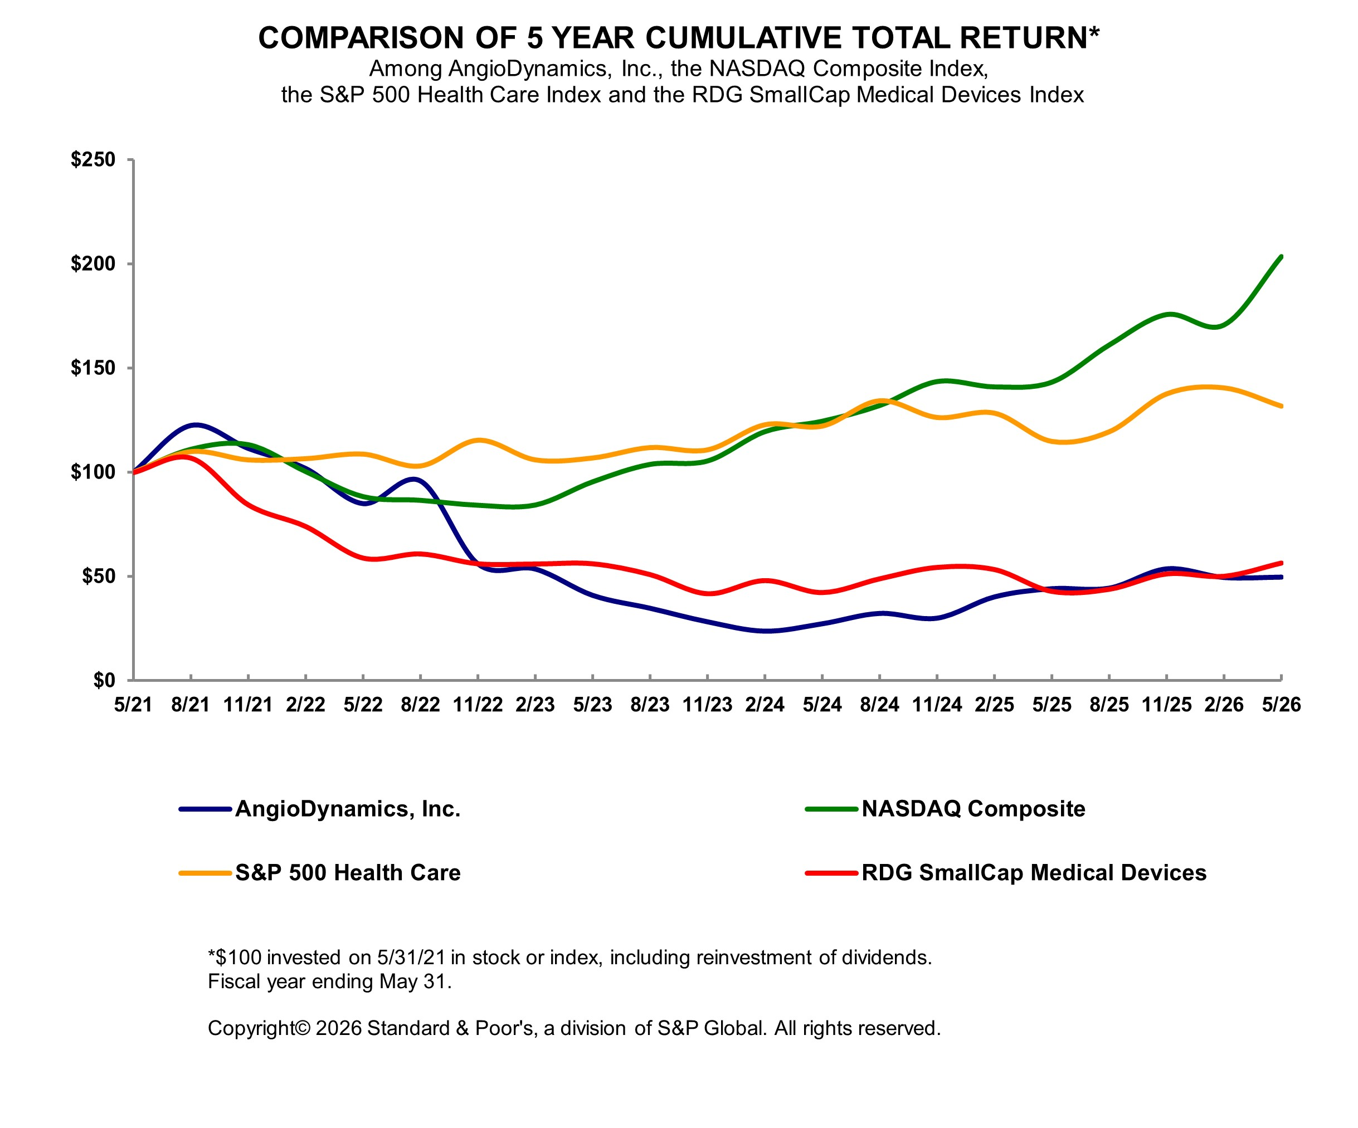
Unregistered Sales of Equity Securities
There were no unregistered sales of equity securities during fiscal year 2026.
Issuer Purchases of Equity Securities
There were no share repurchases during the fourth fiscal quarter ending May 31, 2026.

Item 6. [Reserved]

Item 7. Management’s Discussion and Analysis of Financial Conditions and Results of Operations.
The following information should be read together with the audited consolidated financial statements and the notes thereto and other information included elsewhere in this annual report on Form 10-K. This discussion may contain forward-looking statements related to future events and our future financial performance that are based on current expectation and are subject to risks and uncertainties. Our actual results may differ materially from those anticipated in any forward-looking statements as a result of many factors, including those set forth in Part I, Item 1A, "Risk Factors" and "Disclosure Regarding Forward-Looking Statements" included in this Annual Report on Form 10-K.

33

Company and Market
AngioDynamics is a dynamic, diversified medical technology company committed to expanding treatment options and improving patient outcomes and quality of life by focusing on cardiovascular disease and cancer. Our execution strategy is built on innovative R&D, clinical and regulatory pathway expansion and customer centric sales performance. We design, manufacture and sell a wide range of medical, surgical and diagnostic devices used by professional healthcare providers for vascular access, for the treatment of peripheral vascular disease and for use in oncology and surgical settings. Our devices are generally used in minimally invasive, image-guided procedures. Many of our products are intended to be used once and then discarded, or they may be temporarily implanted for short- or long-term use.
Our business operations cross a variety of markets. Our financial performance is impacted by changing market dynamics, which have included an emergence of value-based purchasing by healthcare providers, consolidation of healthcare providers, the increased role of the consumer in health care decision-making and an aging population, among others. In addition, our growth is impacted by changes within our sector, such as the merging of competitors to gain scale and influence; changes in the regulatory environment for medical device; and fluctuations in the global economy.
Our sales and profitability growth also depends, in part, on the introduction of new and innovative products, together with ongoing enhancements to our existing products. Expansions of our product offerings are created through internal and external product development, technology licensing and strategic alliances. We recognize the importance of, and intend to continue to make investments in research and development activities and selective business development opportunities to provide growth opportunities.
We sell our products in the United States primarily through a direct sales force, and outside the U.S. mainly through distributor relationships. Our end users include interventional radiologists, interventional cardiologists, vascular surgeons, urologists, interventional and surgical oncologists and critical care nurses. We expect our businesses to grow in both sales and profitability by expanding geographically, penetrating new markets, introducing new products and increasing our presence internationally.
The current macroeconomic environment continues to impact our business and may continue to pose future risks. The Company's ability to manufacture products, the reliability of our supply chain, labor shortages, backlog, inflation (including the cost and availability of raw materials, direct labor and shipping) and tariffs have impacted our business, trends that may continue. Accordingly, management continues to evaluate the Company’s liquidity position, communicate with and monitor the actions of our customers and suppliers, and review our near-term financial performance.
On January 5, 2024, the Company announced a restructuring to optimize its manufacturing efficiency, capabilities and footprint (the "Plan"). In the second quarter of fiscal year 2025, the Company announced a modification to the Plan to maintain a presence in Queensbury, NY for the manufacturing of select products, customer service, logistics, shipping, quality and regulatory operations. The restructuring activities associated with the modified Plan are expected to be completed in the first quarter of fiscal year 2027. The modified Plan is still expected to generate $15.0 million in annual cost savings starting in fiscal year 2027.
On July 16, 2024, the Board of Directors approved a share repurchase program (the "Repurchase Program") under which they authorized the Company the option to repurchase up to $15.0 million of its outstanding common stock. The timing and amount of any share repurchases under the authorization will be determined by management within certain parameters and based on market conditions and other considerations. There were no shares repurchased during the twelve months ended May 31, 2026. During fiscal year 2025, the Company repurchased 243,847 shares of common stock in the open market at an aggregate cost of $1.7 million under the Repurchase Program. As of May 31, 2026, $13.3 million remained available for repurchase under the Repurchase Program.
On December 24, 2024, the Company entered into an agreement to sell the manufacturing facilities in Queensbury, NY and Glens Falls, NY for a purchase price of $5.5 million and $1.2 million, respectively, and net proceeds of $5.2 million and $1.1 million, respectively. The Company simultaneously entered into lease agreements with future lease payments of $4.6 million over seven years for the Queensbury, NY facility and $0.4 million over three years for the Glens Falls, NY facility.
On May 28, 2025, the Company entered into a new Credit Agreement (the “Credit Agreement”) with JPMorgan Chase Bank, N.A. The Credit Agreement has a two-year maturity and provides for a $25.0 million secured revolving credit facility (the "Revolving Facility"), which is subject to a borrowing base comprised of certain working capital assets of the Company. As of May 31, 2026, there is no outstanding balance on the Revolving Facility.
34

In evaluating the operating performance of our business, management focuses on revenue, gross margin, operating income, earnings per share and cash flow from operations. A summary of these key financial metrics for the year ended May 31, 2026 compared to the year ended May 31, 2025 follows:
Year ended May 31, 2026:
•Revenue increased by 9.5% to $320.2 million
•Med Tech and Med Device growth of 18.4% and 2.6%, respectively
•Gross margin increased by 70 bps to 54.6%
•Net loss increased by $2.7 million to $36.7 million
•Loss per share increased by $0.05 to a loss of $0.88
•Cash flow from operations increased by $13.2 million resulting in cash provided by operations of $3.1 million
Our Med Tech business, comprised of Auryon, the thrombus management platform and NanoKnife grew 18.4% in fiscal year 2026, driven by growth across all product lines. Our Med Device business increased 2.6% in fiscal year 2026, driven mainly by growth in the Core and Venous product lines which was partially offset by softness in Ports and other Oncology products.
Strategic Initiatives to Drive Growth
The Company is focused on its Med Tech segment which is committed to expanding treatment options and improving patient outcomes and quality of life by focusing on cardiovascular disease and cancer. Our execution strategy is built on innovative R&D, clinical and regulatory pathway expansion and customer centric sales performance. Our investments in our high technology products including Auryon, Mechanical Thrombectomy (which includes AngioVac and AlphaVac) and NanoKnife, will provide us access to larger and faster growing markets.
Throughout the year, we introduced strategic moves designed to streamline our business, improve our overall business operations and position ourselves for growth. Those initiatives included:
•Innovative R&D and Clinical and Regulatory Pathway Expansion. The Company continued its disciplined product development process which is intended to improve the Company’s ability to bring new products to market and achieve clinical and regulatory pathway expansion. The Company:
◦Enrolled the first patients in both the AMBITION BTK and RECOVER-AV trials;
◦Published the NanoKnife PRESERVE study in the journal of European Urology;
◦Received FDA IDE approval for APEX-Return study evaluating AlphaReturn Blood Management System when used with AlphaVac F1885 System;
◦Received FDA IDE approval for PAVE clinical study evaluating AngioVac System for treatment of right-sided infective endocarditis;
◦Received FDA 510(k) clearance for modified AlphaVac F1885 System with expanded indication for use;
◦Presented the two-year follow up data from its PRESERVE pivotal trial at AUA 2026 demonstrating NanoKnife’s durable prostate cancer outcomes;
◦Finalized a local coverage determination with Palmetto covering NanoKnife IRE for qualifying Medicare patients in prostate and liver cancer, effective July 5, 2026; and
◦Received FDA IDE approval for the RELIEF BPH study evaluating NanoKnife IRE for the treatment of benign prostatic hyperplasia.

•Customer Centric Sales Performance. To create value and drive future growth, the Company is focused on ensuring that the sales team is appropriately trained on how to market the products to our customers and that our customers are receiving the appropriate training and exposure to our products. This included:
◦Continued focus on training of the sales teams; and
◦Conducted targeted physician trainings and symposiums both in the U.S. and internationally throughout the year.

•Focused Resource Deployment. The Company continued its discipline on deploying resources. This included:
◦The announcement to restructure the manufacturing footprint, which includes maintaining a presence in Queensbury, NY for select products, customer service, logistics, shipping, quality and regulatory operations, and shifting all other products to an outsourced model utilizing third-party manufacturers to allow the Company to more effectively compete in chosen markets and fundamentally change its corporate gross
35

margin profile. The restructuring activities are expected to be completed in the first quarter of fiscal year 2027 and are expected to generate $15.0 million in annual cost savings starting in fiscal year 2027.
Critical Accounting Policies and Use of Estimates
Our significant accounting policies are summarized in Note 1 "Basis of Presentation, Business Description and Summary of Significant Accounting Policies" in the consolidated financial statements included in this Form 10-K. While all of these significant accounting policies affect the reporting of our financial condition and results of operations, we view certain of these policies as critical. Policies determined to be critical are those policies that have the most significant impact on our financial statements and require us to use a greater degree of judgment and/or estimates. Actual results may differ from those estimates.
Revenue Recognition
Under ASC 606, Revenue from Contracts with Customers, revenue is recognized when a customer obtains control of promised goods or services, in an amount that reflects the consideration which the Company expects to receive in exchange for those goods or services. To determine revenue recognition for such arrangements, the Company performs the following five steps: (i) identify the contract(s) with a customer; (ii) identify the performance obligations in the contract; (iii) determine the transaction price; (iv) allocate the transaction price to the performance obligations in the contract; and (v) recognize revenue when (or as) the entity satisfies a performance obligation.
The Company contracts with its customers based on customer purchase orders, which in many cases are governed by master purchasing agreements. The Company’s contracts with customers are generally for product only, and do not include other performance obligations such as services or other material rights. As part of its assessment of each contract, the Company evaluates certain factors including the customer’s ability to pay (or credit risk). For each contract, the Company considers the promise to transfer products, each of which is distinct, to be the identified performance obligations.
Transaction prices of products are typically based on contracted rates. Product revenue is measured as the amount of consideration the Company expects to receive in exchange for transferring products to a customer, net of any variable consideration as described below.
If a contract contains a single performance obligation, the entire transaction price is allocated to the single performance obligation. Contracts that contain multiple performance obligations require an allocation of the transaction price based on the estimated relative standalone selling prices of the promised products underlying each performance obligation. The Company has standard pricing for its products and determines standalone selling prices based on the price at which the performance obligation is sold separately.
Revenue is recognized when control of the product is transferred to the customer (i.e., when the Company’s performance obligation is satisfied), which occurs at a point in time, and may be upon shipment from the Company’s manufacturing site or delivery to the customer’s named location, based on the shipping terms of a contract.
In determining whether control has transferred, the Company considers if there is a present right to payment from the customer and when physical possession, legal title and risks and rewards of ownership have transferred to the customer.
The Company typically invoices customers upon satisfaction of identified performance obligations. As the Company’s standard payment terms are 30 to 90 days from invoicing, the Company does not provide any significant financing to its customers.
The Company enters into agreements to place placement and evaluation units (“units”) at customer sites, but the Company retains title to the units. For the duration of these agreements the customer has the right to use the unit at no upfront charge in connection with the customer’s ongoing purchase of disposables. These types of agreements include an embedded operating lease for the right to use the units. In these arrangements, revenue recognized for the sale of the disposables is not allocated between the disposable revenue and lease revenue due to the insignificant value of the units in relation to the total agreement value.
Sales, value add, and other taxes collected on behalf of third parties are excluded from revenue.
Revenue from product sales are recorded at the net sales price (transaction price), which includes estimates of variable consideration for which reserves are established for discounts, product returns, rebates and allowances that are offered within contracts between the Company and its customers.
The Company generally offers customers a limited right of return. Product returns after 30 days must be pre-approved by the Company and customers may be subject to a 20% restocking charge. To be accepted, a returned product must be
36

unadulterated, undamaged and have at least twelve months remaining prior to its expiration date. The Company estimates the amount of its product sales that may be returned by its customers and records this estimate as a reduction of revenue in the period the related product revenue is recognized. The Company currently estimates product return liabilities using its historical product return information and considers other factors that it believes could significantly impact its expected returns, including product recalls. Discounts and product returns are based on amounts earned or to be claimed on the related sales and are classified as a contra asset. During the years ended May 31, 2026, 2025 and 2024, such product returns were not material. The Company provides certain customers with rebates and allowances that are explicitly stated in the Company's contracts and are recorded as a reduction of revenue in the period the related product revenue is recognized. The Company establishes reserves for such amounts, which is included in "Accrued liabilities" in the accompanying Consolidated Balance Sheets. These rebates and allowances result from performance-based offers that are primarily based on attaining contractually specified sales volumes. The Company is also required to pay administrative fees to group purchasing organizations.
A receivable is generally recognized in the period the Company ships the product. Payment terms on invoiced amounts are based on contractual terms with each customer and generally coincide with revenue recognition. Accordingly, the Company does not have any contract assets associated with the future right to invoice its customers. In some cases, if control of the product has not yet transferred to the customer or the timing of the payments made by the customer precedes the Company’s fulfillment of the performance obligation, the Company recognizes a contract liability that is included as deferred revenue in "Accrued liabilities" in the accompanying Consolidated Balance Sheets.
Inventory
Inventories are stated at the lower of cost or net realizable value based on the first-in, first-out cost method and consist of raw materials, work in process and finished goods. Appropriate consideration is given to deterioration, obsolescence, expiring and other factors in evaluating net realizable value. When we evaluate inventory for excess quantities and obsolescence, we utilize historical product usage experience and expected demand for establishing our reserve estimates. Our actual product usage may vary from the historical experience and estimating demand is inherently difficult which may result in us recording excess and obsolete inventory amounts that do not match the required amounts. An increase to inventory reserves results in a corresponding increase in cost of revenue. Inventories are written off against the reserve when they are physically disposed.
Results of Operations for the years ended May 31, 2026 and 2025
For the fiscal year ended May 31, 2026, the Company reported a net loss of $36.7 million, or a loss of $0.88 per diluted share, on net sales of $320.2 million compared to a net loss of $34.0 million, or a loss of $0.83 per diluted share, on net sales of $292.5 million in fiscal year 2025.
Net Sales
Net sales - Net sales are derived from the sale of our products and related freight charges, less discounts, rebates and returns.
 |  |  | Year ended May 31,
(in thousands) |  |  | 2026 |  |  |  |  |  | 2025 |  |  |  |  |  | $ Change
Net Sales
Med Tech |  |  | $ | 149,954 |  |  |  |  | $ | 126,653 |  |  |  |  | $ | 23,301
Med Device |  |  | 170,220 |  |  |  |  |  | 165,845 |  |  |  |  |  | $ | 4,375
Total |  |  | $ | 320,174 |  |  |  |  | $ | 292,498 |  |  |  |  | $ | 27,676
Net Sales by Geography
United States |  |  | $ | 274,923 |  |  |  |  | $ | 250,983 |  |  |  |  | $ | 23,940
International |  |  | 45,251 |  |  |  |  |  | 41,515 |  |  |  |  |  | $ | 3,736
Total |  |  | $ | 320,174 |  |  |  |  | $ | 292,498 |  |  |  |  | $ | 27,676
For the year ended May 31, 2026, net sales increased $27.7 million to $320.2 million compared to the year ended May 31, 2025. At May 31, 2026, the Company had a backlog of $0.3 million compared to $0.3 million at the end of May 31, 2025.
The Med Tech business net sales increased $23.3 million for the year ended May 31, 2026 compared to the prior year. The change in sales from the prior year was primarily driven by:
•Increased Auryon sales of $10.0 million;
37

•Increased sales of the thrombus management platform of $4.6 million, which was driven by increases in AngioVac and AlphaVac sales of $0.6 million and $4.7 million, respectfully, which was partially offset by a decrease in thrombolytic sales of $0.7 million; and
•Increased NanoKnife sales of $8.6 million which was driven by increased disposable and capital sales.

The Med Device business net sales increased $4.4 million for the year ended May 31, 2026 compared to the prior year. The backlog, which primarily impacted sales of Core and Vascular Access products, was $0.3 million at May 31, 2026 compared to $0.3 million at May 31, 2025. The change in sales from the prior year was primarily driven by:
•Increased sales of Core and Venous of $3.6 million and $2.2 million, respectively. This increase was partially offset by decreased sales of Ports, Microwave and other Oncology products of $1.2 million, $0.1 million and $0.3 million, respectively.
Gross Margin
 |  |  |  |  |  | Year ended May 31,
(in thousands) |  |  |  |  |  | 2026 |  |  |  |  |  | 2025 |  |  |  |  |  | $ Change
Med Tech |  |  |  |  |  | $ | 95,356 |  |  |  |  | $ | 78,515 |  |  |  |  | $ | 16,841
Gross margin % of sales |  |  |  |  |  | 63.6 |  | % |  |  |  | 62.0 |  | %
Med Device |  |  |  |  |  | $ | 79,536 |  |  |  |  | $ | 79,190 |  |  |  |  | $ | 346
Gross margin % of sales |  |  |  |  |  | 46.7 |  | % |  |  |  | 47.7 |  | %
Total |  |  |  |  |  | $ | 174,892 |  |  |  |  | $ | 157,705 |  |  |  |  | $ | 17,187
Gross margin % of sales |  |  |  |  |  | 54.6 |  | % |  |  |  | 53.9 |  | %
Gross margin - Gross margin consists of net sales less the cost of goods sold, which includes the costs of materials, products purchased from third parties and sold by us, manufacturing personnel, royalties, freight, business insurance, depreciation of property and equipment and other manufacturing overhead, exclusive of intangible amortization.
Total Company gross margin increased by $17.2 million compared to the prior year. The change from the prior year was primarily driven by:
•Sales volume, price and product mix, which positively impacted gross margin by $26.6 million;
•Benefits from product lines transitioned to third-party manufacturers along with other incentives, which positively impacted gross margin by $0.9 million;
•Production volume and other operations costs, which negatively impacted gross margin by $5.2 million;
•Tariffs, which negatively impacted gross margin by $3.2 million; and
•Inflation, which negatively impacted gross margin by $1.9 million.

The Med Tech segment gross margin increased by $16.8 million compared to the prior year. The change from the prior year was primarily driven by:
•Sales volume and price, which positively impacted gross margin by $16.4 million;
•Favorable purchasing price variance due to shifting to lower cost suppliers, which positively impacted gross margin by $2.7 million;
•Tariffs, which positively impacted gross margin by $0.6 million due to refunds received and lower tariff rates;
•Freight and other costs, which negatively impacted gross margin by $1.2 million;
•Product mix, which negatively impacted gross margin by $0.7 million;
•Production volume, which negatively impacted gross margin by $0.1 million; and
•Incremental depreciation on placement units of $0.8 million.
The Med Device segment gross margin increased by $0.3 million compared to the prior year. The change from the prior year was primarily driven by:
•Price and product mix, which positively impacted gross margin by $11.5 million;
•Benefits from product lines transitioned to third-party manufacturers along with other incentives, which positively impacted gross margin by $2.1 million;
38

•Sales volume, which negatively impacted gross margin by $0.5 million;
•Production volume and other operations costs, which negatively impacted gross margin by $5.1 million;
•Tariffs, which negatively impacted gross margin by $3.8 million;
•Inflation, which negatively impacted gross margin by $4.6 million; and
•A decrease in incremental depreciation on placement units of $0.8 million.

Operating Expenses and Other Income (Expense)
 |  |  | Year ended May 31,
(in thousands) |  |  | 2026 |  |  |  |  |  | 2025 |  |  |  |  |  | $ Change
Research and development |  |  | $ | 29,447 |  |  |  |  | $ | 26,222 |  |  |  |  | $ | 3,225
% of sales |  |  | 9.2 |  | % |  |  |  | 9.0 |  | %
Selling and marketing |  |  | $ | 113,401 |  |  |  |  | $ | 103,135 |  |  |  |  | $ | 10,266
% of sales |  |  | 35.4 |  | % |  |  |  | 35.3 |  | %
General and administrative |  |  | $ | 43,691 |  |  |  |  | $ | 42,092 |  |  |  |  | $ | 1,599
% of sales |  |  | 13.6 |  | % |  |  |  | 14.4 |  | %
Research and development expense - Research and development (“R&D”) expense includes internal and external costs to develop new products, enhance existing products, validate new and enhanced products, manage clinical, regulatory and medical affairs.
R&D expense increased $3.2 million compared to the prior year. The change from the prior year was primarily driven by:
•The timing of certain projects and clinical spend associated with the ongoing clinical trials, which increased R&D expense by $2.0 million; and
•Compensation and benefits expenses, which increased $1.2 million.
Sales and marketing expense - Sales and marketing (“S&M”) expense consists primarily of salaries, commissions, travel and related business expenses, attendance at medical society meetings, product promotions and marketing activities.
S&M expense increased by $10.3 million compared to the prior year. The change from the prior year was primarily driven by:
•Compensation and benefits expense, which increased by $7.6 million;
•Consulting, travel and other selling expenses, which increased $1.7 million; and
•Trade shows, subscriptions and other marketing expenses, which increased $1.0 million.

General and administrative expense - General and administrative (“G&A”) expense includes executive management, finance, information technology, human resources, business development, legal, and the administrative and professional costs associated with those activities.
G&A expense increased by $1.6 million compared to the prior year. The change from the prior year was primarily driven by:
•Compensation and benefits expense, which increased $5.6 million;
•Other outside consultant spend, which decreased $3.2 million; and
•Depreciation and other corporate expenses, which decreased $0.8 million.

 |  |  | Year ended May 31,
(in thousands) |  |  | 2026 |  |  |  |  |  | 2025 |  |  |  |  |  | $ Change
Amortization of intangibles |  |  | $ | 10,682 |  |  |  |  | $ | 10,318 |  |  |  |  | $ | 364
Change in fair value of contingent consideration |  |  | $ | — |  |  |  |  | $ | 272 |  |  |  |  | $ | (272)
Acquisition, restructuring and other items, net |  |  | $ | 17,598 |  |  |  |  | $ | 15,620 |  |  |  |  | $ | 1,978
Other income |  |  | $ | 3,627 |  |  |  |  | $ | 5,922 |  |  |  |  | $ | (2,295)
Amortization of intangibles - Represents the amount of amortization expense that was taken on intangible assets held by the Company.
•Amortization expense remained consistent compared to the prior year.
39

Change in fair value of contingent consideration - Represents changes in contingent consideration driven by changes to estimated future payments on earn-out liabilities created through acquisitions and amortization of present value discounts on long-term contingent consideration.
•The change in the fair value for the year ended May 31, 2026 is related to the Eximo contingent consideration. The final milestone associated with the contingent consideration was reached during the third quarter of fiscal year 2025 and was paid during the fourth quarter of fiscal year 2025.
Acquisition, restructuring and other items, net - Acquisition, restructuring and other items, net represents costs associated with mergers and acquisitions, restructuring expenses, legal costs that are related to litigation that is not in the ordinary course of business, legal settlements and other one-time items.
Acquisition, restructuring and other items, net increased by $2.0 million compared to the prior year. The change from the prior year was primarily driven by:
•Legal expense, related to litigation that is outside of the normal course of business, which increased $1.3 million;
•Mergers and acquisitions expense, which decreased $0.7 million;
•Transaction services agreements that were entered into as a result of the divestiture of the PICCs, Midline, dialysis and BioSentry businesses. The decrease in the fees invoiced was $0.3 million;
•Plant closure expense, related to the restructuring of our manufacturing footprint which was announced on January 5, 2024, which decreased $0.6 million;
•Transition expenses related to the upcoming retirement of our CEO which was announced on January 6, 2026, which increased $1.6 million; and
•Other expenses, mainly severance associated with organizational changes, which increased $0.1 million.

Other income (expense) - Other expense includes interest income and expense, foreign currency impacts and bank fees.
Other income, net decreased by $2.3 million compared to the prior year. The change from the prior year was primarily driven by:
•The Company achieved the manufacturing transfer milestone related to divested products in the third quarter of fiscal year 2026 and recorded the associated revenue of $5.0 million which was paid to the Company in the third quarter of fiscal year 2026;
•The Company achieved the sales milestone related to the divested products in the third quarter of fiscal year 2025 and recorded a receivable of $5.5 million which was paid to the Company in the fourth quarter of fiscal year 2025;
•Unrealized foreign currency fluctuations and bank fees, which increased $0.2 million and $0.4 million, respectively; and
•Interest income, which decreased $1.3 million compared to the prior year.
Income Tax Expense (Benefit)
 |  |  | Year ended May 31,
(in thousands) |  |  | 2026 |  |  |  |  |  | 2025
Income tax expense (benefit) |  |  | $ | 442 |  |  |  |  | $ | (39)
Effective tax rate |  |  | (1.2) |  | % |  |  |  | 0.1 |  | %
Our effective tax rate was (1.2)% for fiscal year 2026 compared with an effective tax rate of 0.1% for the prior year. The current year and prior year effective tax rates differ from the U.S. statutory rate primarily due to the impact of the valuation allowance, foreign taxes, and other non-deductible permanent items (such as non-deductible meals and entertainment, Section 162(m) excess compensation), and the impact of stock-based compensation.
The Company regularly assesses its ability to realize its deferred tax assets. Assessing the realization of deferred tax assets requires significant management judgment. In determining whether its deferred tax assets are more likely than not realizable, the Company evaluated all available positive and negative evidence, and weighted the evidence based on its objectivity.
Based on the review of all available evidence, the Company determined that it has not yet attained a sustained level of profitability and the objectively verifiable negative evidence outweighed the positive evidence. As a result of the full impairment of Goodwill and the reversal of the naked credit deferred tax liability sourced income, the Company has recorded a full valuation allowance on its U.S. net deferred tax assets as of May 31, 2026. The Company will continue to assess the level
40

of the valuation allowance required. If sufficient positive evidence exists in future periods to support a release of some or all of the valuation allowance, such a release would likely have a material impact on the Company’s results of operations.
Liquidity and Capital Resources
We regularly review our liquidity and anticipated capital requirements and we believe that our current cash on hand provides sufficient liquidity to meet our anticipated needs for capital for at least the next 12 months.
Our cash and cash equivalents totaled $53.9 million as of May 31, 2026, compared with $55.9 million as of May 31, 2025. As of May 31, 2026 and 2025 the Company did not have any outstanding debt.
The table below summarizes our cash flows for the years ended May 31, 2026 and 2025:
 |  |  | Year ended May 31,
(in thousands) |  |  | 2026 |  |  |  |  |  | 2025
Cash (used in) provided by:
Operating activities |  |  | $ | 3,089 |  |  |  |  | $ | (10,128)
Investing activities |  |  | (5,949) |  |  |  |  |  | (10,178)
Financing activities |  |  | 564 |  |  |  |  |  | (255)
Effect of exchange rate changes on cash and cash equivalents |  |  | 267 |  |  |  |  |  | 398
Net change in cash and cash equivalents |  |  | $ | (2,029) |  |  |  |  | $ | (20,163)
During the years ended May 31, 2026 and 2025, cash flows consisted of the following:
Cash provided by (used in) operating activities:
Years ended May 31, 2026 and 2025:
•Net loss of $36.7 million plus the non-cash items, primarily driven by depreciation and amortization and stock-based compensation, along with the changes in working capital below, contributed to cash provided by operations of $3.1 million for the year ended May 31, 2026.
•For the year ended May 31, 2026, working capital was favorably impacted by decreased inventory of $10.0 million. This was partially offset by a decrease in accounts payable, accrued liabilities and other liabilities of $5.8 million, along with increased accounts receivable and prepaid expenses of $5.8 million and $1.1 million, respectively.
•Net loss of $34.0 million plus the non-cash items, primarily driven by depreciation and amortization and stock-based compensation, along with the changes in working capital below, contributed to cash used in operations of $10.1 million for the year ended May 31, 2025.
•For the year ended May 31, 2025, working capital was unfavorably impacted by decreased accounts payable and accrued liabilities and inventory on hand of $15.9 million and $1.3 million, respectively. This was partially offset by decreased prepaid expenses of $3.1 million.
Cash used in investing activities:
Years ended May 31, 2026 and 2025:
•$2.6 million and $4.5 million, respectively, of cash was used for fixed asset additions; and
•$3.4 million and $5.7 million, respectively, of cash was used for Auryon placement and evaluation unit additions.
•
Cash provided by (used in) financing activities:
Years ended May 31, 2026 and 2025:
•$0.4 million and $0.1 million, respectively, of principal payments on the financing arrangements;
•$6.3 million of proceeds from financing arrangements in fiscal year 2025;
•$5.0 million of contingent consideration payments in fiscal year 2025;
•$1.7 million of cash was used for the repurchase of common shares in fiscal year 2025;
•$0.7 million write-off of deferred financing fees related to the repayment of the Credit Agreement fiscal year 2025; and
•$0.9 million and $0.9 million, respectively, of proceeds from stock option and ESPP activity.
41

On May 28, 2025, the Company entered into a new Credit Agreement (the “Credit Agreement”) with JPMorgan Chase Bank, N.A. The Credit Agreement has a two-year maturity and provides for a $25.0 million secured revolving credit facility (the "Revolving Facility"), which is subject to a borrowing base comprised of certain working capital assets of the Company. As of May 31, 2026, there is no outstanding balance on the Revolving Facility. We believe that our current cash balance, together with cash generated from operations and access to our Revolving Facility, will provide sufficient liquidity to meet our anticipated needs for capital for at least the next 12 months. If we seek to make acquisitions of other businesses or technologies in the future for cash, we may require external financing.
Our contractual obligations as of May 31, 2026 are set forth in the table below (in thousands). We have no variable interest entities or other off-balance sheet obligations.
 |  |  |  |  |  | Cash payments due by period as of May 31, 2026
(in thousands) |  |  |  |  |  | Less than  One Year |  |  |  |  |  | 1-3 Years |  |  |  |  |  | 3-5 Years |  |  |  |  |  | After 5  Years |  |  |  |  |  | Total
Contractual Obligations:
Operating leases (1) |  |  |  |  |  | $ | 1,862 |  |  |  |  | $ | 2,889 |  |  |  |  | $ | 1,457 |  |  |  |  | $ | 49 |  |  |  |  | $ | 6,257
Finance leases |  |  |  |  |  | 804 |  |  |  |  |  | 1,405 |  |  |  |  |  | 1,320 |  |  |  |  |  | 385 |  |  |  |  |  | 3,914
Royalties |  |  |  |  |  | 3,220 |  |  |  |  |  | 6,440 |  |  |  |  |  | 6,440 |  |  |  |  |  | 9,460 |  |  |  |  |  | 25,560
 |  |  |  |  |  | $ | 5,886 |  |  |  |  | $ | 10,734 |  |  |  |  | $ | 9,217 |  |  |  |  | $ | 9,894 |  |  |  |  | $ | 35,731
(1) Operating leases include short-term leases that are not recorded on our Consolidated Balance Sheets under ASU No. 2016-02.

Results of Operations for the years ended May 31, 2025 and 2024
For management discussion and analysis of our 2025 financial results and liquidity compared with 2024, see Part II, Item 7 "Management's Discussion and Analysis of Financial Condition and Results of Operations" in our Annual Report on Form 10-K for the year ended May 31, 2025 filed on July 18, 2025.
Recent Accounting Pronouncements
Refer to Note 1 of the Notes to the consolidated financial statements for Recently Issued Accounting Pronouncements.

42

Item 7A. Quantitative and Qualitative Disclosures about Market Risk.
FOREIGN CURRENCY EXCHANGE RATE RISK
We are exposed to market risk from changes in currency exchange rates, as well as interest rate fluctuations on our credit facility and investments that could impact our results of operations and financial position.
We transact sales in currencies other than the U.S. Dollar, particularly the Euro, British pound and Canadian dollar. Approximately 3.8% of our sales in fiscal year 2026 were denominated in foreign currencies. We do not have expenses denominated in foreign currencies at the level of our sales and as a result, our profitability is exposed to currency fluctuations. When the U.S. Dollar strengthens, our sales and gross margin will be negatively impacted. In addition, we have assets and liabilities denominated in non-functional currencies which are remeasured at each reporting period, with the offset to changes presented as a component of Other (Expense) Income. Significant non-functional balances include accounts receivable due from some of our international customers.
INTEREST RATE RISK
The risk associated with fluctuating interest rates is primarily limited to indebtedness. As of May 31, 2026, the Company does not have any outstanding debt (see Note 11, "Long-Term Debt" set forth in the Notes in the consolidated financial statements included in this Annual Report on Form 10-K).
Interest on the Revolving Facility will be based, at the Company's option, on a rate equal to (i) the Secured Overnight Financing Rate ("SOFR") plus 0.1% (subject to a floor of 0%) ("Adjusted Term SOFR"), or (ii) the alternate base rate (subject to a floor of 0%) ("ABR"), and in each case with a margin for Adjusted Term SOFR loans of 2.0% and for ABR loans of 1.0%. The Revolving Facility will also carry a commitment fee of 0.2% per annum on the unused portion. The Revolving Facility contains customary benchmark replacement and rate fallback provisions.
CONCENTRATION OF CREDIT RISK
Financial instruments, which potentially subject the Company to significant concentrations of credit risk, consist primarily of cash and cash equivalents and trade accounts receivable.
The Company maintains cash and cash equivalents at various institutions and performs periodic evaluations of the relative credit standings of these financial institutions to ensure their credit worthiness.
Concentration of credit risk with respect to trade accounts receivable is limited due to the large number of customers that purchase products from the Company. No single customer represents more than 10% of total sales. The Company monitors the creditworthiness of its customers. As the Company’s standard payment terms are 30 to 90 days from invoicing, the Company does not provide any significant financing to its customers. Although the Company does not currently foresee a significant credit risk associated with the outstanding accounts receivable, repayment is dependent upon the financial stability of our customers.

Item 8. Financial Statements and Supplementary Data.
Financial statements and supplementary data required by Part II, Item 8 are included in Part IV of this report and indexed under Item 15 (a) (1) and (2) of this report, and are incorporated by reference into this Item 8.

Item 9. Changes in and Disagreements with Accountants on Accounting and Financial Disclosure.
None.
43

Item 9A. Controls and Procedures.
Evaluation of disclosure controls and procedures
As of the end of the period covered by this report, our management, under the supervision and with the participation of our Chief Executive Officer and our Chief Financial Officer, evaluated the effectiveness of the design and operation of our disclosure controls and procedures pursuant to Rule 13a-15(b) of the Securities Exchange Act of 1934, as amended. Based on that evaluation, the Chief Executive Officer and the Chief Financial Officer concluded that our disclosure controls and procedures as of the end of the period covered by this report were effective to provide reasonable assurance that the information required to be disclosed by us in reports filed under the Securities Exchange Act of 1934, as amended, is recorded, processed, summarized and reported within the time periods specified in the SEC rules and forms and is accumulated and communicated to management, including our Chief Executive Officer and Chief Financial Officer, as appropriate to allow timely decisions regarding required disclosure.
Management’s Report on Internal Control Over Financial Reporting
Our management is responsible for establishing and maintaining adequate internal control over financial reporting for our Company. Internal control over financial reporting is defined in Rules 13a-15(f) and 15d-15(f) promulgated under the Securities Exchange Act of 1934, as amended, as a process designed by, or under the supervision of, our principal executive and principal financial officers and effected by our Board of Directors, management and other personnel, to provide reasonable assurance regarding the reliability of financial reporting and the preparation of financial statements for external purposes in accordance with accounting principles generally accepted in the United States and includes those policies and procedures that:
•Pertain to the maintenance of records that in reasonable detail accurately and fairly reflect the transactions and dispositions of our assets;
•Provide reasonable assurance that transactions are recorded as necessary to permit preparation of financial statements in accordance with accounting principles generally accepted in the United States, and that our receipts and expenditures are being made only in accordance with authorizations of our management and members of our Board of Directors; and
•Provide reasonable assurance regarding prevention or timely detection of unauthorized acquisition, use or disposition of our assets that could have a material effect on our financial statements.
Because of its inherent limitations, internal control over financial reporting may not prevent or detect misstatements. Also, projections of any evaluation of effectiveness to future periods are subject to the risk that controls may become inadequate because of changes in conditions, or that the degree of compliance with the policies or procedures may deteriorate.
Our management has assessed the effectiveness of our internal control over financial reporting as of May 31, 2026. In making this assessment, management used the criteria set forth by the Committee of Sponsoring Organizations of the Treadway Commission (COSO) in Internal Control-Integrated Framework (2013). Based on this evaluation, management concluded that our internal control over financial reporting was effective as of May 31, 2026.
The effectiveness of our internal control over financial reporting as of May 31, 2026 has been audited by Deloitte & Touche LLP, an independent registered public accounting firm, as stated in their report which appears herein.
Changes in Internal Control over Financial Reporting
There was no change in our internal control over financial reporting for the fiscal year ended May 31, 2026 that has materially affected, or is reasonably likely to materially affect, our internal control over financial reporting.
44

REPORT OF INDEPENDENT REGISTERED PUBLIC ACCOUNTING FIRM

To the Shareholders and the Board of Directors of
AngioDynamics, Inc.
Latham, New York
Opinion on Internal Control over Financial Reporting
We have audited the internal control over financial reporting of AngioDynamics, Inc. and subsidiaries (the “Company”) as of May 31, 2026, based on criteria established in Internal Control — Integrated Framework (2013) issued by the Committee of Sponsoring Organizations of the Treadway Commission (COSO). In our opinion, the Company maintained, in all material respects, effective internal control over financial reporting as of May 31, 2026, based on criteria established in Internal Control — Integrated Framework (2013) issued by COSO.
We have also audited, in accordance with the standards of the Public Company Accounting Oversight Board (United States) (PCAOB), the consolidated financial statements as of and for the year ended May 31, 2026, of the Company and our report dated July 14, 2026, expressed an unqualified opinion on those financial statements.
Basis for Opinion
The Company’s management is responsible for maintaining effective internal control over financial reporting and for its assessment of the effectiveness of internal control over financial reporting, included in the accompanying Management’s Report on Internal Control over Financial Reporting. Our responsibility is to express an opinion on the Company’s internal control over financial reporting based on our audit. We are a public accounting firm registered with the PCAOB and are required to be independent with respect to the Company in accordance with the U.S. federal securities laws and the applicable rules and regulations of the Securities and Exchange Commission and the PCAOB.
We conducted our audit in accordance with the standards of the PCAOB. Those standards require that we plan and perform the audit to obtain reasonable assurance about whether effective internal control over financial reporting was maintained in all material respects. Our audit included obtaining an understanding of internal control over financial reporting, assessing the risk that a material weakness exists, testing and evaluating the design and operating effectiveness of internal control based on the assessed risk, and performing such other procedures as we considered necessary in the circumstances. We believe that our audit provides a reasonable basis for our opinion.

Definition and Limitations of Internal Control over Financial Reporting
A company’s internal control over financial reporting is a process designed to provide reasonable assurance regarding the reliability of financial reporting and the preparation of financial statements for external purposes in accordance with generally accepted accounting principles. A company’s internal control over financial reporting includes those policies and procedures that (1) pertain to the maintenance of records that, in reasonable detail, accurately and fairly reflect the transactions and dispositions of the assets of the company; (2) provide reasonable assurance that transactions are recorded as necessary to permit preparation of financial statements in accordance with generally accepted accounting principles, and that receipts and expenditures of the company are being made only in accordance with authorizations of management and directors of the company; and (3) provide reasonable assurance regarding prevention or timely detection of unauthorized acquisition, use, or disposition of the company’s assets that could have a material effect on the financial statements.
Because of its inherent limitations, internal control over financial reporting may not prevent or detect misstatements. Also, projections of any evaluation of effectiveness to future periods are subject to the risk that controls may become inadequate because of changes in conditions, or that the degree of compliance with the policies or procedures may deteriorate.

/s/ Deloitte & Touche LLP

Boston, Massachusetts
July 14, 2026
45

Item 9B. Other Information.
None.

Item 9C. Foreign Jurisdictions that Prevent Inspections.

Not applicable.

46

Part III
Certain information required by Part III is omitted from this Annual Report on Form 10-K because we will file a definitive proxy statement within 120 days after the end of our fiscal year end pursuant to Regulation 14A (the “Proxy Statement”) for our Annual Meeting of Stockholders, currently scheduled for October 2026. The information included in the Proxy Statement under the respective headings noted below is incorporated herein by reference.

Item 10. Directors, Executive Officers and Corporate Governance.
Information required in this Annual Report on Form 10-K with respect to Executive Officers is contained in the discussion titled “Executive Officers of the Company” in Part I of this Annual Report on Form 10-K. The balance of the information required by Item 10 is incorporated herein by reference to our Proxy Statement under the heading “Election of Directors”.

Item 11. Executive Compensation.
The information required by this caption is incorporated herein by reference to our Proxy Statement under the heading “Executive Compensation”.

Item 12. Security Ownership of Certain Beneficial Owners and Management and Related Stockholder Matters.
The information required by this caption is incorporated herein by reference to our Proxy Statement under the heading “Ownership of Securities”.

Item 13. Certain Relationships and Related Transactions, and Director Independence.
The information required by this caption is incorporated herein by reference to our Proxy Statement under the heading “Certain Relationships and Related Transactions”.

Item 14. Principal Accounting Fees and Services.
The information required by this caption is incorporated herein by reference to our Proxy Statement under the headings “Audit Matters—Principal Accounting Fees and Services and—Policy on Audit Committee Pre-approval of Audit and Permissible Non-Audit Services of Independent Registered Public Accounting Firm”.

47

Part IV

Item 15. Exhibits, Financial Statement Schedules.

(a)(1) Financial Statements
The following consolidated financial statements and supplementary data of Registrant and its subsidiaries required by Part II, Item 8, are included in Part IV of this report:

Report of Independent Registered Public Accounting Firm (PCAOB ID 34) |  |  |  |  |  |  |  |  | 49
Consolidated Statements of Operations—Year ended May 31, 2026, 2025 and 2024 |  |  |  |  |  |  |  |  | 51
Consolidated Statements of Comprehensive Loss - Year ended May 31, 2026, 2025 and 2024 |  |  |  |  |  |  |  |  | 52
Consolidated Balance Sheets—May 31, 2026 and May 31, 2025 |  |  |  |  |  |  |  |  | 53
Consolidated Statements of Stockholders’ Equity—Year ended May 31, 2026, 2025 and 2024 |  |  |  |  |  |  |  |  | 54
Consolidated Statements of Cash Flows—Year ended May 31, 2026, 2025 and 2024 |  |  |  |  |  |  |  |  | 55
Notes to Consolidated Financial Statements |  |  |  |  |  |  |  |  | 57

(2) Financial Statement Schedules
The following consolidated financial statement schedule is included in Part IV of this report:

Schedule II—Valuation and qualifying accounts |  |  | 80
All other schedules are omitted because they are not applicable, not required, or because the required information is included in the consolidated financial statements or notes thereto.

(b) Exhibits |  |  | 81

48

REPORT OF INDEPENDENT REGISTERED PUBLIC ACCOUNTING FIRM
To the Shareholders and the Board of Directors of
AngioDynamics, Inc.
Latham, New York
Opinion on the Financial Statements
We have audited the accompanying consolidated balance sheets of AngioDynamics, Inc. and subsidiaries (the "Company") as of May 31, 2026 and 2025, the related consolidated statements of operations, comprehensive loss, stockholders' equity, and cash flows, for each of the three years in the period ended May 31, 2026, and the related notes and the schedule listed in the Index at Item 15 (collectively referred to as the "financial statements"). In our opinion, the financial statements present fairly, in all material respects, the financial position of the Company as of May 31, 2026 and 2025, and the results of its operations and its cash flows for each of the three years in the period ended May 31, 2026, in conformity with accounting principles generally accepted in the United States of America.
We have also audited, in accordance with the standards of the Public Company Accounting Oversight Board (United States) (PCAOB), the Company's internal control over financial reporting as of May 31, 2026, based on criteria established in Internal Control — Integrated Framework (2013) issued by the Committee of Sponsoring Organizations of the Treadway Commission and our report dated July 14, 2026, expressed an unqualified opinion on the Company's internal control over financial reporting.
Basis for Opinion
These financial statements are the responsibility of the Company's management. Our responsibility is to express an opinion on the Company's financial statements based on our audits. We are a public accounting firm registered with the PCAOB and are required to be independent with respect to the Company in accordance with the U.S. federal securities laws and the applicable rules and regulations of the Securities and Exchange Commission and the PCAOB.
We conducted our audits in accordance with the standards of the PCAOB. Those standards require that we plan and perform the audit to obtain reasonable assurance about whether the financial statements are free of material misstatement, whether due to error or fraud. Our audits included performing procedures to assess the risks of material misstatement of the financial statements, whether due to error or fraud, and performing procedures that respond to those risks. Such procedures included examining, on a test basis, evidence regarding the amounts and disclosures in the financial statements. Our audits also included evaluating the accounting principles used and significant estimates made by management, as well as evaluating the overall
presentation of the financial statements. We believe that our audits provide a reasonable basis for our opinion.

Critical Audit Matters
The critical audit matter communicated below is a matter arising from the current-period audit of the financial statements that was communicated or required to be communicated to the audit committee and that (1) relates to accounts or disclosures that are material to the financial statements and (2) involved our especially challenging, subjective, or complex judgments. The communication of critical audit matters does not alter in any way our opinion on the financial statements, taken as a whole, and we are not, by communicating the critical audit matter below, providing a separate opinion on the critical audit matter or on the accounts or disclosures to which it relates.
Inventories – Excess Quantities and Obsolescence — Refer to Notes 1 & 5
Critical Audit Matter Description
The Company evaluates inventory each reporting period for excess quantities and obsolescence, establishing reserves when necessary, based upon historical experience, assessment of economic conditions, and expected demand. Once recorded, these reserves are considered permanent adjustments to the carrying value of inventory.
We identified the reserve for excess quantities and obsolete inventory as a critical audit matter because of the significant estimates and assumptions management makes to quantify and to record the reserve, including the determination of expected demand. This required a high degree of auditor judgment and an increased extent of effort when performing audit procedures to evaluate the methodology and the reasonableness of assumptions including expected demand.

How the Critical Audit Matter Was Addressed in the Audit
Our audit procedures related to the reserve for excess quantities and obsolete inventory including management’s estimate of expected demand included the following, among others:
•We tested the design and effectiveness of controls over the inventory reserve, specifically those over the estimation of reserves for excess quantities and obsolescence.
49

•We evaluated the reasonableness of the Company's excess and obsolete inventory policy, considering historical experience and the underlying assumptions and considered the Company's disclosures.
•We tested management’s process of the determination of the excess and obsolete reserve pursuant to the Company's policy, including the completeness and accuracy of the data used in the calculation.
•We performed a retrospective review by comparing management’s prior year projections of future demand by product, on a sample basis, with actual product sales in the current year to identify potential bias in the inventory reserve.
•We made inquiries of senior financial and operating management to determine whether any strategic, regulatory, or operational changes in the business were consistent with the projections of future demand that were utilized as the basis for the reserves recorded.

/s/ Deloitte & Touche LLP
Boston, Massachusetts
July 14, 2026
We have served as the Company’s auditor since 2016.

50

AngioDynamics, Inc. and Subsidiaries
CONSOLIDATED STATEMENTS OF OPERATIONS
(in thousands, except per share data)

 |  |  | Year ended May 31,
 |  |  | 2026 |  |  |  |  |  | 2025 |  |  |  |  |  | 2024
Net sales |  |  | $ | 320,174 |  |  |  |  | $ | 292,498 |  |  |  |  | $ | 303,914
Cost of sales (exclusive of intangible amortization) |  |  | 145,282 |  |  |  |  |  | 134,793 |  |  |  |  |  | 149,216
Gross margin |  |  | 174,892 |  |  |  |  |  | 157,705 |  |  |  |  |  | 154,698
Operating expenses
Research and development |  |  | 29,447 |  |  |  |  |  | 26,222 |  |  |  |  |  | 31,512
Sales and marketing |  |  | 113,401 |  |  |  |  |  | 103,135 |  |  |  |  |  | 102,818
General and administrative |  |  | 43,691 |  |  |  |  |  | 42,092 |  |  |  |  |  | 41,164
Amortization of intangibles |  |  | 10,682 |  |  |  |  |  | 10,318 |  |  |  |  |  | 13,048
Goodwill impairment |  |  | — |  |  |  |  |  | — |  |  |  |  |  | 159,476
Change in fair value of contingent consideration |  |  | — |  |  |  |  |  | 272 |  |  |  |  |  | 432
Acquisition, restructuring and other items, net |  |  | 17,598 |  |  |  |  |  | 15,620 |  |  |  |  |  | 53,182
Total operating expenses |  |  | 214,819 |  |  |  |  |  | 197,659 |  |  |  |  |  | 401,632
Gain on sale of assets |  |  | — |  |  |  |  |  | — |  |  |  |  |  | 54,499
Operating loss |  |  | (39,927) |  |  |  |  |  | (39,954) |  |  |  |  |  | (192,435)
Other expenses
Interest income (expense), net |  |  | (299) |  |  |  |  |  | 978 |  |  |  |  |  | 1,614
Other income (expense), net |  |  | 3,926 |  |  |  |  |  | 4,944 |  |  |  |  |  | (817)
Total other income, net |  |  | 3,627 |  |  |  |  |  | 5,922 |  |  |  |  |  | 797
Loss before income tax expense (benefit) |  |  | (36,300) |  |  |  |  |  | (34,032) |  |  |  |  |  | (191,638)
Income tax expense (benefit) |  |  | 442 |  |  |  |  |  | (39) |  |  |  |  |  | (7,289)
Net loss |  |  | $ | (36,742) |  |  |  |  | $ | (33,993) |  |  |  |  | $ | (184,349)
Loss per share
Basic |  |  | $ | (0.88) |  |  |  |  | $ | (0.83) |  |  |  |  | $ | (4.59)
Diluted |  |  | $ | (0.88) |  |  |  |  | $ | (0.83) |  |  |  |  | $ | (4.59)
Weighted average shares outstanding
Basic |  |  | 41,526 |  |  |  |  |  | 40,853 |  |  |  |  |  | 40,181
Diluted |  |  | 41,526 |  |  |  |  |  | 40,853 |  |  |  |  |  | 40,181

The accompanying notes are an integral part of these consolidated financial statements.

51

AngioDynamics, Inc. and Subsidiaries
CONSOLIDATED STATEMENTS OF COMPREHENSIVE LOSS
(in thousands)

 |  |  | Year ended May 31,
 |  |  | 2026 |  |  |  |  |  | 2025 |  |  |  |  |  | 2024
Net loss |  |  | $ | (36,742) |  |  |  |  | $ | (33,993) |  |  |  |  | $ | (184,349)
Other comprehensive income, before tax:
Foreign currency translation gain |  |  | 9,698 |  |  |  |  |  | 2,342 |  |  |  |  |  | 358
Other comprehensive income, before tax |  |  | 9,698 |  |  |  |  |  | 2,342 |  |  |  |  |  | 358
Income tax expense related to items of other comprehensive income (loss) |  |  | — |  |  |  |  |  | — |  |  |  |  |  | —
Other comprehensive income, net of tax |  |  | 9,698 |  |  |  |  |  | 2,342 |  |  |  |  |  | 358
Total comprehensive loss, net of tax |  |  | $ | (27,044) |  |  |  |  | $ | (31,651) |  |  |  |  | $ | (183,991)

The accompanying notes are an integral part of these consolidated financial statements.

52

AngioDynamics, Inc. and Subsidiaries
CONSOLIDATED BALANCE SHEETS
(in thousands, except share data)
 |  |  | May 31, 2026 |  |  |  |  |  | May 31, 2025
Assets
Current Assets
Cash and cash equivalents |  |  | $ | 53,864 |  |  |  |  | $ | 55,893
Accounts receivable, net of allowances of $1,851 and $2,215 respectively |  |  | 48,325 |  |  |  |  |  | 42,890
Inventories |  |  | 52,436 |  |  |  |  |  | 62,006
Prepaid expenses and other |  |  | 8,769 |  |  |  |  |  | 7,535
Total current assets |  |  | 163,394 |  |  |  |  |  | 168,324
Property, plant and equipment, net |  |  | 27,097 |  |  |  |  |  | 32,300
Intangible assets, net |  |  | 67,209 |  |  |  |  |  | 69,116
Other assets |  |  | 9,463 |  |  |  |  |  | 10,404
Total Assets |  |  | $ | 267,163 |  |  |  |  | $ | 280,144
Liabilities and Stockholders' Equity
Current Liabilities
Accounts payable |  |  | $ | 31,513 |  |  |  |  | $ | 33,291
Accrued liabilities |  |  | 38,909 |  |  |  |  |  | 35,518
Other current liabilities |  |  | 4,295 |  |  |  |  |  | 7,388
Total current liabilities |  |  | 74,717 |  |  |  |  |  | 76,197
Deferred income taxes |  |  | 5,316 |  |  |  |  |  | 4,073
Other long-term liabilities |  |  | 16,305 |  |  |  |  |  | 16,904
Total Liabilities |  |  | 96,338 |  |  |  |  |  | 97,174
Commitments and Contingencies (Note 17)
Stockholders’ Equity
Preferred stock, par value $0.01 per share, 5,000,000 shares authorized; no shares issued and outstanding |  |  | — |  |  |  |  |  | —
Common stock, par value $0.01 per share, 75,000,000 shares authorized; 42,314,266 and 41,607,877 shares issued and 41,700,419 and 40,994,030 shares outstanding at May 31, 2026 and 2025, respectively |  |  | 387 |  |  |  |  |  | 385
Additional paid-in capital |  |  | 636,083 |  |  |  |  |  | 621,186
Accumulated deficit |  |  | (465,939) |  |  |  |  |  | (429,197)
Treasury stock, 613,847 shares, at cost at May 31, 2026 and 2025, respectively |  |  | (7,381) |  |  |  |  |  | (7,381)
Accumulated other comprehensive loss |  |  | 7,675 |  |  |  |  |  | (2,023)
Total Stockholders' Equity |  |  | 170,825 |  |  |  |  |  | 182,970
Total Liabilities and Stockholders' Equity |  |  | $ | 267,163 |  |  |  |  | $ | 280,144

The accompanying notes are an integral part of these consolidated financial statements.

53

AngioDynamics, Inc. and Subsidiaries
CONSOLIDATED STATEMENTS OF STOCKHOLDERS’ EQUITY
(in thousands, except share data)

 |  |  | Common Stock |  |  |  |  |  |  |  |  |  |  |  | Additional  paid in  capital |  |  |  |  |  | Accumulated deficit |  |  |  |  |  | Accumulated  other  comprehensive  income (loss) |  |  |  |  |  | Treasury Stock |  |  |  |  |  |  |  |  |  |  |  | Total
 |  |  | Shares |  |  |  |  |  | Amount |  |  |  |  |  |  |  |  |  |  |  |  |  |  |  |  |  |  |  |  |  |  |  | Shares |  |  |  |  |  | Amount
Balance at May 31, 2023 |  |  | 39,981,422 |  |  |  |  |  | $ | 382 |  |  |  |  | $ | 599,206 |  |  |  |  | $ | (210,855) |  |  |  |  | $ | (4,723) |  |  |  |  | (370,000) |  |  |  |  |  | $ | (5,714) |  |  |  |  | 378,296
Net loss |  |  |  |  |  |  |  |  |  |  |  |  |  |  |  |  |  |  |  |  | (184,349) |  |  |  |  |  |  |  |  |  |  |  |  |  |  |  |  |  |  |  |  |  |  |  | (184,349)
Issuance/cancellation of restricted stock units |  |  | 450,561 |  |  |  |  |  |  |  |  |  |  |  | (305) |  |  |  |  |  |  |  |  |  |  |  |  |  |  |  |  |  |  |  |  |  |  |  |  |  |  |  |  |  | (305)
Issuance of performance share units |  |  | 87,377 |  |  |  |  |  |  |  |  |  |  |  | (546) |  |  |  |  |  |  |  |  |  |  |  |  |  |  |  |  |  |  |  |  |  |  |  |  |  |  |  |  |  | (546)
Purchase of common stock under Employee Stock Purchase Plan |  |  | 282,237 |  |  |  |  |  | 3 |  |  |  |  |  | 1,600 |  |  |  |  |  |  |  |  |  |  |  |  |  |  |  |  |  |  |  |  |  |  |  |  |  |  |  |  |  | 1,603
Stock-based compensation |  |  |  |  |  |  |  |  |  |  |  |  |  |  | 10,529 |  |  |  |  |  |  |  |  |  |  |  |  |  |  |  |  |  |  |  |  |  |  |  |  |  |  |  |  |  | 10,529
Other comprehensive income, net of tax |  |  |  |  |  |  |  |  |  |  |  |  |  |  |  |  |  |  |  |  |  |  |  |  |  |  | 358 |  |  |  |  |  |  |  |  |  |  |  |  |  |  |  |  |  | 358
Balance at May 31, 2024 |  |  | 40,801,597 |  |  |  |  |  | $ | 385 |  |  |  |  | $ | 610,484 |  |  |  |  | $ | (395,204) |  |  |  |  | $ | (4,365) |  |  |  |  | (370,000) |  |  |  |  |  | $ | (5,714) |  |  |  |  | $ | 205,586
Net loss |  |  |  |  |  |  |  |  |  |  |  |  |  |  |  |  |  |  |  |  | (33,993) |  |  |  |  |  |  |  |  |  |  |  |  |  |  |  |  |  |  |  |  |  |  |  | (33,993)
Exercise of stock options |  |  | 25,000 |  |  |  |  |  |  |  |  |  |  |  | 248 |  |  |  |  |  |  |  |  |  |  |  |  |  |  |  |  |  |  |  |  |  |  |  |  |  |  |  |  |  | 248
Issuance/cancellation of restricted stock units |  |  | 464,525 |  |  |  |  |  |  |  |  |  |  |  | (326) |  |  |  |  |  |  |  |  |  |  |  |  |  |  |  |  |  |  |  |  |  |  |  |  |  |  |  |  |  | (326)
Issuance/cancellation of performance share units |  |  | 60,731 |  |  |  |  |  |  |  |  |  |  |  | (347) |  |  |  |  |  |  |  |  |  |  |  |  |  |  |  |  |  |  |  |  |  |  |  |  |  |  |  |  |  | (347)
Purchase of common stock under Employee Stock Purchase Plan |  |  | 256,024 |  |  |  |  |  | 3 |  |  |  |  |  | 1,355 |  |  |  |  |  |  |  |  |  |  |  |  |  |  |  |  |  |  |  |  |  |  |  |  |  |  |  |  |  | 1,358
Stock-based compensation |  |  |  |  |  |  |  |  |  |  |  |  |  |  | 9,772 |  |  |  |  |  |  |  |  |  |  |  |  |  |  |  |  |  |  |  |  |  |  |  |  |  |  |  |  |  | 9,772
Common stock repurchased |  |  |  |  |  |  |  |  | (3) |  |  |  |  |  |  |  |  |  |  |  |  |  |  |  |  |  |  |  |  |  |  |  | (243,847) |  |  |  |  |  | (1,667) |  |  |  |  |  | (1,670)
Other comprehensive income, net of tax |  |  |  |  |  |  |  |  |  |  |  |  |  |  |  |  |  |  |  |  |  |  |  |  |  |  | 2,342 |  |  |  |  |  |  |  |  |  |  |  |  |  |  |  |  |  | 2,342
Balance at May 31, 2025 |  |  | 41,607,877 |  |  |  |  |  | $ | 385 |  |  |  |  | $ | 621,186 |  |  |  |  | $ | (429,197) |  |  |  |  | $ | (2,023) |  |  |  |  | (613,847) |  |  |  |  |  | $ | (7,381) |  |  |  |  | $ | 182,970
Net loss |  |  |  |  |  |  |  |  |  |  |  |  |  |  |  |  |  |  |  |  | (36,742) |  |  |  |  |  |  |  |  |  |  |  |  |  |  |  |  |  |  |  |  |  |  |  | (36,742)
Issuance/cancellation of restricted stock units |  |  | 534,382 |  |  |  |  |  |  |  |  |  |  |  | (489) |  |  |  |  |  |  |  |  |  |  |  |  |  |  |  |  |  |  |  |  |  |  |  |  |  |  |  |  |  | (489)
Purchase of common stock under Employee Stock Purchase Plan |  |  | 172,007 |  |  |  |  |  | 2 |  |  |  |  |  | 1,426 |  |  |  |  |  |  |  |  |  |  |  |  |  |  |  |  |  |  |  |  |  |  |  |  |  |  |  |  |  | 1,428
Stock-based compensation |  |  |  |  |  |  |  |  |  |  |  |  |  |  | 13,960 |  |  |  |  |  |  |  |  |  |  |  |  |  |  |  |  |  |  |  |  |  |  |  |  |  |  |  |  |  | 13,960
Other comprehensive income, net of tax |  |  |  |  |  |  |  |  |  |  |  |  |  |  |  |  |  |  |  |  |  |  |  |  |  |  | 9,698 |  |  |  |  |  |  |  |  |  |  |  |  |  |  |  |  |  | 9,698
Balance at May 31, 2026 |  |  | 42,314,266 |  |  |  |  |  | $ | 387 |  |  |  |  | $ | 636,083 |  |  |  |  | $ | (465,939) |  |  |  |  | $ | 7,675 |  |  |  |  | (613,847) |  |  |  |  |  | $ | (7,381) |  |  |  |  | $ | 170,825

The accompanying notes are an integral part of these consolidated financial statements.

54

AngioDynamics, Inc. and Subsidiaries
CONSOLIDATED STATEMENTS OF CASH FLOWS
(in thousands)
 |  |  | Year ended May 31,
 |  |  | 2026 |  |  |  |  |  | 2025 |  |  |  |  |  | 2024
Cash flows from operating activities:
Net loss |  |  | $ | (36,742) |  |  |  |  | $ | (33,993) |  |  |  |  | $ | (184,349)
Adjustments to reconcile net loss to net cash provided by (used in) operating activities:
Depreciation and amortization |  |  | 22,955 |  |  |  |  |  | 25,800 |  |  |  |  |  | 27,712
Non-cash lease expense |  |  | 1,555 |  |  |  |  |  | 1,958 |  |  |  |  |  | 1,931
Non-cash interest expense |  |  | 290 |  |  |  |  |  | — |  |  |  |  |  | —
Goodwill impairment |  |  | — |  |  |  |  |  | — |  |  |  |  |  | 159,476
Stock based compensation |  |  | 13,960 |  |  |  |  |  | 9,772 |  |  |  |  |  | 10,529
Gain on dispositions |  |  | — |  |  |  |  |  | — |  |  |  |  |  | (54,499)
Transaction costs for disposition |  |  | — |  |  |  |  |  | — |  |  |  |  |  | (5,084)
Change in fair value of contingent consideration |  |  | — |  |  |  |  |  | 272 |  |  |  |  |  | 432
Deferred income tax provision |  |  | 143 |  |  |  |  |  | (988) |  |  |  |  |  | (7,968)
Changes in accounts receivable allowances |  |  | 313 |  |  |  |  |  | 699 |  |  |  |  |  | 1,326
Asset impairments and disposals |  |  | 1,304 |  |  |  |  |  | 173 |  |  |  |  |  | 7,108
Write-off of other assets |  |  | — |  |  |  |  |  | — |  |  |  |  |  | 869
Other |  |  | 1,969 |  |  |  |  |  | 291 |  |  |  |  |  | (62)
Changes in operating assets and liabilities:
Accounts receivable |  |  | (5,750) |  |  |  |  |  | 23 |  |  |  |  |  | 7,894
Inventories |  |  | 10,047 |  |  |  |  |  | (1,347) |  |  |  |  |  | (9,410)
Prepaid expenses and other |  |  | (1,122) |  |  |  |  |  | 3,089 |  |  |  |  |  | (11,594)
Accounts payable, accrued and other liabilities |  |  | (5,833) |  |  |  |  |  | (15,877) |  |  |  |  |  | 27,531
Net cash provided by (used in) operating activities |  |  | 3,089 |  |  |  |  |  | (10,128) |  |  |  |  |  | (28,158)
Cash flows from investing activities:
Additions to property, plant and equipment |  |  | (2,581) |  |  |  |  |  | (4,464) |  |  |  |  |  | (2,518)
Additions to placement and evaluation units |  |  | (3,368) |  |  |  |  |  | (5,714) |  |  |  |  |  | (5,015)
Proceeds from sale of assets |  |  | — |  |  |  |  |  | — |  |  |  |  |  | 134,500
Acquisition of intangibles |  |  | — |  |  |  |  |  | — |  |  |  |  |  | (3,250)
Net cash (used in) provided by investing activities |  |  | (5,949) |  |  |  |  |  | (10,178) |  |  |  |  |  | 123,717
Cash flows from financing activities:
Repayment of long-term debt |  |  | — |  |  |  |  |  | — |  |  |  |  |  | (50,000)
Deferred financing costs on long-term debt |  |  | — |  |  |  |  |  | (680) |  |  |  |  |  | —
Principal payments on financing arrangement |  |  | (375) |  |  |  |  |  | (148) |  |  |  |  |  | —
Proceeds from financing arrangement |  |  | — |  |  |  |  |  | 6,310 |  |  |  |  |  | —
Payment of acquisition related contingent consideration |  |  | — |  |  |  |  |  | (5,000) |  |  |  |  |  | (15,000)
Repurchase of common stock |  |  | — |  |  |  |  |  | (1,670) |  |  |  |  |  | —
Proceeds from exercise of stock options and employee stock purchase plan |  |  | 939 |  |  |  |  |  | 933 |  |  |  |  |  | 752
Net cash provided by (used in) financing activities |  |  | 564 |  |  |  |  |  | (255) |  |  |  |  |  | (64,248)
Effect of exchange rate changes on cash and cash equivalents |  |  | 267 |  |  |  |  |  | 398 |  |  |  |  |  | 125
Increase (decrease) in cash and cash equivalents |  |  | (2,029) |  |  |  |  |  | (20,163) |  |  |  |  |  | 31,436
Cash and cash equivalents at beginning of year |  |  | 55,893 |  |  |  |  |  | 76,056 |  |  |  |  |  | 44,620
Cash and cash equivalents at end of year |  |  | $ | 53,864 |  |  |  |  | $ | 55,893 |  |  |  |  | $ | 76,056

The accompanying notes are an integral part of these consolidated financial statements.

55

AngioDynamics, Inc. and Subsidiaries
CONSOLIDATED STATEMENTS OF CASH FLOWS—(Continued)
(in thousands)
 |  |  | Year ended May 31,
 |  |  | 2026 |  |  |  |  |  | 2025 |  |  |  |  |  | 2024
Supplemental disclosure of non-cash investing and financing activities:
Increase (decrease) in accounts payable for purchases of fixed assets |  |  | $ | (68) |  |  |  |  | $ | (49) |  |  |  |  | $ | (78)
Cash paid during the year for:
Interest |  |  | $ | 426 |  |  |  |  | $ | 185 |  |  |  |  | $ | —
Income taxes |  |  | 405 |  |  |  |  |  | 800 |  |  |  |  |  | 455

The accompanying notes are an integral part of these consolidated financial statements.

56

AngioDynamics, Inc. and Subsidiaries
NOTES TO CONSOLIDATED FINANCIAL STATEMENTS

1. BASIS OF PRESENTATION, BUSINESS DESCRIPTION AND SUMMARY OF SIGNIFICANT ACCOUNTING POLICIES

Basis of Presentation and Description of Business
The consolidated financial statements include the accounts of AngioDynamics, Inc. and its wholly owned subsidiaries, (collectively, the "Company", "we", "our", or "us").
The Company is a dynamic, diversified medical technology company committed to expanding treatment options and improving patient outcomes and quality of life by focusing on cardiovascular disease and cancer. Our execution strategy is built on innovative R&D, clinical and regulatory pathway expansion and customer centric sales performance.
Accounting Principles
The consolidated financial statements and accompanying notes have been prepared in conformity with accounting principles generally accepted in the United States of America ("GAAP").
Principles of Consolidation
The consolidated financial statements include the accounts of AngioDynamics and its subsidiaries (all of which are wholly owned). All intercompany balances and transactions have been eliminated.
Use of Estimates
The preparation of consolidated financial statements, in conformity with accounting principles generally accepted in the United States of America, requires management to make estimates and assumptions that affect the reported amounts of assets and liabilities and disclosure of contingent assets and liabilities at the date of the consolidated financial statements. Estimates also affect reported amounts of sales and expenses during the reporting period. Actual results could differ from those estimates.

Cash and Cash Equivalents
The Company considers all unrestricted highly liquid investments with an initial maturity of less than three months at the date of purchase to be cash equivalents. The Company maintains cash and cash equivalent balances with financial institutions in the United States in excess of amounts insured by the Federal Deposit Insurance Corporation.

Fair Value Instruments
The carrying amount of the Company's cash and cash equivalents, accounts receivable, accounts payable and long-term debt approximates fair value due to the short-term nature or market interest rates of these items. The Company bases the fair value of short-term investments on quoted market prices or other relevant information generated by market transactions involving identical or comparable assets. See Note 4, "Fair Value of Financial Instruments" set forth in the Notes to our consolidated financial statements included in this Annual Report on Form 10-K, for further discussion of financial instruments that are carried at fair value on a recurring and nonrecurring basis.

Accounts Receivable
Accounts receivable, principally trade receivables, are generally due within 30 to 90 days and are stated at amounts due from customers, net of an allowance for estimated sales returns and doubtful accounts. The Company performs ongoing credit evaluations of customers and adjusts credit limits based upon payment history and the customer’s current creditworthiness, as determined by a review of their current credit information. The Company continuously monitors aging reports, collections and payments from customers, and a provision for estimated credit losses is maintained based upon historical experience and any specific customer collection issues that have been identified. While such credit losses have historically been within expectations and the provisions established, the Company cannot guarantee that the same credit loss rates will be experienced in the future. The Company writes off accounts receivable when they are determined to be uncollectible.

Inventories
Inventories are stated at the lower of cost or net realizable value based on the first-in, first-out cost method and consist of raw materials, work in process and finished goods. The standard cost of finished goods and work-in-process inventory is composed of material, labor and manufacturing overhead, which approximates actual cost. In addition to stating inventory at the
57

lower of cost or net realizable value, we also evaluate inventory each reporting period for excess quantities and obsolescence, establishing reserves when necessary based upon historical experience, assessment of economic conditions and expected demand. Once recorded, these reserves are considered permanent adjustments to the carrying value of inventory. An increase to inventory reserves results in a corresponding increase in cost of revenue. Inventories are written off against the reserve when they are physically disposed.

Property, Plant and Equipment
Property, plant and equipment are stated at cost, less accumulated depreciation. Depreciation is computed using the straight-line method over the estimated useful lives of the assets. Placement and evaluation units represent capital equipment placed at customer locations under placement or evaluation agreements for which depreciation expense is included in cost of sales on the Consolidated Statements of Operations. Refer below for useful lives by category:
 |  |  | Estimated useful lives
Building and building improvements |  |  | 3 to 39 years
Computer software and equipment |  |  | 1 to 10 years
Machinery and equipment |  |  | 3 to 11 years
Placement and evaluation units |  |  | 5 years
The Company evaluates property, plant and equipment for impairment periodically to determine if changes in circumstances or the occurrence of events suggest the carrying value of the asset or asset group may not be recoverable. Expenditures for repairs and maintenance are charged to expense as incurred. Renewals and betterments are capitalized.

Intangible Assets
Intangible assets are amortized over their estimated useful lives, which range between two to eighteen years, on a straight-line basis over the expected period of benefit. The Company periodically reviews the estimated useful lives of intangible assets and reviews such assets or asset groups for impairment whenever events or changes in circumstances indicate that the carrying value of the assets may not be recoverable. Such conditions could include significant adverse changes in the business climate, current-period operating or cash flow losses, significant declines in forecasted operations, or a current expectation that an asset group will be disposed of before the end of its useful life. When testing for impairment of definite-lived intangible assets held for use, the Company groups assets at the lowest level for which cash flows are separately identifiable. The Company operates as two reporting units and two asset groups. If a triggering event is deemed to exist, the Company performs an undiscounted operating cash flow analysis to determine if an impairment exists. If an intangible asset is considered to be impaired, the amount of the impairment will equal the excess of the carrying value over the fair value of the asset.

Contingent Consideration
The fair value of the liability for contingent consideration recorded on the acquisition date for a business combination is based on probability weighted estimated cash flow streams, discounted back to present value using a discount rate determined in accordance with accepted valuation methods and reflective of the risk associated with the estimated cash flow streams. The liability for contingent consideration is remeasured to fair value at each reporting period with changes recorded in earnings until the contingency is resolved.

Revenue Recognition
The Company recognizes revenue when it transfers control of promised goods or services to its customers in an amount that reflects the consideration to which the Company expects to be entitled to in exchange for those goods and services. See Note 3, “Revenue from Contracts with Customers” set forth in the Notes to our consolidated financial statements included in this Annual Report on Form 10-K for further discussion on revenue.

Research and Development
Research and development costs, including salaries, consulting fees, building costs, utilities and administrative expenses that are related to developing new products, enhancing existing products, validating new and enhanced products, managing clinical, regulatory and medical affairs are expensed as incurred.

Income Taxes
The Company calculates income tax expense for each jurisdiction in which it operates. This involves estimating actual current taxes due plus assessing temporary differences arising from differing treatment for tax and accounting purposes that are
58

recorded as deferred tax assets and liabilities. The Company periodically evaluates deferred tax assets, capital loss carryforwards and tax credit carryforwards to determine their recoverability based primarily on the Company's ability to generate future taxable income and capital gains. Where it is more-likely-than-not these will not be recovered, the Company estimates a valuation allowance and records a corresponding additional tax expense in the Consolidated Statements of Operations.
The Company recognizes and measures uncertain tax positions taken or expected to be taken in a tax return utilizing a two-step approach. The Company first determines if the weight of available evidence indicates that it is more likely than not that the tax position will be sustained on audit, including resolution of any related appeals or litigation processes. The second step is that the Company measures the tax benefit as the largest amount that is more likely than not to be realized upon ultimate settlement. The Company recognizes interest and penalties related to uncertain tax positions in the provision for income taxes on the Consolidated Statements of Operations.

Stock-Based Compensation
Stock-based compensation expense reflects the fair value of stock-based awards measured at the grant date and recognized over the relevant service period. The expense recognized includes the impact of forfeitures as they occur. The Company estimates the fair value of each stock-based award on the measurement date using either the current market price of the stock, the Black-Scholes option valuation model, or the Monte Carlo Simulation valuation model. The Black-Scholes and Monte Carlo Simulation valuation models incorporate assumptions as to stock price volatility, the expected life of options or restricted stock units, a risk-free interest rate and dividend yield. The Company recognizes stock-based compensation expense related to options, restricted stock units and market based performance stock units on a straight-line basis over the service period of the award, which is generally 4 years for options and restricted stock units and 3 years for market based performance stock units.

Foreign Currency Translation
The functional currency of the Company's foreign subsidiaries is the local currency in which the subsidiary operates. For foreign operations where the local currency is considered to be the functional currency, the Company translates assets and liabilities into U.S. dollars at the exchange rate on the balance sheet date. The Company translates income and expense items at average rates of exchange prevailing during each period. The Company accumulates translation adjustments in accumulated other comprehensive loss, a component of stockholders’ equity.
Transaction gains or losses that arise from exchange rate fluctuations on transactions denominated in a currency other than the functional currency are included in "Other expense, net" in the Consolidated Statements of Operations as incurred.

Contingencies
The Company is subject to various legal proceedings that arise in the ordinary course of business, including patent infringement and product liability matters. The Company records accruals for contingencies when it is probable the liability has been incurred and the amount can be reasonably estimated. Legal fees are expensed as incurred. Insurance recoveries related to potential claims are recognized up to the amount of the recorded liability when coverage is confirmed and the estimated recoveries are probable of payment. These recoveries are not netted against the related liabilities for financial statement presentation.

Recently Issued Accounting Pronouncements
Recently Issued Accounting Pronouncements - Adopted
Standard |  |  | Description |  |  | Effective Date |  |  | Effect on the Consolidated Financial Statements
ASU 2023-09, Income Taxes (Topic 740): Improvements to Income Tax Disclosures |  |  | This ASU improves the income tax disclosure requirements on an annual basis by (1) disclose specific categories in the rate reconciliation and (2) provide additional information for reconciling items that meet a quantitative threshold. |  |  | June 1, 2025 |  |  | The Company adopted the new standard in fiscal year 2026 and the related additional disclosures are contained in Note 9 to the consolidated financial statements in this Annual Report on Form 10-K.

59

Recently Issued Accounting Pronouncements - Not Yet Applicable or Adopted
Standard |  |  | Description |  |  | Effective Date |  |  | Effect on the Consolidated Financial Statements
ASU 2024-03, Income Statement-Reporting Comprehensive Income-Expense Disaggregation Disclosures (Subtopic 220-04): Disaggregation of Income Statement Expenses |  |  | This ASU improves the disclosures about a public business entity's costs and expenses by requiring the Company to disclose more detailed information about the types of expenses (including purchases of inventory, employee compensation, depreciation, amortization and depletion) included in each relevant income statement caption. |  |  | June 1, 2027 |  |  | The Company plans to adopt the new standard for the fiscal year 2028 and is assessing the impact to the consolidated financial statements.
ASU 2025-05, Financial Instruments-Credit Losses (Topic 326): Measurement of Credit Losses for Accounts Receivable and Contract Assets |  |  | This ASU addresses challenges encountered when applying the guidance to current account receivable and current contract assets arising from transactions accounted for under Topic 606, Revenue from Contracts with Customers. |  |  | June 1, 2026 |  |  | The Company plans to adopt the new standard for the fiscal year 2027 and is assessing the impact to the consolidated financial statements.
ASU 2025-11, Interim Reporting (Topic 270): Narrow-Scope Improvements |  |  | This ASU improves the guidance in Topic 270 by improving the navigability of the required interim disclosures and clarifying when that guidance is applicable. The amendments also provide additional guidance on what disclosures should be provided in interim reporting periods and adds to Topic 270 a principle that requires entities to disclose events since the end of the last annual reporting period that have a material impact on the entity. |  |  | June 1, 2028 |  |  | The Company plans to adopt the new standard for the fiscal year 2029 and is assessing the impact to the consolidated financial statements.

2. DIVESTITURES
PICCs and Midlines
Pursuant to an asset purchase agreement dated February 15, 2024 (the "Spectrum Asset Purchase Agreement"), the Company completed the divestiture of its PICC and Midline businesses (the "Spectrum Divestiture") to Spectrum Vascular ("Spectrum"). Total consideration received by the Company for the Spectrum Divestiture in the third quarter of fiscal year 2024 was $34.5 million in cash and resulted in a pre-tax book gain of $6.7 million. Included in the agreement is a $5.5 million earn-out related to the sales of divested products over a two year period and a milestone payment of $5.0 million paid upon final transfer of the manufacturing to a third-party that Spectrum will pay to the Company upon achievement. The Company achieved the sales milestone related to the divested products in the third quarter of fiscal year 2025 and $5.5 million was paid to the Company in the fourth quarter of fiscal year 2025. The final transfer of manufacturing was achieved as of May 31, 2026.
The Company and Spectrum entered into various agreements to facilitate the transition of the divested businesses to Spectrum, including a Transition Services Agreement ("TSA") and Transition Manufacturing Agreement. The Company determined that the divestiture of the businesses did not constitute a strategic shift that had a major effect on the Company's operations or financial results and as a result, this transaction will not be classified as discontinued operations.
60

The following table summarizes the major classes of assets sold on the date of the sale:
(in thousands) |  |  | As of February 15, 2024
Current assets:
Inventories |  |  | $ | 4,203
Total current assets |  |  | $ | 4,203
Non-current assets:
Property, plant and equipment, net |  |  | $ | 158
Intangible assets, net |  |  | 20,781
Other assets |  |  | 40
Total non-current assets |  |  | $ | 20,979
Dialysis and BioSentry
Pursuant to an asset purchase agreement dated June 8, 2023 (the "Merit Asset Purchase Agreement"), the Company completed the divestiture of the dialysis and BioSentry tract sealant system biopsy businesses (the "Merit Divestiture") to Merit Medical Systems, Inc. ("Merit"). Total consideration received by the Company for the Merit Divestiture in the first quarter of fiscal year 2024 was $100.0 million in cash and resulted in a pre-tax book gain of $47.8 million.
The Company and Merit entered into various agreements to facilitate the transition of the divested businesses to Merit, including a Transition Services Agreement and Contract Manufacturing Agreement. The Company determined that the divestiture of the businesses did not constitute a strategic shift that had a major effect on the Company's operations or financial results and as a result, this transaction will not be classified as discontinued operations.
The following table summarizes the major classes of assets sold on the date of the sale:
(in thousands) |  |  | As of June 8, 2023
Current assets:
Inventories |  |  | $ | 4,068
Prepaid expenses and other |  |  | 2,000
Total current assets |  |  | $ | 6,068
Non-current assets:
Property, plant and equipment, net |  |  | $ | 54
Intangible assets, net |  |  | 17,629
Goodwill |  |  | 25,980
Total non-current assets |  |  | $ | 43,663

3. REVENUE FROM CONTRACTS WITH CUSTOMERS
Revenue Recognition
Under ASC 606, Revenue from Contracts with Customers, revenue is recognized when a customer obtains control of promised goods or services, in an amount that reflects the consideration which the Company expects to receive in exchange for those goods or services. To determine revenue recognition for arrangements, the Company performs the following five steps: (i) identify the contract(s) with a customer; (ii) identify the performance obligations in the contract; (iii) determine the transaction price; (iv) allocate the transaction price to the performance obligations in the contract; and (v) recognize revenue when (or as) the entity satisfies a performance obligation.
The Company has one primary revenue stream which is the sales of its products.
Disaggregation of Revenue
The following tables summarize net sales by Med Tech, Med Device and by geography:
61

 |  |  | Year ended May 31, 2026 |  |  |  |  |  |  |  |  |  |  |  |  |  |  |  |  |  | Year ended May 31, 2025
(in thousands) |  |  | United States |  |  |  |  |  | International |  |  |  |  |  | Total |  |  |  |  |  | United States |  |  |  |  |  | International |  |  |  |  |  | Total
Net sales
Med Tech |  |  | $ | 129,830 |  |  |  |  | $ | 20,124 |  |  |  |  | $ | 149,954 |  |  |  |  | $ | 109,254 |  |  |  |  | $ | 17,399 |  |  |  |  | $ | 126,653
Med Device |  |  | 145,093 |  |  |  |  |  | 25,127 |  |  |  |  |  | 170,220 |  |  |  |  |  | 141,729 |  |  |  |  |  | 24,116 |  |  |  |  |  | 165,845
Total |  |  | $ | 274,923 |  |  |  |  | $ | 45,251 |  |  |  |  | $ | 320,174 |  |  |  |  | $ | 250,983 |  |  |  |  | $ | 41,515 |  |  |  |  | $ | 292,498
 |  |  | Year ended May 31, 2024
(in thousands) |  |  | United States |  |  |  |  |  | International |  |  |  |  |  | Total
Net sales
Med Tech |  |  | $ | 90,361 |  |  |  |  | $ | 16,042 |  |  |  |  | $ | 106,403
Med Device |  |  | 161,125 |  |  |  |  |  | 36,386 |  |  |  |  |  | 197,511
Total |  |  | $ | 251,486 |  |  |  |  | $ | 52,428 |  |  |  |  | $ | 303,914
Net Product Revenue
The Company's products consist of medical technology products focused on restoring healthy blood flow in the body's vascular system, expanding cancer treatment options and improving quality of life for patients. The Company's products are generally used in minimally invasive, image-guided procedures. Most of the Company's products are intended to be used once and then discarded, or they may be implanted for short or long term use. The Company sells its products to its distributors and to end users, such as interventional radiologists, interventional cardiologists, vascular surgeons, urologists, interventional and surgical oncologists and critical care nurses.
Contracts and Performance Obligations
The Company contracts with its customers based on customer purchase orders, which in many cases are governed by master purchasing agreements. The Company’s contracts with customers are generally for product only, and do not include other performance obligations such as services or other material rights. As part of its assessment of each contract, the Company evaluates certain factors including the customer’s ability to pay (or credit risk). For each contract, the Company considers the promise to transfer products, each of which is distinct, to be the identified performance obligations.
Transaction Price and Allocation to Performance Obligations
Transaction prices of products are typically based on contracted rates. Product revenue is measured as the amount of consideration the Company expects to receive in exchange for transferring products to a customer, net of any variable consideration as described below.
If a contract contains a single performance obligation, the entire transaction price is allocated to the single performance obligation. Contracts that contain multiple performance obligations require an allocation of the transaction price based on the estimated relative standalone selling prices of the promised products underlying each performance obligation. The Company has standard pricing for its products and determines standalone selling prices based on the price at which the performance obligation is sold separately.
Revenue Recognition
Revenue is recognized when control of the product is transferred to the customer (i.e., when the Company’s performance obligation is satisfied), which occurs at a point in time, and may be upon shipment from the Company’s manufacturing site or delivery to the customer’s named location, based on the shipping terms of a contract.
In determining whether control has transferred, the Company considers if there is a present right to payment from the customer and when physical possession, legal title and risks and rewards of ownership have transferred to the customer.
The Company typically invoices customers upon satisfaction of identified performance obligations. As the Company’s standard payment terms are 30 to 90 days from invoicing, the Company does not provide any significant financing to its customers.
The Company enters into agreements to place placement and evaluation units (“units”) at customer sites, but the Company retains title to the units. For the duration of these agreements the customer has the right to use the unit at no upfront charge in connection with the customer’s ongoing purchase of disposables. These types of agreements include an embedded operating lease for the right to use the units. In these arrangements, revenue recognized for the sale of the disposables is not allocated
62

between the disposable revenue and lease revenue due to the insignificant value of the units in relation to the total agreement value.
Sales, value add, and other taxes collected on behalf of third parties are excluded from revenue.
Variable Consideration
Revenue from product sales are recorded at the net sales price (transaction price), which includes estimates of variable consideration for which reserves are established for discounts, product returns, rebates and allowances that are offered within contracts between the Company and its customers. The Company generally offers customers a limited right of return. Product returns after 30 days must be pre-approved by the Company and customers may be subject to a 20% restocking charge. To be accepted, a returned product must be unadulterated, undamaged and have at least twelve months remaining prior to its expiration date. The Company estimates the amount of its product sales that may be returned by its customers and records this estimate as a reduction of revenue in the period the related product revenue is recognized. The Company currently estimates product return liabilities using its historical product return information and considers other factors that it believes could significantly impact its expected returns, including product recalls. Discounts and product returns are based on amounts earned or to be claimed on the related sales and are classified as a contra asset. During the years ended May 31, 2026, 2025 and 2024, such product returns were not material. The Company provides certain customers with rebates and allowances that are explicitly stated in the Company’s contracts and are recorded as a reduction of revenue in the period the related product revenue is recognized. The Company establishes reserves for such amounts, which is included in "Accrued liabilities" in the accompanying Consolidated Balance Sheets. These rebates and allowances result from performance-based offers that are primarily based on attaining contractually specified sales volumes. The Company is also required to pay administrative fees to group purchasing organizations.
Contract Balances with Customers
A receivable is generally recognized in the period the Company ships the product. Payment terms on invoiced amounts are based on contractual terms with each customer and generally coincide with revenue recognition. Accordingly, the Company does not have any contract assets associated with the future right to invoice its customers. In some cases, if control of the product has not yet transferred to the customer or the timing of the payments made by the customer precedes the Company’s fulfillment of the performance obligation, the Company recognizes a contract liability that is included as deferred revenue in "Accrued liabilities" in the accompanying Consolidated Balance Sheets.
The following table presents changes in the Company’s receivables, contract assets and contract liabilities with customers:
(in thousands) |  |  | May 31, 2026 |  |  |  |  |  | May 31, 2025
Receivables |  |  | $ | 48,325 |  |  |  |  | $ | 42,890
Contract assets |  |  | $ | — |  |  |  |  | $ | —
Contract liabilities |  |  | $ | 360 |  |  |  |  | $ | 277
During the years ended May 31, 2026 and 2025, the Company had additions to contract liabilities of $0.4 million and $0.2 million, respectively. This was offset by $0.4 million and $0.3 million in revenue that was recognized during the years ended May 31, 2026 and 2025, respectively.
Costs to Obtain or Fulfill a Customer Contract
Under ASC 606, the Company may recognize an asset for incremental costs of obtaining a contract with a customer if it expects to recover those costs. The Company’s sales incentive compensation plans qualify for capitalization since these plans are directly related to sales achieved during a period of time. However, the Company has elected the practical expedient under ASC 340-40-25-4 to expense the costs as they are incurred within selling and marketing expenses since the amortization period is less than one year.
The Company accounts for shipping and handling activities related to contracts with customers as costs to fulfill the promise to transfer the associated products. Shipping and handling costs, associated with the distribution of finished products to customers, are recorded in costs of goods sold and are recognized when the related finished product is shipped to the customer. Amounts charged to customers for shipping are recorded in net sales.

4. FAIR VALUE OF FINANCIAL INSTRUMENTS
On a recurring basis, the Company measures certain financial assets and financial liabilities at fair value based upon quoted market prices, where available. Where quoted market prices or other observable inputs are not available, the Company
63

applies valuation techniques to estimate fair value. FASB ASC Topic 820, Fair Value Measurements and Disclosures, establishes a three-level valuation hierarchy for disclosure of fair value measurements. The categorization of financial assets and financial liabilities within the valuation hierarchy is based upon the lowest level of input that is significant to the measurement of fair value. The three levels of the hierarchy are defined as follows:
•Level 1 - Inputs to the valuation methodology are quoted market prices for identical assets or liabilities.
•Level 2 - Inputs to the valuation methodology are other observable inputs, including quoted market prices for similar assets or liabilities and market-corroborated inputs.
•Level 3 - Inputs to the valuation methodology are unobservable inputs based on management’s best estimate of inputs market participants would use in pricing the asset or liability at the measurement date, including assumptions about risk.
The Company's financial instruments include cash and cash equivalents, accounts receivable and accounts payable. The carrying amount of cash and cash equivalents, accounts receivable, and accounts payable approximates fair value due to their immediate or short-term maturities. The Company does not have assets or liabilities that require recurring fair value measurements using significant unobservable inputs (Level 3).
Items Measured at Fair Value on a Nonrecurring Basis
There were no other items measured at fair value on a nonrecurring basis during the year ended May 31, 2026 or 2025.

5. INVENTORIES
Inventories are stated at lower of cost and net realizable value (using the first-in, first-out method). Inventories consisted of the following:
(in thousands) |  |  | May 31, 2026 |  |  |  |  |  | May 31, 2025
Raw materials |  |  | $ | 19,307 |  |  |  |  | $ | 27,497
Work in process |  |  | 5,711 |  |  |  |  |  | 7,509
Finished goods |  |  | 27,418 |  |  |  |  |  | 27,000
Total |  |  | $ | 52,436 |  |  |  |  | $ | 62,006
The Company periodically reviews inventory for both obsolescence and loss of value. The Company makes assumptions about the future demand for and market value of the inventory. Based on these assumptions, the Company estimates the amount of obsolete, expiring and slow moving inventory. The total inventory reserve at May 31, 2026 and 2025 was $5.7 million and $4.4 million, respectively.

6. PREPAID EXPENSES AND OTHER
Prepaid expenses and other consisted of the following:
(in thousands) |  |  | May 31, 2026 |  |  |  |  |  | May 31, 2025
Deposits |  |  | $ | 1,778 |  |  |  |  | $ | 1,372
Software licenses |  |  | 1,661 |  |  |  |  |  | 1,801
TSA receivable |  |  | 189 |  |  |  |  |  | 250
License fees |  |  | 296 |  |  |  |  |  | 227
Trade shows |  |  | 568 |  |  |  |  |  | 400
Rent |  |  | 225 |  |  |  |  |  | 247
Other prepaid taxes |  |  | 177 |  |  |  |  |  | 166
Deferred financing fees |  |  | 290 |  |  |  |  |  | —
Other |  |  | 3,585 |  |  |  |  |  | 3,072
Total |  |  | $ | 8,769 |  |  |  |  | $ | 7,535

64

7. PROPERTY, PLANT AND EQUIPMENT, NET
Property, plant and equipment are summarized as follows:
(in thousands) |  |  | May 31, 2026 |  |  |  |  |  | May 31, 2025
Building and building improvements |  |  | $ | 16,621 |  |  |  |  | $ | 16,604
Computer software and equipment |  |  | 29,738 |  |  |  |  |  | 29,038
Machinery and equipment |  |  | 19,008 |  |  |  |  |  | 16,596
Placement and evaluation units |  |  | 40,405 |  |  |  |  |  | 36,991
Construction in progress |  |  | 1,640 |  |  |  |  |  | 3,794
 |  |  | 107,412 |  |  |  |  |  | 103,023
Less accumulated depreciation |  |  | (80,708) |  |  |  |  |  | (71,116)
 |  |  | 26,704 |  |  |  |  |  | 31,907
Land and land improvements |  |  | 393 |  |  |  |  |  | 393
 |  |  | $ | 27,097 |  |  |  |  | $ | 32,300
Depreciation expense for fiscal years 2026, 2025 and 2024 was $10.5 million, $13.5 million and $14.7 million, respectively. Depreciation expense for the year ended May 31, 2026, 2025 and 2024 includes accelerated depreciation of $0.3 million, $3.4 million and $2.4 million, respectively, related to the plant closure announced on January 5, 2024 (see Note 19 "Acquisition, restructuring and other items, net" as set forth in the Notes to the consolidated financial statements in this Annual Report on Form 10-K).

8. INTANGIBLE ASSETS
Definite Lived Intangible Assets
Intangible assets are amortized over their estimated useful lives on a straight-line basis. Useful lives range from two to eighteen years. The Company periodically reviews, and adjusts, if necessary, the estimated useful lives of its intangible assets and reviews such assets or asset groups for impairment whenever events or changes in circumstances indicate that the carrying value of the assets or asset groups may not be recoverable. If an intangible asset or asset group is considered to be impaired, the amount of the impairment will equal the excess of the carrying value over the fair value of the asset.
There were no impairment charges on definite lived intangible assets for the years ended May 31, 2026 and 2025, respectively.
Intangible assets consisted of the following:
 |  |  | May 31, 2026
(in thousands) |  |  | Gross carrying  value |  |  |  |  |  | Accumulated  amortization |  |  |  |  |  | Net carrying  value
Product technologies |  |  | $ | 193,784 |  |  |  |  | $ | (129,188) |  |  |  |  | $ | 64,596
Customer relationships |  |  | 7,749 |  |  |  |  |  | (5,255) |  |  |  |  |  | 2,494
Trademarks |  |  | 2,100 |  |  |  |  |  | (2,100) |  |  |  |  |  | —
Licenses |  |  | 3,837 |  |  |  |  |  | (3,718) |  |  |  |  |  | 119
 |  |  | $ | 207,470 |  |  |  |  | $ | (140,261) |  |  |  |  | $ | 67,209
 |  |  | May 31, 2025
(in thousands) |  |  | Gross carrying  value |  |  |  |  |  | Accumulated  amortization |  |  |  |  |  | Net carrying  value
Product technologies |  |  | $ | 178,673 |  |  |  |  | $ | (112,657) |  |  |  |  | $ | 66,016
Customer relationships |  |  | 7,749 |  |  |  |  |  | (4,802) |  |  |  |  |  | 2,947
Trademarks |  |  | 2,100 |  |  |  |  |  | (2,081) |  |  |  |  |  | 19
Licenses |  |  | 3,837 |  |  |  |  |  | (3,703) |  |  |  |  |  | 134
 |  |  | $ | 192,359 |  |  |  |  | $ | (123,243) |  |  |  |  | $ | 69,116
Amortization expense was $10.7 million, $10.3 million and $13.0 million for fiscal years 2026, 2025 and 2024, respectively.
65

Expected future amortization expense related to the intangible assets for each of the following fiscal years is as follows:
(in thousands)
2027 |  |  | $ | 11,219
2028 |  |  | 11,170
2029 |  |  | 11,072
2030 |  |  | 11,059
2031 |  |  | 5,306
2032 and thereafter |  |  | 17,383
 |  |  | $ | 67,209

9. INCOME TAXES
The components of loss before income tax expense (benefit) are as follows:
 |  |  | Year ended May 31,
(in thousands) |  |  | 2026 |  |  |  |  |  | 2025 |  |  |  |  |  | 2024
Income (loss) before tax expense:
U.S. |  |  | $ | (37,787) |  |  |  |  | $ | (30,172) |  |  |  |  | $ | (177,314)
Non U.S. |  |  | 1,487 |  |  |  |  |  | (3,860) |  |  |  |  |  | (14,324)
 |  |  | $ | (36,300) |  |  |  |  | $ | (34,032) |  |  |  |  | $ | (191,638)
Income tax expense (benefit) is comprised of the following:
 |  |  | Year ended May 31,
(in thousands) |  |  | 2026 |  |  |  |  |  | 2025 |  |  |  |  |  | 2024
Current
Federal |  |  | $ | — |  |  |  |  | $ | 13 |  |  |  |  | $ | 147
State |  |  | 113 |  |  |  |  |  | 608 |  |  |  |  |  | 171
Non U.S. |  |  | 186 |  |  |  |  |  | 328 |  |  |  |  |  | 361
 |  |  | 299 |  |  |  |  |  | 949 |  |  |  |  |  | 679
Deferred
Federal |  |  | — |  |  |  |  |  | — |  |  |  |  |  | (6,427)
State |  |  | — |  |  |  |  |  | — |  |  |  |  |  | (612)
Non U.S. |  |  | 143 |  |  |  |  |  | (988) |  |  |  |  |  | (929)
 |  |  | 143 |  |  |  |  |  | (988) |  |  |  |  |  | (7,968)
Income tax expense (benefit) |  |  | $ | 442 |  |  |  |  | $ | (39) |  |  |  |  | $ | (7,289)
66

Temporary differences that give rise to deferred tax assets and liabilities are summarized as follows:
(in thousands) |  |  | May 31, 2026 |  |  |  |  |  | May 31, 2025
Deferred tax assets
Net operating loss carryforward |  |  | $ | 46,341 |  |  |  |  | $ | 34,388
Stock-based compensation |  |  | 4,901 |  |  |  |  |  | 3,396
Federal and state R&D tax credit carryforward |  |  | 7,852 |  |  |  |  |  | 8,275
Inventories |  |  | 1,302 |  |  |  |  |  | 1,016
Expenses incurred not currently deductible |  |  | 11,903 |  |  |  |  |  | 18,188
Accrued liabilities |  |  | 36 |  |  |  |  |  | 34
Gross deferred tax asset |  |  | 72,335 |  |  |  |  |  | 65,297
Deferred tax liabilities
Depreciation and amortization |  |  | 12,072 |  |  |  |  |  | 10,915
 |  |  | 12,072 |  |  |  |  |  | 10,915
Valuation allowance |  |  | (65,493) |  |  |  |  |  | (58,440)
Net deferred tax liability |  |  | $ | (5,230) |  |  |  |  | $ | (4,058)
The net deferred tax liability of $5.2 million and $4.0 million as of May 31, 2026 and 2025, respectively, principally relates to the stock acquisition of Eximo Medical Ltd., related to book intangibles partially offset by tax net operating losses and capitalized R&D expenditures.
The Company's U.S. Federal net operating loss carryforwards as of May 31, 2026 after considering IRC Section 382 limitations are $188.9 million. The expiration of the Federal net operating loss carryforwards are as follows: $37.1 million between 2030 and 2032, and $151.8 million indefinitely.
The Company's state net operating loss carryforwards as of May 31, 2026 after considering remaining IRC Section 382 limitations are $42.2 million which expire in various years from 2030 to 2044. The Company has Israel tax net operating losses of $18.1 million that can be carried forward indefinitely.
Beginning in 2018, except for the Global Intangible Low-Taxed Income, the Company will no longer record United States federal income tax on its share of the income of its foreign subsidiaries, nor will it record a benefit for foreign tax credits related to that income. Upon distribution of these earnings in the form of dividends or otherwise, the Company would be subject to withholding taxes payable, where applicable, to foreign countries, but would have no further federal income tax liability. The Company intends to indefinitely reinvest the unremitted foreign earnings of all other subsidiaries as of May 31, 2026, as well as all subsequent earnings generated by all of our foreign subsidiaries. Determining the amount of unrecognized deferred tax liability related to any additional outside basis difference in these entities is not practical.
The Company regularly assesses its ability to realize its deferred tax assets. Assessing the realization of deferred tax assets requires significant management judgment. In determining whether its deferred tax assets are more likely than not realizable, the Company evaluated all available positive and negative evidence, and weighted the evidence based on its objectivity.
Based on the review of all available evidence, the Company determined that it has not yet attained a sustained level of profitability and the objectively verifiable negative evidence outweighed the positive evidence. As a result of the full impairment of Goodwill and the reversal of the naked credit deferred tax liability sourced income, the Company has recorded a full valuation allowance on its US net deferred tax assets as of May 31, 2026. The Company will continue to assess the level of the valuation allowance required. If sufficient positive evidence exists in future periods to support a release of some or all of the valuation allowance, such a release would likely have a material impact on the Company’s results of operations.
We adopted ASC Update No. 2023-09, Income Taxes (Topic 740): Improvements to Income Tax Disclosures (ASU 2023-09) on a prospective basis beginning with the year ended May 31, 2026.
The reconciliation of income taxes at the federal statutory rate to the reported rate for income taxes pursuant to the disclosure requirements of ASU 2023-09 for the year ended May 31, 2026 is as follows:
67

 |  |  | Year ended May 31, 2026
(in thousands) |  |  | Amount |  |  |  |  |  | Rate
Statutory Rate |  |  | $ | (7,623) |  |  |  |  | 21.00 |  | %
State & local income tax, net of federal (national) income tax effect (1) |  |  | 90 |  |  |  |  |  | (0.25) |  | %
Foreign tax effects |  |  | 16 |  |  |  |  |  | (0.05) |  | %
Effect of cross-border tax laws |  |  | 104 |  |  |  |  |  | (0.29) |  | %
Research & development tax credit |  |  | 422 |  |  |  |  |  | (1.16) |  | %
Changes in valuation allowance |  |  | 6,475 |  |  |  |  |  | (17.84) |  | %
Nontaxable or nondeductible items |  |  | 756 |  |  |  |  |  | (2.08) |  | %
Other adjustments |  |  | 202 |  |  |  |  |  | (0.56) |  | %
Total income tax expense |  |  | $ | 442 |  |  |  |  | (1.23) |  | %
(1) State taxes in Texas make up the majority (greater than 50%) of the tax effect in this category
The reconciliation of income taxes at the federal statutory rate to the reported rate for income taxes for years prior to our adoption of ASU 2023-09 is as follows:
 |  |  |  |  | Year ended May 31,
(in thousands) |  |  |  |  | 2025 |  |  |  |  |  | 2024
Income tax benefit at federal statutory tax rate of 21.0% and 21.0%, respectively |  |  |  |  | $ | (7,147) |  |  |  |  | $ | (40,244)
State income taxes, net of Federal tax benefit |  |  |  |  | 10 |  |  |  |  |  | (3,016)
Impact of Non-U.S. operations |  |  |  |  | 150 |  |  |  |  |  | 2,440
Research and development tax credit |  |  |  |  | (497) |  |  |  |  |  | (907)
Meals and entertainment |  |  |  |  | 250 |  |  |  |  |  | 244
Goodwill impairment |  |  |  |  | — |  |  |  |  |  | 4,867
Non-deductible executive compensation |  |  |  |  | 294 |  |  |  |  |  | 201
Change in valuation allowance |  |  |  |  | 5,760 |  |  |  |  |  | 26,921
Stock based compensation |  |  |  |  | 1,325 |  |  |  |  |  | 1,357
Other |  |  |  |  | (184) |  |  |  |  |  | 848
Income tax benefit |  |  |  |  | $ | (39) |  |  |  |  | $ | (7,289)
The following table provides a reconciliation of the beginning and ending amount of unrecognized tax benefits:
 |  |  | Year ended May 31,
(in thousands) |  |  | 2026 |  |  |  |  |  | 2025 |  |  |  |  |  | 2024
Unrecognized tax benefits balance at June 1 |  |  | $ | — |  |  |  |  | $ | — |  |  |  |  | $ | 464
Decrease in gross amounts of tax positions related to prior years due to U.S. tax reform |  |  | — |  |  |  |  |  | — |  |  |  |  |  | —
Decrease due to lapse in statute of limitations |  |  | — |  |  |  |  |  | — |  |  |  |  |  | (464)
Unrecognized tax benefits balance at May 31 |  |  | $ | — |  |  |  |  | $ | — |  |  |  |  | $ | —
The table above includes unrecognized tax benefits associated with the calculation of limitations placed on the utilization of tax attributes related to an acquired company.
The Company recognizes interest and penalties related to unrecognized tax benefits as a component of income tax expense. There are no accrued interest and penalties recognized in the Consolidated Balance Sheets as of May 31, 2026 and 2025.
The Company files income tax returns in the U.S. federal jurisdiction and various state and foreign jurisdictions. In the normal course of business the Company is subject to examination by taxing authorities throughout the world. Fiscal years 2023 through 2025 remain open to examination by the various tax authorities.
68

A reconciliation of income taxes paid, net of refunds received, by jurisdiction pursuant to the disclosure requirements of ASU 2023-09 for the year ended May 31, 2026 is as follows:
(in thousands) |  |  | Year ended May 31, 2026
Federal |  |  | $ | —
State and local
Texas |  |  | 104
Other states |  |  | 37
Foreign
Canada |  |  | 50
France |  |  | 33
Netherlands |  |  | 59
United Kingdom |  |  | 84
Other foreign |  |  | 38
Total income taxes paid, net of refunds |  |  | $ | 405

10. ACCRUED LIABILITIES
Accrued liabilities consist of the following:
(in thousands) |  |  | May 31, 2026 |  |  |  |  |  | May 31, 2025
Payroll and related expenses |  |  | $ | 24,869 |  |  |  |  | $ | 20,397
Outside services |  |  | 3,057 |  |  |  |  |  | 3,243
Research and development |  |  | 1,597 |  |  |  |  |  | 1,459
Royalties |  |  | 2,699 |  |  |  |  |  | 2,642
Sales and franchise taxes |  |  | 476 |  |  |  |  |  | 531
Deferred warranties |  |  | 288 |  |  |  |  |  | 374
Transaction service agreement payable |  |  | — |  |  |  |  |  | 2,241
Rebates |  |  | 423 |  |  |  |  |  | 446
Accrued freight |  |  | 1,200 |  |  |  |  |  | 875
Accrued severance |  |  | 1,843 |  |  |  |  |  | 800
Other |  |  | 2,457 |  |  |  |  |  | 2,510
Total |  |  | $ | 38,909 |  |  |  |  | $ | 35,518

11. LONG-TERM DEBT
On May 28, 2025, the Company entered into a new Credit Agreement (the “Credit Agreement”) with its subsidiary RITA Medical Systems, LLC (“RITA” and, together with the Company, the “Loan Parties”), the lenders party thereto and JPMorgan Chase Bank, N.A., individually and as administrative agent, issuing bank and swingline lender.
The Credit Agreement provides for a $25.0 million secured revolving credit facility (the "Revolving Facility"), which is subject to a borrowing base comprised of certain working capital assets of the Company. Additionally, until such time as the Company has demonstrated a fixed charge coverage ratio greater than 1.10 to 1.00, the Revolving Facility will be further reduced by $5,000,000 (such period, the “Availability Block Period”). To the extent requested by the Company, and subject to certain customary limitations, the lenders will make revolving loan advances to the Company and the issuing bank will issue letters of credit for the account of the Company, in each case in an aggregate amount not exceeding the availability under the Revolving Facility. Issuances of letters of credit under the Revolving Facility shall further be limited by an issuance cap, which as at the closing date is set at $2,000,000. The proceeds of the Revolving Facility may be used for working capital and for general corporate needs of AngioDynamics and its subsidiaries.
The Credit Agreement has a two-year maturity. Interest on the Revolving Facility will be based, at the Company's option, on a rate equal to (i) the Secured Overnight Financing Rate ("SOFR") plus 0.1% (subject to a floor of 0%) ("Adjusted Term SOFR"), or (ii) the alternate base rate (subject to a floor of 0%) ("ABR"), and in each case with a margin for Adjusted Term
69

SOFR loans of 2.0% and for ABR loans of 1.0%. The Revolving Facility will also carry a commitment fee of 0.2% per annum on the unused portion. The Revolving Facility contains customary benchmark replacement and rate fallback provisions.
The Company's obligations under the Credit Agreement are unconditionally guaranteed, jointly and severally, by the Company's material direct and indirect domestic subsidiaries (the “Guarantors”). The sole Guarantor as at the closing date is RITA. All obligations of the Company and the Guarantors under the Revolving Facility are secured by first priority security interests in substantially all of the assets of the Loan Parties and the Guarantors.
The Credit Agreement includes customary representations, warranties and covenants, and acceleration, indemnity and events of default provisions, including, among other things, a financial covenant which requires the Company to maintain, as of the end of each calendar month commencing after the end of the Availability Block Period, a fixed charge coverage ratio of EBITDA* minus unfinanced capital expenditures to consolidated interest expense paid or payable in cash plus scheduled principal payments in respect of indebtedness under the Credit Agreement of not less than 1.05 to 1.00.
* The definitions of total indebtedness, EBITDA, capital expenditures and interest expense are specifically defined in the Credit Agreement included as an exhibit to Form 8-K filed on May 28, 2025.
As of May 31, 2026 there were no amounts outstanding on the Revolving Facility. As of May 31, 2026, the carrying value of long-term debt approximated its fair market value.

12. RETIREMENT PLANS
The Company has a 401(k) plan under which eligible employees can defer a portion of their compensation, part of which is matched by the Company. Matching contributions were $4.4 million, $4.5 million and $4.6 million in 2026, 2025 and 2024, respectively. There are also various immaterial foreign retirement plans.

13. STOCKHOLDERS’ EQUITY
Capitalization
On October 29, 2014, the Board of Directors approved the Amended and Restated Certificate of Incorporation (the “Amended Certificate”). Under the Amended Certificate, the authorized capital stock is 80,000,000 shares, consisting of 75,000,000 shares of common stock, par value $.01 per share and 5,000,000 shares of preferred stock, par value $.01 per share.
The holders of common stock are entitled to one vote for each share held. Subject to preferences applicable to any outstanding shares of preferred stock, the holders of common stock are entitled to receive ratably dividends, if any, as may be declared by the Board of Directors out of funds legally available for dividend payments. If the Company liquidates, dissolves, or winds up, the holders of common stock are entitled to share ratably in all assets remaining after payment of liabilities and liquidation preferences of any outstanding shares of preferred stock. Holders of common stock have no pre-emptive rights or rights to convert their common stock into any other securities. There are no redemption or sinking fund provisions applicable to the common stock. The rights, preferences and privileges of the holders of common stock are subject to, and may be adversely affected by, the rights of the holders of shares of any series of preferred stock that the Company may designate in the future.
The Board of Directors has the authority to (i) issue the undesignated preferred stock in one or more series, (ii) determine the powers, preferences and rights and the qualifications, limitations or restrictions granted to or imposed upon any wholly un-issued series of undesignated preferred stock and (iii) fix the number of shares constituting any series and the designation of the series, without any further vote or action by the Company's stockholders.
Stock Options
On October 13, 2020, the Company's shareholders approved the 2020 Stock and Incentive Award Plan (the “2020 Plan”). The 2020 Plan provides for the grant of incentive stock options, non-statutory stock options, restricted stock, restricted stock units, stock appreciation rights, performance share units, performance shares and other incentive awards to the Company's employees, directors and other service providers. On November 3, 2022 and November 14, 2023, the Company’s shareholders approved amendments to the 2020 Plan to increase the reserve of shares of common stock available for grants by 1.95 million shares and 1.5 million shares, respectively. On November 12, 2024, the Company's shareholders approved an additional amendment to the 2020 Plan to increase the reserve of shares of common stock available for future grants by 3.2 million shares. As of May 31, 2026, there remained approximately 2.6 million shares of common stock available for future grant under the 2020 Plan.
70

Prior to the adoption of the 2020 Plan, equity awards were issued under the 2004 Stock and Incentive Award Plan (the “2004 Plan”). The adoption of the 2020 Plan did not impact the administration of equity awards issued under the 2004 Plan but following the adoption of the 2020 Plan, equity award grants are no longer made under the 2004 Plan.
The following table summarizes information about stock option activity for the fiscal year ended May 31, 2026:
 |  |  | Shares |  |  |  |  |  | Weighted average exercise price |  |  |  |  |  | Weighted average remaining contractual life |  |  |  |  |  | Aggregate intrinsic value (in thousands)
Outstanding at beginning of year - June 1, 2025 |  |  | 2,535,502 |  |  |  |  |  | $ | 14.36
Granted |  |  | — |  |  |  |  |  | $ | —
Exercised |  |  | — |  |  |  |  |  | $ | —
Forfeited |  |  | (30,882) |  |  |  |  |  | $ | 21.91
Expired |  |  | — |  |  |  |  |  | $ | —
Outstanding at end of year - May 31, 2026 |  |  | 2,504,620 |  |  |  |  |  | $ | 14.26 |  |  |  |  | 5.35 |  |  |  |  |  | $ | 3,887
Options exercisable at year-end |  |  | 1,838,794 |  |  |  |  |  | $ | 16.29 |  |  |  |  | 4.49 |  |  |  |  |  | $ | 1,620
Options expected to vest in future periods |  |  | 665,826 |  |  |  |  |  | $ | 8.66 |  |  |  |  | 7.75 |  |  |  |  |  | $ | 2,267
Stock options are granted at exercise prices equal to the quoted market price of common stock at the date of the grant. Options vest 25% per year over four years for employees. Stock options granted prior to May 1, 2007 and after June 1, 2017 expire on the tenth anniversary of the grant date.
The Company measures the fair value of each stock option grant at the date of grant using a Black-Scholes option pricing model. There were no options granted during the year ended May 31, 2026. The weighted average grant-date fair value of options granted during the years ended May 31, 2025 and 2024 was $3.75, and $4.30, respectively. The following assumptions were used in arriving at the fair value of options granted during 2025 and 2024, respectively: risk-free interest rates of 4.06% and 3.96%; expected volatility of 52%, and 49%; and expected lives of 5.36 years, and 5.23 years. The Company does not declare dividends therefore a dividend yield of zero was used for the years ended May 31, 2025 and 2024. Risk-free interest rates reflect the yield on zero-coupon U.S. Treasury bonds whose maturity period equals the expected term of the option. Expected volatilities are based on the historical volatility of the Company's stock. The expected option lives are based on historical experience of employee exercise behavior.
There were no options exercised during the years ended May 31, 2026 and 2024. The total intrinsic value of options exercised during the year ended May 31, 2025 was $0.1 million. As of May 31, 2026, there was $1.7 million of total unrecognized compensation cost related to non-vested options, which is expected to be recognized over a weighted average period of 2 years.
There were no options exercised during the years ended May 31, 2026 and 2024. Cash received from option exercises during 2025 was $0.2 million. Due to the valuation allowance there was no tax benefit realized from stock option exercises during the years ended May 31, 2026, 2025 and 2024.
Restricted Stock Unit and Performance Share Awards
The Company grants restricted stock units to certain employees under the 2020 Plan, and historically under the 2004 Plan, which give the recipients the right to receive shares of Company stock upon vesting. The restricted stock unit awards vest in four equal annual installments beginning on the first anniversary of the grant date. In July 2023, the Board of Directors approved a change in terms of restricted stock units granted to non-employee directors to provide for immediate vesting upon grant of the award. Unvested restricted stock unit awards will be forfeited if the recipient ceases to be employed by the Company.
71

The following table summarizes information about restricted stock unit activity for the year ended May 31, 2026:
 |  |  | Restricted Stock Units |  |  |  |  |  | Weighted Average Grant-Date Fair Value
Non-vested at beginning of year, June 1, 2025 |  |  | 1,508,239 |  |  |  |  |  | $ | 9.34
Granted |  |  | 1,202,263 |  |  |  |  |  | $ | 8.72
Vested |  |  | (589,451) |  |  |  |  |  | $ | 9.03
Canceled |  |  | (173,157) |  |  |  |  |  | $ | 8.67
Non-vested at end of year, May 31, 2026 |  |  | 1,947,894 |  |  |  |  |  | $ | 8.66
The fair value of each restricted stock unit is the market price of Company stock on the date of grant. The weighted average grant date fair value of restricted stock units granted during the years ended May 31, 2026, 2025 and 2024 was $8.72, $7.47 and $8.74, respectively. The total intrinsic value of restricted stock units (meaning the fair value of the units on the date of vest) vesting during the years ended May 31, 2026, 2025 and 2024 was $5.3 million, $3.7 million, and $4.2 million, respectively. As of May 31, 2026, there was $11.5 million of total unrecognized compensation cost related to non-vested restricted stock awards, which is expected to be recognized over a weighted average period of 3 years.
The Company grants performance share awards to certain employees under the 2020 Plan, and historically under the 2004 Plan, which gives the recipients the right to receive shares of Company stock if certain criteria is met.
The following table summarizes information about performance unit award activity for the year ended May 31, 2026:
 |  |  | Performance Unit Awards |  |  |  |  |  | Weighted Average Grant-Date Fair Value
Non-vested at beginning of year, June 1, 2025 |  |  | 1,077,332 |  |  |  |  |  | $ | 10.81
Granted |  |  | 545,860 |  |  |  |  |  | $ | 8.60
Vested |  |  | — |  |  |  |  |  | $ | —
Canceled |  |  | (163,296) |  |  |  |  |  | $ | 21.74
Non-vested at end of year, May 31, 2026 |  |  | 1,459,896 |  |  |  |  |  | $ | 9.02
During fiscal years 2026, 2025 and 2024, the Company granted performance unit awards. Performance unit awards subject to vesting are based on the Company's level of attainment of the performance targets which are set for each of the three performance years along with continued employment of the grantee. At the end of the three year period, the vested shares are subject to modification based on the Company’s Total Shareholder Return ("TSR") targets relative to the percentage appreciation of a specified index of companies for the respective three-year period.
In order to estimate the fair value of such awards, a Monte Carlo Simulation valuation model on the date of the grant was used. For the years ended May 31, 2026, 2025 and 2024, the weighted average grant date fair market value for new grants was $9.29, $8.29 and $9.53, respectively. Compensation cost is recognized over the performance period which is typically three years. As of May 31, 2026, there was $6.8 million of unrecognized compensation cost which is expected to be recognized over a weighted average period of 1 year.
Compensation Expense
The following table represents the break out of stock-based compensation included in the Company's Consolidated Statement of Operations:
 |  |  | Year ended May 31,
(in thousands) |  |  | 2026 |  |  |  |  |  | 2025 |  |  |  |  |  | 2024
Cost of sales |  |  | $ | 291 |  |  |  |  | $ | 218 |  |  |  |  | $ | 288
Research and development |  |  | 1,461 |  |  |  |  |  | 1,413 |  |  |  |  |  | 1,400
Sales and marketing |  |  | 3,216 |  |  |  |  |  | 2,554 |  |  |  |  |  | 3,243
General and administrative |  |  | 8,984 |  |  |  |  |  | 5,479 |  |  |  |  |  | 5,595
Acquisition, restructuring and other items, net |  |  | 8 |  |  |  |  |  | 108 |  |  |  |  |  | 3
 |  |  | $ | 13,960 |  |  |  |  | $ | 9,772 |  |  |  |  | $ | 10,529
72

The income tax benefit on the compensation expense recognized for all stock-based compensation arrangements was $3.2 million, $2.2 million and $2.4 million for the years ended May 31, 2026, 2025 and 2024, respectively. The income tax benefit for 2026, 2025 and 2024 are negated by the full valuation allowance recorded against the deferred tax assets.
Employee Stock Purchase Plan
The Employee Stock Purchase Plan (the “Stock Purchase Plan”) provides a means by which employees (the “participants”) are given an opportunity to purchase the Company's common stock through payroll deductions. A total of 5,000,000 shares of common stock have been reserved for issuance under the Stock Purchase Plan. Shares are offered through two purchase periods, each with duration of approximately 6 months, commencing on the first business day of the first and third fiscal quarters. An employee is eligible to participate in an offering period if, on the first day of an offering period, he or she has been employed in a full-time capacity for at least six months, with a customary working schedule of 20 or more hours per week and more than five months in a calendar year. Employees who own stock possessing 5% or more of the total combined voting power or value of all classes of stock are not eligible to participate in the Stock Purchase Plan. The purchase price of the shares of common stock acquired on each purchase date will be the lower of (i) 85% of the fair market value of a share of common stock on the first day of the offering period or (ii) 85% of the fair market value of a share of common stock on the last day of the purchase period, subject to adjustments made by the Board of Directors. The Stock Purchase Plan is intended to qualify as an “employee stock purchase plan” within the meaning of Section 423 of the Internal Revenue Code. On November 3, 2022 the Company's shareholders approved an amendment to the employee stock purchase plan to increase the reserve of shares of common stock available for future grants by 1,000,000 shares.
The Company uses the Black-Scholes option-pricing model to calculate the purchase date fair value of the shares issued under the Stock Purchase Plan and recognize expense related to shares purchased ratably over the offering period. During the years ended May 31, 2026, 2025 and 2024, 172,007, 256,024 and 282,237 shares, respectively, were issued at an average price of $8.30, $5.31 and $5.68, respectively, under the Stock Purchase Plan. As of May 31, 2026, 2.5 million shares remained available for future purchases under the Stock Purchase Plan.

14. EQUITY
On July 16, 2024, the Board of Directors approved a share repurchase program (the "Repurchase Program") under which they authorized the Company the option to repurchase up to $15.0 million of its outstanding common stock. The timing and amount of any share repurchases under the authorization will be determined by management within certain parameters and based on market conditions and other considerations. There were no shares repurchased during the twelve months ended May 31, 2026. During fiscal year 2025, the Company repurchased 243,847 shares of common stock in the open market at an aggregate cost of $1.7 million under the Repurchase Program. As of May 31, 2026, $13.3 million remained available for repurchase under the Repurchase Program.

15. EARNINGS PER SHARE
Basic earnings per share are based on the weighted average number of common shares outstanding. In addition, diluted earnings per share include the dilutive effect of potential common stock consisting of stock options, restricted stock units and performance stock units, provided that the inclusion of such securities is not anti-dilutive. In periods with a net loss, stock options and restricted stock units are not included in the computation of basic loss per share as the impact would be anti-dilutive.
The following table reconciles basic to diluted weighted average shares outstanding:
 |  |  | Year ended May 31,
 |  |  | 2026 |  |  |  |  |  | 2025 |  |  |  |  |  | 2024
Basic |  |  | 41,525,697 |  |  |  |  |  | 40,852,564 |  |  |  |  |  | 40,180,925
Effect of dilutive securities |  |  | — |  |  |  |  |  | — |  |  |  |  |  | —
Diluted |  |  | 41,525,697 |  |  |  |  |  | 40,852,564 |  |  |  |  |  | 40,180,925
Securities excluded as their inclusion would be anti-dilutive |  |  | 5,912,410 |  |  |  |  |  | 5,121,073 |  |  |  |  |  | 3,973,382

16. LEASES
The Company determines if an arrangement is a lease at inception of the contract. The Company has operating leases for buildings, primarily for office space, R&D and warehousing. The Company has financing arrangements for manufacturing and distribution.
73

Financing Arrangement
On December 24, 2024, the Company entered into an agreement to sell the manufacturing facilities in Queensbury, NY and Glens Falls, NY for a purchase price of $5.5 million and $1.2 million, respectively, and net proceeds of $5.2 million and $1.1 million, respectively. The Company simultaneously entered into lease agreements with future lease payments of $4.6 million over seven years for the Queensbury, NY facility and $0.4 million over three years for the Glens Falls, NY facility.
Based on certain criteria, the transaction was accounted for as a financing arrangement, as it did not meet the criteria for a sale-leaseback. As a result, the assets remain in "Property, plant and equipment, net" on the Consolidated Balance Sheets at their historical book value and are depreciated over the term of the lease agreements. A financing arrangement was recorded in the amount of the net proceeds received. The Company will recognize monthly rent as a reduction of the finance arrangement and interest expense, using the effective interest rate method. No gain or loss was recognized related to the financing arrangement for the twelve months ended May 31, 2026.
As of May 31, 2026, the carrying value of the financing arrangement was $5.8 million, of which $0.4 million was classified as "Other current liabilities" and $5.4 million was classified as "Other long-term liabilities" on the Consolidated Balance Sheets. As of May 31, 2025, the carrying value of the financing arrangement was $6.2 million, of which $0.4 million was classified as "Other current liabilities" and $5.8 million was classified as "Other long-term liabilities" on the Consolidated Balance Sheets. Interest expense associated with the financing arrangement was $0.4 million and $0.2 million, respectively, for the twelve months ending May 31, 2026 and 2025.
Remaining future cash payments related to the financing arrangement as of May 31, 2026 for each of the following fiscal years is:
(in thousands) |  |  | May 31, 2026
2027 |  |  | $ | 804
2028 |  |  | 745
2029 |  |  | 660
2030 |  |  | 660
2031 and thereafter |  |  | 1,045
Total minimum liability payments |  |  | $ | 3,914
Less: imputed interest |  |  | (1,603)
Total |  |  | $ | 2,311
Operating Leases
Operating lease right-of-use (“ROU”) assets and operating lease liabilities are recognized based on the present value of the future minimum lease payments over the lease term at commencement date. Many of the lease agreements contain renewal or termination clauses that are factored into the determination of the lease term if it is reasonably certain that these options would be exercised. The Company recognizes lease expense for these leases on a straight-line basis over the lease term.
The Company elected the three practical expedients that permit an entity to (a) not reassess whether expired or existing contracts contain leases, (b) not reassess lease classification for existing or expired leases, and (c) not consider whether previously capitalized initial direct costs would be appropriate under the new standard. Further, the Company has elected to not recognize leases with terms of 12 months or less on the balance sheet, and elected to account for lease and non-lease components as a single component for certain classes of assets.
The Company extended the lease for the corporate headquarters in Latham, NY through June 2031 and the Company increased its footprint for its research and development facility in Marlborough, MA through September 2030.
The following table presents supplemental balance sheet information related to leases:
74

(in thousands) |  |  | Balance Sheet Location |  |  |  |  |  | May 31, 2026 |  |  |  |  |  | May 31, 2025
Assets
Operating lease ROU assets |  |  | Other assets |  |  |  |  |  | $ | 5,053 |  |  |  |  | $ | 3,850
Liabilities
Current operating lease liabilities |  |  | Other current liabilities |  |  |  |  |  | 1,296 |  |  |  |  |  | 1,840
Non-current operating lease liabilities |  |  | Other long-term liabilities |  |  |  |  |  | 3,860 |  |  |  |  |  | 2,106
Total lease liabilities |  |  |  |  |  |  |  |  | $ | 5,156 |  |  |  |  | $ | 3,946
The interest rate implicit in lease agreements is typically not readily determinable, and as such the Company used the incremental borrowing rate based on the information available at commencement date in determining the present value of future payments. The incremental borrowing rate is defined as the interest the Company would pay to borrow on a collateralized basis, considering factors such as length of lease term. The following table presents the weighted average remaining lease term and discount rate:
 |  |  | May 31, 2026 |  |  |  |  |  | May 31, 2025
Weighted average remaining term (in years) |  |  | 4.04 |  |  |  |  |  | 2.77
Weighted average discount rate |  |  | 5.7 |  | % |  |  |  | 4.8 |  | %
The maturities of the lease liabilities for each of the following fiscal years is:
(in thousands) |  |  | May 31, 2026
2027 |  |  | $ | 1,550
2028 |  |  | 1,485
2029 |  |  | 1,278
2030 |  |  | 778
2031 and thereafter |  |  | 697
Total lease payments |  |  | $ | 5,788
Less: Imputed Interest |  |  | 632
Total lease obligations |  |  | $ | 5,156
Less: Current portion of lease obligations |  |  | 1,296
Long-term lease obligations |  |  | $ | 3,860
During the years ended May 31, 2026, 2025 and 2024 the Company recognized operating lease expense, which includes immaterial short-term leases, of $2.3 million, $2.6 million and $2.5 million, respectively. The expenses on the Consolidated Statement of Operations were classified as follows:
(in thousands) |  |  | May 31, 2026 |  |  |  |  |  | May 31, 2025 |  |  |  |  |  | May 31, 2024
Cost of sales |  |  | $ | 711 |  |  |  |  | $ | 896 |  |  |  |  | $ | 866
Research and development |  |  | 522 |  |  |  |  |  | 372 |  |  |  |  |  | 195
Sales and marketing |  |  | 161 |  |  |  |  |  | 167 |  |  |  |  |  | 161
General and administrative |  |  | 853 |  |  |  |  |  | 1,155 |  |  |  |  |  | 1,327
Acquisition, restructuring and other items, net |  |  | 98 |  |  |  |  |  | 42 |  |  |  |  |  | —
 |  |  | $ | 2,345 |  |  |  |  | $ | 2,632 |  |  |  |  | $ | 2,549
The following table presents supplemental cash flow and other information related to leases:
(in thousands) |  |  | May 31, 2026 |  |  |  |  |  | May 31, 2025
Cash paid for amounts included in the measurement of lease liabilities
Operating cash flows from operating leases |  |  | $ | 1,808 |  |  |  |  | $ | 2,207
ROU assets obtained in exchange for lease liabilities
Operating leases |  |  | 2,753 |  |  |  |  |  | —

75

17. COMMITMENTS AND CONTINGENCIES
Other Commitments and Contingencies
The following table summarizes the Company's other future commitments and contingencies as of May 31, 2026:
(in thousands) |  |  | 2027 |  |  |  |  |  | 2028 |  |  |  |  |  | 2029 |  |  |  |  |  | 2030 |  |  |  |  |  | 2031 and thereafter |  |  |  |  |  | Total
Royalties (1) |  |  | $ | 3,220 |  |  |  |  | $ | 3,220 |  |  |  |  | $ | 3,220 |  |  |  |  | $ | 3,220 |  |  |  |  | $ | 12,680 |  |  |  |  | $ | 25,560
 |  |  | $ | 3,220 |  |  |  |  | $ | 3,220 |  |  |  |  | $ | 3,220 |  |  |  |  | $ | 3,220 |  |  |  |  | $ | 12,680 |  |  |  |  | $ | 25,560
(1) These are future minimum royalty payments.
Legal Proceedings
The Company is involved in various legal proceedings, including commercial, intellectual property, product liability, and regulatory matters of a nature considered normal for its business. The Company accrues for amounts related to these matters if it is probable that a liability has been incurred, and an amount can be reasonably estimated. The Company discloses such matters when there is at least a reasonable possibility that a material loss may have been incurred. However, the Company cannot predict the outcome of any litigation or the potential for future litigation.
C.R. Bard, Inc. v. AngioDynamics, Inc.
On January 11, 2012, C.R. Bard, Inc. (“Bard”) filed a suit in the United States District Court of Utah claiming certain of the Company's implantable port products infringe on three U.S. patents held by Bard (US Patent Nos. 7,785,302 ("302"), 7,959,615 (“615”) and 7,947,022 ("022")).
On March 10, 2015, Bard and Bard Peripheral Vascular filed suit in the District of Delaware claiming certain of the Company's implantable port products infringe on three U.S. patents held by Bard (US Patent Nos. 8,475,417, 8,545,460, 8,805,478). The Court entered Judgement on June 1, 2023 in favor of the Company.
On March 8, 2021, Bard filed suit in the District of Delaware asserting certain of the Company’s port products (including certain related infusion sets) infringe U.S. Patent Nos. 8,025,639, 9,603,992 and 9,603,993. The Company counterclaimed, alleging that certain of Bard’s catheter products infringe U.S. Patent Nos. 8,377,011, 10,729,881, 8,454,574.
On March 31, 2024, the Company and Bard’s parent company Becton, Dickinson and Company (collectively, “BD”) entered into a settlement agreement (the “Settlement Agreement”) to resolve the ongoing litigations. Neither party admitted any liability and the Settlement Agreement contains mutual covenants not to sue and releases. Under the terms of the Settlement Agreement, BD granted a license to the Company under certain of BD’s port patents and AngioDynamics granted BD a license under certain of the Company’s catheter patents. The Company made a one-time lump sum payment to BD in the amount of $7.0 million, $3.0 million which was paid within 5 business days of execution of the Settlement Agreement, and the remainder is payable in installments during 12 month period ending March 31, 2025. The Company will also make six minimum annual payments to BD of $2.5 million which started in fiscal year 2025, and potential additional payments if six percent (6%) of annual net sales of the Company’s port products exceed the minimum payment. The Company made payments of $2.5 million related to the minimum annual payments to BD during the fiscal year ended May 31, 2026. The parties participated in the appeal before the Federal Circuit of the case that was filed March 10, 2015 and on December 15, 2025, the Federal Circuit affirmed the District Court’s findings of patent invalidity and entered judgement in favor of AngioDynamics. While the Company will continue to make annual payments to BD pursuant to the Settlement Agreement, no additional contingent payments are due as a result of the Federal Circut's affirmance. As of May 31, 2026, there was $2.5 million payable to BD recorded in other current liabilities and $6.9 million recorded in other long-term liabilities.
Patent Infringement
On April 23, 2026, the Company filed a complaint commencing a patent infringement lawsuit in the United States District Court for the District of Delaware against Endovascular Engineering, Inc. (“E2”). The complaint alleges that E2’s Hēlo Thrombectomy System unlawfully incorporates several features protected by registered patents held by the Company, including relating to the Company’s proprietary self-expanding funnel technology and related features that improve the removal of thrombi and emboli from the body. The complaint seeks damages and equitable relief. The Company believes that vigorous protection of its intellectual property rights supports continued innovation and improved care for patients.
Port Product Claims
76

As of May 31, 2026, the Company is defending approximately 412 product liability claims involving the Company's port products (collectively, the “Port Product Claims”). The Port Product Claims are consolidated for pretrial proceedings in the United States District Court for the Southern District of California. The Port Product Claims generally seek damages for personal injury allegedly resulting from use of the products. The Company has limited information regarding the nature and quantity of certain of the Port Product Claims. The Company continues to receive claims and lawsuits and may in future periods learn additional information regarding other unfiled or unknown claims, or other lawsuits, which could materially impact the Company’s estimate of the number of claims or lawsuits against the Company.

18. SEGMENTS AND GEOGRAPHIC INFORMATION
Segment information
The Company regularly reviews its segments and the approach used by the chief operating decision maker, the President and CEO, to evaluate performance and allocate resources. The Company manages its operations through two operating segments, Med Tech and Med Device. The CEO evaluates these two operating segments based on gross margin to, among other items, allocate resources and assess performance. The CEO uses gross margin in the budgeting and forecasting process to assess profitability and enable decision making regarding strategic initiatives, investments and personnel across the two operating segments. Executives reporting to the CEO include those responsible for commercial operations, manufacturing operations, regulatory and quality and certain corporate functions.
The Med Tech segment is comprised of our technology portfolio including Auryon, the thrombus management platform and NanoKnife. The Med Device segment is comprised of our Core, Venous, Ports and other Oncology products.
The Company manages its assets on a total company basis, not by operating segment; therefore, the CEO does not review any asset information by operating segment and, accordingly, asset information is not reported or evaluated by operating segment.
The table below summarizes net sales, cost of sales and gross margin by Med Tech and Med Device:
77

 |  |  | Year ended May 31,
(in thousands) |  |  | 2026 |  |  |  |  |  | 2025 |  |  |  |  |  | 2024
Med Tech Net Sales |  |  | $ | 149,954 |  |  |  |  | $ | 126,653 |  |  |  |  | $ | 106,403
Med Tech Cost of Sales (exclusive of intangible amortization) |  |  | $ | 54,598 |  |  |  |  | $ | 48,138 |  |  |  |  | $ | 39,205
Gross Margin |  |  | $ | 95,356 |  |  |  |  | $ | 78,515 |  |  |  |  | $ | 67,198
Gross Margin % |  |  | 63.6 |  | % |  |  |  | 62.0 |  | % |  |  |  | 63.2 |  | %
Med Device Net Sales |  |  | $ | 170,220 |  |  |  |  | $ | 165,845 |  |  |  |  | $ | 197,511
Med Device Cost of Sales (exclusive of intangible amortization) |  |  | $ | 90,684 |  |  |  |  | $ | 86,655 |  |  |  |  | $ | 110,011
Gross Margin |  |  | $ | 79,536 |  |  |  |  | $ | 79,190 |  |  |  |  | $ | 87,500
Gross Margin % |  |  | 46.7 |  | % |  |  |  | 47.7 |  | % |  |  |  | 44.3 |  | %
Total Net Sales |  |  | $ | 320,174 |  |  |  |  | $ | 292,498 |  |  |  |  | $ | 303,914
Total Cost of Sales (exclusive of intangible amortization) |  |  | $ | 145,282 |  |  |  |  | $ | 134,793 |  |  |  |  | $ | 149,216
Gross Margin |  |  | $ | 174,892 |  |  |  |  | $ | 157,705 |  |  |  |  | $ | 154,698
Gross Margin % |  |  | 54.6 |  | % |  |  |  | 53.9 |  | % |  |  |  | 50.9 |  | %
Operating expenses(1) |  |  | $ | 214,819 |  |  |  |  | $ | 197,659 |  |  |  |  | $ | 401,632
Gain on sale of assets(2) |  |  | — |  |  |  |  |  | — |  |  |  |  |  | 54,499
Other income (expense), net(3) |  |  | 3,627 |  |  |  |  |  | 5,922 |  |  |  |  |  | 797
Loss before income tax benefit |  |  | $ | (36,300) |  |  |  |  | $ | (34,032) |  |  |  |  | $ | (191,638)
(1) Operating expenses include Research and development, Sales and marketing, General and administrative, Amortization of intangibles, Goodwill impairment, Change in fair value of contingent consideration and Acquisition, restructuring and other items, net.
(2) Gain on sale of assets includes the gain on the sale of divested products.
(3) Other income (expense), net includes interest income, interest expense, foreign currency impacts and bank fees.
Geographic information
The table below summarizes net sales by geographic area based on external customer location:
 |  |  | Year ended May 31,
(in thousands) |  |  | 2026 |  |  |  |  |  | 2025 |  |  |  |  |  | 2024
Net sales by Geography
United States |  |  | $ | 274,923 |  |  |  |  | $ | 250,983 |  |  |  |  | $ | 251,486
International |  |  | 45,251 |  |  |  |  |  | 41,515 |  |  |  |  |  | 52,428
Total |  |  | $ | 320,174 |  |  |  |  | $ | 292,498 |  |  |  |  | $ | 303,914
For fiscal years 2026, 2025 and 2024, international sales as a percentage of total net sales were 14%, 14% and 17%, respectively. Sales to any one country outside the U.S., as determined by shipment destination, did not comprise a material portion of net sales in any of the last three fiscal years. In addition, no one customer represents more than 10% of consolidated net sales. 59% of long-lived assets are located within the United States and 41% are located within Israel.

19. ACQUISITION, RESTRUCTURING AND OTHER ITEMS, NET
Acquisition, restructuring and other items, net consisted of:
78

 |  |  | Year ended May 31,
(in thousands) |  |  | 2026 |  |  |  |  |  | 2025 |  |  |  |  |  | 2024
Legal (1) |  |  | $ | 2,012 |  |  |  |  | $ | 715 |  |  |  |  | $ | 34,942
Mergers and acquisitions (2) |  |  | — |  |  |  |  |  | 737 |  |  |  |  |  | 399
Transition service agreement (3) |  |  | (1,540) |  |  |  |  |  | (1,838) |  |  |  |  |  | (1,092)
Plant Closure (4) |  |  | 13,119 |  |  |  |  |  | 13,761 |  |  |  |  |  | 9,481
Manufacturing Relocation (5) |  |  | — |  |  |  |  |  | — |  |  |  |  |  | 587
Intangible and other asset impairment (6) |  |  | — |  |  |  |  |  | — |  |  |  |  |  | 6,260
CEO Transition (7) |  |  | 1,629 |  |  |  |  |  | — |  |  |  |  |  | —
Other (8) |  |  | 2,378 |  |  |  |  |  | 2,245 |  |  |  |  |  | 2,605
Total |  |  | $ | 17,598 |  |  |  |  | $ | 15,620 |  |  |  |  | $ | 53,182
(1) Legal expenses related to litigation that is outside the normal course of business. For the year ended May 31, 2024, a $19.3 million settlement expense was recorded as a result of the Settlement Agreement that was entered into between the Company and BD.
(2) Mergers and acquisitions expenses related to investment banking, legal and due diligence.
(3) Transition services agreement that were entered into with Merit and Spectrum.
(4) Plant closure expense, related to the restructuring of our manufacturing footprint which was announced on January 5, 2024.
(5) Expenses to relocate manufacturing lines out of Queensbury, NY.
(6) An impairment of $3.4 million on intangible and fixed assets and an inventory write-off of $2.9 million was taken in the third quarter of fiscal year 2024 relating to the abandonment of the Syntrax and RF product lines.
(7) CEO retirement and transition expenses related to the CEO search and retention agreements with the Company's executive leadership team.
(8) Included in the $2.4 million, $2.2 million and $2.6 million for the years ended May 31, 2026, 2025 and 2024 is $0.7 million, $0.9 million and $1.4 million, respectively, of severance due to restructurings outside of the plant closure. In addition, for the year ended May 31, 2024, $0.9 million of deferred financing fees that were written-off in conjunction with the divestiture of the Dialysis and BioSentry businesses and concurrent extinguishment of the debt.

Restructuring
The Company evaluates its performance and looks for opportunities to improve the overall operations of the Company on an ongoing basis. As a result of this evaluation, certain restructuring initiatives are taken to enhance the Company’s overall operations. On January 5, 2024, the Company announced a restructuring to optimize its manufacturing efficiency, capabilities and footprint (the "Plan").
In the second quarter of fiscal year 2025, the Company announced a modification to the Plan to maintain a presence in Queensbury, NY for the manufacturing of select products, customer service, logistics, shipping, quality and regulatory operations. The restructuring activities associated with the modified Plan are expected to be completed in the first quarter of fiscal year 2027.
The following table provides a summary of our estimated costs associated with the plan:
Type of cost (in thousands) |  |  |  |  | Total modified estimated amount expected to be incurred
Facilities closeout fees (1) |  |  |  |  |  |  |  |  | $ | 16,000 |  | to |  |  | $ | 17,000
Termination benefits |  |  |  |  |  |  |  |  | 6,200 |  |  | to |  |  | 7,200
Outside consultants |  |  |  |  |  |  |  |  | 7,500 |  |  | to |  |  | 8,500
Validation expenses |  |  |  |  |  |  |  |  | 3,400 |  |  | to |  |  | 4,400
Regulatory filings |  |  |  |  |  |  |  |  | 150 |  |  | to |  |  | 650
Other |  |  |  |  |  |  |  |  | 150 |  |  | to |  |  | 650
 |  |  |  |  |  |  |  |  | $ | 33,400 |  | to |  |  | $ | 38,400
(1) Included in the original and modified estimate is approximately $13.6 million and $13.3 million of non-cash charges for accelerated depreciation and building impairment.
The Company recorded restructuring charges related to the Plan during the years ended May 31, 2026, 2025 and 2024 of $13.1 million, $13.8 million and $9.5 million respectively. Total restructuring charges recorded to date are $36.4 million.
79

Termination benefits are only earned if an employee stays until their termination date; therefore, the expenses related to termination benefits are being recorded ratably over the service period.
The table below presents the restructuring reserve for the twelve months ending May 31, 2026:
 |  |  | May 31, 2026
 |  |  | Termination Benefits |  |  |  |  |  | Outside Consultants |  |  |  |  |  | Validation Expenses |  |  |  |  |  | Facilities Closeout Fees |  |  |  |  |  | Regulatory Filings |  |  |  |  |  | Other |  |  |  |  |  | Total
(in thousands)
Balance at May 31, 2025 |  |  | $ | 629 |  |  |  |  | $ | 622 |  |  |  |  | $ | 86 |  |  |  |  | $ | — |  |  |  |  | $ | — |  |  |  |  | $ | 166 |  |  |  |  | $ | 1,503
Charges |  |  | $ | 1,883 |  |  |  |  | $ | 5,795 |  |  |  |  | $ | 1,375 |  |  |  |  | $ | 337 |  |  |  |  | $ | 60 |  |  |  |  | $ | 3,669 |  |  |  |  | $ | 13,119
Non-cash adjustments |  |  | $ | — |  |  |  |  | $ | — |  |  |  |  | $ | — |  |  |  |  | $ | (337) |  |  |  |  | $ | — |  |  |  |  | $ | — |  |  |  |  | $ | (337)
Cash payments |  |  | $ | (1,928) |  |  |  |  | $ | (5,823) |  |  |  |  | $ | (1,368) |  |  |  |  | $ | — |  |  |  |  | $ | (60) |  |  |  |  | $ | (2,780) |  |  |  |  | $ | (11,959)
Balance at May 31, 2026 |  |  | $ | 584 |  |  |  |  | $ | 594 |  |  |  |  | $ | 93 |  |  |  |  | $ | — |  |  |  |  | $ | — |  |  |  |  | $ | 1,055 |  |  |  |  | $ | 2,326

AngioDynamics, Inc. and Subsidiaries

(in thousands) |  |  | SCHEDULE II -VALUATION AND QUALIFYING ACCOUNTS
Description |  |  | Balance at Beginning of Year |  |  |  |  |  | Additions - Charged to costs and expenses |  |  |  |  |  | Deductions |  |  |  |  |  | Balance at End of Period
Year Ended May 31, 2024
Allowance for deferred tax asset |  |  | $ | 25,759 |  |  |  |  | $ | 26,921 |  |  |  |  | $ | — |  |  |  |  | $ | 52,680
Allowance for sales returns and doubtful accounts |  |  | $ | 2,150 |  |  |  |  | $ | 1,073 |  |  |  |  | $ | (1,082) |  |  |  |  | $ | 2,141
Year Ended May 31, 2025
Allowance for deferred tax asset |  |  | $ | 52,680 |  |  |  |  | $ | 5,760 |  |  |  |  | $ | — |  |  |  |  | $ | 58,440
Allowance for sales returns and doubtful accounts |  |  | $ | 2,141 |  |  |  |  | $ | 886 |  |  |  |  | $ | (812) |  |  |  |  | $ | 2,215
Year Ended May 31, 2026
Allowance for deferred tax asset |  |  | $ | 58,440 |  |  |  |  | $ | 7,053 |  |  |  |  | $ | — |  |  |  |  | $ | 65,493
Allowance for sales returns and doubtful accounts |  |  | $ | 2,215 |  |  |  |  | $ | 385 |  |  |  |  | $ | (749) |  |  |  |  | $ | 1,851

80

EXHIBITS

 |  |  |  |  |  | Incorporated by Reference
Exhibit Number |  |  | Description of Exhibits |  |  | Form |  |  | Exhibit |  |  | Filing Date
2.2 |  |  | Asset Purchase Agreement dated as of June 8, 2023 by and between AngioDynamics, Inc. and Merit Medical Systems, Inc. |  |  | 8-K |  |  | 2.4 |  |  | June 14, 2023
3.1.1 |  |  | Amended and Restated Certificate of Incorporation. |  |  | 10-Q |  |  | 3.1 |  |  | October 7, 2005
3.1.2 |  |  | Certificate of Amendment to the Amended and Restated Certificate of Incorporation of AngioDynamics, Inc. |  |  | 10-K |  |  | 3.1.2 |  |  | August 10, 2015
3.2 |  |  | Second Amended and Restated By-Laws, effective October 16, 2015. |  |  | 8-K |  |  | 10.1 |  |  | October 21, 2015
10.1 |  |  | Credit Agreement, dated as of May 28, 2025, by and among AngioDynamics, Inc., RITA Medical Systems, LLC, the lenders party thereto, JPMorgan Chase Bank, N.A., individually and as administrative agent, issuing bank and swingline lender. |  |  | 8-K |  |  | 10.1 |  |  | May 28, 2025
10.1.2 |  |  | Transition and Retirement Agreement, dated as of February 3, 2026, by and between AngioDynamics, Inc. and James C. Clemmer |  |  | 8-K |  |  | 10.1 |  |  | February 3, 2026
10.1.3 |  |  | AngioDynamics, Inc. 2004 Stock and Incentive Award Plan (as amended). |  |  | DEF 14A |  |  |  |  |  | August 30, 2018
10.1.6 |  |  | AngioDynamics 2017 Total Shareholder Return Performance Unit Agreement Program. |  |  | 10-Q |  |  | 10.1 |  |  | September 29, 2017
10.1.7 |  |  | AngioDynamics 2018 Total Shareholder Return Performance Unit Agreement Program. |  |  | 10-K |  |  | 10.1.7 |  |  | July 23, 2018
10.1.8 |  |  | AngioDynamics 2019 Total Shareholder Return Performance Unit Agreement Program. |  |  | 10-Q |  |  | 10.1.8 |  |  | January 8, 2020
10.1.9 |  |  | AngioDynamics, Inc. 2020 Stock and Incentive Award Plan (as amended) |  |  | DEF 14A |  |  |  |  |  | September 28, 2023
10.2 |  |  | AngioDynamics, Inc. Employee Stock Purchase Plan (as amended). |  |  | DEF 14A |  |  |  |  |  | September 3, 2020
10.2.1 |  |  | Form of AngioDynamics Retention Incentive Letter Agreement |  |  | 8-K |  |  | 10.2 |  |  | February 3, 2026
10.3 |  |  | Form of Non-Statutory Stock Option Agreement pursuant to the AngioDynamics, Inc. Stock and Incentive Award Plan. |  |  | 10-Q |  |  | 10.1 |  |  | October 12, 2004
10.3.1 |  |  | Form of Non-Statutory Stock Option Agreement pursuant to the AngioDynamics, Inc. Stock and Incentive Award Plan. |  |  | 10-K |  |  | 10.3.1 |  |  | July 23, 2018
10.4.3 |  |  | Form of 2016 Performance Share Award Agreement pursuant to the AngioDynamics, Inc. 2004 Stock and Incentive Award Plan. |  |  | 10-Q |  |  | 10.2 |  |  | October 5, 2016
10.4.4 |  |  | Form of 2017 Performance Share Award Agreement pursuant to the AngioDynamics, Inc. 2004 Stock and Incentive Award Plan. |  |  | 10-Q |  |  | 10.2 |  |  | September 29, 2017
10.4.5 |  |  | Form of 2018 Performance Share Award Agreement pursuant to the AngioDynamics, Inc. 2004 Stock and Incentive Award Plan. |  |  | 10-K |  |  | 10.4.5 |  |  | July 23, 2018
10.4.6 |  |  | Form of 2020 Performance Share Award Agreement pursuant to the AngioDynamics, Inc. 2004 Stock and Incentive Award Plan |  |  | 10-Q |  |  | 10.4.6 |  |  | January 8, 2021
10.4.7 |  |  | Form of Performance Share Award Agreement pursuant to the 2020 Stock and Incentive Award Plan |  |  | 10-Q |  |  | 10.4.7 |  |  | September 30, 2021
10.5 |  |  | Form of Restricted Stock Award Agreement pursuant to the AngioDynamics, Inc. 2004 Stock and Incentive Award Plan. |  |  | 8-K |  |  | 10.3 |  |  | May 12, 2005
10.6 |  |  | Rita Medical Systems, Inc. 1994 Incentive Stock Plan. |  |  | S-1 |  |  | 10.2 |  |  | May 3, 2000
10.7 |  |  | Horizon Medical Products, Inc. 1998 Stock Incentive Plan. |  |  | S-1 |  |  | 10.11 |  |  | February 13, 1998
10.8 |  |  | Rita Medical Systems, Inc. 2000 Stock Plan. |  |  | S-1/A |  |  | 10.3 |  |  | June 14, 2000
81

Exhibit Number |  |  | Description of Exhibits |  |  | Form |  |  | Exhibit |  |  | Filing Date
10.9 |  |  | Rita Medical Systems, Inc. 2000 Directors’ Stock Plan, as amended on June 8, 2005. |  |  | S-8 |  |  | 99.2 |  |  | July 8, 2005
10.10 |  |  | Rita Medical Systems, Inc. 2005 Stock and Incentive Plan. |  |  | S-8 |  |  | 99.1 |  |  | July 8, 2005
10.11 |  |  | Form of Indemnification Agreement of AngioDynamics, Inc. |  |  | 8-K |  |  | 10.1 |  |  | May 12, 2006
10.11.1 |  |  | Employment Agreement, dated April 1, 2016, between AngioDynamics, Inc. and James C. Clemmer. |  |  | 8-K |  |  | 10.1 |  |  | April 6, 2016
10.12 |  |  | Change in Control Agreement, dated April 1, 2016, between AngioDynamics, Inc. and James C. Clemmer. |  |  | 8-K |  |  | 10.2 |  |  | April 6, 2016
10.12.2 |  |  | Form of Severance Agreement of AngioDynamics, Inc. |  |  | 10-K |  |  | 10.12.2 |  |  | August 10, 2020
10.13 |  |  | Form of Change in Control Agreement. |  |  | 10-K/A |  |  | 10.13 |  |  | January 12, 2015
10.14 |  |  | Performance Share Award Agreement, with a grant date of April 4, 2016, between AngioDynamics, Inc. and James C. Clemmer. |  |  | 8-K |  |  | 10.3 |  |  | April 6, 2016
10.15 |  |  | AngioDynamics, Inc. Total Shareholder Return Performance Share Award Program - Performance Period Ending July 2019. |  |  | 8-K |  |  | 10.4 |  |  | April 6, 2016
10.16 |  |  | Stock Option Award Agreement, with a grant date of April 4, 2016, between AngioDynamics, Inc. and James C. Clemmer. |  |  | 8-K |  |  | 10.5 |  |  | April 6, 2016
10.17 |  |  | Restricted Stock Unit Award Agreement, with a grant date of April 4, 2016, between AngioDynamics, Inc. and James C. Clemmer. |  |  | 8-K |  |  | 10.6 |  |  | April 6, 2016
10.18 |  |  | Separation Agreement and General Release, dated April 22, 2016, between AngioDynamics, Inc. and Joseph M. DeVivo. |  |  | 8-K |  |  | 10.1 |  |  | April 27, 2016
10.19 |  |  | Amended and Restated Change in Control Agreement, by and between AngioDynamics, Inc. and James C. Clemmer. |  |  | 8-K |  |  | 10.1 |  |  | February 3, 2021
10.2 |  |  | Form of Amended and Restated Change in Control Agreement with AngioDynamics, Inc. |  |  | 8-K |  |  | 10.2 |  |  | February 3, 2021
10.21* |  |  | Settlement and License Agreement, dated March 31, 2024, by and among Becton, Dickinson and Company, C.R. Bard, Inc., Bard Peripheral Vascular, Inc. and AngioDynamics Inc. |  |  | 10-K |  |  | 10.21 |  |  | July 25, 2024
14 |  |  | Code of Conduct
19 |  |  | Insider Trading Policy |  |  | 10-K |  |  | 19 |  |  | July 18, 2025
21 |  |  | Subsidiaries
23 |  |  | Consent of Deloitte & Touche LLP, an independent registered public accounting firm.
31.1 |  |  | Certification by the Chief Executive Officer Pursuant to Section 302 of the Sarbanes-Oxley Act of 2002.
31.2 |  |  | Certification by the Chief Financial Officer Pursuant to Section 302 of the Sarbanes-Oxley Act of 2002.
32.1 |  |  | Certification by the Chief Executive Officer Pursuant to 18 U.S.C. Section 1350, as Adopted Pursuant to Section 906 of the Sarbanes-Oxley Act of 2002.
32.2 |  |  | Certification by the Chief Financial Officer Pursuant to 18 U.S.C. Section 1350, as Adopted Pursuant to Section 906 of the Sarbanes-Oxley Act of 2002.
97 |  |  | Clawback Policy |  |  | 10-K |  |  | 97 |  |  | July 18, 2025
101.INS |  |  | XBRL Instance Document
101.SCH |  |  | XBRL Schema Document
101.CAL |  |  | XBRL Calculation Linkbase Documents
101.DEF |  |  | XBRL Taxonomy Extension Definition Linkbase Document
101.LAB |  |  | XBRL Labels Linkbase Documents
101.PRE |  |  | XBRL Presentation Linkbase Documents

*Certain exhibits and schedules have been omitted pursuant to Item 601(a)(5) of Regulation S-K. The registrant undertakes to furnish supplementally a copy of any omitted exhibit or schedule upon request by the SEC.

82

SIGNATURES
Pursuant to the requirements of Section 13 or 15(d) of the Securities Exchange Act of 1934, the registrant has duly caused this report to be signed on its behalf by the undersigned, thereunto duly authorized.

 |  |  |  |  |  |  |  |  | ANGIODYNAMICS, INC.
Date: |  |  |  |  |  | July 14, 2026 |  |  | By: |  |  |  |  |  | /S/ HOWARD W. DONNELLY
Howard W. Donnelly,
Chairman of the Board, Director
Pursuant to the requirements of the Securities Exchange Act of 1934, this report has been signed below by the following persons on behalf of the registrant and in the capacities and on the dates indicated.

Date: |  |  |  |  |  | July 14, 2026 |  |  | /S/ HOWARD W. DONNELLY
 |  |  |  |  |  |  |  |  | Howard W. Donnelly,
 |  |  |  |  |  |  |  |  | Chairman of the Board, Director
Date: |  |  |  |  |  | July 14, 2026 |  |  | /S/ JAMES C. CLEMMER
 |  |  |  |  |  |  |  |  | James C. Clemmer,
President, Chief Executive Officer
(Principal Executive Officer)
Date: |  |  |  |  |  | July 14, 2026 |  |  | /S/ STEPHEN A. TROWBRIDGE
 |  |  |  |  |  |  |  |  | Stephen A. Trowbridge,
Executive Vice President, Chief Financial Officer,
(Principal Financial and Accounting Officer)
Date: |  |  |  |  |  | July 14, 2026 |  |  | /S/ WESLEY E. JOHNSON, JR.
 |  |  |  |  |  |  |  |  | Wesley E. Johnson, Jr.,
 |  |  |  |  |  |  |  |  | Director
Date: |  |  |  |  |  | July 14, 2026 |  |  | /S/ JAN S. REED
 |  |  |  |  |  |  |  |  | Jan S. Reed,
 |  |  |  |  |  |  |  |  | Director
Date: |  |  |  |  |  | July 14, 2026 |  |  | /S/ EILEEN O. AUEN
 |  |  |  |  |  |  |  |  | Eileen O. Auen,
 |  |  |  |  |  |  |  |  | Director
Date: |  |  |  |  |  | July 14, 2026 |  |  | /S/ KAREN A. LICITRA
 |  |  |  |  |  |  |  |  | Karen A. Licitra,
 |  |  |  |  |  |  |  |  | Director
Date: |  |  |  |  |  | July 14, 2026 |  |  | /S/ MICHAEL E. TARNOFF
 |  |  |  |  |  |  |  |  | Michael E. Tarnoff,
 |  |  |  |  |  |  |  |  | Director
Date: |  |  |  |  |  | July 14, 2026 |  |  | /S/ LORINDA A. BURGESS
 |  |  |  |  |  |  |  |  | Lorinda A. Burgess,
 |  |  |  |  |  |  |  |  | Director

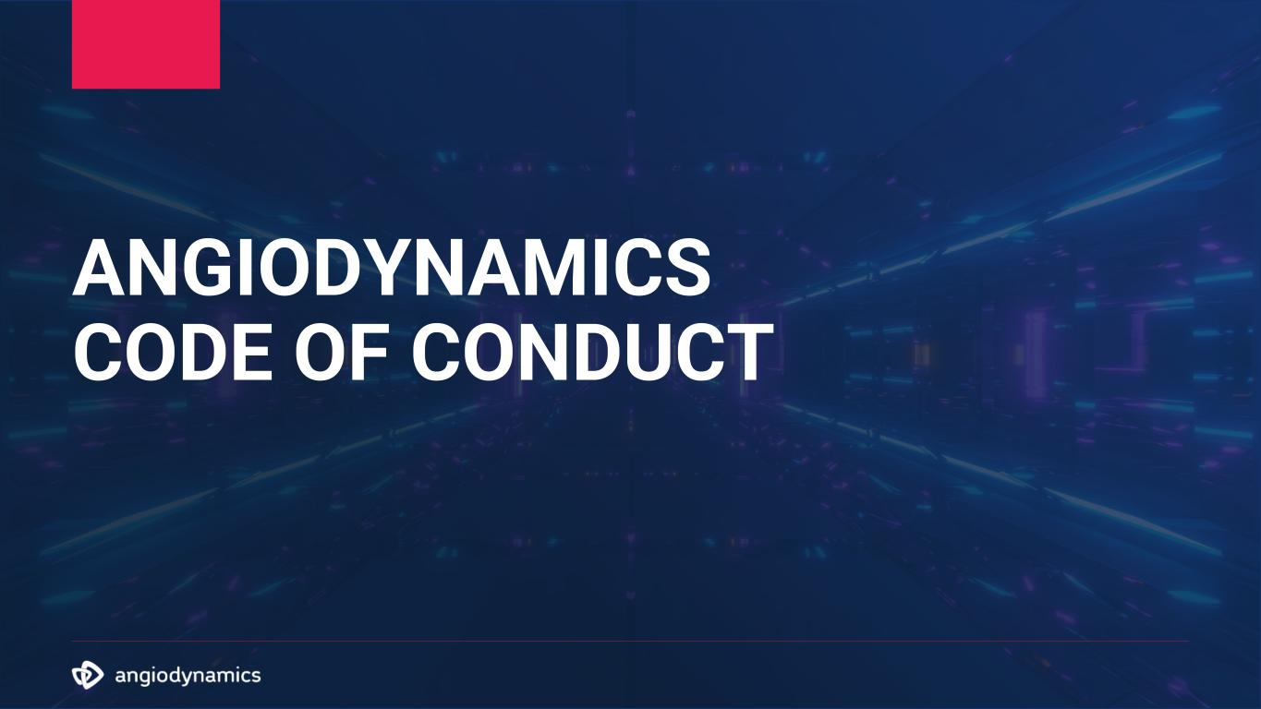
83
ANGIODYNAMICS CODE OF CONDUCT

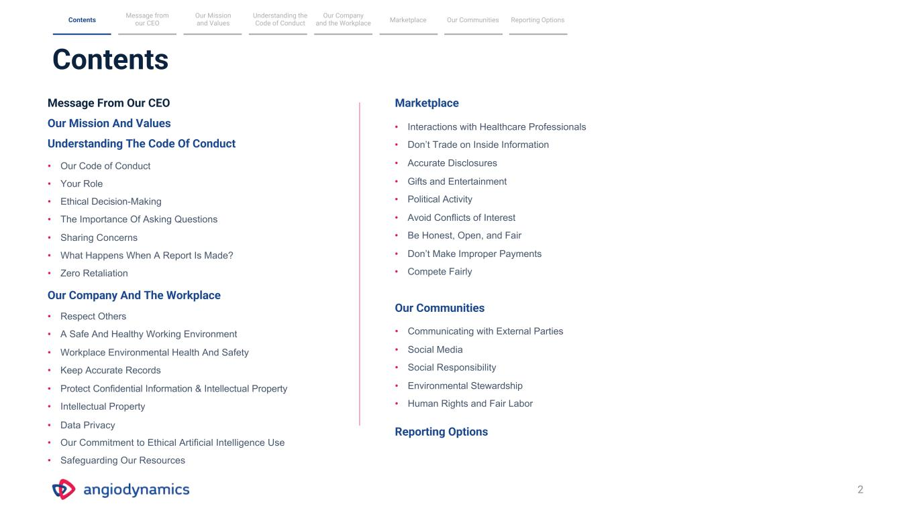
Contents 2 Message from our CEO Our Mission and Values Understanding the Code of Conduct MarketplaceContents Our Communities Reporting Options Message From Our CEO Our Mission And Values Understanding The Code Of Conduct • Our Code of Conduct • Your Role • Ethical Decision-Making • The Importance Of Asking Questions • Sharing Concerns • What Happens When A Report Is Made? • Zero Retaliation Our Company And The Workplace • Respect Others • A Safe And Healthy Working Environment • Workplace Environmental Health And Safety • Keep Accurate Records • Protect Confidential Information & Intellectual Property • Intellectual Property • Data Privacy • Our Commitment to Ethical Artificial Intelligence Use • Safeguarding Our Resources Marketplace • Interactions with Healthcare Professionals • Don’t Trade on Inside Information • Accurate Disclosures • Gifts and Entertainment • Political Activity • Avoid Conflicts of Interest • Be Honest, Open, and Fair • Don’t Make Improper Payments • Compete Fairly Our Communities • Communicating with External Parties • Social Media • Social Responsibility • Environmental Stewardship • Human Rights and Fair Labor Reporting Options Our Company and the Workplace

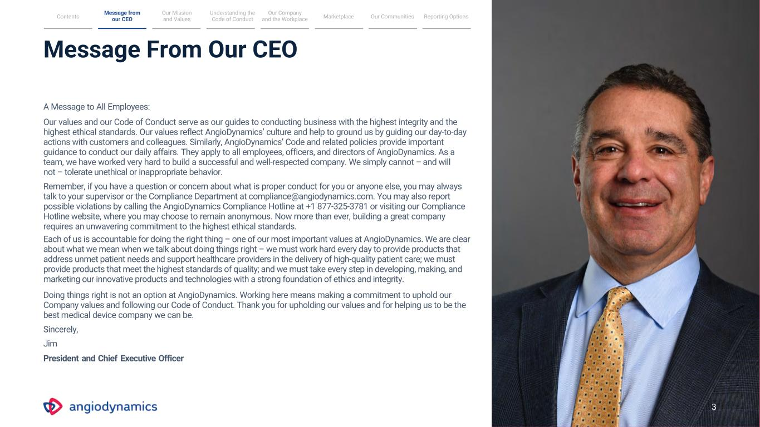
Message From Our CEO A Message to All Employees: Our values and our Code of Conduct serve as our guides to conducting business with the highest integrity and the highest ethical standards. Our values reflect AngioDynamics’ culture and help to ground us by guiding our day-to-day actions with customers and colleagues. Similarly, AngioDynamics’ Code and related policies provide important guidance to conduct our daily affairs. They apply to all employees, officers, and directors of AngioDynamics. As a team, we have worked very hard to build a successful and well-respected company. We simply cannot – and will not – tolerate unethical or inappropriate behavior. Remember, if you have a question or concern about what is proper conduct for you or anyone else, you may always talk to your supervisor or the Compliance Department at compliance@angiodynamics.com. You may also report possible violations by calling the AngioDynamics Compliance Hotline at +1 877-325-3781 or visiting our Compliance Hotline website, where you may choose to remain anonymous. Now more than ever, building a great company requires an unwavering commitment to the highest ethical standards. Each of us is accountable for doing the right thing – one of our most important values at AngioDynamics. We are clear about what we mean when we talk about doing things right – we must work hard every day to provide products that address unmet patient needs and support healthcare providers in the delivery of high-quality patient care; we must provide products that meet the highest standards of quality; and we must take every step in developing, making, and marketing our innovative products and technologies with a strong foundation of ethics and integrity. Doing things right is not an option at AngioDynamics. Working here means making a commitment to uphold our Company values and following our Code of Conduct. Thank you for upholding our values and for helping us to be the best medical device company we can be. Sincerely, Jim President and Chief Executive Officer Message from our CEO Our Mission and Values Understanding the Code of Conduct MarketplaceContents Our Communities Reporting Options Our Company and the Workplace 3

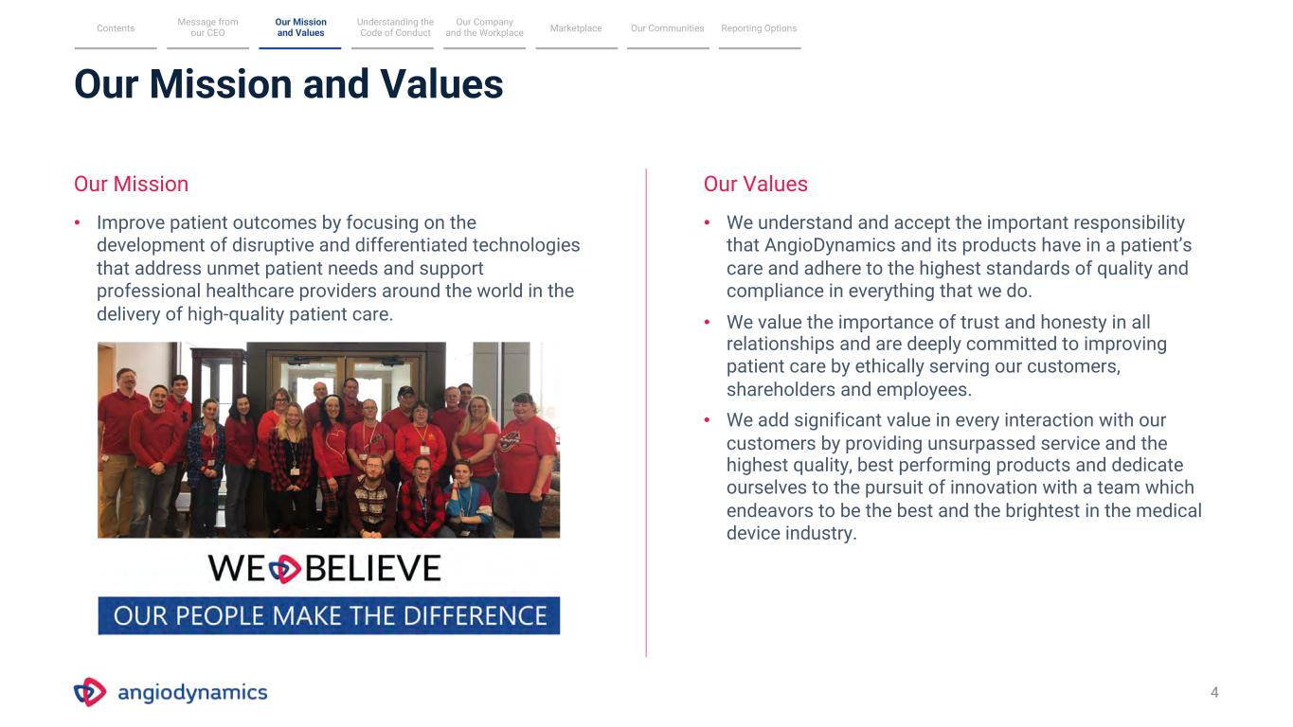
Our Mission and Values 4 Our Mission Our Values • Improve patient outcomes by focusing on the development of disruptive and differentiated technologies that address unmet patient needs and support professional healthcare providers around the world in the delivery of high-quality patient care. • We understand and accept the important responsibility that AngioDynamics and its products have in a patient’s care and adhere to the highest standards of quality and compliance in everything that we do. • We value the importance of trust and honesty in all relationships and are deeply committed to improving patient care by ethically serving our customers, shareholders and employees. • We add significant value in every interaction with our customers by providing unsurpassed service and the highest quality, best performing products and dedicate ourselves to the pursuit of innovation with a team which endeavors to be the best and the brightest in the medical device industry. Message from our CEO Our Mission and Values Understanding the Code of Conduct MarketplaceContents Our Communities Reporting Options Our Company and the Workplace

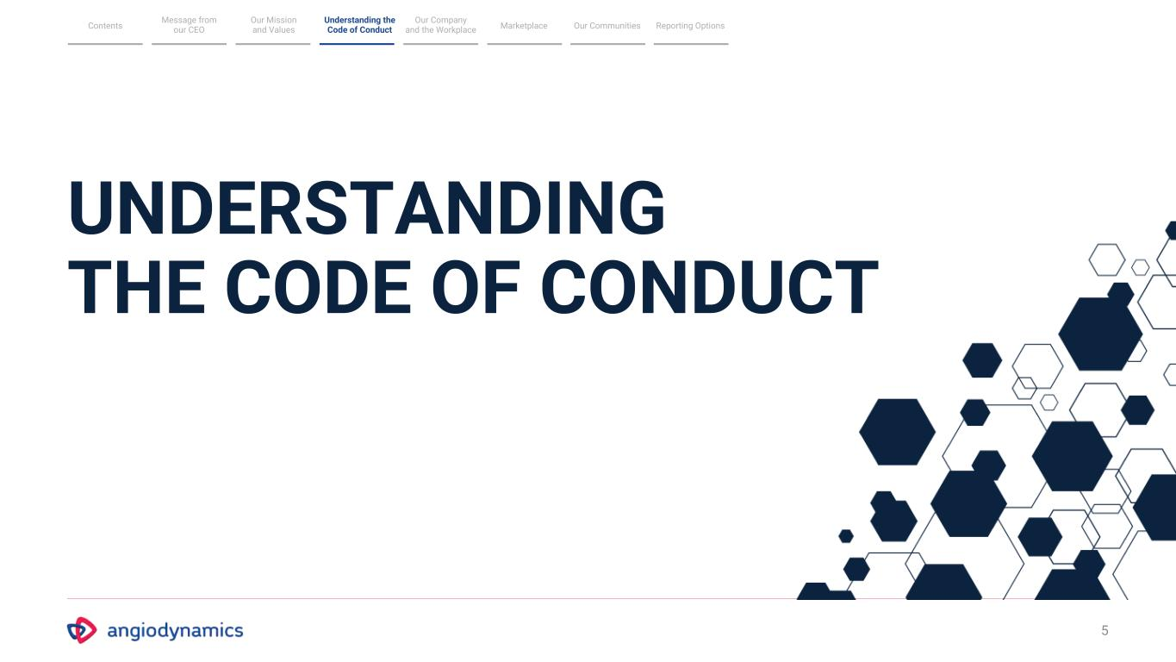
5 UNDERSTANDING THE CODE OF CONDUCT Message from our CEO Our Mission and Values Understanding the Code of Conduct MarketplaceContents Our Communities Reporting Options Our Company and the Workplace

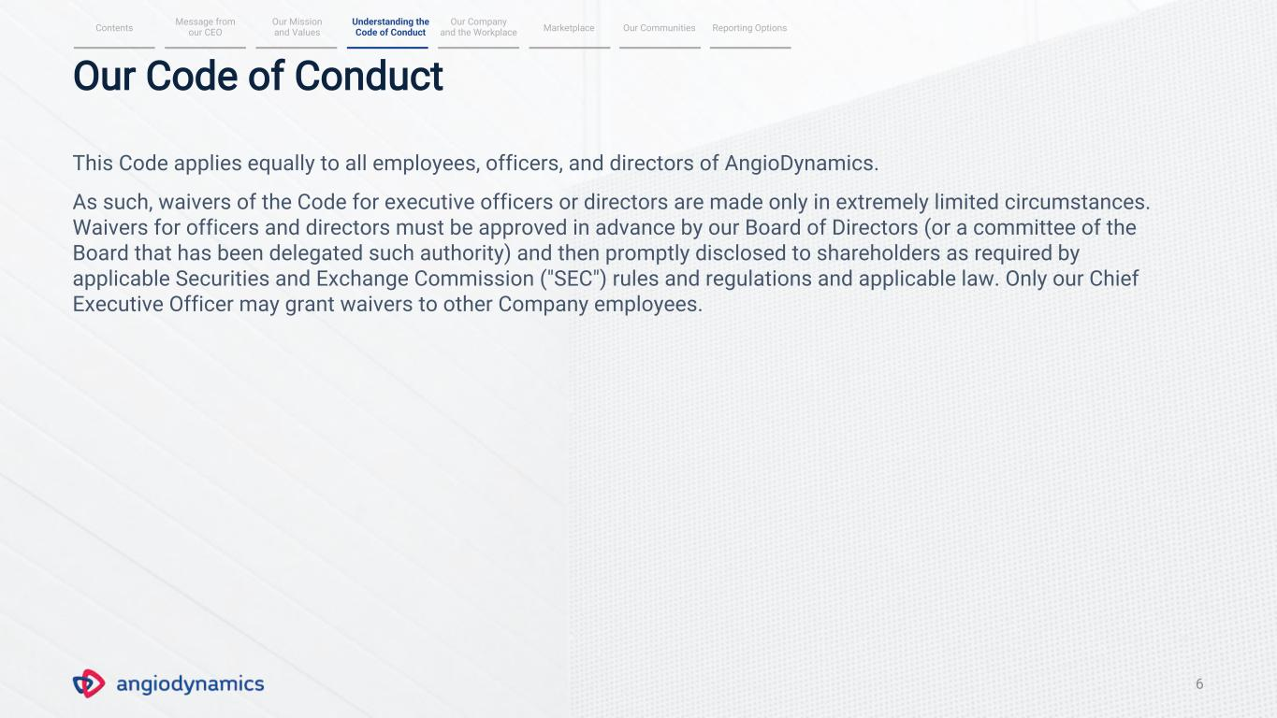
6 Our Code of Conduct This Code applies equally to all employees, officers, and directors of AngioDynamics. As such, waivers of the Code for executive officers or directors are made only in extremely limited circumstances. Waivers for officers and directors must be approved in advance by our Board of Directors (or a committee of the Board that has been delegated such authority) and then promptly disclosed to shareholders as required by applicable Securities and Exchange Commission ("SEC") rules and regulations and applicable law. Only our Chief Executive Officer may grant waivers to other Company employees. Message from our CEO Our Mission and Values MarketplaceContents Our Communities Reporting Options Our Company and the Workplace Understanding the Code of Conduct

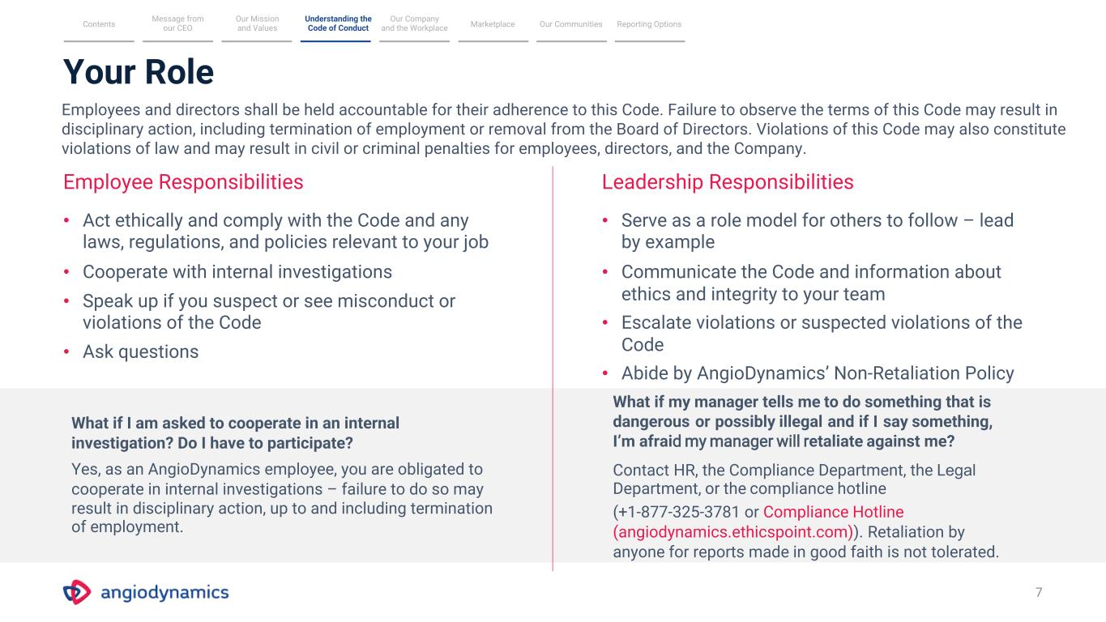
What if I am asked to cooperate in an internal investigation? Do I have to participate? Yes, as an AngioDynamics employee, you are obligated to cooperate in internal investigations – failure to do so may result in disciplinary action, up to and including termination of employment. Your Role 7 Employee Responsibilities Leadership Responsibilities • Act ethically and comply with the Code and any laws, regulations, and policies relevant to your job • Cooperate with internal investigations • Speak up if you suspect or see misconduct or violations of the Code • Ask questions • Serve as a role model for others to follow – lead by example • Communicate the Code and information about ethics and integrity to your team • Escalate violations or suspected violations of the Code • Abide by AngioDynamics’ Non-Retaliation Policy What if my manager tells me to do something that is dangerous or possibly illegal and if I say something, I’m afraid my manager will retaliate against me? Contact HR, the Compliance Department, the Legal Department, or the compliance hotline (+1-877-325-3781 or Compliance Hotline (angiodynamics.ethicspoint.com)). Retaliation by anyone for reports made in good faith is not tolerated. Message from our CEO Our Mission and Values MarketplaceContents Our Communities Reporting Options Our Company and the Workplace Understanding the Code of Conduct Employees and directors shall be held accountable for their adherence to this Code. Failure to observe the terms of this Code may result in disciplinary action, including termination of employment or removal from the Board of Directors. Violations of this Code may also constitute violations of law and may result in civil or criminal penalties for employees, directors, and the Company.

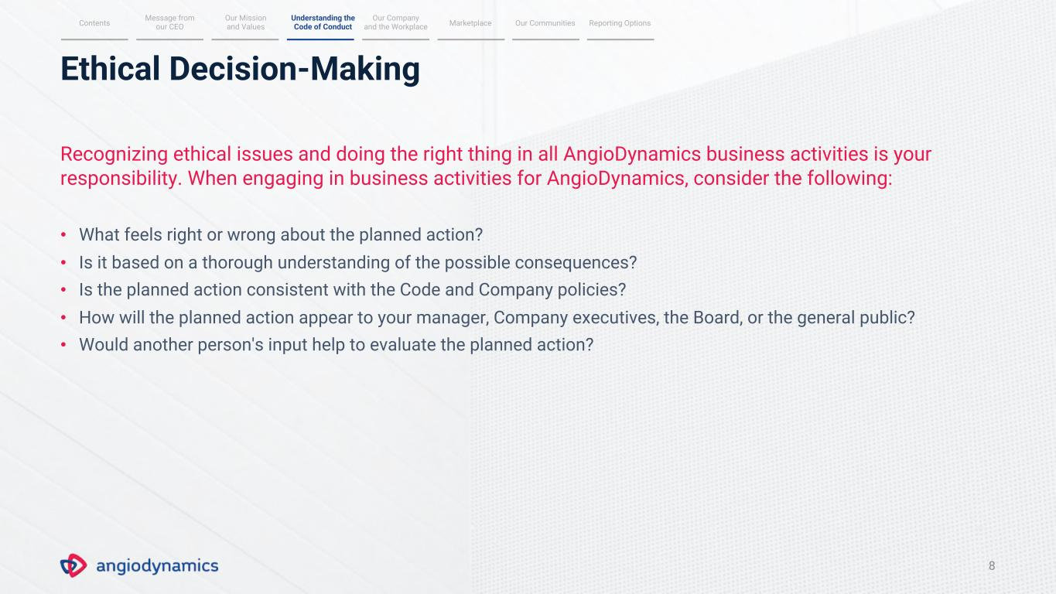
Ethical Decision-Making 8 Recognizing ethical issues and doing the right thing in all AngioDynamics business activities is your responsibility. When engaging in business activities for AngioDynamics, consider the following: • What feels right or wrong about the planned action? • Is it based on a thorough understanding of the possible consequences? • Is the planned action consistent with the Code and Company policies? • How will the planned action appear to your manager, Company executives, the Board, or the general public? • Would another person's input help to evaluate the planned action? Message from our CEO Our Mission and Values MarketplaceContents Our Communities Reporting Options Our Company and the Workplace Understanding the Code of Conduct

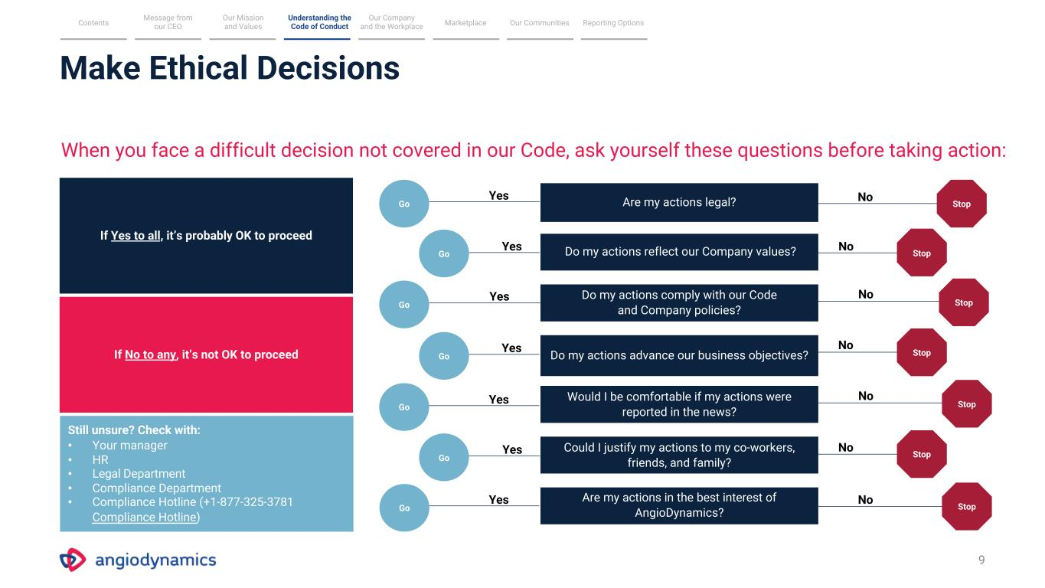
Make Ethical Decisions 9 When you face a difficult decision not covered in our Code, ask yourself these questions before taking action: If Yes to all, it’s probably OK to proceed If No to any, it’s not OK to proceed Still unsure? Check with: • Your manager • HR • Legal Department • Compliance Department • Compliance Hotline (+1-877-325-3781 Compliance Hotline) Are my actions legal? Do my actions reflect our Company values? Do my actions comply with our Code and Company policies? Do my actions advance our business objectives? Would I be comfortable if my actions were reported in the news? Could I justify my actions to my co-workers, friends, and family? Are my actions in the best interest of AngioDynamics? Stop Stop Stop Stop Stop Stop Stop NoYes No No No No No No Yes Yes Yes Yes Yes Yes Go Go Go Go Go Go Go Message from our CEO Our Mission and Values MarketplaceContents Our Communities Reporting Options Our Company and the Workplace Understanding the Code of Conduct


The Importance of Asking Questions We believe that acting with integrity means always being truthful, accountable, and doing the right thing. While this sounds simple enough, sometimes this can be difficult in practice. We work in a very complex environment where we may encounter situations with unclear or conflicting goals. Any time you have questions about whether an action is lawful or complies with our Code, seek advice. Depending on the circumstances, you may seek advice from a coworker, your manager or supervisor, an HR representative, or the Legal or Compliance Departments. Always ask questions when you are unsure of the right course of action. Message from our CEO Our Mission and Values MarketplaceContents Our Communities Reporting Options Our Company and the Workplace Understanding the Code of Conduct 10

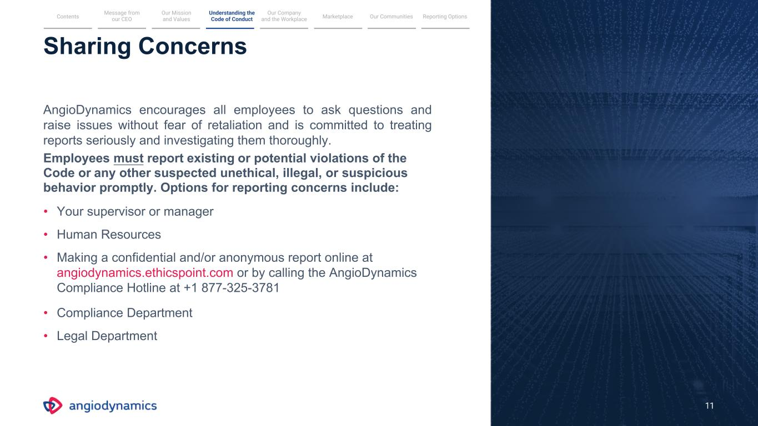
11 Sharing Concerns AngioDynamics encourages all employees to ask questions and raise issues without fear of retaliation and is committed to treating reports seriously and investigating them thoroughly. Employees must report existing or potential violations of the Code or any other suspected unethical, illegal, or suspicious behavior promptly. Options for reporting concerns include: • Your supervisor or manager • Human Resources • Making a confidential and/or anonymous report online at angiodynamics.ethicspoint.com or by calling the AngioDynamics Compliance Hotline at +1 877-325-3781 • Compliance Department • Legal Department Message from our CEO Our Mission and Values MarketplaceContents Our Communities Reporting Options Our Company and the Workplace Understanding the Code of Conduct

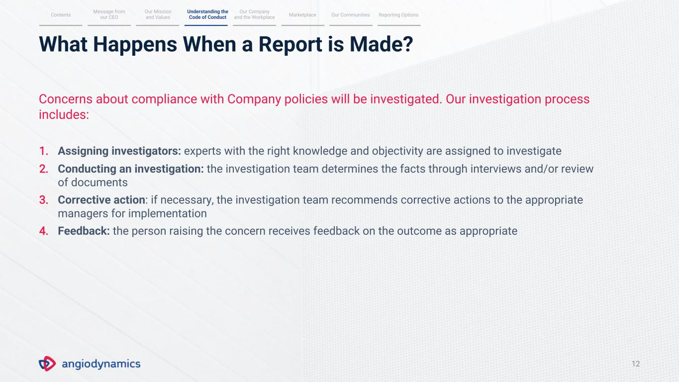
What Happens When a Report is Made? 12 Concerns about compliance with Company policies will be investigated. Our investigation process includes: 1. Assigning investigators: experts with the right knowledge and objectivity are assigned to investigate 2. Conducting an investigation: the investigation team determines the facts through interviews and/or review of documents 3. Corrective action: if necessary, the investigation team recommends corrective actions to the appropriate managers for implementation 4. Feedback: the person raising the concern receives feedback on the outcome as appropriate Message from our CEO Our Mission and Values MarketplaceContents Our Communities Reporting Options Our Company and the Workplace Understanding the Code of Conduct

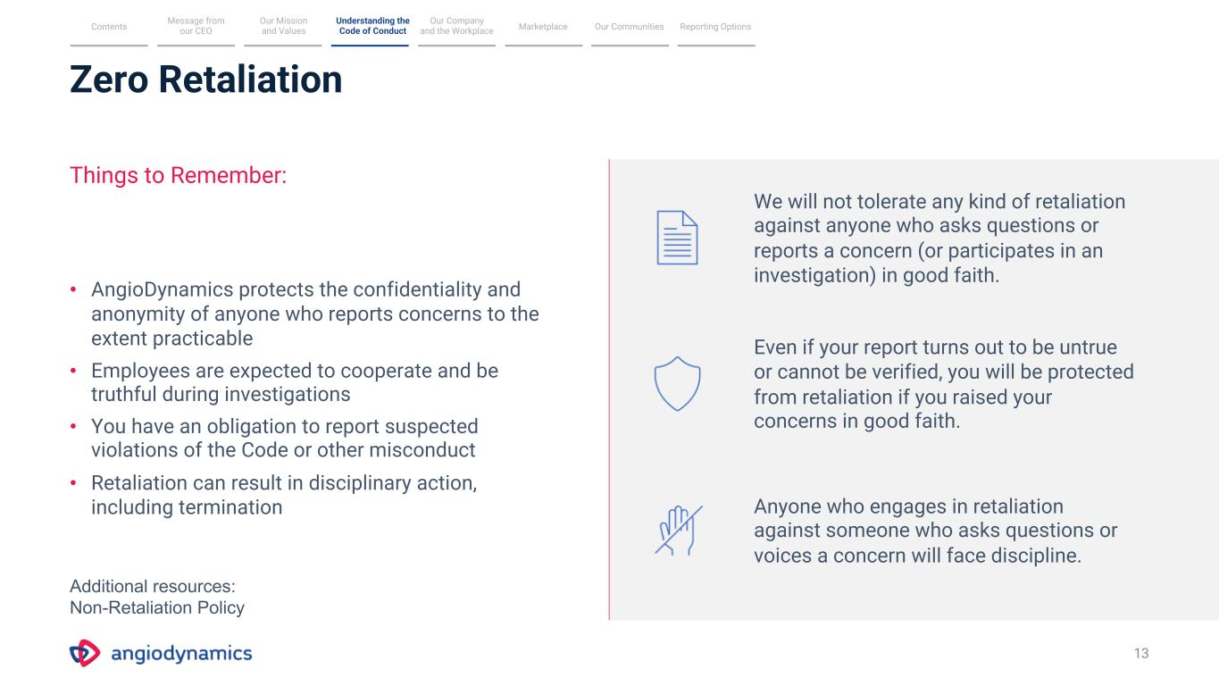
Zero Retaliation 13 Things to Remember: • AngioDynamics protects the confidentiality and anonymity of anyone who reports concerns to the extent practicable • Employees are expected to cooperate and be truthful during investigations • You have an obligation to report suspected violations of the Code or other misconduct • Retaliation can result in disciplinary action, including termination We will not tolerate any kind of retaliation against anyone who asks questions or reports a concern (or participates in an investigation) in good faith. Even if your report turns out to be untrue or cannot be verified, you will be protected from retaliation if you raised your concerns in good faith. Anyone who engages in retaliation against someone who asks questions or voices a concern will face discipline. Message from our CEO Our Mission and Values MarketplaceContents Our Communities Reporting Options Our Company and the Workplace Understanding the Code of Conduct Additional resources: Non-Retaliation Policy

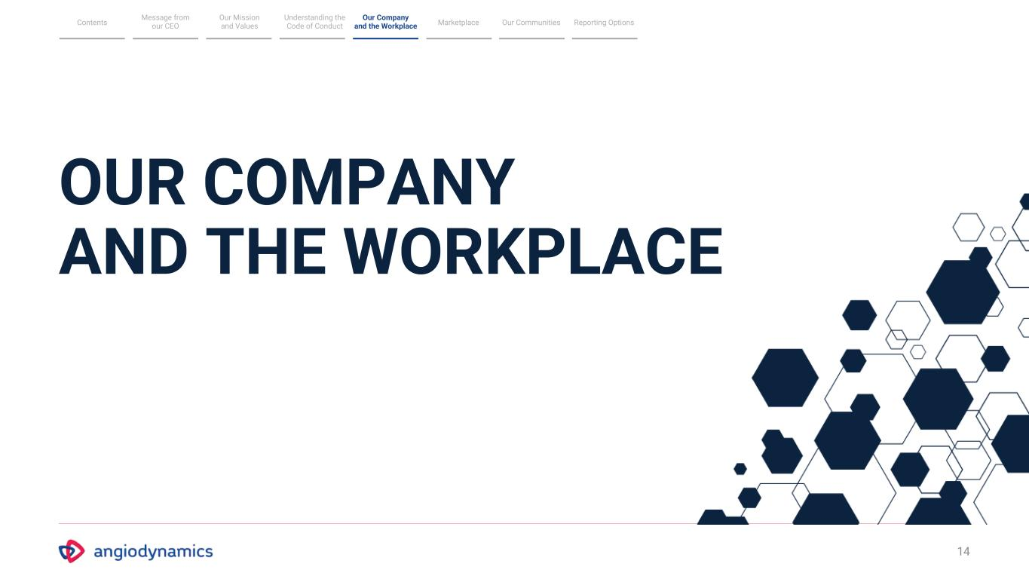
14 OUR COMPANY AND THE WORKPLACE Message from our CEO Our Mission and Values Understanding the Code of Conduct MarketplaceContents Our Communities Reporting Options Our Company and the Workplace

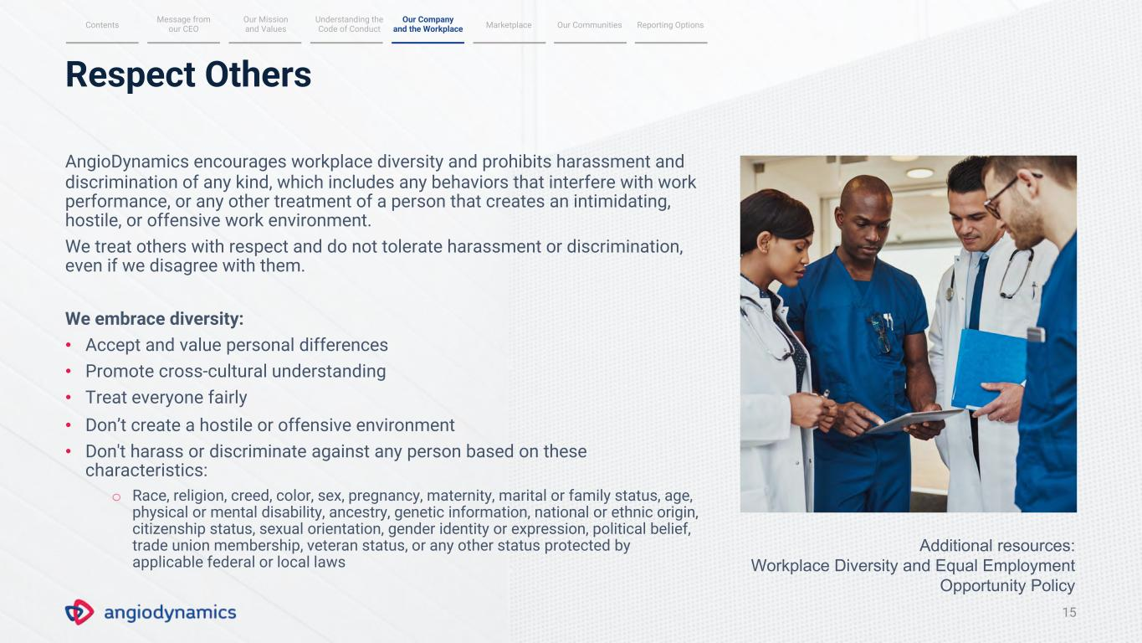
Respect Others 15 AngioDynamics encourages workplace diversity and prohibits harassment and discrimination of any kind, which includes any behaviors that interfere with work performance, or any other treatment of a person that creates an intimidating, hostile, or offensive work environment. We treat others with respect and do not tolerate harassment or discrimination, even if we disagree with them. We embrace diversity: • Accept and value personal differences • Promote cross-cultural understanding • Treat everyone fairly • Don’t create a hostile or offensive environment • Don't harass or discriminate against any person based on these characteristics: o Race, religion, creed, color, sex, pregnancy, maternity, marital or family status, age, physical or mental disability, ancestry, genetic information, national or ethnic origin, citizenship status, sexual orientation, gender identity or expression, political belief, trade union membership, veteran status, or any other status protected by applicable federal or local laws Message from our CEO Our Mission and Values Understanding the Code of Conduct MarketplaceContents Our Communities Reporting Options Our Company and the Workplace Additional resources: Workplace Diversity and Equal Employment Opportunity Policy

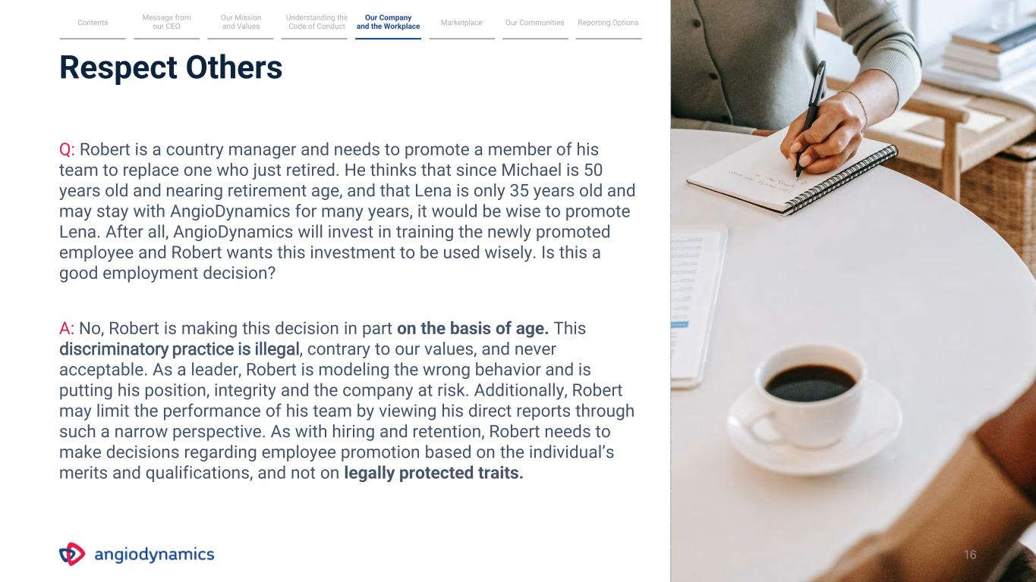
Respect Others Q: Robert is a country manager and needs to promote a member of his team to replace one who just retired. He thinks that since Michael is 50 years old and nearing retirement age, and that Lena is only 35 years old and may stay with AngioDynamics for many years, it would be wise to promote Lena. After all, AngioDynamics will invest in training the newly promoted employee and Robert wants this investment to be used wisely. Is this a good employment decision? A: No, Robert is making this decision in part on the basis of age. This discriminatory practice is illegal, contrary to our values, and never acceptable. As a leader, Robert is modeling the wrong behavior and is putting his position, integrity and the company at risk. Additionally, Robert may limit the performance of his team by viewing his direct reports through such a narrow perspective. As with hiring and retention, Robert needs to make decisions regarding employee promotion based on the individual’s merits and qualifications, and not on legally protected traits. Message from our CEO Our Mission and Values Understanding the Code of Conduct MarketplaceContents Our Communities Reporting Options Our Company and the Workplace 16

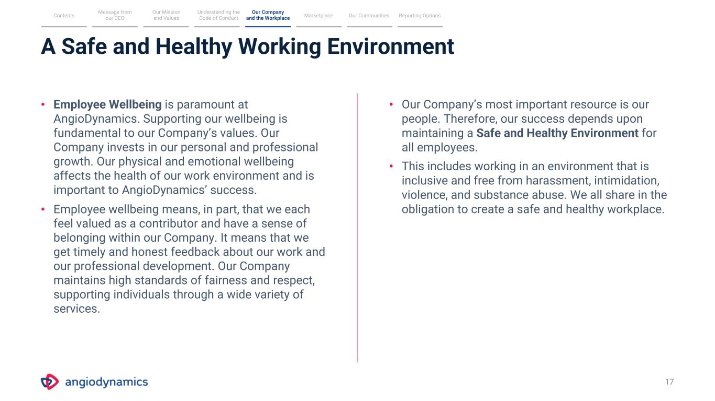
A Safe and Healthy Working Environment 17 • Employee Wellbeing is paramount at AngioDynamics. Supporting our wellbeing is fundamental to our Company’s values. Our Company invests in our personal and professional growth. Our physical and emotional wellbeing affects the health of our work environment and is important to AngioDynamics’ success. • Employee wellbeing means, in part, that we each feel valued as a contributor and have a sense of belonging within our Company. It means that we get timely and honest feedback about our work and our professional development. Our Company maintains high standards of fairness and respect, supporting individuals through a wide variety of services. • Our Company’s most important resource is our people. Therefore, our success depends upon maintaining a Safe and Healthy Environment for all employees. • This includes working in an environment that is inclusive and free from harassment, intimidation, violence, and substance abuse. We all share in the obligation to create a safe and healthy workplace. Message from our CEO Our Mission and Values Understanding the Code of Conduct MarketplaceContents Our Communities Reporting Options Our Company and the Workplace

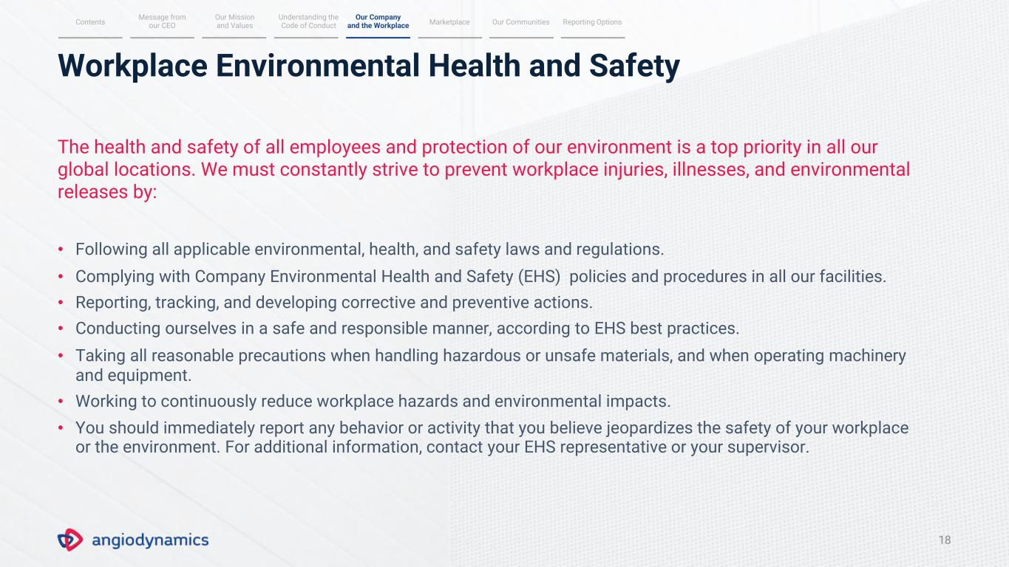
18 Workplace Environmental Health and Safety The health and safety of all employees and protection of our environment is a top priority in all our global locations. We must constantly strive to prevent workplace injuries, illnesses, and environmental releases by: • Following all applicable environmental, health, and safety laws and regulations. • Complying with Company Environmental Health and Safety (EHS) policies and procedures in all our facilities. • Reporting, tracking, and developing corrective and preventive actions. • Conducting ourselves in a safe and responsible manner, according to EHS best practices. • Taking all reasonable precautions when handling hazardous or unsafe materials, and when operating machinery and equipment. • Working to continuously reduce workplace hazards and environmental impacts. • You should immediately report any behavior or activity that you believe jeopardizes the safety of your workplace or the environment. For additional information, contact your EHS representative or your supervisor. Message from our CEO Our Mission and Values Understanding the Code of Conduct MarketplaceContents Our Communities Reporting Options Our Company and the Workplace

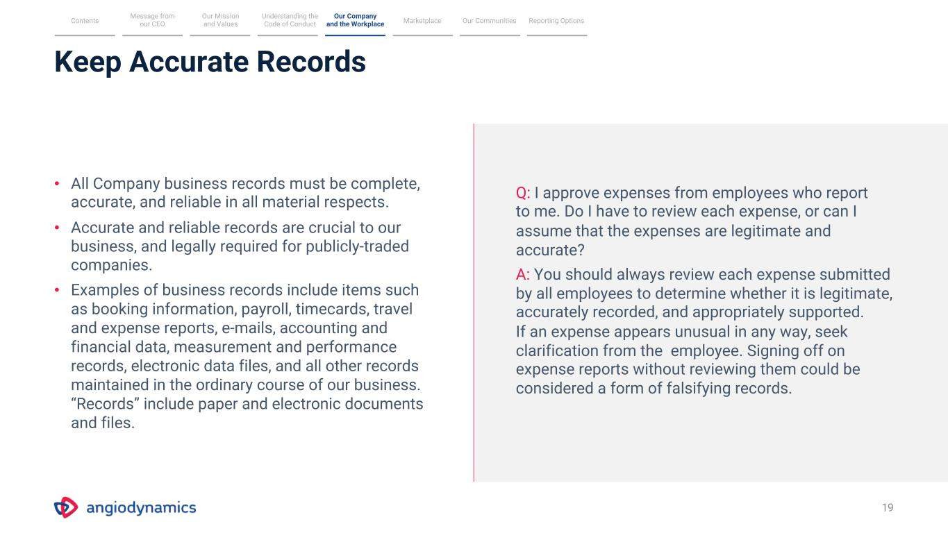
Keep Accurate Records 19 • All Company business records must be complete, accurate, and reliable in all material respects. • Accurate and reliable records are crucial to our business, and legally required for publicly-traded companies. • Examples of business records include items such as booking information, payroll, timecards, travel and expense reports, e-mails, accounting and financial data, measurement and performance records, electronic data files, and all other records maintained in the ordinary course of our business. “Records” include paper and electronic documents and files. Q: I approve expenses from employees who report to me. Do I have to review each expense, or can I assume that the expenses are legitimate and accurate? A: You should always review each expense submitted by all employees to determine whether it is legitimate, accurately recorded, and appropriately supported. If an expense appears unusual in any way, seek clarification from the employee. Signing off on expense reports without reviewing them could be considered a form of falsifying records. Message from our CEO Our Mission and Values Understanding the Code of Conduct MarketplaceContents Our Communities Reporting Options Our Company and the Workplace

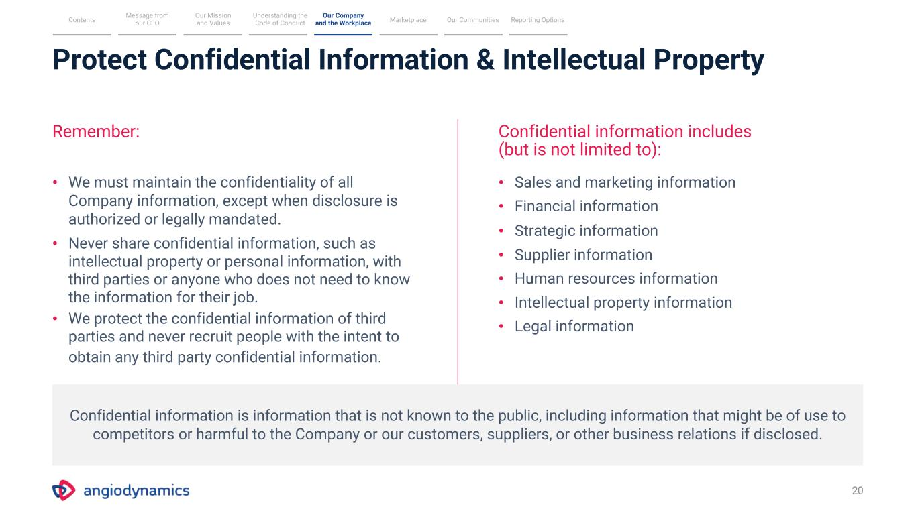
Protect Confidential Information & Intellectual Property 20 Remember: Confidential information includes (but is not limited to): • We must maintain the confidentiality of all Company information, except when disclosure is authorized or legally mandated. • Never share confidential information, such as intellectual property or personal information, with third parties or anyone who does not need to know the information for their job. • We protect the confidential information of third parties and never recruit people with the intent to obtain any third party confidential information. • Sales and marketing information • Financial information • Strategic information • Supplier information • Human resources information • Intellectual property information • Legal information Confidential information is information that is not known to the public, including information that might be of use to competitors or harmful to the Company or our customers, suppliers, or other business relations if disclosed. Message from our CEO Our Mission and Values Understanding the Code of Conduct MarketplaceContents Our Communities Reporting Options Our Company and the Workplace

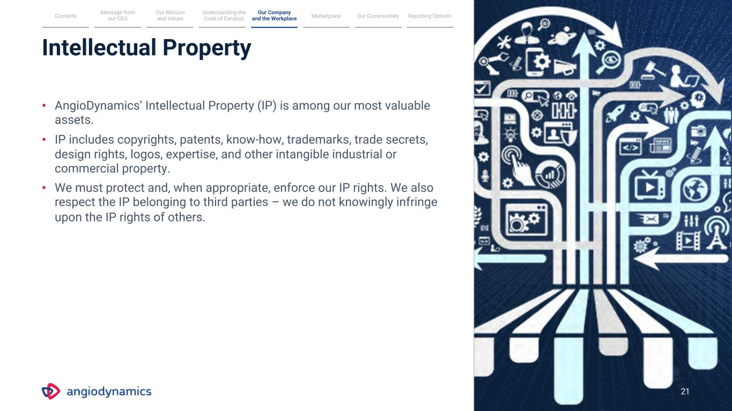
Intellectual Property 21 • AngioDynamics’ Intellectual Property (IP) is among our most valuable assets. • IP includes copyrights, patents, know-how, trademarks, trade secrets, design rights, logos, expertise, and other intangible industrial or commercial property. • We must protect and, when appropriate, enforce our IP rights. We also respect the IP belonging to third parties – we do not knowingly infringe upon the IP rights of others. Message from our CEO Our Mission and Values Understanding the Code of Conduct MarketplaceContents Our Communities Reporting Options Our Company and the Workplace

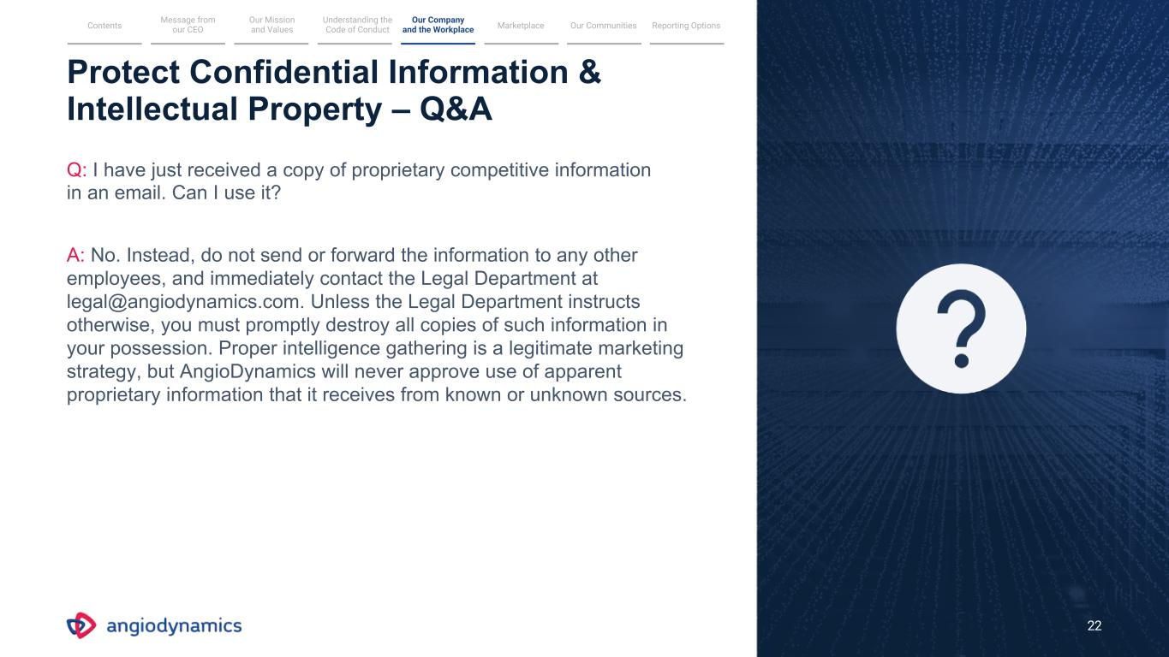
Protect Confidential Information & Intellectual Property – Q&A Q: I have just received a copy of proprietary competitive information in an email. Can I use it? A: No. Instead, do not send or forward the information to any other employees, and immediately contact the Legal Department at legal@angiodynamics.com. Unless the Legal Department instructs otherwise, you must promptly destroy all copies of such information in your possession. Proper intelligence gathering is a legitimate marketing strategy, but AngioDynamics will never approve use of apparent proprietary information that it receives from known or unknown sources. 22 Message from our CEO Our Mission and Values Understanding the Code of Conduct MarketplaceContents Our Communities Reporting Options Our Company and the Workplace

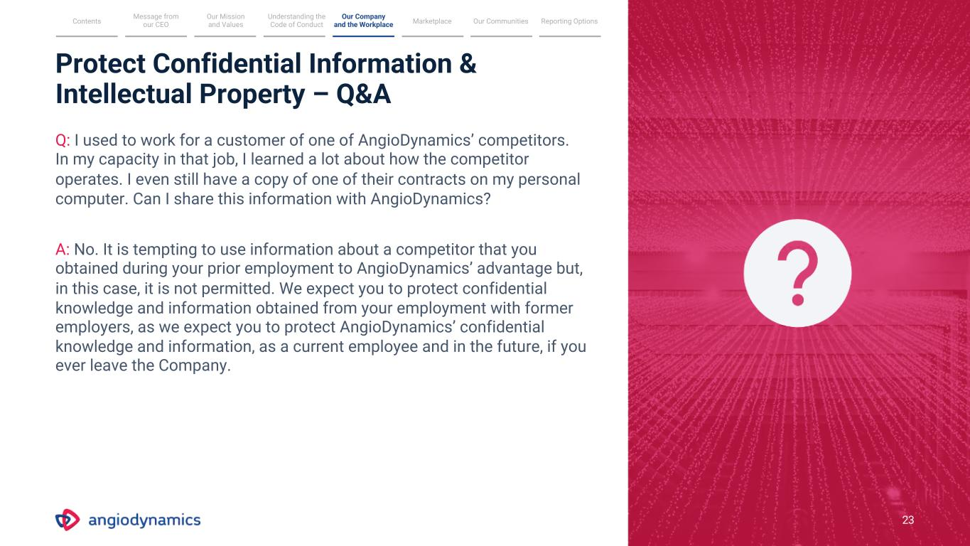
23 Q: I used to work for a customer of one of AngioDynamics’ competitors. In my capacity in that job, I learned a lot about how the competitor operates. I even still have a copy of one of their contracts on my personal computer. Can I share this information with AngioDynamics? A: No. It is tempting to use information about a competitor that you obtained during your prior employment to AngioDynamics’ advantage but, in this case, it is not permitted. We expect you to protect confidential knowledge and information obtained from your employment with former employers, as we expect you to protect AngioDynamics’ confidential knowledge and information, as a current employee and in the future, if you ever leave the Company. Protect Confidential Information & Intellectual Property – Q&A Message from our CEO Our Mission and Values Understanding the Code of Conduct MarketplaceContents Our Communities Reporting Options Our Company and the Workplace

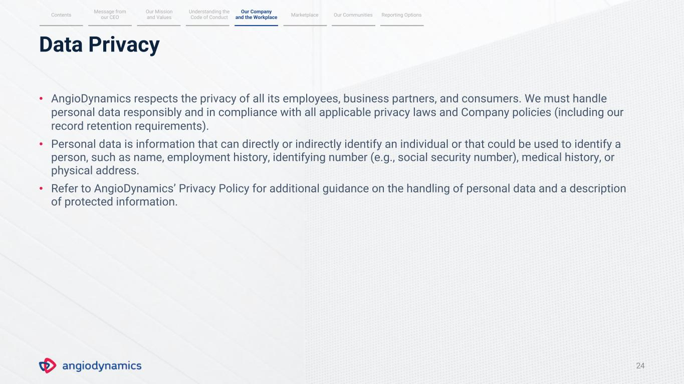
Data Privacy 24 • AngioDynamics respects the privacy of all its employees, business partners, and consumers. We must handle personal data responsibly and in compliance with all applicable privacy laws and Company policies (including our record retention requirements). • Personal data is information that can directly or indirectly identify an individual or that could be used to identify a person, such as name, employment history, identifying number (e.g., social security number), medical history, or physical address. • Refer to AngioDynamics’ Privacy Policy for additional guidance on the handling of personal data and a description of protected information. Message from our CEO Our Mission and Values Understanding the Code of Conduct MarketplaceContents Our Communities Reporting Options Our Company and the Workplace

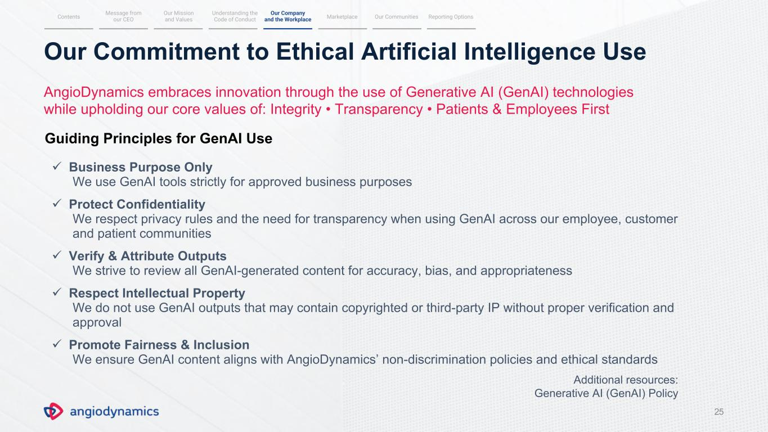
25 ✓ Business Purpose Only We use GenAI tools strictly for approved business purposes ✓ Protect Confidentiality We respect privacy rules and the need for transparency when using GenAI across our employee, customer and patient communities ✓ Verify & Attribute Outputs We strive to review all GenAI-generated content for accuracy, bias, and appropriateness ✓ Respect Intellectual Property We do not use GenAI outputs that may contain copyrighted or third-party IP without proper verification and approval ✓ Promote Fairness & Inclusion We ensure GenAI content aligns with AngioDynamics’ non-discrimination policies and ethical standards Message from our CEO Our Mission and Values Understanding the Code of Conduct MarketplaceContents Our Communities Reporting Options Our Company and the Workplace Our Commitment to Ethical Artificial Intelligence Use AngioDynamics embraces innovation through the use of Generative AI (GenAI) technologies while upholding our core values of: Integrity • Transparency • Patients & Employees First Guiding Principles for GenAI Use Additional resources: Generative AI (GenAI) Policy

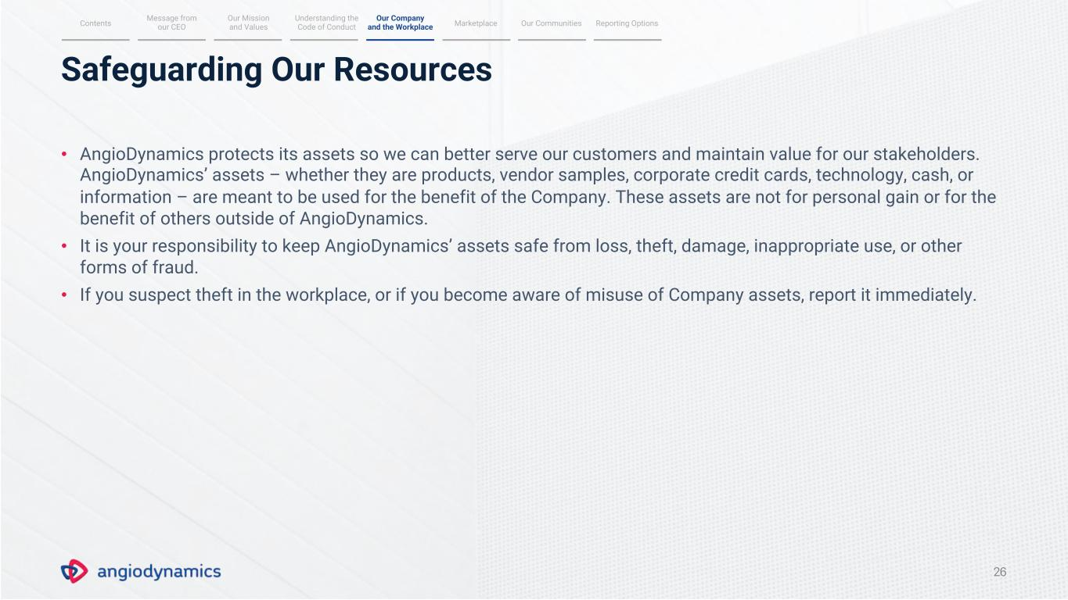
Safeguarding Our Resources 26 • AngioDynamics protects its assets so we can better serve our customers and maintain value for our stakeholders. AngioDynamics’ assets – whether they are products, vendor samples, corporate credit cards, technology, cash, or information – are meant to be used for the benefit of the Company. These assets are not for personal gain or for the benefit of others outside of AngioDynamics. • It is your responsibility to keep AngioDynamics’ assets safe from loss, theft, damage, inappropriate use, or other forms of fraud. • If you suspect theft in the workplace, or if you become aware of misuse of Company assets, report it immediately. Message from our CEO Our Mission and Values Understanding the Code of Conduct MarketplaceContents Our Communities Reporting Options Our Company and the Workplace

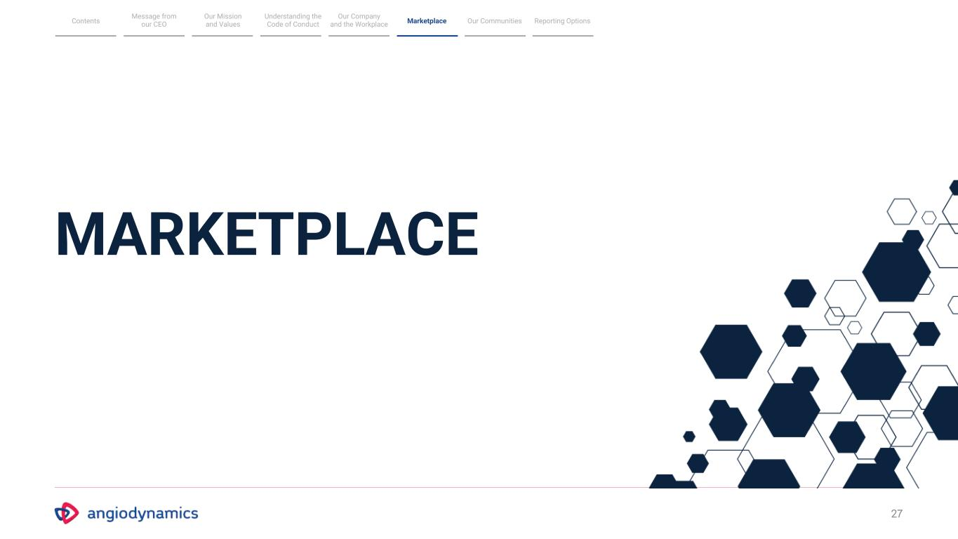
27 MARKETPLACE Message from our CEO Our Mission and Values Understanding the Code of Conduct MarketplaceContents Our Communities Reporting Options Our Company and the Workplace

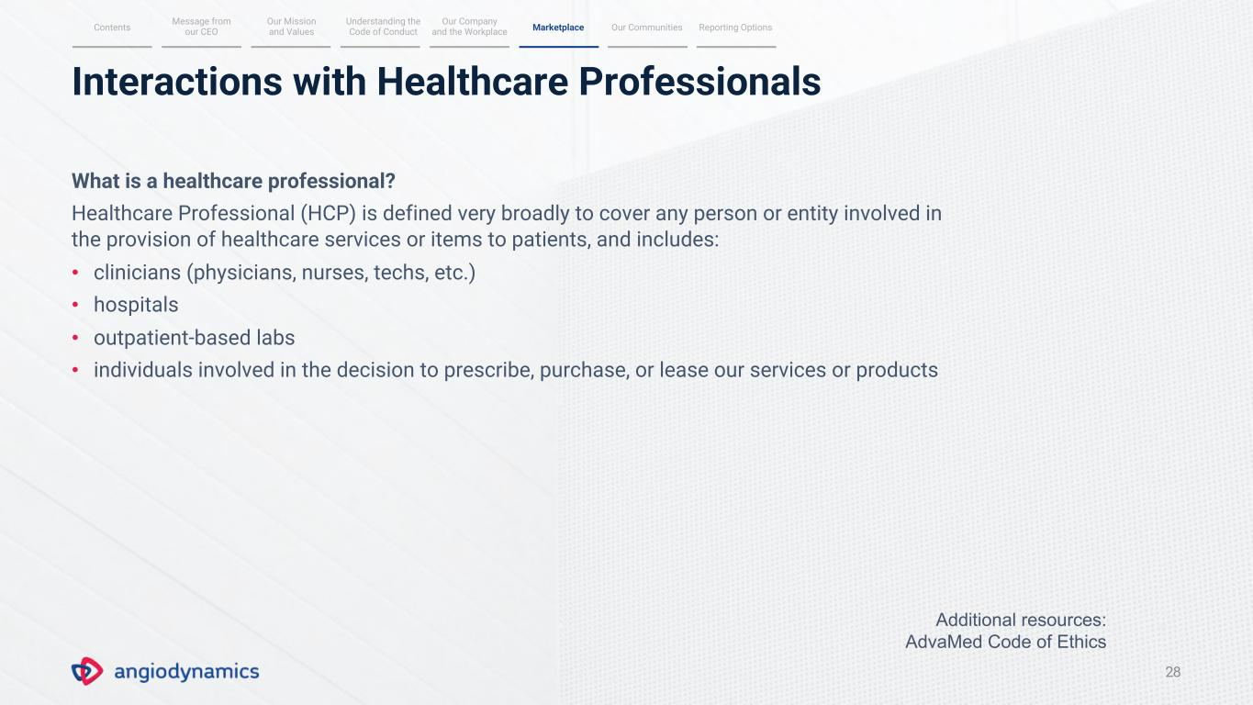
Interactions with Healthcare Professionals 28 What is a healthcare professional? Healthcare Professional (HCP) is defined very broadly to cover any person or entity involved in the provision of healthcare services or items to patients, and includes: • clinicians (physicians, nurses, techs, etc.) • hospitals • outpatient-based labs • individuals involved in the decision to prescribe, purchase, or lease our services or products Message from our CEO Our Mission and Values Understanding the Code of ConductContents Our Communities Reporting Options Our Company and the Workplace Marketplace Additional resources: AdvaMed Code of Ethics

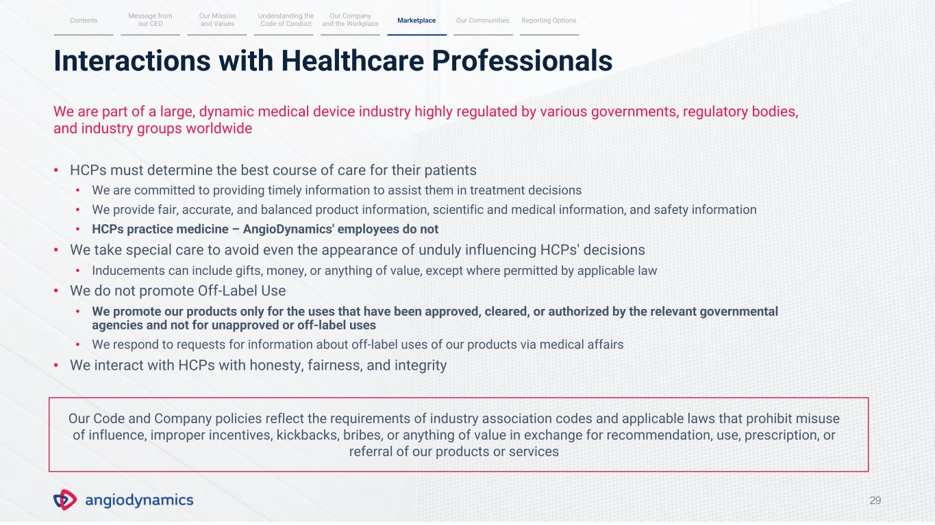
Interactions with Healthcare Professionals 29 We are part of a large, dynamic medical device industry highly regulated by various governments, regulatory bodies, and industry groups worldwide • HCPs must determine the best course of care for their patients • We are committed to providing timely information to assist them in treatment decisions • We provide fair, accurate, and balanced product information, scientific and medical information, and safety information • HCPs practice medicine – AngioDynamics' employees do not • We take special care to avoid even the appearance of unduly influencing HCPs' decisions • Inducements can include gifts, money, or anything of value, except where permitted by applicable law • We do not promote Off-Label Use • We promote our products only for the uses that have been approved, cleared, or authorized by the relevant governmental agencies and not for unapproved or off-label uses • We respond to requests for information about off-label uses of our products via medical affairs • We interact with HCPs with honesty, fairness, and integrity Our Code and Company policies reflect the requirements of industry association codes and applicable laws that prohibit misuse of influence, improper incentives, kickbacks, bribes, or anything of value in exchange for recommendation, use, prescription, or referral of our products or services Message from our CEO Our Mission and Values Understanding the Code of ConductContents Our Communities Reporting Options Our Company and the Workplace Marketplace

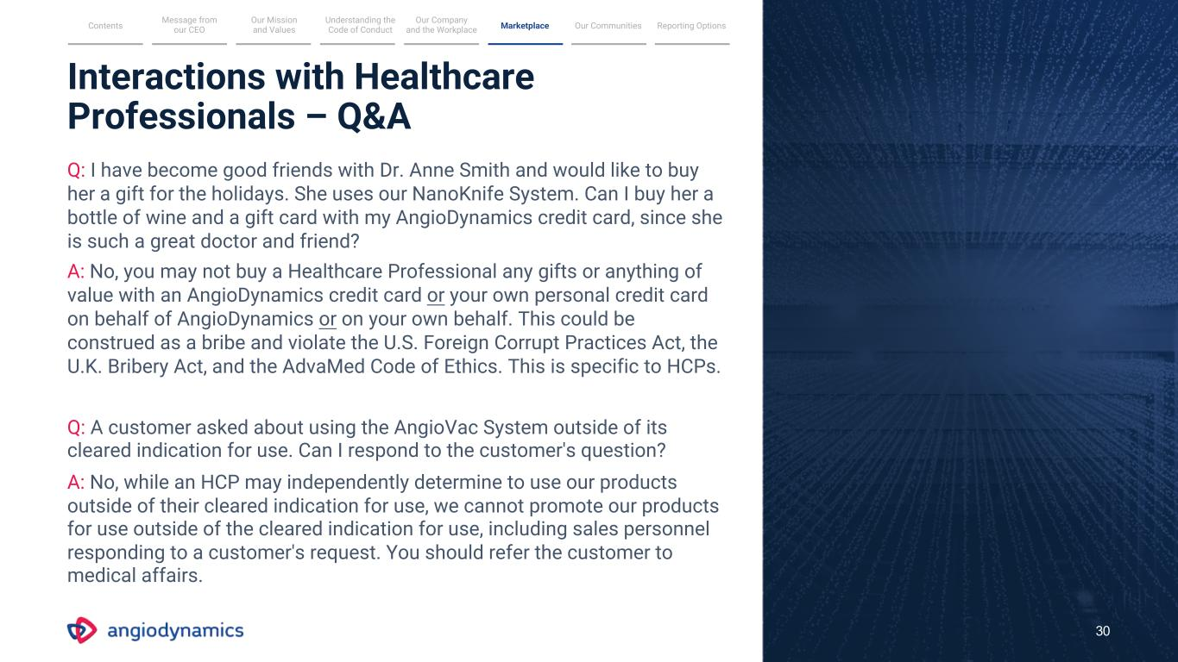
Q: A customer asked about using the AngioVac System outside of its cleared indication for use. Can I respond to the customer's question? A: No, while an HCP may independently determine to use our products outside of their cleared indication for use, we cannot promote our products for use outside of the cleared indication for use, including sales personnel responding to a customer's request. You should refer the customer to medical affairs. Interactions with Healthcare Professionals – Q&A Q: I have become good friends with Dr. Anne Smith and would like to buy her a gift for the holidays. She uses our NanoKnife System. Can I buy her a bottle of wine and a gift card with my AngioDynamics credit card, since she is such a great doctor and friend? A: No, you may not buy a Healthcare Professional any gifts or anything of value with an AngioDynamics credit card or your own personal credit card on behalf of AngioDynamics or on your own behalf. This could be construed as a bribe and violate the U.S. Foreign Corrupt Practices Act, the U.K. Bribery Act, and the AdvaMed Code of Ethics. This is specific to HCPs. 30 Message from our CEO Our Mission and Values Understanding the Code of ConductContents Our Communities Reporting Options Our Company and the Workplace Marketplace

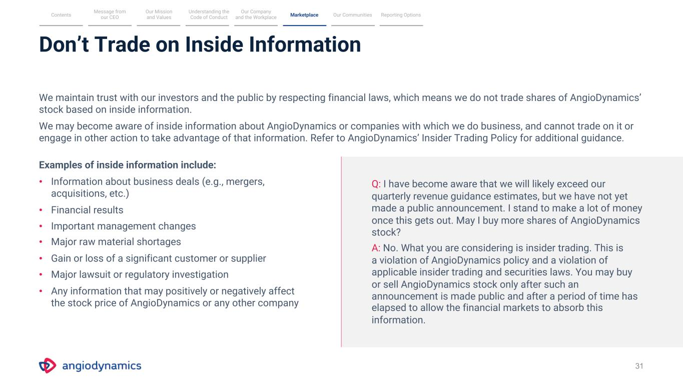
Don’t Trade on Inside Information 31 We maintain trust with our investors and the public by respecting financial laws, which means we do not trade shares of AngioDynamics’ stock based on inside information. We may become aware of inside information about AngioDynamics or companies with which we do business, and cannot trade on it or engage in other action to take advantage of that information. Refer to AngioDynamics’ Insider Trading Policy for additional guidance. Examples of inside information include: • Information about business deals (e.g., mergers, acquisitions, etc.) • Financial results • Important management changes • Major raw material shortages • Gain or loss of a significant customer or supplier • Major lawsuit or regulatory investigation • Any information that may positively or negatively affect the stock price of AngioDynamics or any other company Q: I have become aware that we will likely exceed our quarterly revenue guidance estimates, but we have not yet made a public announcement. I stand to make a lot of money once this gets out. May I buy more shares of AngioDynamics stock? A: No. What you are considering is insider trading. This is a violation of AngioDynamics policy and a violation of applicable insider trading and securities laws. You may buy or sell AngioDynamics stock only after such an announcement is made public and after a period of time has elapsed to allow the financial markets to absorb this information. Message from our CEO Our Mission and Values Understanding the Code of ConductContents Our Communities Reporting Options Our Company and the Workplace Marketplace

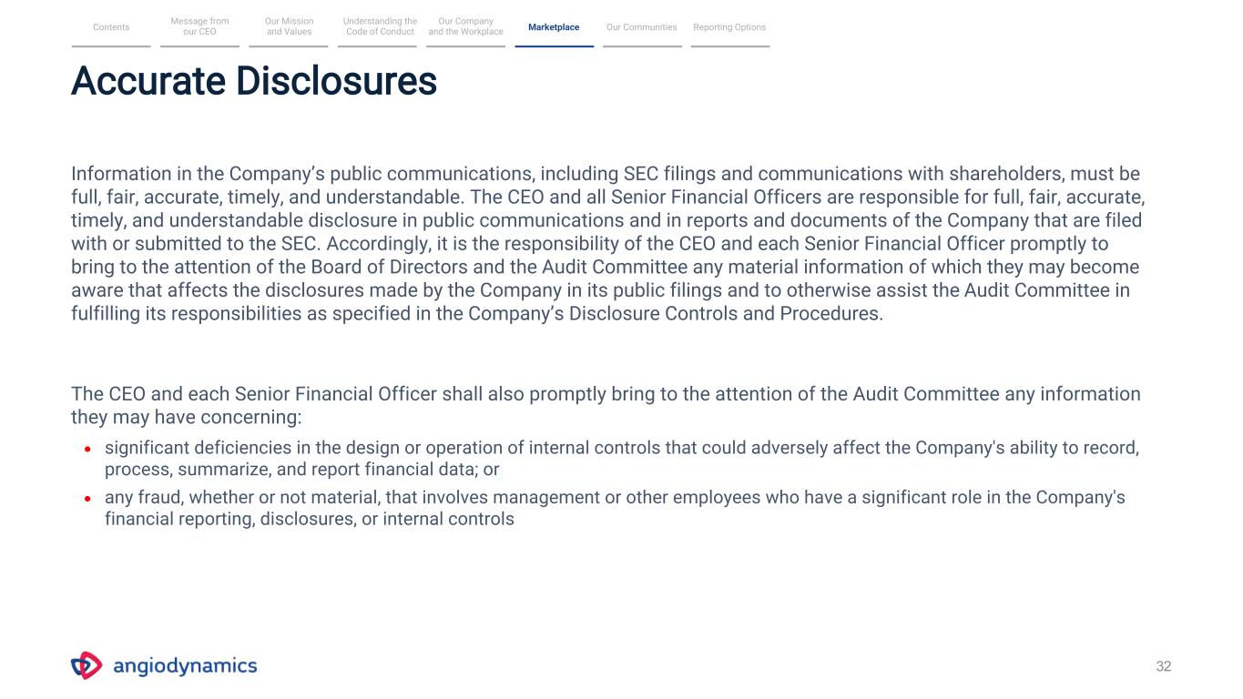
32 • significant deficiencies in the design or operation of internal controls that could adversely affect the Company's ability to record, process, summarize, and report financial data; or • any fraud, whether or not material, that involves management or other employees who have a significant role in the Company's financial reporting, disclosures, or internal controls Message from our CEO Our Mission and Values Understanding the Code of ConductContents Our Communities Reporting Options Our Company and the Workplace Marketplace Accurate Disclosures Information in the Company’s public communications, including SEC filings and communications with shareholders, must be full, fair, accurate, timely, and understandable. The CEO and all Senior Financial Officers are responsible for full, fair, accurate, timely, and understandable disclosure in public communications and in reports and documents of the Company that are filed with or submitted to the SEC. Accordingly, it is the responsibility of the CEO and each Senior Financial Officer promptly to bring to the attention of the Board of Directors and the Audit Committee any material information of which they may become aware that affects the disclosures made by the Company in its public filings and to otherwise assist the Audit Committee in fulfilling its responsibilities as specified in the Company’s Disclosure Controls and Procedures. The CEO and each Senior Financial Officer shall also promptly bring to the attention of the Audit Committee any information they may have concerning:

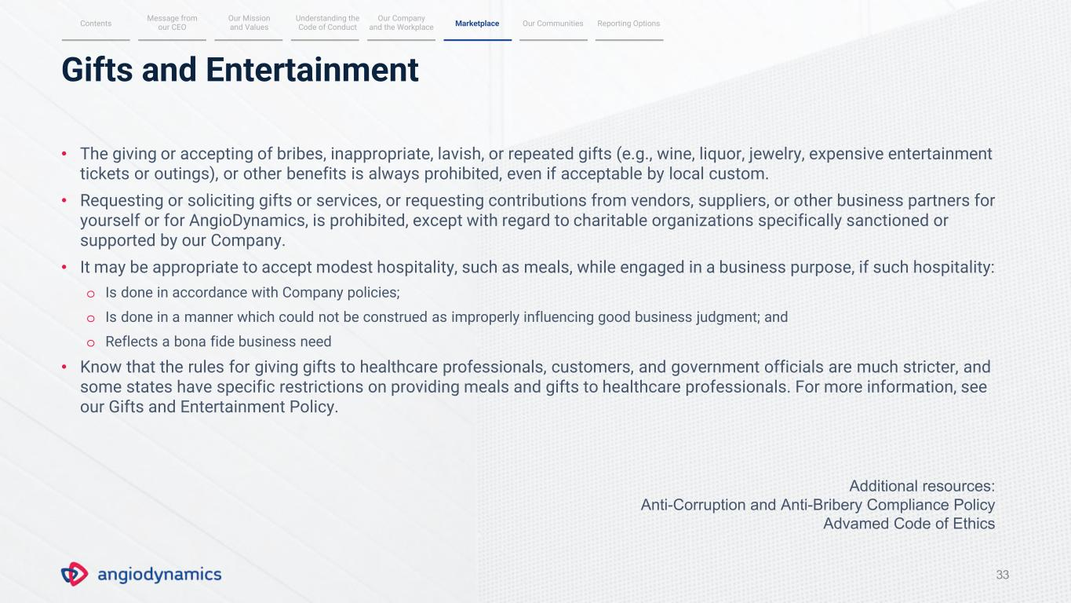
Gifts and Entertainment 33 • The giving or accepting of bribes, inappropriate, lavish, or repeated gifts (e.g., wine, liquor, jewelry, expensive entertainment tickets or outings), or other benefits is always prohibited, even if acceptable by local custom. • Requesting or soliciting gifts or services, or requesting contributions from vendors, suppliers, or other business partners for yourself or for AngioDynamics, is prohibited, except with regard to charitable organizations specifically sanctioned or supported by our Company. • It may be appropriate to accept modest hospitality, such as meals, while engaged in a business purpose, if such hospitality: o Is done in accordance with Company policies; o Is done in a manner which could not be construed as improperly influencing good business judgment; and o Reflects a bona fide business need • Know that the rules for giving gifts to healthcare professionals, customers, and government officials are much stricter, and some states have specific restrictions on providing meals and gifts to healthcare professionals. For more information, see our Gifts and Entertainment Policy. Message from our CEO Our Mission and Values Understanding the Code of ConductContents Our Communities Reporting Options Our Company and the Workplace Marketplace Additional resources: Anti-Corruption and Anti-Bribery Compliance Policy Advamed Code of Ethics

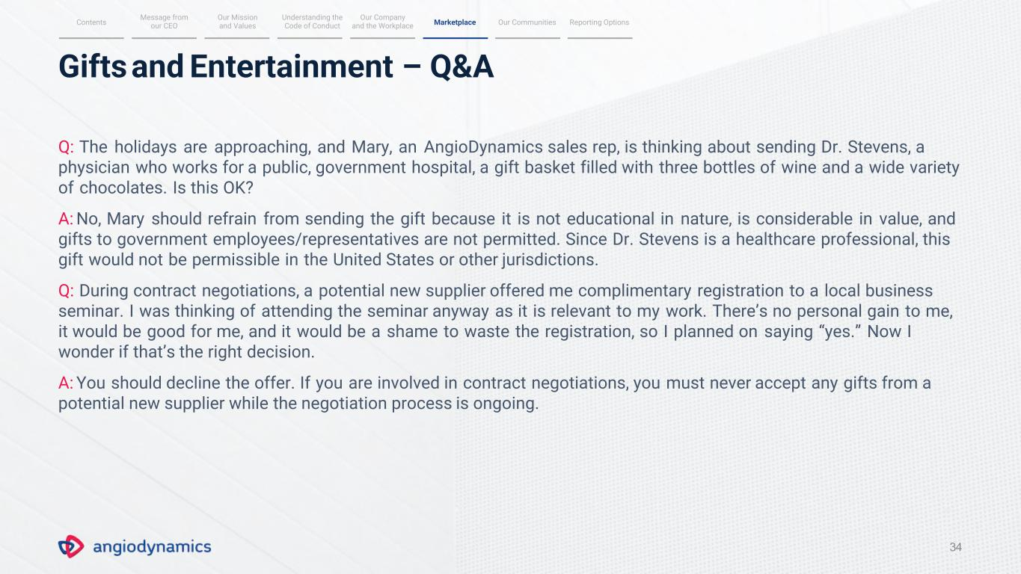
34 Gifts and Entertainment – Q&A Q: The holidays are approaching, and Mary, an AngioDynamics sales rep, is thinking about sending Dr. Stevens, a physician who works for a public, government hospital, a gift basket filled with three bottles of wine and a wide variety of chocolates. Is this OK? A: No, Mary should refrain from sending the gift because it is not educational in nature, is considerable in value, and gifts to government employees/representatives are not permitted. Since Dr. Stevens is a healthcare professional, this gift would not be permissible in the United States or other jurisdictions. Q: During contract negotiations, a potential new supplier offered me complimentary registration to a local business seminar. I was thinking of attending the seminar anyway as it is relevant to my work. There’s no personal gain to me, it would be good for me, and it would be a shame to waste the registration, so I planned on saying “yes.” Now I wonder if that’s the right decision. A: You should decline the offer. If you are involved in contract negotiations, you must never accept any gifts from a potential new supplier while the negotiation process is ongoing. Message from our CEO Our Mission and Values Understanding the Code of ConductContents Our Communities Reporting Options Our Company and the Workplace Marketplace

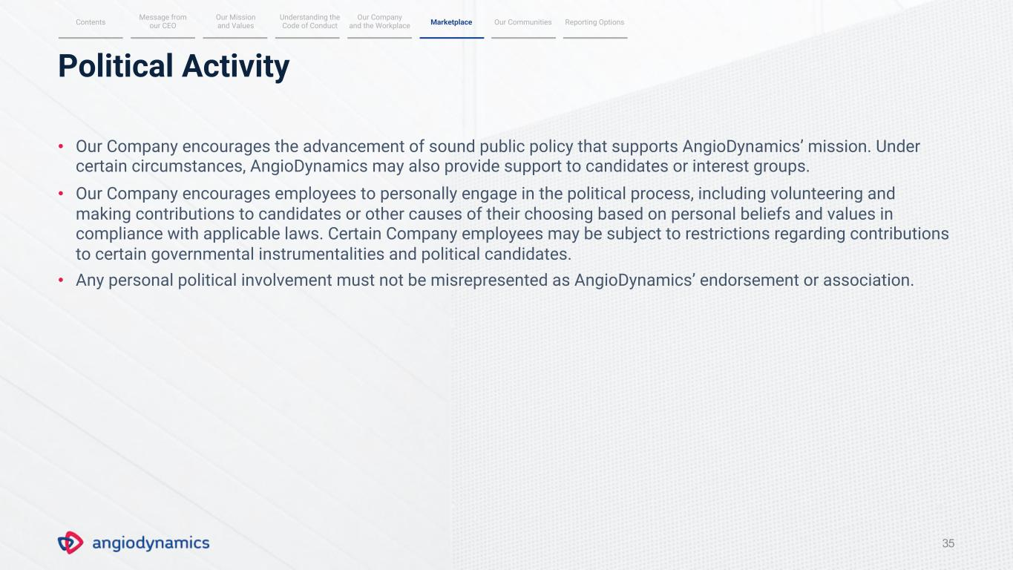
Political Activity 35 • Our Company encourages the advancement of sound public policy that supports AngioDynamics’ mission. Under certain circumstances, AngioDynamics may also provide support to candidates or interest groups. • Our Company encourages employees to personally engage in the political process, including volunteering and making contributions to candidates or other causes of their choosing based on personal beliefs and values in compliance with applicable laws. Certain Company employees may be subject to restrictions regarding contributions to certain governmental instrumentalities and political candidates. • Any personal political involvement must not be misrepresented as AngioDynamics’ endorsement or association. Message from our CEO Our Mission and Values Understanding the Code of ConductContents Our Communities Reporting Options Our Company and the Workplace Marketplace

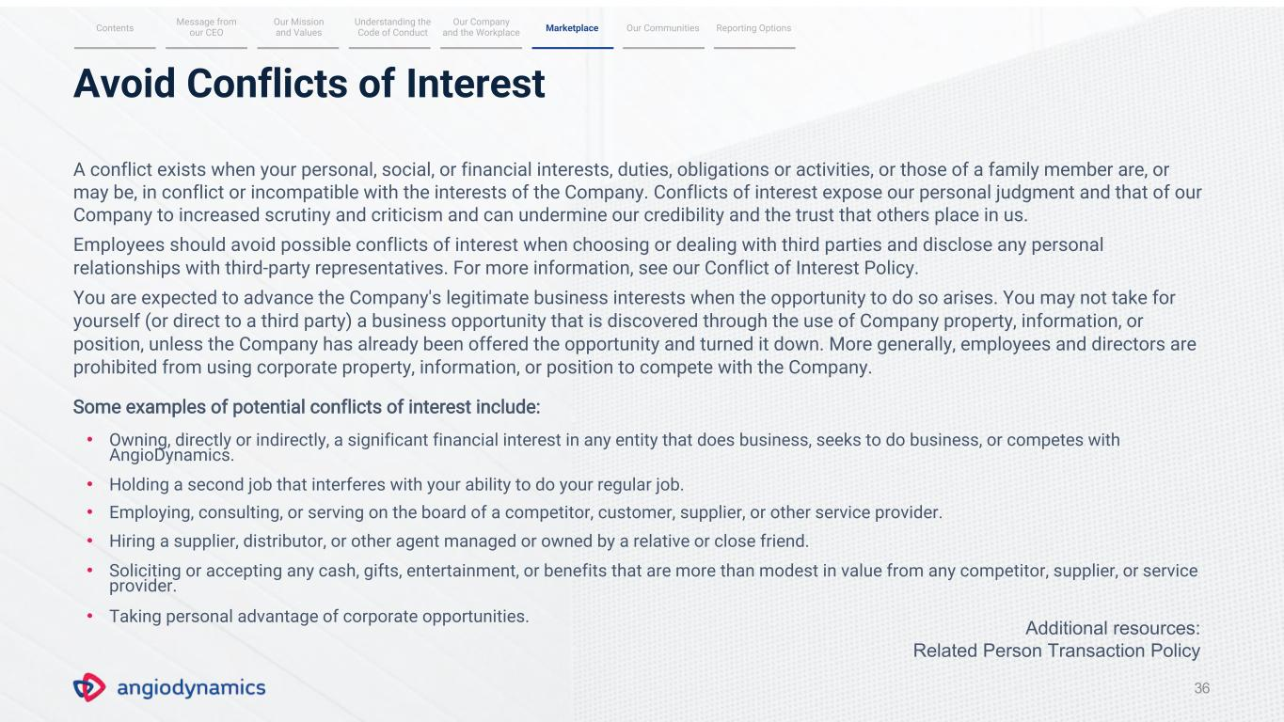
36 Avoid Conflicts of Interest A conflict exists when your personal, social, or financial interests, duties, obligations or activities, or those of a family member are, or may be, in conflict or incompatible with the interests of the Company. Conflicts of interest expose our personal judgment and that of our Company to increased scrutiny and criticism and can undermine our credibility and the trust that others place in us. Employees should avoid possible conflicts of interest when choosing or dealing with third parties and disclose any personal relationships with third-party representatives. For more information, see our Conflict of Interest Policy. You are expected to advance the Company's legitimate business interests when the opportunity to do so arises. You may not take for yourself (or direct to a third party) a business opportunity that is discovered through the use of Company property, information, or position, unless the Company has already been offered the opportunity and turned it down. More generally, employees and directors are prohibited from using corporate property, information, or position to compete with the Company. Some examples of potential conflicts of interest include: • Owning, directly or indirectly, a significant financial interest in any entity that does business, seeks to do business, or competes with AngioDynamics. • Holding a second job that interferes with your ability to do your regular job. • Employing, consulting, or serving on the board of a competitor, customer, supplier, or other service provider. • Hiring a supplier, distributor, or other agent managed or owned by a relative or close friend. • Soliciting or accepting any cash, gifts, entertainment, or benefits that are more than modest in value from any competitor, supplier, or service provider. • Taking personal advantage of corporate opportunities. Message from our CEO Our Mission and Values Understanding the Code of ConductContents Our Communities Reporting Options Our Company and the Workplace Marketplace Additional resources: Related Person Transaction Policy

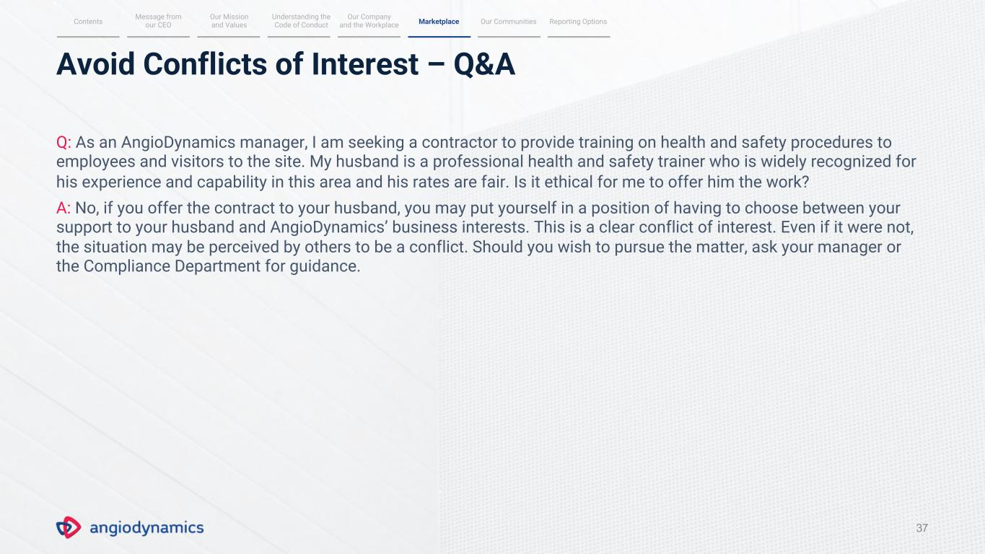
Avoid Conflicts of Interest – Q&A 37 Q: As an AngioDynamics manager, I am seeking a contractor to provide training on health and safety procedures to employees and visitors to the site. My husband is a professional health and safety trainer who is widely recognized for his experience and capability in this area and his rates are fair. Is it ethical for me to offer him the work? A: No, if you offer the contract to your husband, you may put yourself in a position of having to choose between your support to your husband and AngioDynamics’ business interests. This is a clear conflict of interest. Even if it were not, the situation may be perceived by others to be a conflict. Should you wish to pursue the matter, ask your manager or the Compliance Department for guidance. Message from our CEO Our Mission and Values Understanding the Code of ConductContents Our Communities Reporting Options Our Company and the Workplace Marketplace

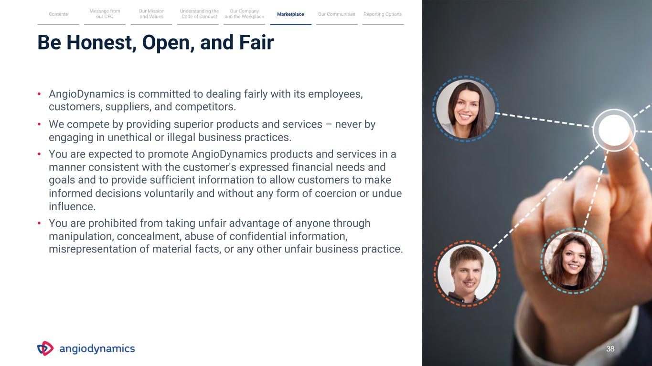
Be Honest, Open, and Fair • AngioDynamics is committed to dealing fairly with its employees, customers, suppliers, and competitors. • We compete by providing superior products and services – never by engaging in unethical or illegal business practices. • You are expected to promote AngioDynamics products and services in a manner consistent with the customer's expressed financial needs and goals and to provide sufficient information to allow customers to make informed decisions voluntarily and without any form of coercion or undue influence. • You are prohibited from taking unfair advantage of anyone through manipulation, concealment, abuse of confidential information, misrepresentation of material facts, or any other unfair business practice. Message from our CEO Our Mission and Values Understanding the Code of ConductContents Our Communities Reporting Options Our Company and the Workplace Marketplace 38

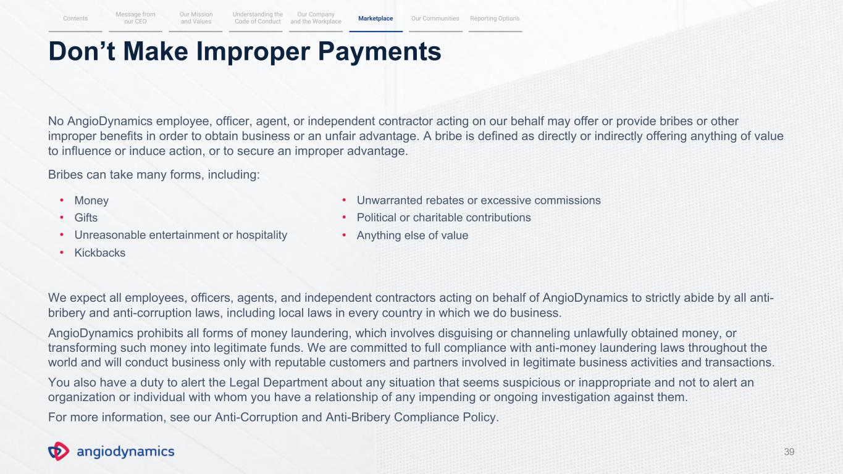
39 Don’t Make Improper Payments No AngioDynamics employee, officer, agent, or independent contractor acting on our behalf may offer or provide bribes or other improper benefits in order to obtain business or an unfair advantage. A bribe is defined as directly or indirectly offering anything of value to influence or induce action, or to secure an improper advantage. Bribes can take many forms, including: • Money • Gifts • Unreasonable entertainment or hospitality • Kickbacks We expect all employees, officers, agents, and independent contractors acting on behalf of AngioDynamics to strictly abide by all anti- bribery and anti-corruption laws, including local laws in every country in which we do business. AngioDynamics prohibits all forms of money laundering, which involves disguising or channeling unlawfully obtained money, or transforming such money into legitimate funds. We are committed to full compliance with anti-money laundering laws throughout the world and will conduct business only with reputable customers and partners involved in legitimate business activities and transactions. You also have a duty to alert the Legal Department about any situation that seems suspicious or inappropriate and not to alert an organization or individual with whom you have a relationship of any impending or ongoing investigation against them. For more information, see our Anti-Corruption and Anti-Bribery Compliance Policy. Message from our CEO Our Mission and Values Understanding the Code of ConductContents Our Communities Reporting Options Our Company and the Workplace Marketplace • Unwarranted rebates or excessive commissions • Political or charitable contributions • Anything else of value

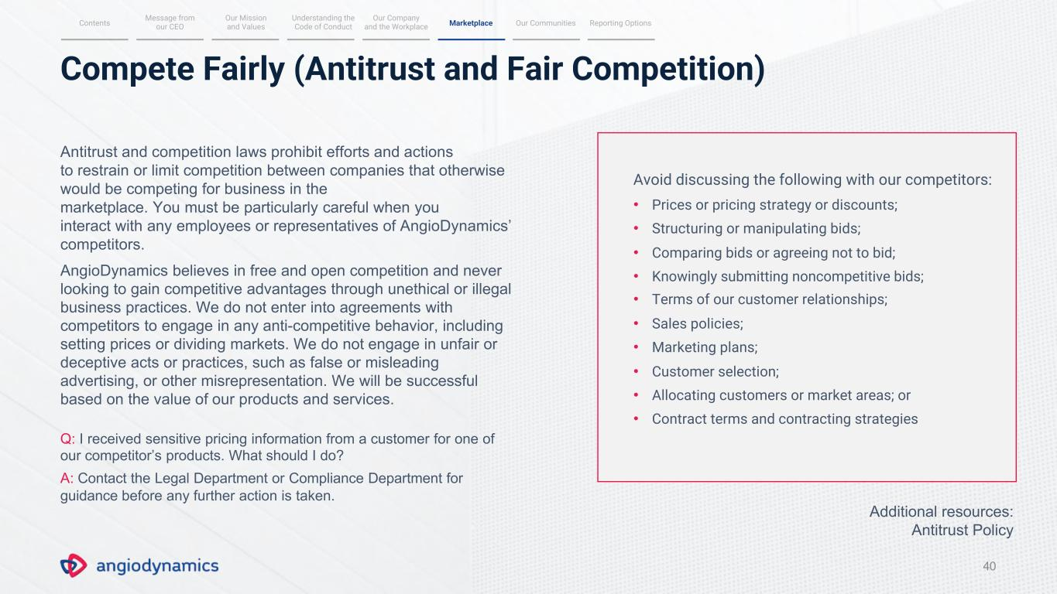
Compete Fairly (Antitrust and Fair Competition) 40 Antitrust and competition laws prohibit efforts and actions to restrain or limit competition between companies that otherwise would be competing for business in the marketplace. You must be particularly careful when you interact with any employees or representatives of AngioDynamics’ competitors. AngioDynamics believes in free and open competition and never looking to gain competitive advantages through unethical or illegal business practices. We do not enter into agreements with competitors to engage in any anti-competitive behavior, including setting prices or dividing markets. We do not engage in unfair or deceptive acts or practices, such as false or misleading advertising, or other misrepresentation. We will be successful based on the value of our products and services. Q: I received sensitive pricing information from a customer for one of our competitor’s products. What should I do? A: Contact the Legal Department or Compliance Department for guidance before any further action is taken. Avoid discussing the following with our competitors: • Prices or pricing strategy or discounts; • Structuring or manipulating bids; • Comparing bids or agreeing not to bid; • Knowingly submitting noncompetitive bids; • Terms of our customer relationships; • Sales policies; • Marketing plans; • Customer selection; • Allocating customers or market areas; or • Contract terms and contracting strategies Message from our CEO Our Mission and Values Understanding the Code of ConductContents Our Communities Reporting Options Our Company and the Workplace Marketplace Additional resources: Antitrust Policy


41 OUR COMMUNITIES Message from our CEO Our Mission and Values Understanding the Code of Conduct MarketplaceContents Our Communities Reporting Options Our Company and the Workplace

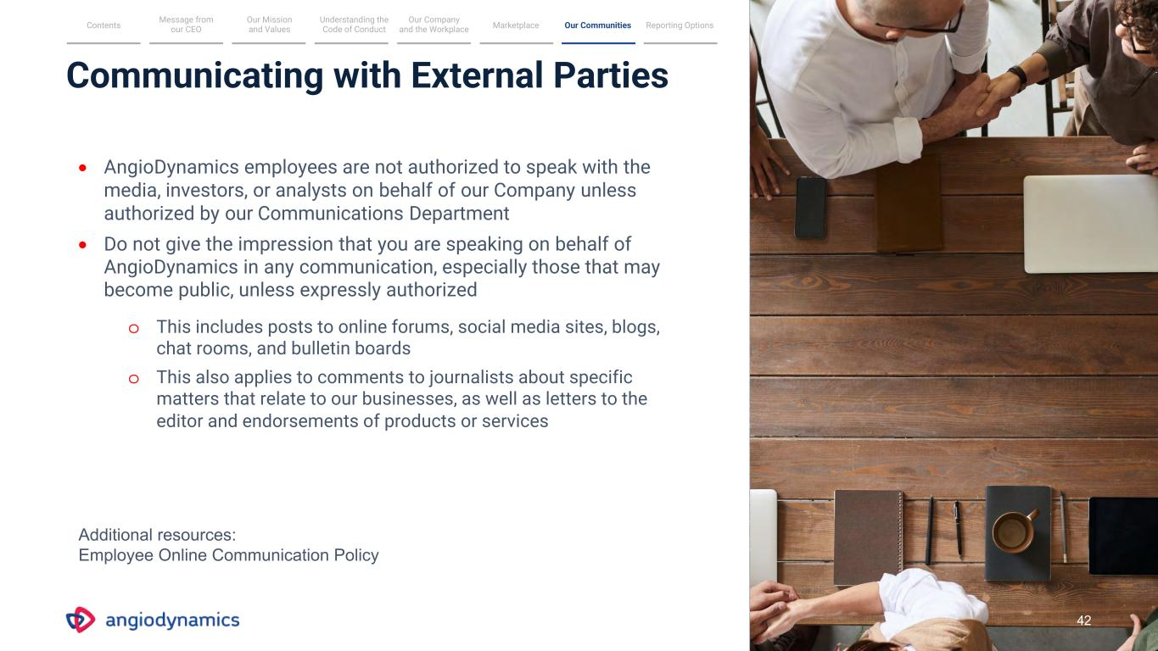
Communicating with External Parties • AngioDynamics employees are not authorized to speak with the media, investors, or analysts on behalf of our Company unless authorized by our Communications Department • Do not give the impression that you are speaking on behalf of AngioDynamics in any communication, especially those that may become public, unless expressly authorized o This includes posts to online forums, social media sites, blogs, chat rooms, and bulletin boards o This also applies to comments to journalists about specific matters that relate to our businesses, as well as letters to the editor and endorsements of products or services Message from our CEO Our Mission and Values Understanding the Code of Conduct MarketplaceContents Reporting Options Our Company and the Workplace Our Communities 42 Additional resources: Employee Online Communication Policy

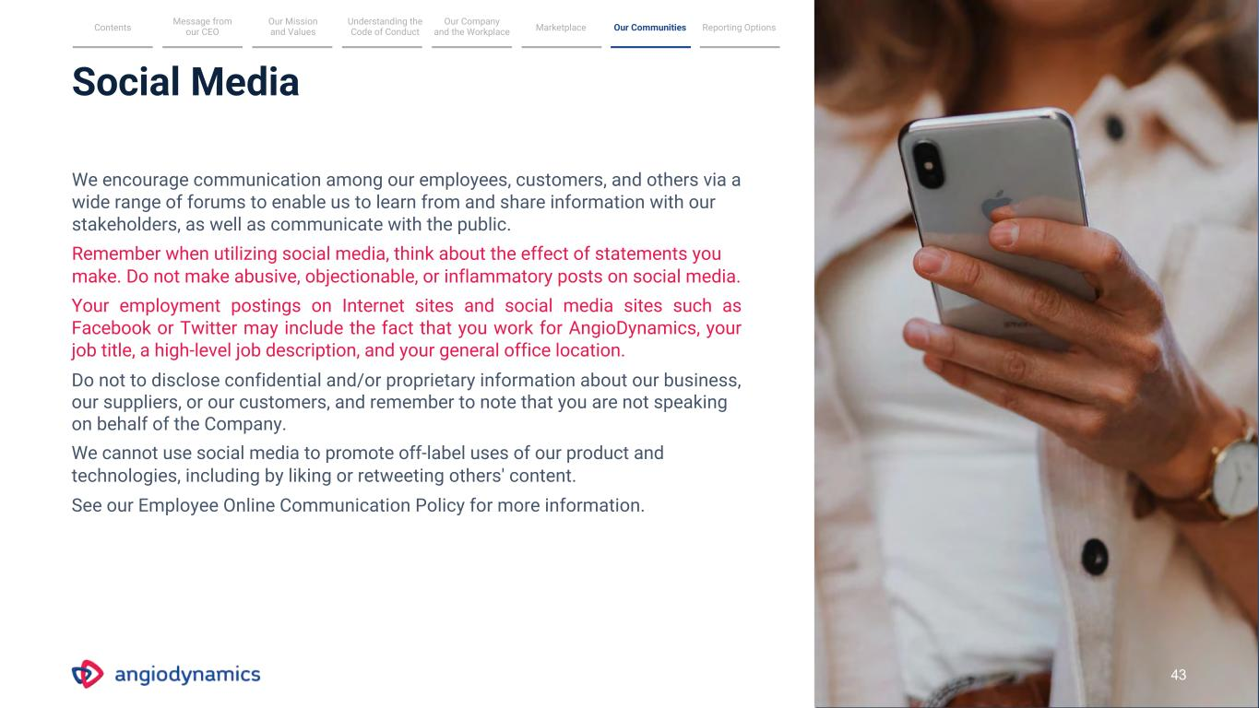
Social Media We encourage communication among our employees, customers, and others via a wide range of forums to enable us to learn from and share information with our stakeholders, as well as communicate with the public. Remember when utilizing social media, think about the effect of statements you make. Do not make abusive, objectionable, or inflammatory posts on social media. Your employment postings on Internet sites and social media sites such as Facebook or Twitter may include the fact that you work for AngioDynamics, your job title, a high-level job description, and your general office location. Do not to disclose confidential and/or proprietary information about our business, our suppliers, or our customers, and remember to note that you are not speaking on behalf of the Company. We cannot use social media to promote off-label uses of our product and technologies, including by liking or retweeting others' content. See our Employee Online Communication Policy for more information. Message from our CEO Our Mission and Values Understanding the Code of Conduct MarketplaceContents Reporting Options Our Company and the Workplace Our Communities 43

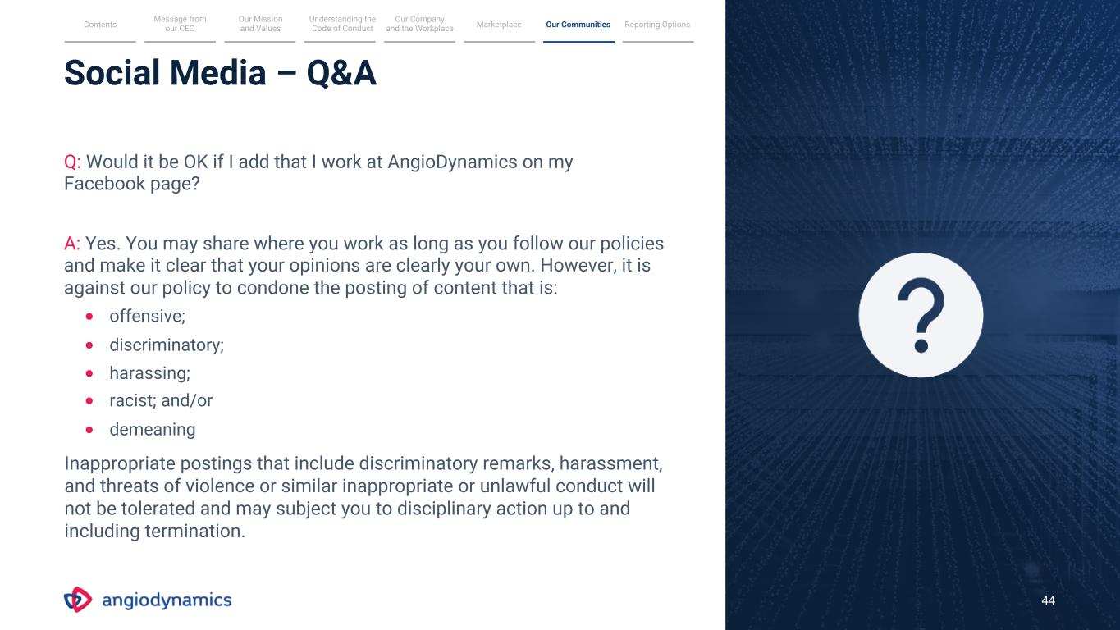
Q: Would it be OK if I add that I work at AngioDynamics on my Facebook page? A: Yes. You may share where you work as long as you follow our policies and make it clear that your opinions are clearly your own. However, it is against our policy to condone the posting of content that is: • offensive; • discriminatory; • harassing; • racist; and/or • demeaning Inappropriate postings that include discriminatory remarks, harassment, and threats of violence or similar inappropriate or unlawful conduct will not be tolerated and may subject you to disciplinary action up to and including termination. Social Media – Q&A 44 Message from our CEO Our Mission and Values Understanding the Code of Conduct MarketplaceContents Reporting Options Our Company and the Workplace Our Communities

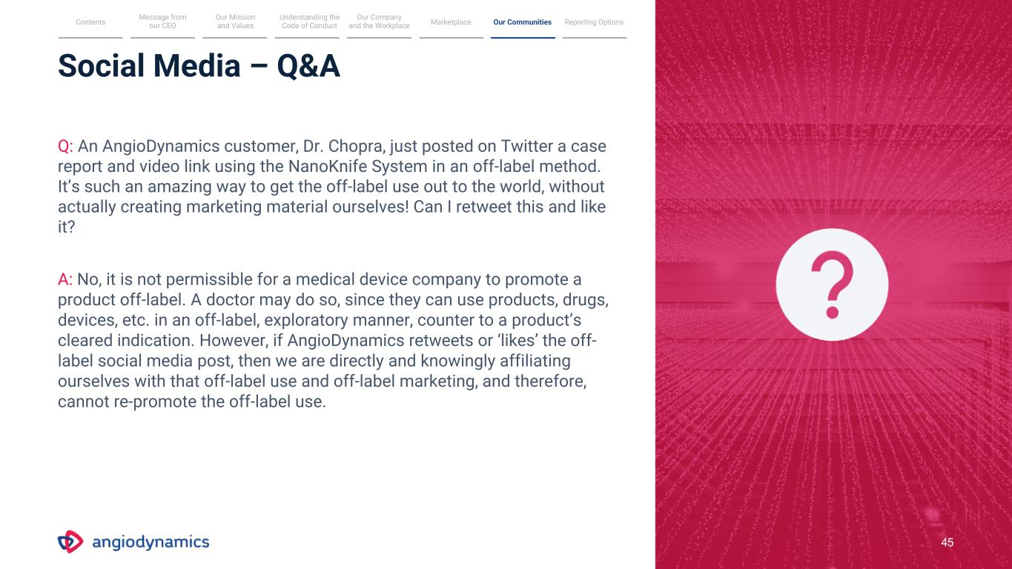
45 Social Media – Q&A Q: An AngioDynamics customer, Dr. Chopra, just posted on Twitter a case report and video link using the NanoKnife System in an off-label method. It’s such an amazing way to get the off-label use out to the world, without actually creating marketing material ourselves! Can I retweet this and like it? A: No, it is not permissible for a medical device company to promote a product off-label. A doctor may do so, since they can use products, drugs, devices, etc. in an off-label, exploratory manner, counter to a product’s cleared indication. However, if AngioDynamics retweets or ‘likes’ the off- label social media post, then we are directly and knowingly affiliating ourselves with that off-label use and off-label marketing, and therefore, cannot re-promote the off-label use. Message from our CEO Our Mission and Values Understanding the Code of Conduct MarketplaceContents Reporting Options Our Company and the Workplace Our Communities

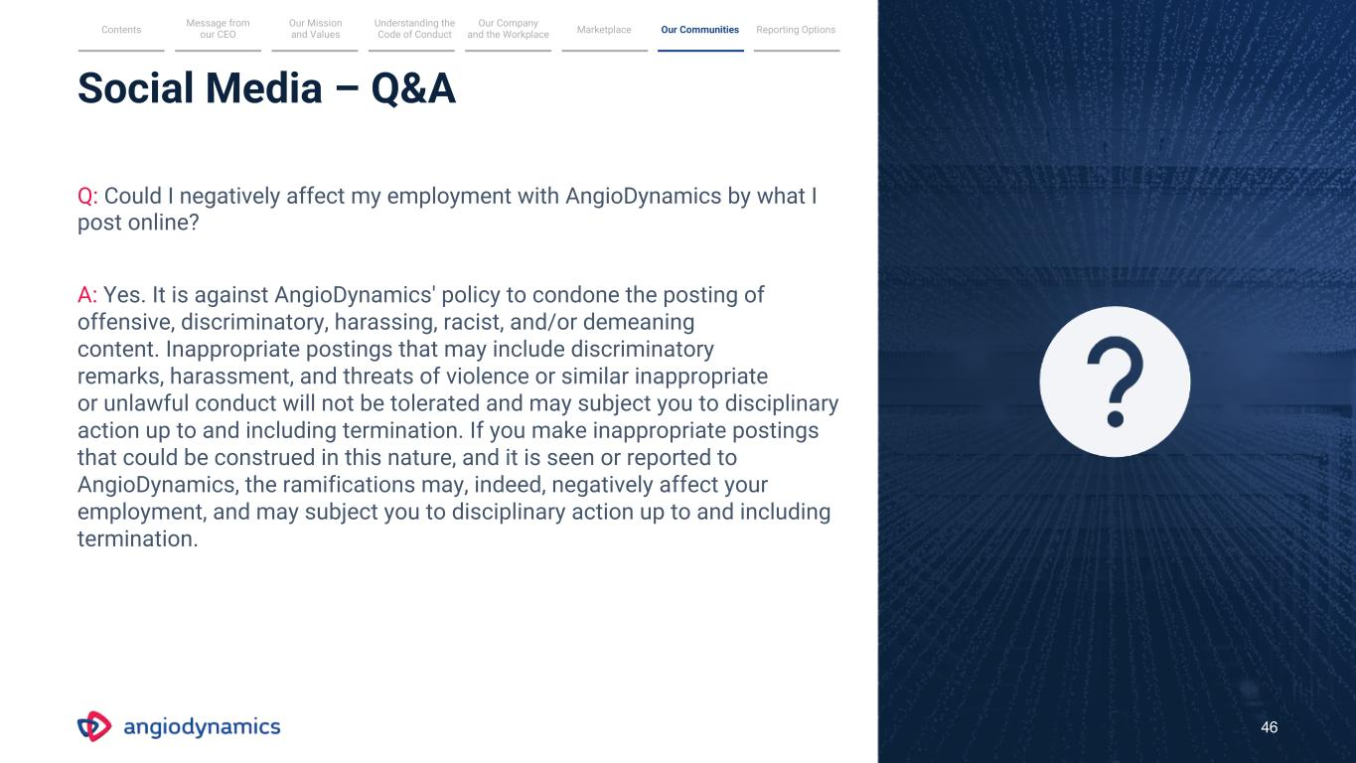
Social Media – Q&A Q: Could I negatively affect my employment with AngioDynamics by what I post online? A: Yes. It is against AngioDynamics' policy to condone the posting of offensive, discriminatory, harassing, racist, and/or demeaning content. Inappropriate postings that may include discriminatory remarks, harassment, and threats of violence or similar inappropriate or unlawful conduct will not be tolerated and may subject you to disciplinary action up to and including termination. If you make inappropriate postings that could be construed in this nature, and it is seen or reported to AngioDynamics, the ramifications may, indeed, negatively affect your employment, and may subject you to disciplinary action up to and including termination. 46 Message from our CEO Our Mission and Values Understanding the Code of Conduct MarketplaceContents Reporting Options Our Company and the Workplace Our Communities

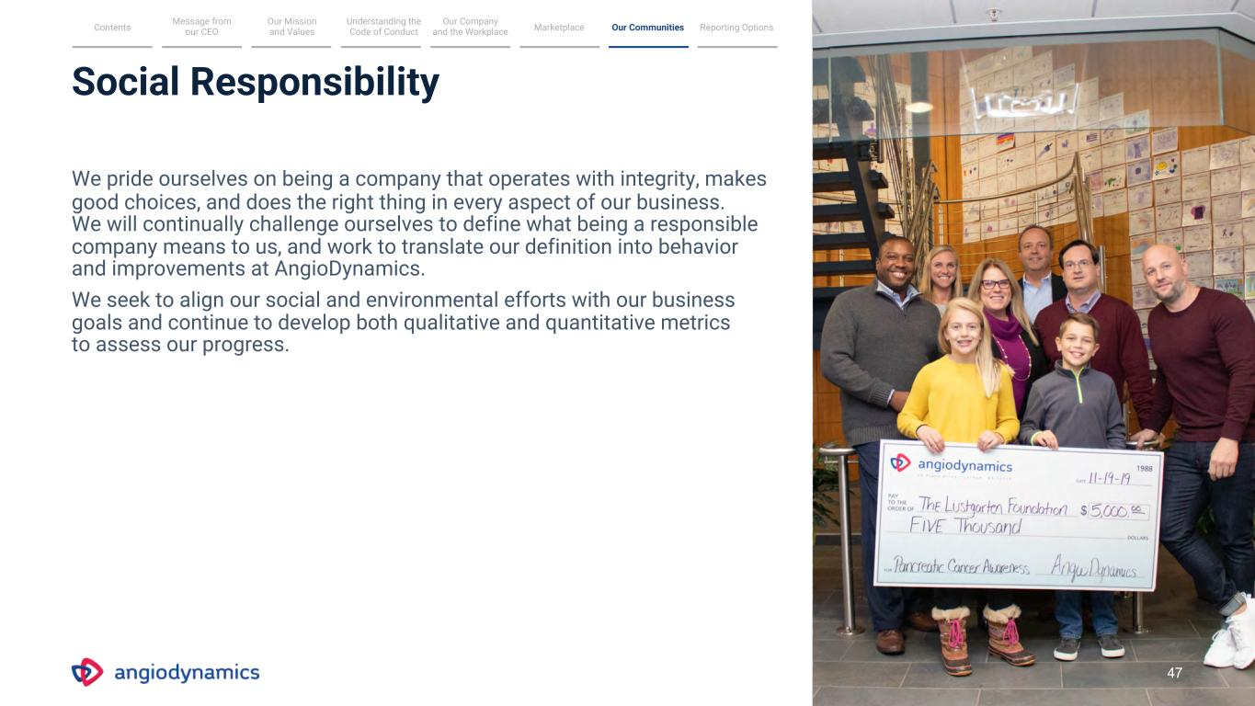
Social Responsibility We pride ourselves on being a company that operates with integrity, makes good choices, and does the right thing in every aspect of our business. We will continually challenge ourselves to define what being a responsible company means to us, and work to translate our definition into behavior and improvements at AngioDynamics. We seek to align our social and environmental efforts with our business goals and continue to develop both qualitative and quantitative metrics to assess our progress. Message from our CEO Our Mission and Values Understanding the Code of Conduct MarketplaceContents Reporting Options Our Company and the Workplace Our Communities 47

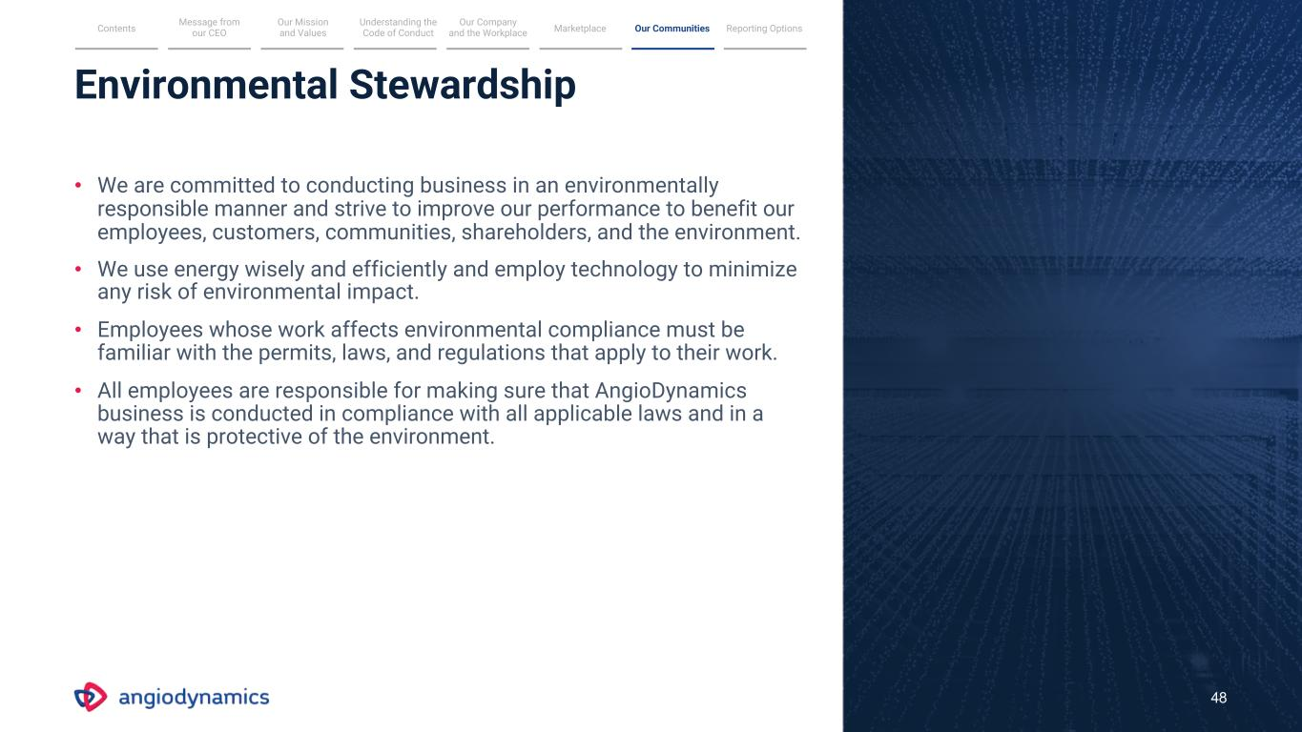
Environmental Stewardship 48 • We are committed to conducting business in an environmentally responsible manner and strive to improve our performance to benefit our employees, customers, communities, shareholders, and the environment. • We use energy wisely and efficiently and employ technology to minimize any risk of environmental impact. • Employees whose work affects environmental compliance must be familiar with the permits, laws, and regulations that apply to their work. • All employees are responsible for making sure that AngioDynamics business is conducted in compliance with all applicable laws and in a way that is protective of the environment. Message from our CEO Our Mission and Values Understanding the Code of Conduct MarketplaceContents Reporting Options Our Company and the Workplace Our Communities

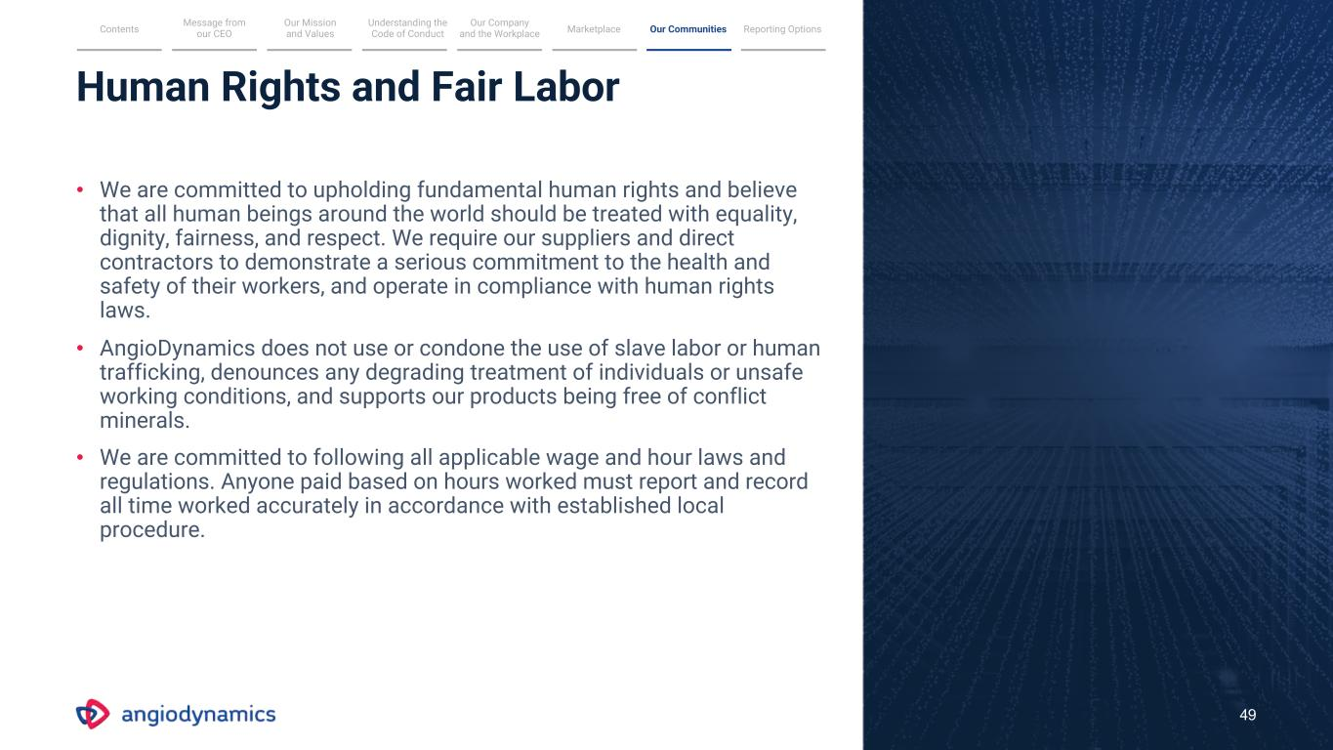
Human Rights and Fair Labor 49 • We are committed to upholding fundamental human rights and believe that all human beings around the world should be treated with equality, dignity, fairness, and respect. We require our suppliers and direct contractors to demonstrate a serious commitment to the health and safety of their workers, and operate in compliance with human rights laws. • AngioDynamics does not use or condone the use of slave labor or human trafficking, denounces any degrading treatment of individuals or unsafe working conditions, and supports our products being free of conflict minerals. • We are committed to following all applicable wage and hour laws and regulations. Anyone paid based on hours worked must report and record all time worked accurately in accordance with established local procedure. Message from our CEO Our Mission and Values Understanding the Code of Conduct MarketplaceContents Reporting Options Our Company and the Workplace Our Communities

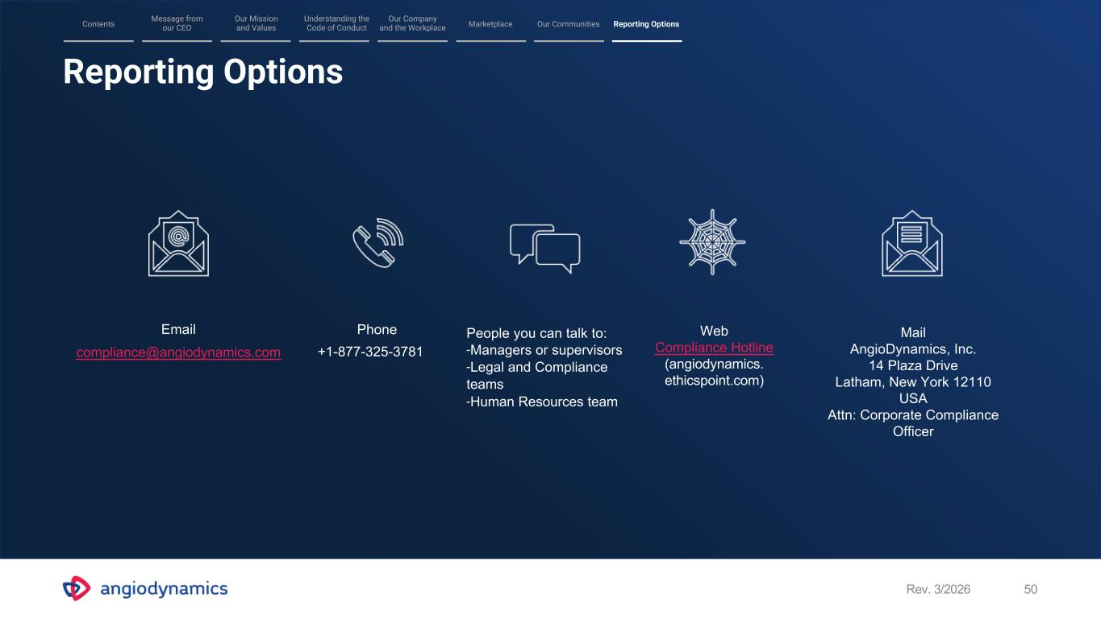
Reporting Options Rev. 3/2026 50 Email compliance@angiodynamics.com Phone +1-877-325-3781 Web Compliance Hotline (angiodynamics. ethicspoint.com) Mail AngioDynamics, Inc. 14 Plaza Drive Latham, New York 12110 USA Attn: Corporate Compliance Officer People you can talk to: -Managers or supervisors -Legal and Compliance teams -Human Resources team Message from our CEO Our Mission and Values Understanding the Code of Conduct MarketplaceContents Our Communities Reporting Options Our Company and the Workplace

Exhibit 21
Subsidiaries of AngioDynamics, Inc.

Subsidiary |  |  |  |  |  | State of Incorporation or Organization
AngioDynamics UK Limited |  |  |  |  |  | United Kingdom
AngioDynamics Netherlands B. V. |  |  |  |  |  | Netherlands
RITA Medical Systems, LLC |  |  |  |  |  | Delaware
AngioDynamics France, SARL |  |  |  |  |  | France
AngioDynamics Canada Inc. |  |  |  |  |  | Canada
AngioDynamics Medical Brasil Servicos de Marketing Ltda. |  |  |  |  |  | Brazil
Eximo Medical, Ltd. |  |  |  |  |  | Israel
AngioDynamics Italy S.r.l |  |  |  |  |  | Italy

Exhibit 23
CONSENT OF INDEPENDENT REGISTERED PUBLIC ACCOUNTING FIRM
We consent to the incorporation by reference in Registration Statement Nos. 333-120053, 333-120057, 333-138456, 333-140627, 333-161355, 333-162844, 333-170619, 333-190640, 333-203441, 333-229814, 333-252209, 333-269151 and 333-290994 on Form S-8 of our reports dated July 14, 2026, relating to the financial statements of AngioDynamics Inc. and the effectiveness of AngioDynamics Inc.'s internal control over financial reporting appearing in this Annual Report on Form 10-K for the year ended May 31, 2026.

/s/ Deloitte & Touche LLP

Boston, Massachusetts
July 14, 2026

Exhibit 31.1
CERTIFICATION
I, James C. Clemmer, certify that:
1. |  |  | I have reviewed this annual report on Form 10-K of AngioDynamics, Inc.;

2. |  |  | Based on my knowledge, this report does not contain any untrue statement of a material fact or omit to state a material fact necessary to make the statements made, in light of the circumstances under which such statements were made, not misleading with respect to the period covered by this report;

3. |  |  | Based on my knowledge, the financial statements, and other financial information included in this report, fairly present in all material respects the financial condition, results of operations and cash flows of the registrant as of, and for, the periods presented in this report;

4. |  |  | The registrant’s other certifying officer and I are responsible for establishing and maintaining disclosure controls and procedures (as defined in Exchange Act Rules 13a-15(e) and 15d-15(e)) and internal control over financial reporting (as defined in Exchange Act Rules 13a-15(f) and 15d-15(f)) for the registrant and have:
(a)Designed such disclosure controls and procedures, or caused such disclosure controls and procedures to be designed under our supervision, to ensure that material information relating to the registrant, including its consolidated subsidiaries, is made known to us by others within those entities, particularly during the period in which this report is being prepared;
(b)Designed such internal control over financial reporting, or caused such internal control over financial reporting to be designed under our supervision, to provide reasonable assurance regarding the reliability of financial reporting and the preparation of financial statements for external purposes in accordance with generally accepted accounting principles;
(c)Evaluated the effectiveness of the registrant’s disclosure controls and procedures and presented in this report our conclusions about the effectiveness of the disclosure controls and procedures, as of the end of the period covered by this report based on such evaluation; and
(d)Disclosed in this report any change in the registrant’s internal control over financial reporting that occurred during the registrant’s most recent fiscal quarter (the registrant’s fourth fiscal quarter in the case of an annual report) that has materially affected, or is reasonably likely to materially affect, the registrant’s internal control over financial reporting; and

5. |  |  | The registrant’s other certifying officer and I have disclosed, based on our most recent evaluation of internal control over financial reporting, to the registrant’s auditors and the audit committee of the registrant’s board of directors (or persons performing the equivalent functions):
(a)All significant deficiencies and material weaknesses in the design or operation of internal control over financial reporting which are reasonably likely to adversely affect the registrant’s ability to record, process, summarize and report financial information; and
(b)Any fraud, whether or not material, that involves management or other employees who have a significant role in the registrant’s internal control over financial reporting.
Date: July 14, 2026

/ S / JAMES C. CLEMMER
James C. Clemmer, President,
Chief Executive Officer

Exhibit 31.2
CERTIFICATION
I, Stephen A. Trowbridge, certify that:
1. |  |  | I have reviewed this annual report on Form 10-K of AngioDynamics, Inc.;

2. |  |  | Based on my knowledge, this report does not contain any untrue statement of a material fact or omit to state a material fact necessary to make the statements made, in light of the circumstances under which such statements were made, not misleading with respect to the period covered by this report;

3. |  |  | Based on my knowledge, the financial statements, and other financial information included in this report, fairly present in all material respects the financial condition, results of operations and cash flows of the registrant as of, and for, the periods presented in this report;

4. |  |  | The registrant’s other certifying officer and I are responsible for establishing and maintaining disclosure controls and procedures (as defined in Exchange Act Rules 13a-15(e) and 15d-15(e)) and internal control over financial reporting (as defined in Exchange Act Rules 13a-15(f) and 15d-15(f)) for the registrant and have:
(a)Designed such disclosure controls and procedures, or caused such disclosure controls and procedures to be designed under our supervision, to ensure that material information relating to the registrant, including its consolidated subsidiaries, is made known to us by others within those entities, particularly during the period in which this report is being prepared;
(b)Designed such internal control over financial reporting, or caused such internal control over financial reporting to be designed under our supervision, to provide reasonable assurance regarding the reliability of financial reporting and the preparation of financial statements for external purposes in accordance with generally accepted accounting principles;
(c)Evaluated the effectiveness of the registrant’s disclosure controls and procedures and presented in this report our conclusions about the effectiveness of the disclosure controls and procedures, as of the end of the period covered by this report based on such evaluation; and
(d)Disclosed in this report any change in the registrant’s internal control over financial reporting that occurred during the registrant’s most recent fiscal quarter (the registrant’s fourth fiscal quarter in the case of an annual report) that has materially affected, or is reasonably likely to materially affect, the registrant’s internal control over financial reporting; and

5. |  |  | The registrant’s other certifying officer and I have disclosed, based on our most recent evaluation of internal control over financial reporting, to the registrant’s auditors and the audit committee of the registrant’s board of directors (or persons performing the equivalent functions):
(a)All significant deficiencies and material weaknesses in the design or operation of internal control over financial reporting which are reasonably likely to adversely affect the registrant’s ability to record, process, summarize and report financial information; and
(b)Any fraud, whether or not material, that involves management or other employees who have a significant role in the registrant’s internal control over financial reporting.
Date: July 14, 2026

/ S / STEPHEN A. TROWBRIDGE
Stephen A. Trowbridge, Executive Vice President,
Chief Financial Officer

Exhibit 32.1
CERTIFICATION OF CHIEF EXECUTIVE OFFICER PURSUANT TO TITLE 18,
UNITED STATES CODE, SECTION 1350, AS ADOPTED PURSUANT TO
SECTION 906 OF THE SARBANES-OXLEY ACT OF 2002
I, James C. Clemmer, President, Chief Executive Officer and Director of ANGIODYNAMICS, Inc. (the “Company”), certify, pursuant to Section 906 of the Sarbanes-Oxley Act of 2002, 18 U.S.C. Section 1350, that, to the best of my knowledge:
1. |  |  | the annual report on Form 10-K of the Company for the fiscal year ended May 31, 2026 (the “Report”) fully complies with the requirements of Section 13(a) or 15(d) of the Securities Exchange Act of 1934 (15 U.S.C. 78m or 78o(d)); and
2. |  |  | the information contained in the Report fairly presents, in all material respects, the financial condition and results of operations of the Company.

Date: July 14, 2026

/S/ JAMES C. CLEMMER
James C. Clemmer, President,
Chief Executive Officer

Exhibit 32.2
CERTIFICATION OF CHIEF FINANCIAL OFFICER PURSUANT TO TITLE 18,
UNITED STATES CODE, SECTION 1350, AS ADOPTED PURSUANT TO
SECTION 906 OF THE SARBANES-OXLEY ACT OF 2002
I, Stephen A. Trowbridge, Chief Financial Officer of ANGIODYNAMICS, Inc. (the “Company”), certify, pursuant to Section 906 of the Sarbanes-Oxley Act of 2002, 18 U.S.C. Section 1350, that, to the best of my knowledge:
1. |  |  | the annual report on Form 10-K of the Company for the fiscal year ended May 31, 2026 (the “Report”) fully complies with the requirements of Section 13(a) or 15(d) of the Securities Exchange Act of 1934 (15 U.S.C. 78m or 78o(d)); and

2. |  |  | the information contained in the Report fairly presents, in all material respects, the financial condition and results of operations of the Company.

Date: July 14, 2026

/S/ STEPHEN A. TROWBRIDGE
Stephen A. Trowbridge, Executive Vice President,
Chief Financial Officer

