UNITED STATES
SECURITIES AND EXCHANGE COMMISSION
WASHINGTON, D.C. 20549

FORM 8-K

CURRENT REPORT
Pursuant to Section 13 or 15(d) of the
Securities Exchange Act of 1934

Date of Report (Date of earliest event reported): July 14, 2026

AngioDynamics, Inc.
(Exact Name of Registrant as Specified in Charter)

Delaware | 000-50761 | 11-3146460
(State or Other Jurisdiction of Incorporation) | (Commission File Number) | (IRS Employer Identification No.)

14 Plaza Drive, Latham, New York |  | 12110
(Address of Principal Executive Offices) |  | (Zip Code)
(518) 795-1400
(Registrant’s telephone number, including area code)

Check the appropriate box below if the Form 8-K filing is intended to simultaneously satisfy the filing obligation of the registrant under any of the following provisions:

☐ | Written communications pursuant to Rule 425 under the Securities Act (17 CFR 230.425)

☐ | Soliciting material pursuant to Rule 14a-12 under the Exchange Act (17 CFR 240.14a-12)

☐ | Pre-commencement communications pursuant to Rule 14d-2(b) under the Exchange Act (17 CFR 240.14d-2 (b))

☐ | Pre-commencement communications pursuant to Rule 13e-4(c) under the Exchange Act (17 CFR 240.13e-4 (c))

Securities registered pursuant to Section 12(b) of the Act:

Title of each class | Trading Symbol(s) | Name of each exchange on which  registered
Common Stock, par value $0.01 per share | ANGO | NASDAQ Global Select Market

Indicate by check mark whether the registrant is an emerging growth company as defined in Rule 405 of the Securities Act of 1933 (§230.405 of this chapter) or Rule 12b-2 of the Securities Exchange Act of 1934 (§240.12b-2 of this chapter).

Emerging growth company ☐

If an emerging growth company, indicate by check mark if the registrant has elected not to use the extended transition period for complying with any new or revised financial accounting standards provided pursuant to Section 13(a) of the Exchange Act. ☐

Item 2.02 – Results of Operations and Financial Condition.

On July 14, 2026, AngioDynamics, Inc. (“AngioDynamics”) issued a press release announcing financial results for the fiscal fourth quarter and full year ended May 31, 2026. A copy of the press release is furnished herewith as Exhibit 99.1.

The information set forth in Item 2.02 of this Form 8-K (including Exhibit 99.1) shall not be deemed “filed” for purposes of Section 18 of the Securities Exchange Act of 1934, as amended (the “Exchange Act”), or otherwise subject to the liabilities under that Section. Furthermore, such information shall not be deemed to be incorporated by reference into any filing under the Securities Act of 1933, as amended (the “Securities Act”), or the Exchange Act, except as shall be expressly set forth by specific reference in such a filing.

Item 7.01 – Regulation FD Disclosure.

Presentation slides discussing AngioDynamics and its fiscal fourth quarter and full year ended May 31, 2026 are furnished herewith as Exhibit 99.2.

The presentation slides furnished pursuant to Item 7.01 of this Form 8-K (including Exhibit 99.2) shall not be deemed “filed” for purposes of Section 18 of the Exchange Act, or otherwise subject to the liabilities under that Section. Furthermore, the presentation slides shall not be deemed to be incorporated by reference into any filing under the Securities Act or the Exchange Act.

Forward-Looking Statements

This document and its attachments contain forward-looking statements within the meaning of the Private Securities Litigation Reform Act of 1995. All statements regarding AngioDynamics’ expected future financial position, results of operations, cash flows, business strategy, budgets, projected costs, capital expenditures, products, competitive positions, growth opportunities, plans and objectives of management for future operations, as well as statements that include the words such as “expects,” “reaffirms,” “intends,” “anticipates,” “plans,” “believes,” “seeks,” “estimates,” “projects”, “optimistic,” or variations of such words and similar expressions, are forward-looking statements. These forward-looking statements are not guarantees of future performance and are subject to risks and uncertainties. Investors are cautioned that actual events or results may differ materially from AngioDynamics’ expectations, expressed or implied. Factors that may affect the actual results achieved by AngioDynamics include, without limitation, the scale and scope of the COVID-19 global pandemic, the ability of AngioDynamics to develop its existing and new products, technological advances and patents attained by competitors, infringement of AngioDynamics’ technology or assertions that AngioDynamics’ technology infringes the technology of third parties, the ability of AngioDynamics to effectively compete against competitors that have substantially greater resources, future actions by the FDA or other regulatory agencies, domestic and foreign health care reforms and government regulations, results of pending or future clinical trials, overall economic conditions (including inflation, tariffs, labor shortages and supply chain challenges including the cost and availability of raw materials), the results of on-going litigation, challenges with respect to third-party distributors or joint venture partners or collaborators, the results of sales efforts, the effects of product recalls and product liability claims, changes in key personnel, the ability of AngioDynamics to execute on strategic initiatives, the effects of economic, credit and capital market conditions, general market conditions, market acceptance, foreign currency exchange rate fluctuations, the effects on pricing from group purchasing organizations and competition, the ability of AngioDynamics to obtain regulatory clearances or approval of its products, or to integrate acquired businesses, as well as the risk factors listed from time to time in AngioDynamics’ SEC filings, including but not limited to its Annual Report on Form 10-K for the year ended May 31, 2025. AngioDynamics does not assume any obligation to publicly update or revise any forward-looking statements for any reason.

Item 9.01 – Financial Statements and Exhibits.

(d) | Exhibits.

Exhibit No. | Description
99.1 | Press Release, dated July 14, 2026.
99.2 | Presentation, dated July 14, 2026.

SIGNATURE

Pursuant to the requirements of the Securities Exchange Act of 1934, the registrant has duly caused this report to be signed on its behalf by the undersigned hereunto duly authorized.

 | ANGIODYNAMICS, INC.
 | (Registrant)
Date: July 14, 2026 | By: | /s/ Lawrence T. Weiss
 |  | Name: | Lawrence T. Weiss
 |  | Title: | Senior Vice President, Chief
 | Legal Officer and Corporate Secretary

Exhibit 99.1

AngioDynamics Reports Record Fiscal Year 2026 Fourth Quarter and Full Year Financial Results; Continued Execution Drives Med Tech Growth and Full-Year Profitability

Delivered its seventh consecutive quarter of double-digit Med Tech segment growth and positive adjusted EBITDA

LATHAM, N.Y.--(BUSINESS WIRE)— July 14, 2026-- AngioDynamics, Inc. (NASDAQ: ANGO), a leading and transformative medical technology company focused on restoring healthy blood flow in the body’s vascular system, expanding cancer treatment options, and improving quality of life for patients, today announced financial results for the fourth quarter and fiscal year 2026, which ended May 31, 2026.

Fiscal Year 2026 Fourth Quarter Financial Highlights

 | Quarter Ended  May 31, 2026 | Pro Forma* YoY Growth
Pro Forma* Net Sales | $86.6 million | 8.0%
Med Tech Net Sales | $41.8 million | 16.7%
Med Device Net Sales | $44.8 million | 1.1%

 | • | GAAP gross margin of 54.0%

 | • | GAAP loss per share of $0.27

 | • | Adjusted loss per share of $0.07

 | • | Adjusted EBITDA of $3.3 million

Fiscal Year 2026 Financial Highlights

 | Year Ended  May 31, 2026 | Pro Forma* YoY Growth
Pro Forma* Net Sales | $320.2 million | 9.4%
Med Tech Net Sales | $150.0 million | 18.4%
Med Device Net Sales | $170.2 million | 2.5%

 | • | GAAP gross margin of 54.6%

 | • | GAAP loss per share of $0.88

 | • | Adjusted loss per share of $0.24

 | • | Adjusted EBITDA of $13.2 million

 | • | Ended fiscal year 2026 with $53.9 million in cash

1

*Pro forma results exclude the Dialysis and BioSentry businesses divested in June 2023 and the PICC and Midline product portfolios divested in February 2024, as well as the discontinued RadioFrequency and Syntrax products in February 2024.

Clinical, Regulatory, and Market Access Highlights

During the fiscal year:

 | • | Received FDA IDE approval for APEX-Return study evaluating AlphaReturn Blood Management System when used with AlphaVac F1885 System

 | • | Received FDA IDE approval for PAVE clinical study evaluating AngioVac System for treatment of right-sided infective endocarditis

 | • | Initiated both the AMBITION BTK and RECOVER-AV trials

During the fourth quarter:

 | • | Two-year follow up data from its PRESERVE pivotal trial presented at the American Urological Association conference in 2026 demonstrating NanoKnife’s durable prostate cancer outcomes

 | • | Palmetto GBA (Government Benefits Administrators) finalized a local coverage determination covering NanoKnife IRE for qualifying Medicare patients in prostate and liver cancer, effective July 5, 2026

Subsequent to fiscal year end:

 | • | Received FDA IDE (Investigational Device Exemption) approval for the RELIEF study evaluating NanoKnife IRE for the treatment of benign prostatic hyperplasia

"Our strong fourth quarter capped a year of consistent execution at AngioDynamics," said Jim Clemmer, President and Chief Executive Officer of AngioDynamics, Inc. "Full-year Med Tech growth of more than 18% reflects the continued progress of our strategic transformation, as our innovative platform technologies across cardiology and interventional oncology took share in large, fast-growing global markets. Combined with our operational discipline, that growth drove continued profitability even as we absorbed tariff-related headwinds."

"We advanced our portfolio on multiple fronts during the year. We generated compelling two-year PRESERVE clinical data and secured a critical Medicare coverage pathway for NanoKnife in prostate and liver, while achieving key regulatory milestones across our Mechanical Thrombectomy portfolio, including IDE approvals for our AlphaVac blood return and AngioVac right-sided endocarditis studies. Auryon delivered its 20th consecutive quarter of double-digit growth, and NanoKnife adoption accelerated following the effective date of the Category I CPT code for prostate."

2

Mr. Clemmer continued, "As we look ahead to fiscal 2027, we remain focused on driving sustained growth led by our Med Tech segment. Med Tech represented 47% of our total revenue in fiscal 2026, up approximately 22% from when we began our strategic transformation in 2020. We expect that mix to continue shifting toward our higher-growth, higher-margin platforms. With a differentiated technology portfolio, multiple growth catalysts ahead, and a debt-free balance sheet with positive cash generation, we are well-positioned to deliver continued value creation in fiscal 2027 and beyond."

Fiscal Fourth Quarter 2026 Financial Results

Unless otherwise noted, all financial comparisons below are presented on a pro forma basis excluding the Dialysis and BioSentry businesses divested in June 2023, the PICC, Midline, and tip location product portfolios divested in February 2024, and the RadioFrequency and Syntrax support catheter products discontinued in February 2024.

Net sales for the fourth quarter of fiscal year 2026 were $86.6 million, an increase of 8.0% compared to the prior-year quarter.

Med Tech net sales were $41.8 million, a 16.7% increase from $35.8 million in the prior-year period. Med Tech includes the Auryon peripheral atherectomy platform, our thrombus management platform which is led by AlphaVac and AngioVac, and the NanoKnife irreversible electroporation platform.

Growth during the quarter was driven by solid performance across the Med Tech segment. Auryon sales were $17.8 million, an increase of 14.4% compared to the prior-year quarter. In our Mechanical Thrombectomy business, AlphaVac sales grew 38.4% compared to the prior year quarter, while AngioVac faced a tough comparison, declining 15.8% versus prior year. Overall, Mechanical Thrombectomy delivered sales of $11.1 million, a decrease of 1.1% compared to the prior-year quarter. NanoKnife sales were $11.8 million, an increase of 64.5% compared to the prior-year quarter, including 47.0% growth in probes and 132.5% growth in capital sales.

Med Device net sales were $44.8 million, a 1.1% increase compared to $44.4 million in the prior-year period.

Gross margin for the fourth quarter of fiscal 2026 was 54.0%, which was 130 basis points higher compared to the fourth quarter of fiscal 2025, primarily driven by favorable pricing and the ongoing revenue mix shift toward Med Tech, partially offset by the manufacturing transition and global inflation all of which were in-line with the Company's expectations.

The Company recorded a GAAP net loss of $11.4 million, or a loss per share of $0.27, in the fourth quarter of fiscal 2026, compared to a net loss of $6.1 million, or a loss per share of $0.15, a year ago. Excluding the items shown in the non-GAAP reconciliation table below, adjusted net loss for the fourth quarter of fiscal 2026 was $2.8 million, or a loss per share of $0.07. This compares to an adjusted net loss during the fiscal fourth quarter of 2025 of $1.1 million, or a loss per share of $0.03.

3

Adjusted EBITDA in the fourth quarter of fiscal 2026, excluding the items shown in the non-GAAP reconciliation table below, was $3.3 million, compared to $3.4 million in the fourth quarter of fiscal 2025.

Tariff-related expenses were $0.5 million during the quarter, compared to $1.6 million for the prior year quarter, in-line with the Company's expectations.

In the fourth quarter of fiscal 2026, the Company generated $17.5 million of cash from operations, slightly ahead of the Company's expectations.

Full-Year 2026 Financial Results

Unless otherwise noted, all financial comparisons below are presented on a pro forma basis excluding the Dialysis and BioSentry businesses divested in June 2023, the PICC, Midline, and tip location product portfolios divested in February 2024, and the RadioFrequency and Syntrax support catheter products discontinued in February 2024.

Net sales were $320.2 million, an increase of 9.4%, compared to $292.7 million for the prior year period.

Med Tech net sales were $150.0 million, an 18.4% increase from $126.7 million in the prior year.

Med Device net sales were $170.2 million, an increase of 2.5% from $166.0 million in the prior year.

Gross margin increased 70 basis points to 54.6% from 53.9% in the prior year, with tariffs creating a 151-basis point headwind.

The Company's GAAP net loss was $36.7 million, or a loss per share of $0.88, compared to a net loss of $34.0 million, or a loss per share of $0.83, a year ago. Excluding the items shown in the non-GAAP reconciliation table below, adjusted net loss was $10.0 million, with adjusted loss per share of $0.24, compared to adjusted net loss of $10.2 million, or adjusted loss per share of $0.25, a year ago.

Adjusted EBITDA, excluding the items shown in the reconciliation table below, was $13.2 million, compared to $7.6 million for the prior year.

Tariff-related expenses were $4.8 million during the year, compared to $1.6 million for the prior year, in-line with the Company's expectations.

In the full year of fiscal 2026, the Company generated $3.1 million of cash from operations, slightly ahead of the Company's stated expectations following Q3.

4

At May 31, 2026, the Company had $53.9 million in cash and maintains a debt-free balance sheet.

FDA IDE Approval for RELIEF BPH Study

Subsequent to fiscal year-end, the Company received FDA approval of its IDE for the RELIEF study, a feasibility trial evaluating NanoKnife IRE for the treatment of benign prostatic hyperplasia. The study is designed to enroll 40 subjects at up to five U.S. clinical sites, with a primary endpoint measuring change in the International Prostate Symptom Score at six months. RELIEF extends the NanoKnife IRE platform beyond oncology into one of the most common conditions affecting men's health. The Company views the study as an important step in expanding the long-term addressable market for its IRE technology.

Two-Year PRESERVE Data Demonstrates Durable Prostate Cancer Outcomes

In May 2026, the Company presented two-year results from its PRESERVE pivotal trial at the American Urological Association Annual Meeting, demonstrating durable outcomes for the NanoKnife System in the focal ablation of intermediate-risk prostate cancer. PRESERVE is a prospective, single-arm pivotal IDE study that enrolled 121 patients across 17 U.S. clinical sites in collaboration with the Society of Urologic Oncology Clinical Trials Consortium. At 24 months, no new treatment failures were identified among patients with available follow-up, and 97% of patients had a PSA below their baseline value, with no new device- or procedure-related adverse events reported between the 12- and 24-month assessments. These results build on the trial's previously published 12-month primary endpoint and reinforce the durability of focal IRE as a treatment option that preserves quality of life.

Category I CPT Codes and Medicare Coverage Advance NanoKnife Reimbursement

The Company continued to advance the reimbursement framework for irreversible electroporation (IRE) delivered by the NanoKnife System. Effective January 1, 2026, Category I CPT codes for IRE procedures in the prostate and liver became active, reflecting the American Medical Association's formal recognition of the procedure and supporting standardized billing across hospital outpatient and ambulatory surgical center settings. Building on this, in May 2026 Palmetto GBA issued a final Local Coverage Determination establishing Medicare coverage guidance for IRE in favorable intermediate-risk prostate cancer and metastatic colorectal cancer to the liver, effective July 5, 2026. Together, these milestones enable eligible patients and treating physicians to access reimbursement under Medicare and mark an important step toward broader national payer adoption.

5

FDA IDE Approval for APEX-Return Study

During the fiscal year, the Company announced that the FDA approved its IDE application for its APEX-Return study. The pivotal study will evaluate the safety and effectiveness of the AlphaReturn Blood Management System when used with the AlphaVac F1885 Multipurpose Mechanical Aspiration (MMA) System in the treatment of acute pulmonary embolism (PE). The APEX-Return study will enroll up to 40 patients across multiple sites and will assess key safety and effectiveness endpoints, including device-related adverse events and procedural outcomes. The AlphaReturn Blood Management System addresses market feedback by enabling the collection, filtration and reinfusion of aspirated blood during thrombectomy procedures, which may reduce the need for blood transfusions.

FDA IDE Approval for PAVE Clinical Study

During the fiscal year, the Company announced that the FDA approved its IDE application for the PAVE clinical study. The PAVE (Percutaneous AngioVac Vegetation Extraction) pilot trial will evaluate the Company's AngioVac System for the percutaneous removal of vegetation from the right heart in patients with right-sided infective endocarditis (RSIE). The study is intended to assess whether a minimally invasive approach using the AngioVac System may provide an alternative option for this underserved patient population who have limited treatment options, particularly when surgical risk is high. The PAVE study is a prospective, single-arm, multicenter feasibility trial that will enroll up to 30 patients with RSIE at up to six U.S. centers. In August 2023, the AngioVac System received an FDA Breakthrough Device designation for the removal of right heart vegetation.

Advancing Clinical Evidence Across the Portfolio

During the fiscal year, the Company initiated patient enrollment in two key clinical trials. The AMBITION BTK trial evaluates the Auryon Atherectomy System in critical limb ischemia patients with challenging below-the-knee blockages. The RECOVER-AV trial assesses the AlphaVac F1885 System for intermediate-risk pulmonary embolism. Together, these trials reflect the Company's commitment to generating high-quality clinical evidence to drive adoption and expand addressable markets across its vascular portfolio.

6

Fiscal Year 2027 Financial Guidance

Guidance Metric | Guidance  (As of July 14, 2026)
Net Sales | $336.0M - $341.0M
Med Tech Net Sales Growth | 12% – 15%
Med Device Net Sales Growth | Flat
Gross Margin | 54% – 55%
Adjusted EBITDA | $13.0M - $16.0M
Adjusted EPS | ($0.29) – ($0.24)

Tariff Related Guidance Assumptions

For fiscal 2027, the Company expects a tariff impact broadly similar to fiscal 2026, based on its current view of the tariff situation, which remains dynamic and subject to change.

Conference Call

The Company’s management will host a conference call at 8:00 am ET on the date of this announcement to discuss the results.

To participate in the conference call, dial 1-877-407-0784 (domestic) or +1-201-689-8560 (international). This conference call will also be webcast and can be accessed from the “Investors” section of the AngioDynamics website at www.angiodynamics.com. The webcast replay of the call will be available at the same site approximately one hour after the end of the call.

7

Use of Non-GAAP Measures

Management uses non-GAAP measures to establish operational goals and believes that non-GAAP measures may assist investors in analyzing the underlying trends in AngioDynamics' business over time. Investors should consider these non-GAAP measures in addition to, not as a substitute for or as superior to, financial reporting measures prepared in accordance with GAAP. In this news release, AngioDynamics has reported pro forma results, adjusted EBITDA, adjusted net income and adjusted earnings per share. Management uses these measures in its internal analysis and review of operational performance. Management believes that these measures provide investors with useful information in comparing AngioDynamics' performance over different periods. By using these non-GAAP measures, management believes that investors get a better picture of the performance of AngioDynamics' underlying business. Management encourages investors to review AngioDynamics' financial results prepared in accordance with GAAP to understand AngioDynamics' performance taking into account all relevant factors, including those that may only occur from time to time but have a material impact on AngioDynamics' financial results. Please see the tables that follow for a reconciliation of non-GAAP measures to measures prepared in accordance with GAAP.

About AngioDynamics, Inc.

AngioDynamics is a leading and transformative medical technology company focused on restoring healthy blood flow in the body’s vascular system, expanding cancer treatment options and improving quality of life for patients.

The Company’s innovative technologies and devices are chosen by talented physicians in fast-growing healthcare markets to treat unmet patient needs. For more information, visit www.angiodynamics.com.

Safe Harbor

This release contains forward-looking statements within the meaning of the Private Securities Litigation Reform Act of 1995. All statements regarding AngioDynamics' expected future financial position, results of operations, cash flows, business strategy, budgets, projected costs, capital expenditures, products, competitive positions, growth opportunities, plans and objectives of management for future operations, as well as statements that include the words such as "expects," "reaffirms," "intends," "anticipates," "plans," "believes," "seeks," "estimates," "projects," "optimistic," or variations of such words and similar expressions, are forward-looking statements. These forward-looking statements are not guarantees of future performance and are subject to risks and uncertainties. Investors are cautioned that actual events or results may differ materially from AngioDynamics' expectations, expressed or implied. Factors that may affect the actual results achieved by AngioDynamics include, without limitation, the scale and scope of the COVID-19 global pandemic, the ability of AngioDynamics to develop its existing and new products, technological advances and patents attained by competitors, infringement of AngioDynamics' technology or assertions that AngioDynamics' technology infringes the technology of third parties, the ability of AngioDynamics to effectively compete against competitors that have substantially greater resources, future actions by the FDA or other regulatory agencies, domestic and foreign health care reforms and government regulations, results of pending or future clinical trials, overall economic conditions (including inflation, tariffs, labor shortages and supply chain challenges including the cost and availability of raw materials), the results of on-going litigation, challenges with respect to third-party distributors or joint venture partners or collaborators, the results of sales efforts, the effects of product recalls and product liability claims, changes in key personnel, the ability of AngioDynamics to execute on strategic initiatives, the effects of economic, credit and capital market conditions, general market conditions, market acceptance, foreign currency exchange rate fluctuations, the effects on pricing from group purchasing organizations and competition, the ability of AngioDynamics to obtain regulatory clearances or approval of its products, or to integrate acquired businesses, as well as the risk factors listed from time to time in AngioDynamics' SEC filings, including but not limited to its Annual Report on Form 10-K for the year ended May 31, 2026. AngioDynamics does not assume any obligation to publicly update or revise any forward-looking statements for any reason.

8

ANGIODYNAMICS, INC. AND SUBSIDIARIES
CONSOLIDATED INCOME STATEMENTS
(in thousands, except per share data)

 |  | Three Months Ended
 |  | Actual (1)  May 31, 2026 |  |  |  | As Reported (1)  May 31, 2025 |  |  |  | Pro Forma  Adjustments (2)  May 31, 2025 |  |  |  | Pro Forma  May 31, 2025
 |  | (unaudited) |  |  |  | (audited) |  |  |  | (unaudited) |  |  |  | (unaudited)
Net sales |  | $ | 86,607 |  |  | $ | 80,158 |  |  |  | (1 | ) |  | $ | 80,157
Cost of sales (exclusive of intangible amortization) |  |  | 39,834 |  |  |  | 37,940 |  |  |  | 2 |  |  |  | 37,942
Gross margin |  |  | 46,773 |  |  |  | 42,218 |  |  |  | (3 | ) |  |  | 42,215
% of net sales |  |  | 54.0 | % |  |  | 52.7 | % |  |  |  |  |  |  | 52.7 | %
Operating expenses
Research and development |  |  | 8,178 |  |  |  | 6,590 |  |  |  | — |  |  |  | 6,590
Sales and marketing |  |  | 31,123 |  |  |  | 26,437 |  |  |  | — |  |  |  | 26,437
General and administrative |  |  | 10,266 |  |  |  | 10,236 |  |  |  | — |  |  |  | 10,236
Amortization of intangibles |  |  | 2,718 |  |  |  | 2,588 |  |  |  | — |  |  |  | 2,588
Acquisition, restructuring and other items, net |  |  | 4,683 |  |  |  | 2,155 |  |  |  | — |  |  |  | 2,155
Total operating expenses |  |  | 56,968 |  |  |  | 48,006 |  |  |  | — |  |  |  | 48,006
Operating loss |  |  | (10,195 | ) |  |  | (5,788 | ) |  |  | (3 | ) |  |  | (5,791 | )
Interest income (expense), net |  |  | (105 | ) |  |  | 3 |  |  |  | — |  |  |  | 3
Other expense, net |  |  | (735 | ) |  |  | (325 | ) |  |  | — |  |  |  | (325 | )
Total other expense, net |  |  | (840 | ) |  |  | (322 | ) |  |  | — |  |  |  | (322 | )
Loss before income tax (benefit) expense |  |  | (11,035 | ) |  |  | (6,110 | ) |  |  | (3 | ) |  |  | (6,113 | )
Income tax (benefit) expense |  |  | 370 |  |  |  | (60 | ) |  |  | — |  |  |  | (60 | )
Net loss |  | $ | (11,405 | ) |  | $ | (6,050 | ) |  | $ | (3 | ) |  | $ | (6,053 | )
Loss per share
Basic |  | $ | (0.27 | ) |  | $ | (0.15 | ) |  |  |  |  |  | $ | (0.15 | )
Diluted |  | $ | (0.27 | ) |  | $ | (0.15 | ) |  |  |  |  |  | $ | (0.15 | )
Weighted average shares outstanding
Basic |  |  | 41,696 |  |  |  | 40,984 |  |  |  |  |  |  |  | 40,984
Diluted |  |  | 41,696 |  |  |  | 40,984 |  |  |  |  |  |  |  | 40,984

(1) Reflects the Company's US GAAP consolidated financial statements before pro forma adjustments related to the sale of the Dialysis and BioSentry Businesses on June 8, 2023, the sale of the PICCs and Midlines Businesses on February 15, 2024 and the discontinuation of the RadioFrequency Ablation and Syntrax products ("the Businesses") as of February 29, 2024, for the three months ended May 31, 2025.
(2) Reflects the elimination of revenues and expenses representing the operating results from the sales and discontinuation of the Businesses.

9

ANGIODYNAMICS, INC. AND SUBSIDIARIES
CONSOLIDATED INCOME STATEMENTS
(in thousands, except per share data)

 |  | Twelve months ended
 |  | Actual (1)  May 31, 2026 |  |  |  | Pro Forma  Adjustments (2)  May 31, 2026 |  |  |  | Pro Forma  May 31, 2026 |  |  |  | As Reported (1)  May 31, 2025 |  |  |  | Pro Forma  Adjustments (2)  May 31, 2025 |  |  |  | Pro Forma  May 31, 2025
 |  | (unaudited) |  |  |  | (unaudited) |  |  |  | (unaudited) |  |  |  | (audited) |  |  |  | (unaudited) |  |  |  | (unaudited)
Net sales |  | $ | 320,174 |  |  |  | (2 | ) |  | $ | 320,172 |  |  | $ | 292,498 |  |  |  | 187 |  |  | $ | 292,685
Cost of sales (exclusive of intangible amortization) |  |  | 145,282 |  |  |  | — |  |  |  | 145,282 |  |  |  | 134,793 |  |  |  | 157 |  |  |  | 134,950
Gross margin |  |  | 174,892 |  |  |  | (2 | ) |  |  | 174,890 |  |  |  | 157,705 |  |  |  | 30 |  |  |  | 157,735
% of net sales |  |  | 54.6 | % |  |  |  |  |  |  | 54.6 | % |  |  | 53.9 | % |  |  |  |  |  |  | 53.9 | %
Operating expenses
Research and development |  |  | 29,447 |  |  |  | — |  |  |  | 29,447 |  |  |  | 26,222 |  |  |  | — |  |  |  | 26,222
Sales and marketing |  |  | 113,401 |  |  |  | — |  |  |  | 113,401 |  |  |  | 103,135 |  |  |  | — |  |  |  | 103,135
General and administrative |  |  | 43,691 |  |  |  | — |  |  |  | 43,691 |  |  |  | 42,092 |  |  |  | — |  |  |  | 42,092
Amortization of intangibles |  |  | 10,682 |  |  |  | — |  |  |  | 10,682 |  |  |  | 10,318 |  |  |  | — |  |  |  | 10,318
Change in fair value of contingent consideration |  |  | — |  |  |  | — |  |  |  | — |  |  |  | 272 |  |  |  | — |  |  |  | 272
Acquisition, restructuring and other items, net |  |  | 17,598 |  |  |  | — |  |  |  | 17,598 |  |  |  | 15,620 |  |  |  | 161 |  |  |  | 15,781
Total operating expenses |  |  | 214,819 |  |  |  | — |  |  |  | 214,819 |  |  |  | 197,659 |  |  |  | 161 |  |  |  | 197,820
Operating loss |  |  | (39,927 | ) |  |  | (2 | ) |  |  | (39,929 | ) |  |  | (39,954 | ) |  |  | (131 | ) |  |  | (40,085 | )
Interest income (expense), net |  |  | (299 | ) |  |  | — |  |  |  | (299 | ) |  |  | 978 |  |  |  | — |  |  |  | 978
Other income (expense), net |  |  | 3,926 |  |  |  | (5,000 | ) |  |  | (1,074 | ) |  |  | 4,944 |  |  |  | (5,500 | ) |  |  | (556 | )
Total other income (expense), net |  |  | 3,627 |  |  |  | (5,000 | ) |  |  | (1,373 | ) |  |  | 5,922 |  |  |  | (5,500 | ) |  |  | 422
Loss before income tax (benefit) expense |  |  | (36,300 | ) |  |  | (5,002 | ) |  |  | (41,302 | ) |  |  | (34,032 | ) |  |  | (5,631 | ) |  |  | (39,663 | )
Income tax (benefit) expense |  |  | 442 |  |  |  | — |  |  |  | 442 |  |  |  | (39 | ) |  |  | — |  |  |  | (39 | )
Net loss |  | $ | (36,742 | ) |  | $ | (5,002 | ) |  | $ | (41,744 | ) |  | $ | (33,993 | ) |  | $ | (5,631 | ) |  | $ | (39,624 | )
Loss per share
Basic |  | $ | (0.88 | ) |  |  |  |  |  | $ | (1.01 | ) |  | $ | (0.83 | ) |  |  |  |  |  | $ | (0.97 | )
Diluted |  | $ | (0.88 | ) |  |  |  |  |  | $ | (1.01 | ) |  | $ | (0.83 | ) |  |  |  |  |  | $ | (0.97 | )
Weighted average shares outstanding
Basic |  |  | 41,526 |  |  |  |  |  |  |  | 41,526 |  |  |  | 40,853 |  |  |  |  |  |  |  | 40,853
Diluted |  |  | 41,526 |  |  |  |  |  |  |  | 41,526 |  |  |  | 40,853 |  |  |  |  |  |  |  | 40,853

(1) Reflects the Company's US GAAP consolidated financial statements before pro forma adjustments related to the sale of the Dialysis and BioSentry Businesses on June 8, 2023, the sale of the PICCs and Midlines Businesses on February 15, 2024 and the discontinuation of the RadioFrequency Ablation and Syntrax products ("the Businesses") as of February 29, 2024, for the twelve months ended May 31, 2026 and 2025.
(2) Reflects the elimination of revenues and expenses representing the operating results from the sales and discontinuation of the Businesses.

10

ANGIODYNAMICS, INC. AND SUBSIDIARIES
GAAP TO NON-GAAP RECONCILIATION
(in thousands, except per share data)

Reconciliation of Net Loss to non-GAAP Adjusted Net Loss and Pro Forma Adjusted Net Loss:

 |  | Three Months Ended
 |  | Actual  May 31, 2026 |  |  |  | As Reported (1)  May 31, 2025 |  |  |  | Pro Forma  Adjustments (2)  May 31, 2025 |  |  |  | Pro Forma  May 31, 2025
 |  | (unaudited) |  |  |  | (unaudited) |  |  |  | (unaudited) |  |  |  | (unaudited)
Net loss |  | $ | (11,405 | ) |  | $ | (6,050 | ) |  | $ | (3 | ) |  | $ | (6,053 | )
Amortization of intangibles |  |  | 2,718 |  |  |  | 2,588 |  |  |  | — |  |  |  | 2,588
Acquisition, restructuring and other items, net (3) |  |  | 4,683 |  |  |  | 2,155 |  |  |  | — |  |  |  | 2,155
Tax effect of non-GAAP items (4) |  |  | 1,206 |  |  |  | 254 |  |  |  | 1 |  |  |  | 255
Adjusted net loss |  | $ | (2,798 | ) |  | $ | (1,053 | ) |  | $ | (2 | ) |  | $ | (1,055 | )

Reconciliation of Diluted Loss Per Share to non-GAAP Adjusted and Pro Forma Adjusted Diluted Loss Per Share:

 |  | Three Months Ended
 |  | Actual  May 31, 2026 |  |  |  | As Reported (1)  May 31, 2025 |  |  |  | Pro Forma  Adjustments (2)  May 31, 2025 |  |  |  | Pro Forma  May 31, 2025
 |  | (unaudited) |  |  |  | (unaudited) |  |  |  | (unaudited) |  |  |  | (unaudited)
Diluted loss per share |  | $ | (0.27 | ) |  | $ | (0.15 | ) |  | $ | — |  |  | $ | (0.15 | )
Amortization of intangibles |  |  | 0.07 |  |  |  | 0.06 |  |  |  | — |  |  |  | 0.06
Acquisition, restructuring and other items, net (3) |  |  | 0.10 |  |  |  | 0.05 |  |  |  | — |  |  |  | 0.05
Tax effect of non-GAAP items (4) |  |  | 0.03 |  |  |  | 0.01 |  |  |  | — |  |  |  | 0.01
Adjusted diluted loss per share |  | $ | (0.07 | ) |  | $ | (0.03 | ) |  | $ | — |  |  | $ | (0.03 | )
Adjusted diluted sharecount |  |  | 41,696 |  |  |  | 40,984 |  |  |  | 40,984 |  |  |  | 40,984

(1) Reflects the Company's US GAAP consolidated financial statements before pro forma adjustments related to the sale of the Dialysis and BioSentry Businesses on June 8, 2023, the sale of the PICCs and Midlines Businesses on February 15, 2024 and the discontinuation of the RadioFrequency Ablation and Syntrax products ("the Businesses") as of February 29, 2024, for the three months ended May 31, 2025.
(2) Reflects the elimination of revenues and expenses representing the operating results from the sales and discontinuation of the Businesses.
(3) Includes costs related to merger and acquisition activities, restructuring, and unusual items, including asset impairments and write-offs, certain litigation, and other items.
(4) Adjustment to reflect the income tax provision on a non-GAAP basis has been calculated assuming no valuation allowance on the Company's U.S. deferred tax assets and an effective tax rate of 23% for the periods ended May 31, 2026 and 2025.

11

ANGIODYNAMICS, INC. AND SUBSIDIARIES
GAAP TO NON-GAAP RECONCILIATION (Continued)
(in thousands, except per share data)

Reconciliation of Net Loss and non-GAAP Pro Forma Adjusted Net Loss to Adjusted EBITDA and Pro Forma Adjusted EBITDA:

 |  | Three Months Ended
 |  | Actual  May 31, 2026 |  |  |  | As Reported (1)  May 31, 2025 |  |  |  | Pro Forma  Adjustments (2)  May 31, 2025 |  |  |  | Pro Forma  May 31, 2025
 |  | (unaudited) |  |  |  | (unaudited) |  |  |  | (unaudited) |  |  |  | (unaudited)
Net loss |  | $ | (11,405 | ) |  | $ | (6,050 | ) |  | $ | (3 | ) |  | $ | (6,053 | )
Income tax benefit |  |  | 370 |  |  |  | (60 | ) |  |  | — |  |  |  | (60 | )
Interest income (expense), net |  |  | 105 |  |  |  | (3 | ) |  |  | — |  |  |  | (3 | )
Depreciation and amortization |  |  | 5,597 |  |  |  | 5,833 |  |  |  | — |  |  |  | 5,833
Stock based compensation |  |  | 3,915 |  |  |  | 1,641 |  |  |  | — |  |  |  | 1,641
Acquisition, restructuring and other items, net (3) |  |  | 4,683 |  |  |  | 2,000 |  |  |  | — |  |  |  | 2,000
Adjusted EBITDA |  | $ | 3,265 |  |  | $ | 3,361 |  |  | $ | (3 | ) |  | $ | 3,358

(1) Reflects the Company's US GAAP consolidated financial statements before pro forma adjustments related to the sale of the Dialysis and BioSentry Businesses on June 8, 2023, the sale of the PICCs and Midlines Businesses on February 15, 2024 and the discontinuation of the RadioFrequency Ablation and Syntrax products ("the Businesses") as of February 29, 2024, for the three months ended May 31, 2025.
(2) Reflects the elimination of revenues and expenses representing the operating results from the sales and discontinuation of the Businesses.
(3) Includes costs related to merger and acquisition activities, restructuring, and unusual items, including asset impairments and write-offs, certain litigation, and other items.

12

ANGIODYNAMICS, INC. AND SUBSIDIARIES
GAAP TO NON-GAAP RECONCILIATION
(in thousands, except per share data)

Reconciliation of Net Loss to non-GAAP Adjusted Net Loss and Pro Forma Adjusted Net Loss:

 |  | Twelve Months Ended
 |  | Actual (1)  May 31, 2026 |  |  |  | Pro Forma  Adjustments (2)  May 31, 2026 |  |  |  | Pro Forma  May 31, 2026 |  |  |  | As Reported (1)  May 31, 2025 |  |  |  | Pro Forma  Adjustments (2)  May 31, 2025 |  |  |  | Pro Forma  May 31, 2025
 |  | (unaudited) |  |  |  | (unaudited) |  |  |  | (unaudited) |  |  |  | (unaudited) |  |  |  | (unaudited) |  |  |  | (unaudited)
Net Loss |  | $ | (36,742 | ) |  | $ | (5,002 | ) |  | $ | (41,744 | ) |  | $ | (33,993 | ) |  | $ | (5,631 | ) |  | $ | (39,624 | )
Amortization of intangibles |  |  | 10,682 |  |  |  | — |  |  | $ | 10,682 |  |  |  | 10,318 |  |  |  | — |  |  |  | 10,318
Change in fair value of contingent consideration |  |  | — |  |  |  | — |  |  | $ | — |  |  |  | 272 |  |  |  | — |  |  |  | 272
Acquisition, restructuring and other items, net (3) |  |  | 17,598 |  |  |  | — |  |  | $ | 17,598 |  |  |  | 15,620 |  |  |  | 161 |  |  |  | 15,781
Tax effect of non-GAAP items (4) |  |  | 2,287 |  |  |  | 1,149 |  |  |  | 3,436 |  |  |  | 1,760 |  |  |  | 1,258 |  |  |  | 3,018
Adjusted net loss |  | $ | (6,175 | ) |  | $ | (3,853 | ) |  | $ | (10,028 | ) |  | $ | (6,023 | ) |  | $ | (4,212 | ) |  | $ | (10,235 | )

Reconciliation of Diluted Loss Per Share to non-GAAP Adjusted and Pro Forma Adjusted Diluted Loss Per Share:

 |  | Twelve Months Ended
 |  | Actual (1)  May 31, 2026 |  |  |  | Pro Forma  Adjustments (2)  May 31, 2026 |  |  |  | Pro Forma  May 31, 2026 |  |  |  | As Reported (1)  May 31, 2025 |  |  |  | Pro Forma  Adjustments (2)  May 31, 2025 |  |  |  | Pro Forma  May 31, 2025
 |  | (unaudited) |  |  |  | (unaudited) |  |  |  | (unaudited) |  |  |  | (unaudited) |  |  |  | (unaudited) |  |  |  | (unaudited)
Diluted loss per share |  | $ | (0.88 | ) |  | $ | (0.13 | ) |  | $ | (1.01 | ) |  | $ | (0.83 | ) |  | $ | (0.14 | ) |  | $ | (0.97 | )
Amortization of intangibles |  |  | 0.26 |  |  |  | — |  |  |  | 0.26 |  |  |  | 0.25 |  |  |  | — |  |  |  | 0.25
Change in fair value of contingent consideration |  |  | — |  |  |  | — |  |  |  | — |  |  |  | 0.01 |  |  |  | — |  |  |  | 0.01
Acquisition, restructuring and other items, net (3) |  |  | 0.41 |  |  |  | — |  |  |  | 0.41 |  |  |  | 0.38 |  |  |  | 0.01 |  |  |  | 0.39
Tax effect of non-GAAP items (4) |  |  | 0.06 |  |  |  | 0.04 |  |  |  | 0.10 |  |  |  | 0.04 |  |  |  | 0.03 |  |  |  | 0.07
Adjusted pro forma diluted loss per share |  | $ | (0.15 | ) |  | $ | (0.09 | ) |  | $ | (0.24 | ) |  | $ | (0.15 | ) |  | $ | (0.10 | ) |  | $ | (0.25 | )
Adjusted diluted sharecount |  |  | 41,526 |  |  |  | 41,526 |  |  |  | 41,526 |  |  |  | 40,853 |  |  |  | 40,853 |  |  |  | 40,853

(1) Reflects the Company's US GAAP consolidated financial statements before pro forma adjustments related to the sale of the Dialysis and BioSentry Businesses on June 8, 2023, the sale of the PICCs and Midlines Businesses on February 15, 2024 and the discontinuation of the RadioFrequency Ablation and Syntrax products ("the Businesses") as of February 29, 2024, for the twelve months ended May 31, 2026 and 2025.
(2) Reflects the elimination of revenues and expenses representing the operating results from the sales and discontinuation of the Businesses.
(3) Includes costs related to merger and acquisition activities, restructuring, and unusual items, including asset impairments and write-offs, certain litigation, and other items
(4) Adjustment to reflect the income tax provision on a non-GAAP basis has been calculated assuming no valuation allowance on the Company's U.S. deferred tax assets and an effective tax rate of 23% for the periods ended May 31, 2026 and 2025.

13

ANGIODYNAMICS, INC. AND SUBSIDIARIES
GAAP TO NON-GAAP RECONCILIATION (Continued)
(in thousands, except per share data)

Reconciliation of Net Loss and non-GAAP Pro Forma Adjusted Net Loss to Adjusted EBITDA and Pro Forma Adjusted EBITDA:

 |  | Twelve Months Ended
 |  | Actual (1)  May 31, 2026 |  |  |  | Pro Forma  Adjustments (2)  May 31, 2026 |  |  |  | Pro Forma  May 31, 2026 |  |  |  | As Reported (1)  May 31, 2025 |  |  |  | Pro Forma  Adjustments (2)  May 31, 2025 |  |  |  | Pro Forma  May 31, 2025
 |  | (unaudited) |  |  |  | (unaudited) |  |  |  | (unaudited) |  |  |  | (unaudited) |  |  |  | (unaudited) |  |  |  | (unaudited)
Net loss |  | $ | (36,742 | ) |  | $ | (5,002 | ) |  | $ | (41,744 | ) |  | $ | (33,993 | ) |  | $ | (5,631 | ) |  | $ | (39,624 | )
Income tax (benefit) expense |  |  | 442 |  |  |  | — |  |  |  | 442 |  |  |  | (39 | ) |  |  | — |  |  |  | (39 | )
Interest income (expense), net |  |  | 299 |  |  |  | — |  |  |  | 299 |  |  |  | (978 | ) |  |  | — |  |  |  | (978 | )
Depreciation and amortization |  |  | 22,955 |  |  |  | — |  |  |  | 22,955 |  |  |  | 25,800 |  |  |  | — |  |  |  | 25,800
Change in fair value of contingent consideration |  |  | — |  |  |  | — |  |  |  | — |  |  |  | 272 |  |  |  | — |  |  |  | 272
Stock based compensation |  |  | 13,960 |  |  |  | — |  |  |  | 13,960 |  |  |  | 9,772 |  |  |  | — |  |  |  | 9,772
Acquisition, restructuring and other items, net (3) |  |  | 17,261 |  |  |  | — |  |  |  | 17,261 |  |  |  | 12,239 |  |  |  | 161 |  |  |  | 12,400
Adjusted EBITDA |  | $ | 18,175 |  |  | $ | (5,002 | ) |  | $ | 13,173 |  |  | $ | 13,073 |  |  | $ | (5,470 | ) |  | $ | 7,603

(1) Reflects the Company's US GAAP consolidated financial statements before pro forma adjustments related to the sale of the Dialysis and BioSentry Businesses on June 8, 2023, the sale of the PICCs and Midlines Businesses on February 15, 2024 and the discontinuation of the RadioFrequency Ablation and Syntrax products ("the Businesses") as of February 29, 2024, for the twelve months ended May 31, 2026 and 2025.
(2) Reflects the elimination of revenues and expenses representing the operating results from the sales and discontinuation of the Businesses.
(3) Includes costs related to merger and acquisition activities, restructuring, and unusual items, including asset impairments and write-offs, certain litigation, and other items.

14

ANGIODYNAMICS, INC. AND SUBSIDIARIES
ACQUISITION, RESTRUCTURING, AND OTHER ITEMS, NET DETAIL
(in thousands)

 |  | Three Months Ended |  |  |  |  |  |  |  | Twelve Months Ended
 |  | May 31, 2026 |  |  |  | May 31, 2025 |  |  |  | May 31, 2026 |  |  |  | May 31, 2025
 |  | (unaudited) |  |  |  | (audited) |  |  |  | (unaudited) |  |  |  | (audited)
Legal (1) |  | $ | 181 |  |  | $ | 309 |  |  | $ | 2,012 |  |  | $ | 715
Mergers and acquisitions (2) |  |  | — |  |  |  | — |  |  |  | — |  |  |  | 737
Transition service agreement (3) |  |  | (17 | ) |  |  | (414 | ) |  |  | (1,540 | ) |  |  | (1,838 | )
Plant Closure (4) |  |  | 3,208 |  |  |  | 1,941 |  |  |  | 13,119 |  |  |  | 13,761
CEO Transition (5) |  |  | 759 |  |  |  | — |  |  |  | 1,629 |  |  |  | —
Other |  |  | 552 |  |  |  | 319 |  |  |  | 2,378 |  |  |  | 2,245
Total |  | $ | 4,683 |  |  | $ | 2,155 |  |  | $ | 17,598 |  |  | $ | 15,620

(1) Legal expenses related to litigation that is outside the normal course of business.
(2) Mergers and acquisitions expenses related to investment banking, legal and due diligence.
(3) Transition services agreement that were entered into with Merit and Spectrum.
(4) Plant closure expense, related to the restructuring of our manufacturing footprint which was announced on January 5, 2024.
(5) CEO retirement and transition expenses related to the CEO search and retention agreements with the Company's executive leadership team.

15

ANGIODYNAMICS, INC. AND SUBSIDIARIES
NET SALES BY PRODUCT CATEGORY AND BY GEOGRAPHY
(in thousands)

 |  | Three Months Ended
 |  | Actual  May 31, 2026 |  |  |  | As  Reported (1)  May 31, 2025 |  |  |  | Pro Forma  Adjustments (2)  May 31, 2025 |  |  |  | Pro Forma  May 31, 2025 |  |  |  | Actual  % Growth |  |  |  | Pro Forma  % Growth
 |  | (unaudited) |  |  |  | (audited) |  |  |  | (unaudited) |  |  |  | (unaudited)
Net Sales
Med Tech |  | $ | 41,758 |  |  | $ | 35,790 |  |  | $ | — |  |  | $ | 35,790 |  |  |  | 16.7 | % |  |  | 16.7 | %
Med Device |  |  | 44,849 |  |  |  | 44,368 |  |  |  | (1 | ) |  |  | 44,367 |  |  |  | 1.1 | % |  |  | 1.1 | %
 |  | $ | 86,607 |  |  | $ | 80,158 |  |  | $ | (1 | ) |  | $ | 80,157 |  |  |  | 8.0 | % |  |  | 8.0 | %
Net Sales
United States |  | $ | 73,595 |  |  | $ | 67,484 |  |  | $ | (1 | ) |  | $ | 67,483 |  |  |  | 9.1 | % |  |  | 9.1 | %
International |  |  | 13,012 |  |  |  | 12,674 |  |  |  | — |  |  |  | 12,674 |  |  |  | 2.7 | % |  |  | 2.7 | %
 |  | $ | 86,607 |  |  | $ | 80,158 |  |  | $ | (1 | ) |  | $ | 80,157 |  |  |  | 8.0 | % |  |  | 8.0 | %

(1) Reflects the Company's US GAAP consolidated financial statements before pro forma adjustments related to the sale of the Dialysis and BioSentry Businesses on June 8, 2023, the sale of the PICCs and Midlines Businesses on February 15, 2024 and the discontinuation of the RadioFrequency Ablation and Syntrax products ("the Businesses") as of February 29, 2024, for the three months ended May 31, 2025.
(2) Reflects the elimination of revenues and expenses representing the operating results from the sale and discontinuation of the Businesses.

GROSS MARGIN BY PRODUCT CATEGORY

(in thousands)

 |  | Three Months Ended
 |  | Actual  May 31, 2026 |  |  |  | As Reported (1)  May 31, 2025 |  |  |  | Pro Forma  Adjustments (2)  May 31, 2025 |  |  |  | Pro Forma  May 31, 2025 |  |  |  | Actual  % Change |  |  |  | Pro Forma  % Change
 |  | (unaudited) |  |  |  | (audited) |  |  |  | (unaudited) |  |  |  | (unaudited)
Med Tech |  | $ | 26,856 |  |  | $ | 21,117 |  |  | $ | — |  |  | $ | 21,117 |  |  |  | 27.2 | % |  |  | 27.2 | %
Gross margin % of sales |  |  | 64.3 | % |  |  | 59.0 | % |  |  |  |  |  |  | 59.0 | %
Med Device |  | $ | 19,917 |  |  | $ | 21,101 |  |  | $ | (3 | ) |  | $ | 21,098 |  |  |  | (5.6 | )% |  |  | (5.6 | )%
Gross margin % of sales |  |  | 44.4 | % |  |  | 47.6 | % |  |  |  |  |  |  | 47.6 | %
Total |  | $ | 46,773 |  |  | $ | 42,218 |  |  | $ | (3 | ) |  | $ | 42,215 |  |  |  | 10.8 | % |  |  | 10.8 | %
Gross margin % of sales |  |  | 54.0 | % |  |  | 52.7 | % |  |  |  |  |  |  | 52.7 | %

(1) Reflects the Company's US GAAP consolidated financial statements before pro forma adjustments related to the sale of the Dialysis and BioSentry Businesses on June 8, 2023, the sale of the PICCs and Midlines Businesses on February 15, 2024 and the discontinuation of the RadioFrequency Ablation and Syntrax products ("the Businesses") as of February 29, 2024, for the three months ended May 31, 2025.
(2) Reflects the elimination of revenues and expenses representing the operating results from the sale and discontinuation of the Businesses.

16

ANGIODYNAMICS, INC. AND SUBSIDIARIES
NET SALES BY PRODUCT CATEGORY AND BY GEOGRAPHY
(in thousands)

 |  | Twelve Months Ended
 |  | Actual (1)  May 31, 2026 |  |  |  | Pro Forma  Adjustments (2)  May 31, 2026 |  |  |  | Pro Forma  May 31, 2026 |  |  |  | As  Reported (1)  May 31, 2025 |  |  |  | Pro Forma  Adjustments (2)  May 31, 2025 |  |  |  | Pro Forma  May 31, 2025 |  |  |  | Actual  % Growth |  |  |  |  | Pro Forma  % Growth
 |  | (unaudited) |  |  |  | (unaudited) |  |  |  | (unaudited) |  |  |  | (audited) |  |  |  | (unaudited) |  |  |  | (unaudited)
Net Sales
Med Tech |  | $ | 149,954 |  |  | $ | — |  |  | $ | 149,954 |  |  | $ | 126,653 |  |  | $ | — |  |  | $ | 126,653 |  |  |  | 18.4 | % |  |  | 18.4 | %
Med Device |  |  | 170,220 |  |  |  | (2 | ) |  |  | 170,218 |  |  |  | 165,845 |  |  |  | 187 |  |  |  | 166,032 |  |  |  | 2.6 | % |  |  | 2.5 | %
 |  | $ | 320,174 |  |  | $ | (2 | ) |  | $ | 320,172 |  |  | $ | 292,498 |  |  | $ | 187 |  |  | $ | 292,685 |  |  |  | 9.5 | % |  |  | 9.4 | %
Net Sales
United States |  | $ | 274,923 |  |  | $ | (2 | ) |  | $ | 274,921 |  |  | $ | 250,983 |  |  | $ | 13 |  |  | $ | 250,996 |  |  |  | 9.5 | % |  |  | 9.5 | %
International |  |  | 45,251 |  |  |  | — |  |  |  | 45,251 |  |  |  | 41,515 |  |  |  | 174 |  |  |  | 41,689 |  |  |  | 9.0 | % |  |  | 8.5 | %
 |  | $ | 320,174 |  |  | $ | (2 | ) |  | $ | 320,172 |  |  | $ | 292,498 |  |  | $ | 187 |  |  | $ | 292,685 |  |  |  | 9.5 | % |  |  | 9.4 | %

(1) Reflects the Company's US GAAP consolidated financial statements before pro forma adjustments related to the divestiture of the Dialysis and BioSentry Businesses, the sale of the PICCs and Midlines Businesses and the discontinuation of the RadioFrequency Ablation and Syntrax products ("the Businesses") for the twelve months ended May 31, 2026 and 2025.
(2) Reflects the elimination of revenues and expenses representing the operating results from the sales and discontinuation of the Businesses.

GROSS MARGIN BY PRODUCT CATEGORY

(in thousands)

 |  | Twelve Months Ended
 |  | Actual (1)  May 31, 2026 |  |  |  | Pro Forma  Adjustments (2)  May 31, 2026 |  |  |  | Pro Forma  May 31, 2026 |  |  |  | As Reported (1)  May 31, 2025 |  |  |  | Pro Forma  Adjustments (2)  May 31, 2025 |  |  |  | Pro Forma  May 31, 2025 |  |  |  | Actual  % Change |  |  |  | Pro Forma  % Change
 |  | (unaudited) |  |  |  | (unaudited) |  |  |  | (unaudited) |  |  |  | (audited) |  |  |  | (unaudited) |  |  |  | (unaudited)
Med Tech |  | $ | 95,356 |  |  | $ | — |  |  | $ | 95,356 |  |  | $ | 78,515 |  |  | $ | — |  |  | $ | 78,515 |  |  |  | 21.4 | % |  |  | 21.4 | %
Gross margin % of sales |  |  | 63.6 | % |  |  | 63.6 | % |  |  | 62.0 | % |  |  | 62.0 | %
Med Device |  | $ | 79,536 |  |  | $ | (2 | ) |  | $ | 79,534 |  |  | $ | 79,190 |  |  | $ | 30 |  |  | $ | 79,220 |  |  |  | 0.4 | % |  |  | 0.4 | %
Gross margin % of sales |  |  | 46.7 | % |  |  | 46.7 | % |  |  | 47.7 | % |  |  | 47.7 | %
Total |  | $ | 174,892 |  |  | $ | (2 | ) |  | $ | 174,890 |  |  | $ | 157,705 |  |  | $ | 30 |  |  | $ | 157,735 |  |  |  | 10.9 | % |  |  | 10.9 | %
Gross margin % of sales |  |  | 54.6 | % |  |  | 54.6 | % |  |  | 53.9 | % |  |  | 53.9 | %

(1) Reflects the Company's US GAAP consolidated financial statements before pro forma adjustments related to the divestiture of the Dialysis and BioSentry Businesses, the sale of the PICCs and Midlines Businesses and the discontinuation of the RadioFrequency Ablation and Syntrax products ("the Businesses") for the twelve months ended May 31, 2026 and 2025.
(2) Reflects the elimination of revenues and expenses representing the operating results from the sales and discontinuation of the Businesses.

17

ANGIODYNAMICS, INC. AND SUBSIDIARIES
CONSOLIDATED BALANCE SHEETS
(in thousands)

 |  | May 31, 2026 |  |  |  | May 31, 2025
 |  | (unaudited) |  |  |  | (audited)
Assets
Current assets:
Cash and cash equivalents |  | $ | 53,864 |  |  | $ | 55,893
Accounts receivable, net |  |  | 48,325 |  |  |  | 42,890
Inventories |  |  | 52,436 |  |  |  | 62,006
Prepaid expenses and other |  |  | 8,769 |  |  |  | 7,535
Total current assets |  |  | 163,394 |  |  |  | 168,324
Property, plant and equipment, net |  |  | 27,097 |  |  |  | 32,300
Other assets |  |  | 9,463 |  |  |  | 10,404
Intangible assets, net |  |  | 67,209 |  |  |  | 69,116
Total assets |  | $ | 267,163 |  |  | $ | 280,144
Liabilities and stockholders' equity
Current liabilities:
Accounts payable |  | $ | 31,513 |  |  | $ | 33,291
Accrued liabilities |  |  | 38,909 |  |  |  | 35,518
Other current liabilities |  |  | 4,295 |  |  |  | 7,388
Total current liabilities |  |  | 74,717 |  |  |  | 76,197
Deferred income taxes |  |  | 5,316 |  |  |  | 4,073
Other long-term liabilities |  |  | 16,305 |  |  |  | 16,904
Total liabilities |  |  | 96,338 |  |  |  | 97,174
Stockholders' equity |  |  | 170,825 |  |  |  | 182,970
Total Liabilities and Stockholders' Equity |  | $ | 267,163 |  |  | $ | 280,144

18

ANGIODYNAMICS, INC. AND SUBSIDIARIES
CONSOLIDATED STATEMENTS OF CASH FLOWS
(in thousands)

 |  | Three Months Ended |  |  |  |  |  |  |  | Twelve Months Ended
 |  | May 31, 2026 |  |  |  | May 31, 2025 |  |  |  | May 31, 2026 |  |  |  | May 31, 2025
 |  | (unaudited) |  |  |  | (unaudited) |  |  |  | (unaudited) |  |  |  | (audited)
Cash flows from operating activities:
Net loss |  | $ | (11,405 | ) |  | $ | (6,050 | ) |  | $ | (36,742 | ) |  | $ | (33,993 | )
Adjustments to reconcile net loss to net cash provided by (used in) operating activities:
Depreciation and amortization |  |  | 5,597 |  |  |  | 5,833 |  |  |  | 22,955 |  |  |  | 25,800
Non-cash lease expense |  |  | 355 |  |  |  | 462 |  |  |  | 1,555 |  |  |  | 1,958
Non-cash interest expense |  |  | 73 |  |  |  | — |  |  |  | 290 |  |  |  | —
Stock based compensation |  |  | 3,915 |  |  |  | 1,641 |  |  |  | 13,960 |  |  |  | 9,772
Change in fair value of contingent consideration |  |  | — |  |  |  | — |  |  |  | — |  |  |  | 272
Deferred income tax provision |  |  | 150 |  |  |  | (193 | ) |  |  | 143 |  |  |  | (988 | )
Change in accounts receivable allowances |  |  | 123 |  |  |  | 169 |  |  |  | 313 |  |  |  | 699
Asset impairments and disposals |  |  | 986 |  |  |  | 76 |  |  |  | 1,304 |  |  |  | 173
Other |  |  | 1,152 |  |  |  | 142 |  |  |  | 1,969 |  |  |  | 291
Changes in operating assets and liabilities, net of acquisitions:
Accounts receivable |  |  | (2,903 | ) |  |  | 447 |  |  |  | (5,750 | ) |  |  | 23
Inventories |  |  | 6,463 |  |  |  | 1,146 |  |  |  | 10,047 |  |  |  | (1,347 | )
Prepaid expenses and other |  |  | 5,250 |  |  |  | 12,548 |  |  |  | (1,122 | ) |  |  | 3,089
Accounts payable, accrued and other liabilities |  |  | 7,696 |  |  |  | 2,590 |  |  |  | (5,833 | ) |  |  | (15,877 | )
Net cash provided by (used in) operating activities |  |  | 17,452 |  |  |  | 18,811 |  |  |  | 3,089 |  |  |  | (10,128 | )
Cash flows from investing activities:
Additions to property, plant and equipment |  |  | (413 | ) |  |  | (777 | ) |  |  | (2,581 | ) |  |  | (4,464 | )
Additions to placement and evaluation units |  |  | (857 | ) |  |  | (1,846 | ) |  |  | (3,368 | ) |  |  | (5,714 | )
Proceeds from sale of assets |  |  | — |  |  |  | — |  |  |  | — |  |  |  | —
Acquisition of intangibles |  |  | — |  |  |  | — |  |  |  | — |  |  |  | —
Net cash used in investing activities |  |  | (1,270 | ) |  |  | (2,623 | ) |  |  | (5,949 | ) |  |  | (10,178 | )
Cash flows from financing activities:
Deferred financing costs on long-term debt |  |  | — |  |  |  | (680 | ) |  |  | — |  |  |  | (680 | )
Payment of acquisition related contingent consideration |  |  | — |  |  |  | (5,000 | ) |  |  | — |  |  |  | (5,000 | )
Repurchase of common stock |  |  | — |  |  |  | — |  |  |  | — |  |  |  | (1,670 | )
Principal payments on financing arrangement |  |  | (97 | ) |  |  | (90 | ) |  |  | (375 | ) |  |  | (148 | )
Proceeds from financing arrangement |  |  | — |  |  |  | — |  |  |  | — |  |  |  | 6,310
Proceeds from exercise of stock options and employee stock purchase plan |  |  | (11 | ) |  |  | — |  |  |  | 939 |  |  |  | 933
Net cash provided by (used in) financing activities |  |  | (108 | ) |  |  | (5,770 | ) |  |  | 564 |  |  |  | (255 | )
Effect of exchange rate changes on cash and cash equivalents |  |  | (20 | ) |  |  | 715 |  |  |  | 267 |  |  |  | 398
Increase (decrease) in cash and cash equivalents |  |  | 16,054 |  |  |  | 11,133 |  |  |  | (2,029 | ) |  |  | (20,163 | )
Cash and cash equivalents at beginning of period |  |  | 37,810 |  |  |  | 44,760 |  |  |  | 55,893 |  |  |  | 76,056
Cash and cash equivalents at end of period |  | $ | 53,864 |  |  | $ | 55,893 |  |  | $ | 53,864 |  |  | $ | 55,893

19

Exhibit 99.2


Fourth Quarter and Full Year 2026Earnings Results July 14, 2026

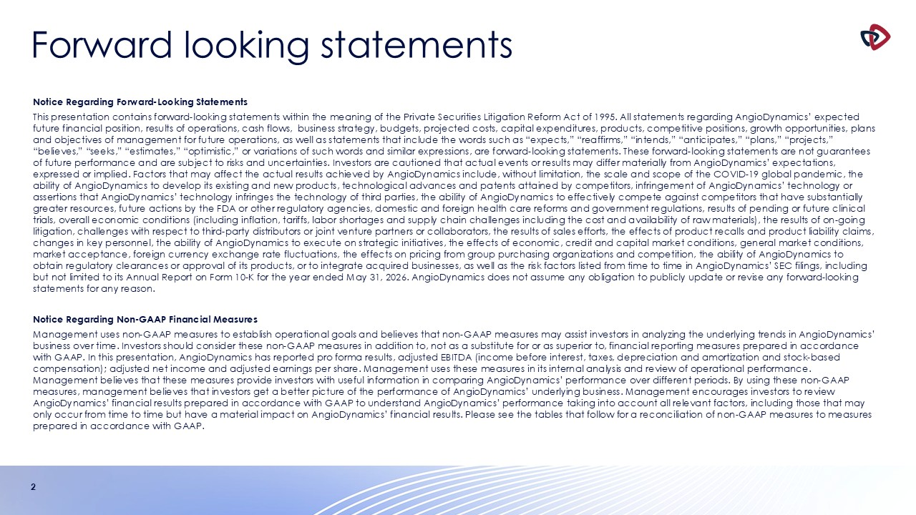
Forward looking statements 2 Notice Regarding Forward-Looking Statements This presentation contains forward-looking statements within the meaning of the Private Securities Litigation Reform Act of 1995. All statements regarding AngioDynamics’ expected future financial position, results of operations, cash flows, business strategy, budgets, projected costs, capital expenditures, products, competitive positions, growth opportunities, plans and objectives of management for future operations, as well as statements that include the words such as “expects,” “reaffirms,” “intends,” “anticipates,” “plans,” “projects,” “believes,” “seeks,” “estimates,” “optimistic,” or variations of such words and similar expressions, are forward-looking statements. These forward-looking statements are not guarantees of future performance and are subject to risks and uncertainties. Investors are cautioned that actual events or results may differ materially from AngioDynamics’ expectations, expressed or implied. Factors that may affect the actual results achieved by AngioDynamics include, without limitation, the scale and scope of the COVID-19 global pandemic, the ability of AngioDynamics to develop its existing and new products, technological advances and patents attained by competitors, infringement of AngioDynamics’ technology or assertions that AngioDynamics’ technology infringes the technology of third parties, the ability of AngioDynamics to effectively compete against competitors that have substantially greater resources, future actions by the FDA or other regulatory agencies, domestic and foreign health care reforms and government regulations, results of pending or future clinical trials, overall economic conditions (including inflation, tariffs, labor shortages and supply chain challenges including the cost and availability of raw materials), the results of on-going litigation, challenges with respect to third-party distributors or joint venture partners or collaborators, the results of sales efforts, the effects of product recalls and product liability claims, changes in key personnel, the ability of AngioDynamics to execute on strategic initiatives, the effects of economic, credit and capital market conditions, general market conditions, market acceptance, foreign currency exchange rate fluctuations, the effects on pricing from group purchasing organizations and competition, the ability of AngioDynamics to obtain regulatory clearances or approval of its products, or to integrate acquired businesses, as well as the risk factors listed from time to time in AngioDynamics’ SEC filings, including but not limited to its Annual Report on Form 10-K for the year ended May 31, 2026. AngioDynamics does not assume any obligation to publicly update or revise any forward-looking statements for any reason. Notice Regarding Non-GAAP Financial Measures Management uses non-GAAP measures to establish operational goals and believes that non-GAAP measures may assist investors in analyzing the underlying trends in AngioDynamics’ business over time. Investors should consider these non-GAAP measures in addition to, not as a substitute for or as superior to, financial reporting measures prepared in accordance with GAAP. In this presentation, AngioDynamics has reported pro forma results, adjusted EBITDA (income before interest, taxes, depreciation and amortization and stock-based compensation); adjusted net income and adjusted earnings per share. Management uses these measures in its internal analysis and review of operational performance. Management believes that these measures provide investors with useful information in comparing AngioDynamics’ performance over different periods. By using these non-GAAP measures, management believes that investors get a better picture of the performance of AngioDynamics’ underlying business. Management encourages investors to review AngioDynamics’ financial results prepared in accordance with GAAP to understand AngioDynamics’ performance taking into account all relevant factors, including those that may only occur from time to time but have a material impact on AngioDynamics’ financial results. Please see the tables that follow for a reconciliation of non-GAAP measures to measures prepared in accordance with GAAP.

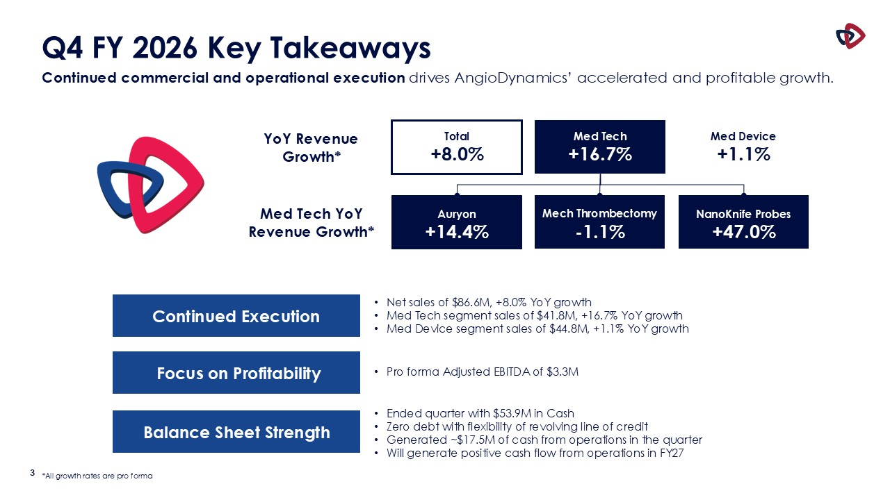
3 Q4 FY 2026 Key Takeaways Continued commercial and operational execution drives AngioDynamics’ accelerated and profitable growth. Total +8.0% YoY Revenue Growth* Med Tech +16.7% Med Device +1.1% Auryon +14.4% Med Tech YoY Revenue Growth* Mech Thrombectomy -1.1% NanoKnife Probes +47.0% Focus on Profitability Balance Sheet Strength Ended quarter with $53.9M in Cash Zero debt with flexibility of revolving line of credit Generated ~$17.5M of cash from operations in the quarter Will generate positive cash flow from operations in FY27 Pro forma Adjusted EBITDA of $3.3M Continued Execution Net sales of $86.6M, +8.0% YoY growth Med Tech segment sales of $41.8M, +16.7% YoY growth Med Device segment sales of $44.8M, +1.1% YoY growth *All growth rates are pro forma

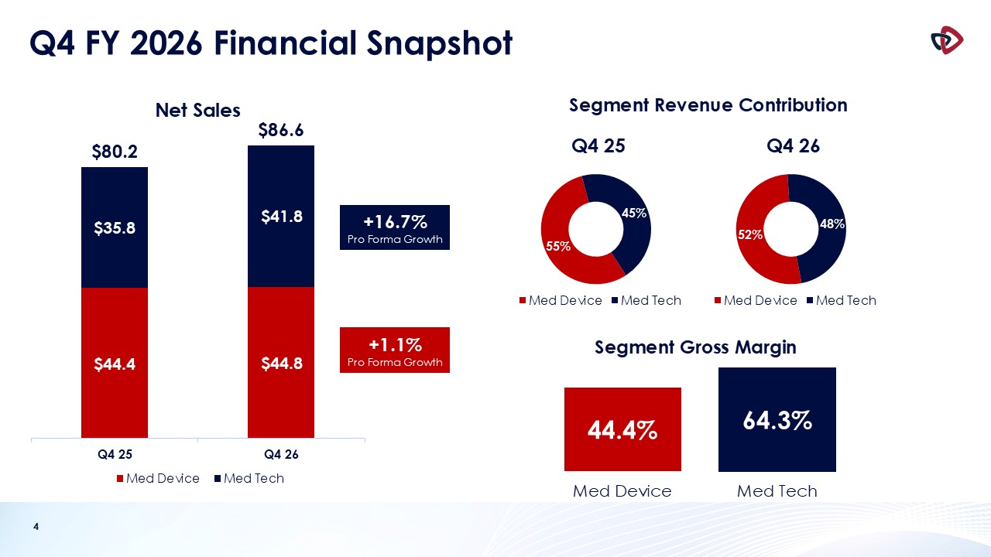
4 Q4 FY 2026 Financial Snapshot +1.1% Pro Forma Growth +16.7% Pro Forma Growth Segment Revenue Contribution Segment Gross Margin 44.4% 64.3% Med Device Med Tech

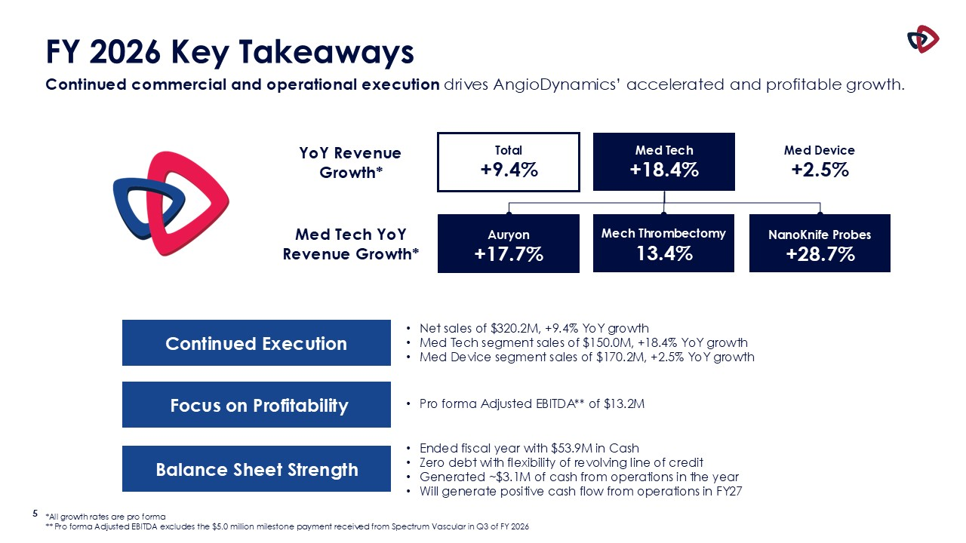
5 FY 2026 Key Takeaways Continued commercial and operational execution drives AngioDynamics’ accelerated and profitable growth. Total +9.4% YoY Revenue Growth* Med Tech +18.4% Med Device +2.5% Auryon +17.7% Med Tech YoY Revenue Growth* Mech Thrombectomy 13.4% NanoKnife Probes +28.7% Focus on Profitability Balance Sheet Strength Ended fiscal year with $53.9M in Cash Zero debt with flexibility of revolving line of credit Generated ~$3.1M of cash from operations in the year Will generate positive cash flow from operations in FY27 Pro forma Adjusted EBITDA** of $13.2M Continued Execution Net sales of $320.2M, +9.4% YoY growth Med Tech segment sales of $150.0M, +18.4% YoY growth Med Device segment sales of $170.2M, +2.5% YoY growth *All growth rates are pro forma ** Pro forma Adjusted EBITDA excludes the $5.0 million milestone payment received from Spectrum Vascular in Q3 of FY 2026

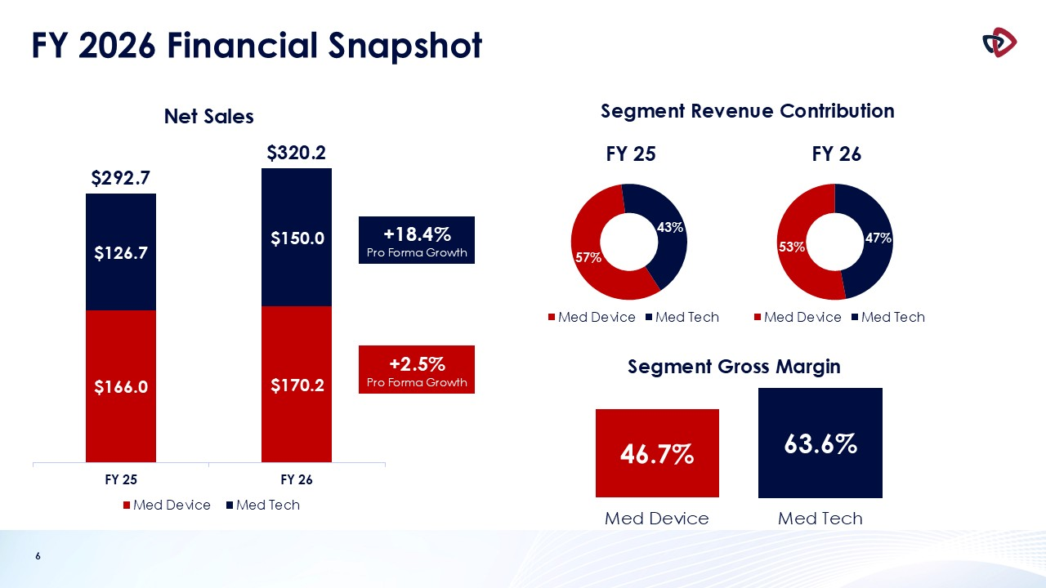
6 FY 2026 Financial Snapshot +2.5% Pro Forma Growth +18.4% Pro Forma Growth Segment Revenue Contribution Segment Gross Margin 46.7% 63.6% Med Device Med Tech

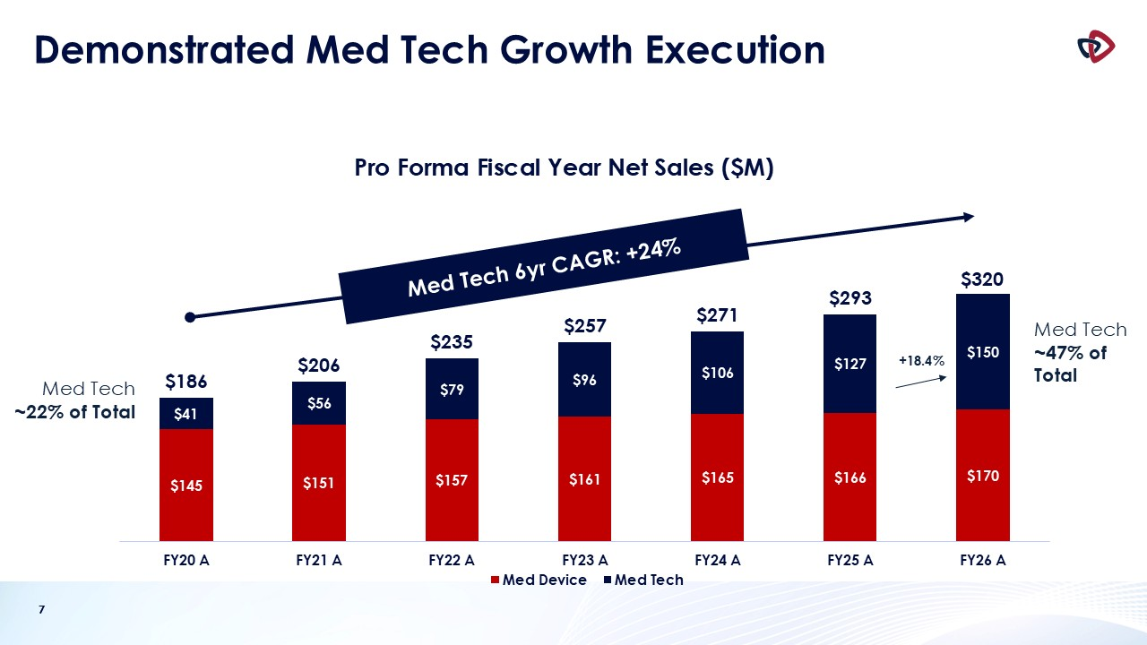
7 Demonstrated Med Tech Growth Execution 7 Med Tech ~22% of Total Med Tech ~47% of Total +18.4% Med Tech 6yr CAGR: +24%

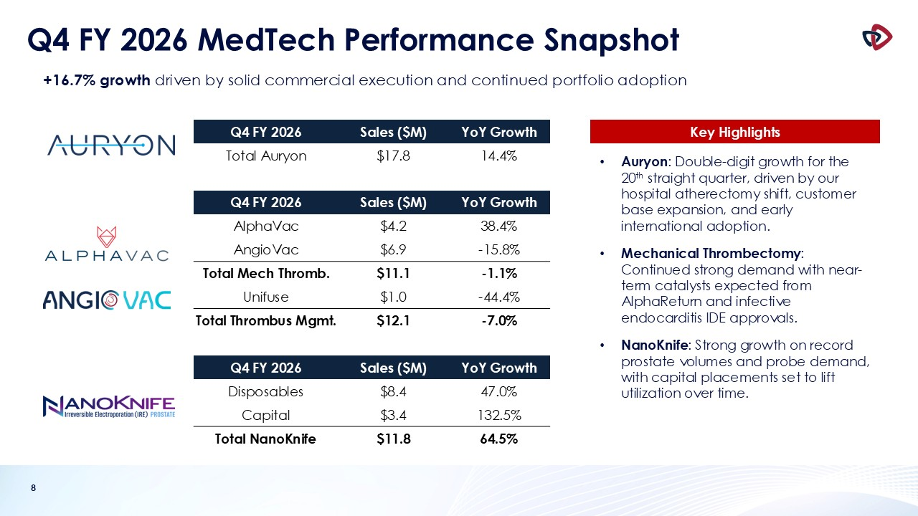
8 Q4 FY 2026 MedTech Performance Snapshot Auryon: Double-digit growth for the 20th straight quarter, driven by our hospital atherectomy shift, customer base expansion, and early international adoption. Mechanical Thrombectomy: Continued strong demand with near-term catalysts expected from AlphaReturn and infective endocarditis IDE approvals. NanoKnife: Strong growth on record prostate volumes and probe demand, with capital placements set to lift utilization over time. Q4 FY 2026 Sales ($M) YoY Growth Total Auryon $17.8 14.4% Q4 FY 2026 Sales ($M) YoY Growth AlphaVac $4.2 38.4% AngioVac $6.9 -15.8% Total Mech Thromb. $11.1 -1.1% Unifuse $1.0 -44.4% Total Thrombus Mgmt. $12.1 -7.0% Q4 FY 2026 Sales ($M) YoY Growth Disposables $8.4 47.0% Capital $3.4 132.5% Total NanoKnife $11.8 64.5% +16.7% growth driven by solid commercial execution and continued portfolio adoption Key Highlights

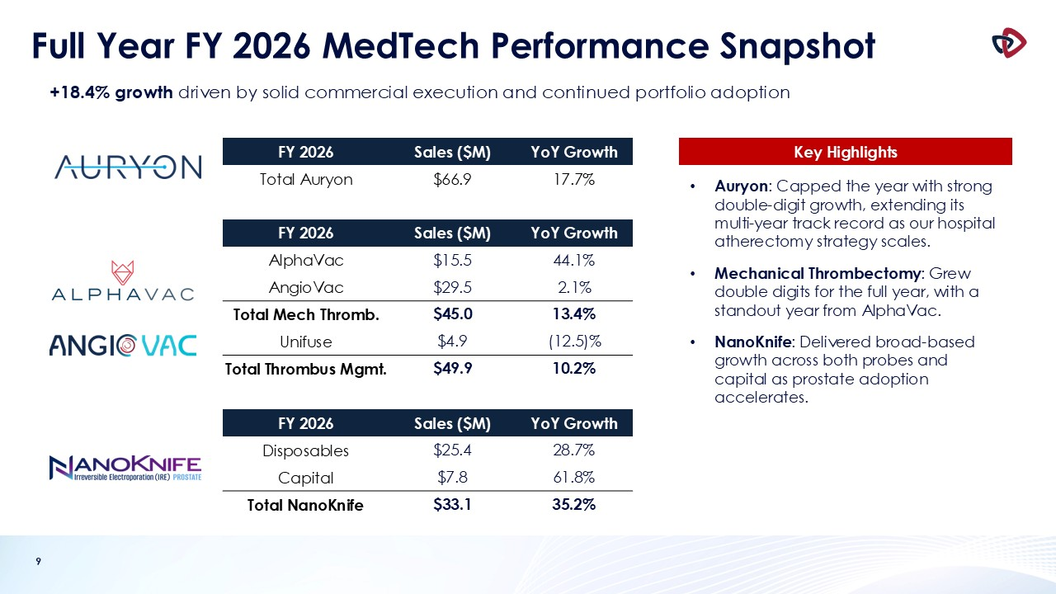
9 Full Year FY 2026 MedTech Performance Snapshot FY 2026 Sales ($M) YoY Growth Total Auryon $66.9 17.7% FY 2026 Sales ($M) YoY Growth AlphaVac $15.5 44.1% AngioVac $29.5 2.1% Total Mech Thromb. $45.0 13.4% Unifuse $4.9 (12.5)% Total Thrombus Mgmt. $49.9 10.2% FY 2026 Sales ($M) YoY Growth Disposables $25.4 28.7% Capital $7.8 61.8% Total NanoKnife $33.1 35.2% +18.4% growth driven by solid commercial execution and continued portfolio adoption Key Highlights Auryon: Capped the year with strong double-digit growth, extending its multi-year track record as our hospital atherectomy strategy scales. Mechanical Thrombectomy: Grew double digits for the full year, with a standout year from AlphaVac. NanoKnife: Delivered broad-based growth across both probes and capital as prostate adoption accelerates.

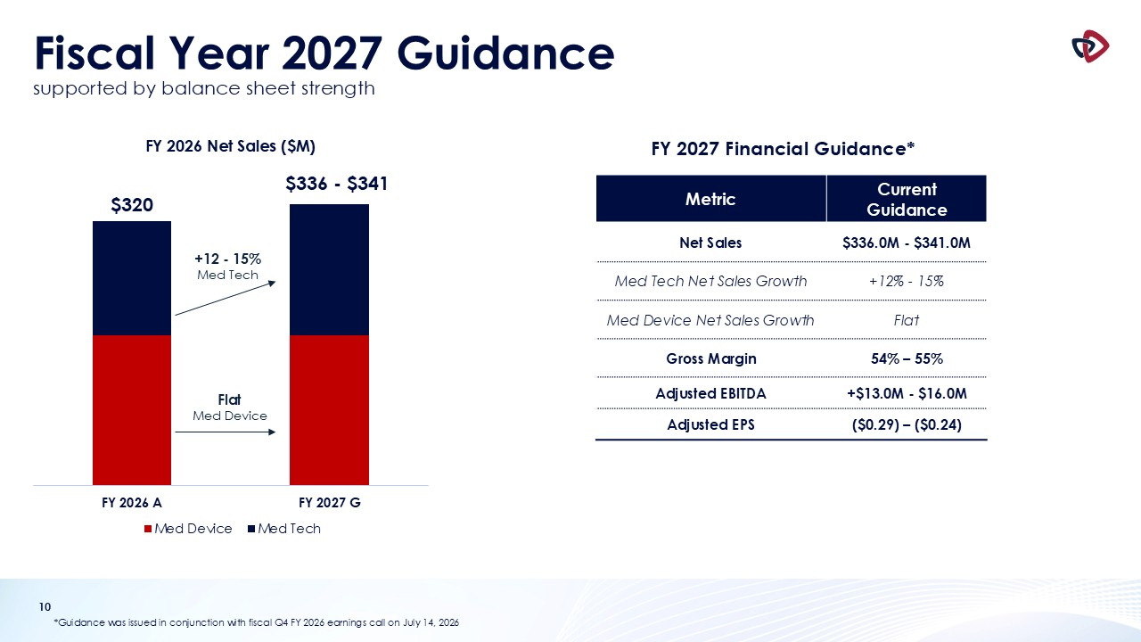
10 Fiscal Year 2027 Guidancesupported by balance sheet strength *Guidance was issued in conjunction with fiscal Q4 FY 2026 earnings call on July 14, 2026 +12 - 15% Med Tech Metric Current Guidance Net Sales $336.0M - $341.0M Med Tech Net Sales Growth +12% - 15% Med Device Net Sales Growth Flat Gross Margin 54% – 55% Adjusted EBITDA +$13.0M - $16.0M Adjusted EPS ($0.29) – ($0.24) Flat Med Device FY 2027 Financial Guidance*

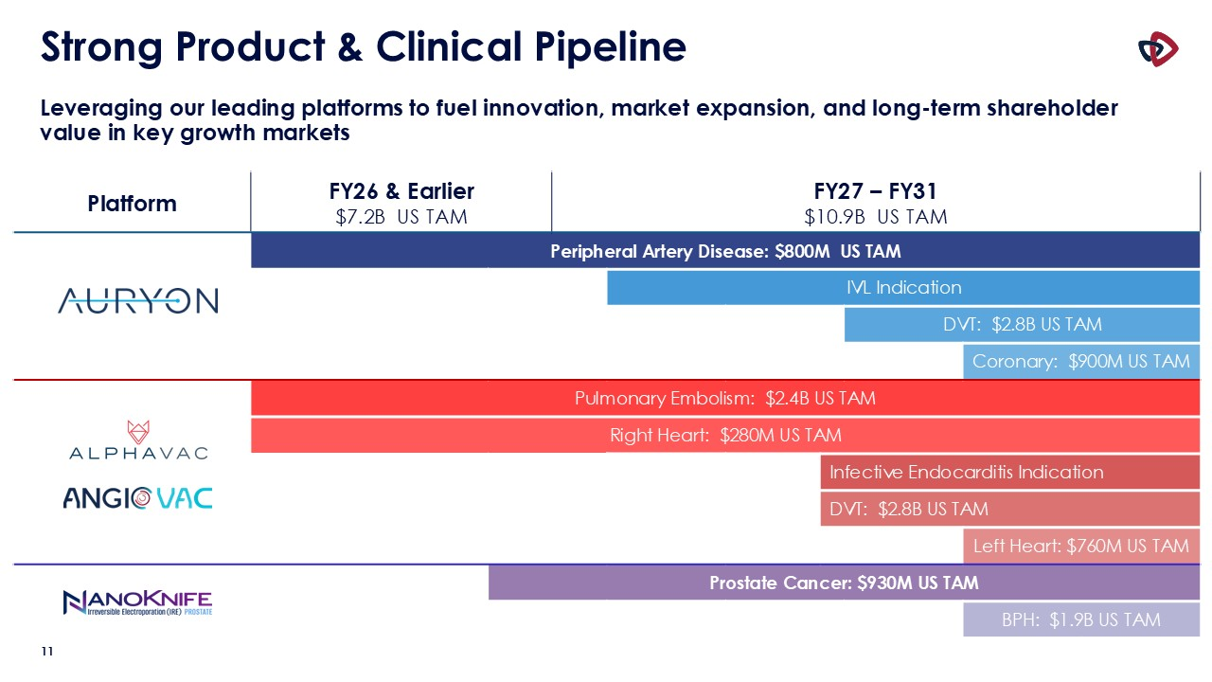
Strong Product & Clinical Pipeline Leveraging our leading platforms to fuel innovation, market expansion, and long-term shareholder value in key growth markets Platform FY26 & Earlier $7.2B US TAM FY26 – FY31 $10.9B US TAM FY27 – FY31 $10.9B US TAM FY27 – FY31 $10.9B US TAM Peripheral Artery Disease: $800M US TAM IVL Indication DVT: $2.8B US TAM Coronary: $900M US TAM Pulmonary Embolism: $2.4B US TAM Right Heart: $280M US TAM Infective Endocarditis Indication Infective Endocarditis Indication: $270M TAM* DVT: $2.8B US TAM DVT: 2.8B TAM Left Heart: $760M US TAM Prostate Cancer: $930M US TAM BPH: $1.9B US TAM 11

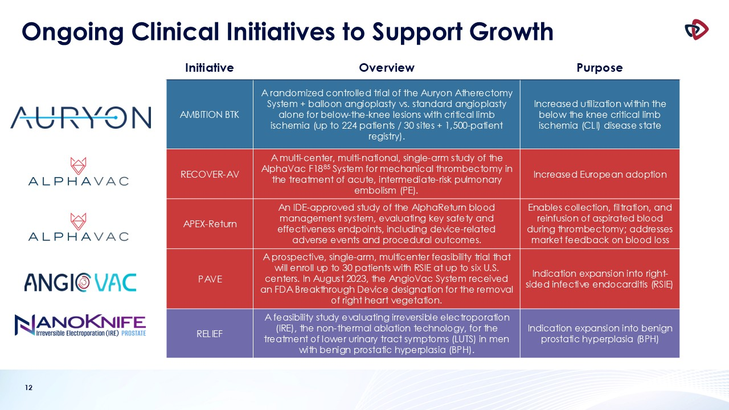
12 Ongoing Clinical Initiatives to Support Growth Initiative Overview Purpose AMBITION BTK A randomized controlled trial of the Auryon Atherectomy System + balloon angioplasty vs. standard angioplasty alone for below-the-knee lesions with critical limb ischemia (up to 224 patients / 30 sites + 1,500-patient registry). Increased utilization within the below the knee critical limb ischemia (CLI) disease state RECOVER-AV A multi-center, multi-national, single-arm study of the AlphaVac F1885 System for mechanical thrombectomy in the treatment of acute, intermediate-risk pulmonary embolism (PE). Increased European adoption APEX-Return An IDE-approved study of the AlphaReturn blood management system, evaluating key safety and effectiveness endpoints, including device-related adverse events and procedural outcomes. Enables collection, filtration, and reinfusion of aspirated blood during thrombectomy; addresses market feedback on blood loss PAVE A prospective, single-arm, multicenter feasibility trial that will enroll up to 30 patients with RSIE at up to six U.S. centers. In August 2023, the AngioVac System received an FDA Breakthrough Device designation for the removal of right heart vegetation. Indication expansion into right-sided infective endocarditis (RSIE) RELIEF A feasibility study evaluating irreversible electroporation (IRE), the non-thermal ablation technology, for the treatment of lower urinary tract symptoms (LUTS) in men with benign prostatic hyperplasia (BPH). Indication expansion into benign prostatic hyperplasia (BPH)


13 Appendix

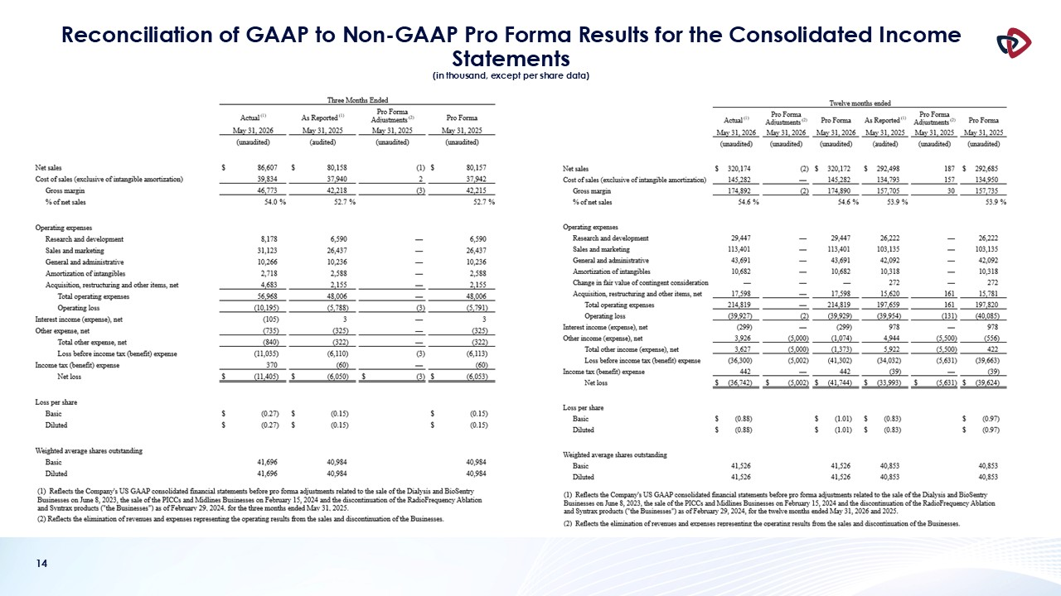
14 Reconciliation of GAAP to Non-GAAP Pro Forma Results for the Consolidated Income Statements (in thousand, except per share data)

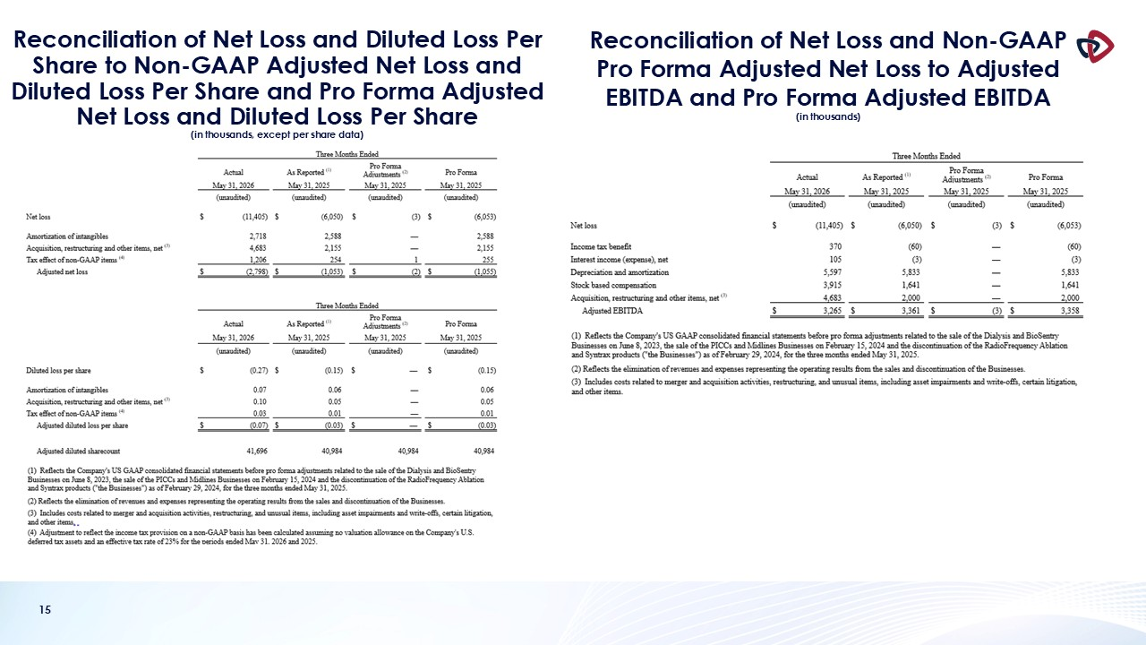
15 Reconciliation of Net Loss and Diluted Loss Per Share to Non-GAAP Adjusted Net Loss and Diluted Loss Per Share and Pro Forma Adjusted Net Loss and Diluted Loss Per Share (in thousands, except per share data) Reconciliation of Net Loss and Non-GAAP Pro Forma Adjusted Net Loss to Adjusted EBITDA and Pro Forma Adjusted EBITDA (in thousands)

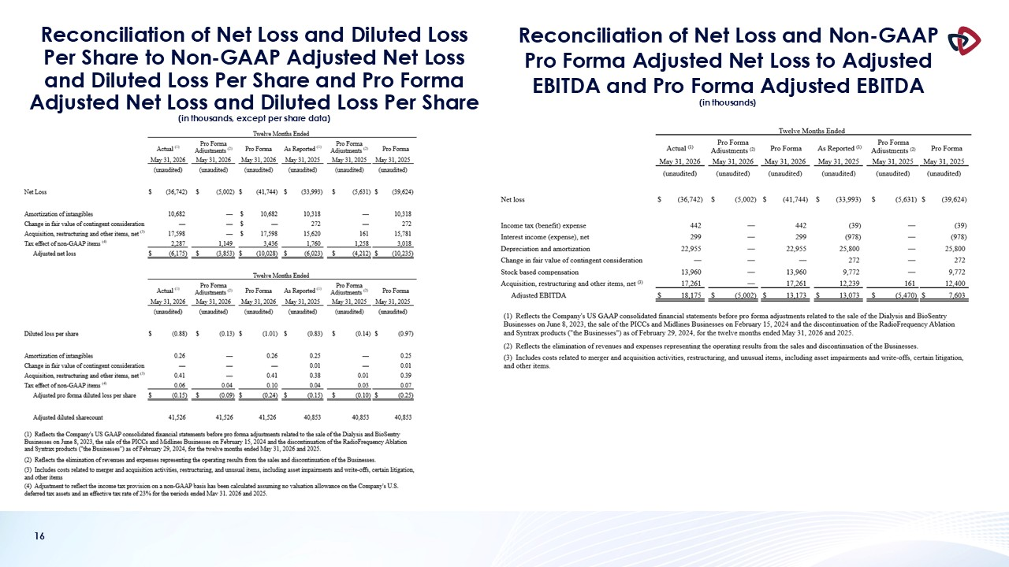
16 Reconciliation of Net Loss and Diluted Loss Per Share to Non-GAAP Adjusted Net Loss and Diluted Loss Per Share and Pro Forma Adjusted Net Loss and Diluted Loss Per Share(in thousands, except per share data) Reconciliation of Net Loss and Non-GAAP Pro Forma Adjusted Net Loss to Adjusted EBITDA and Pro Forma Adjusted EBITDA (in thousands)

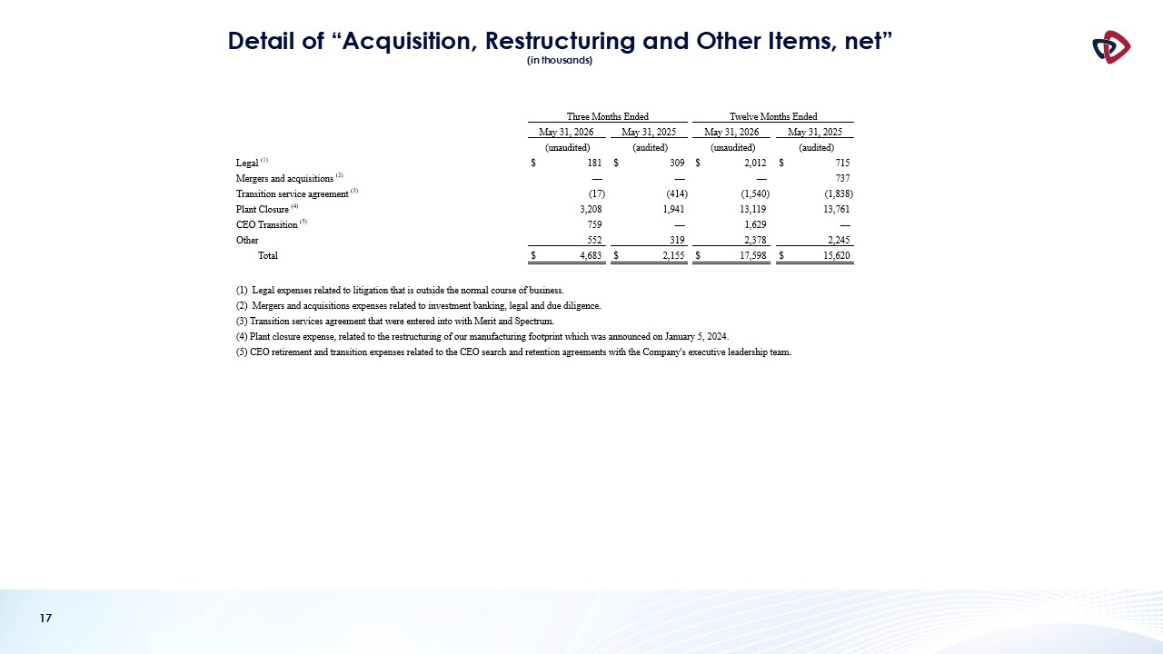
17 Detail of “Acquisition, Restructuring and Other Items, net” (in thousands)

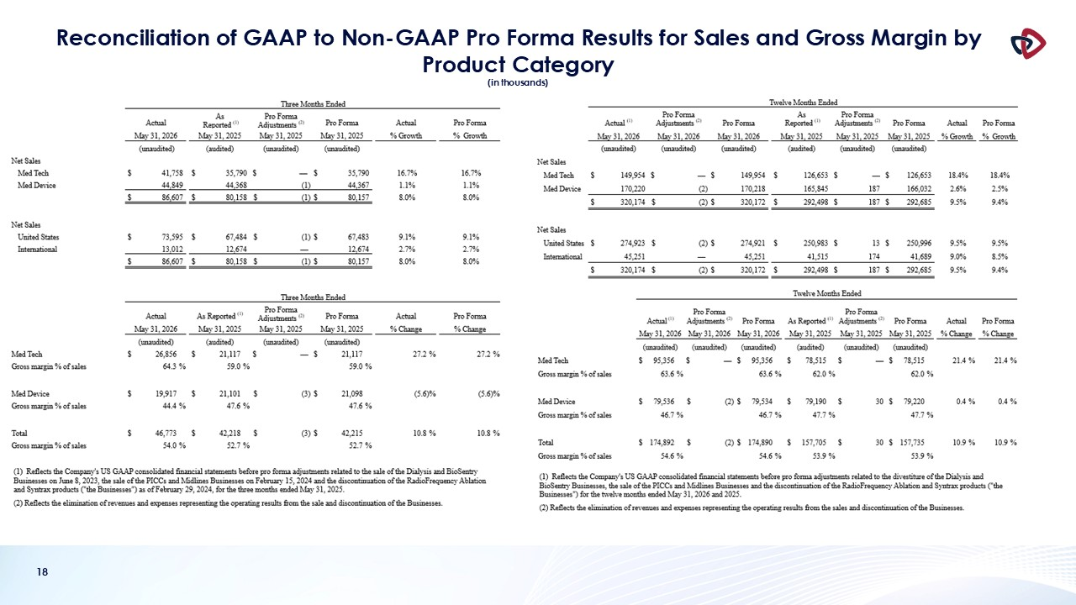
18 Reconciliation of GAAP to Non-GAAP Pro Forma Results for Sales and Gross Margin by Product Category (in thousands)

